**Expected hours** are calculated by summing the nursing times in minutes (from the CMS Time Study found in Appendix Table A1) connected to each RUG category across all residents in the category and across all categories. The total minutes are then divided by the number of residents included in the calculations. The number of minutes per resident is converted to hours by dividing by 60. The result is the “expected” number of hours per resident day for each nursing category. 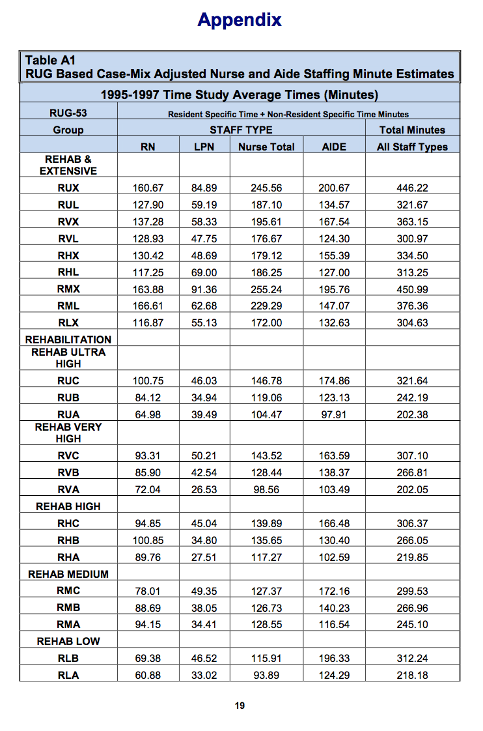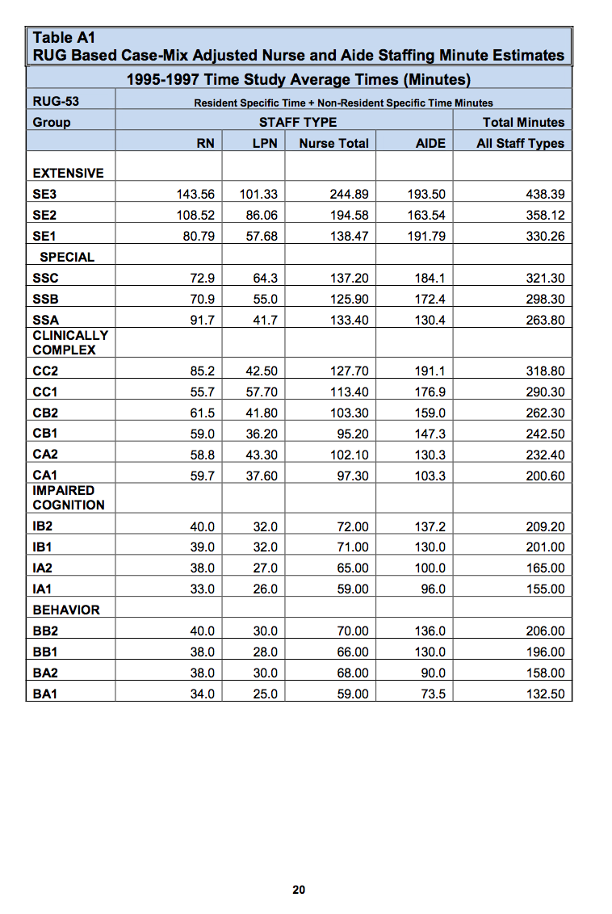

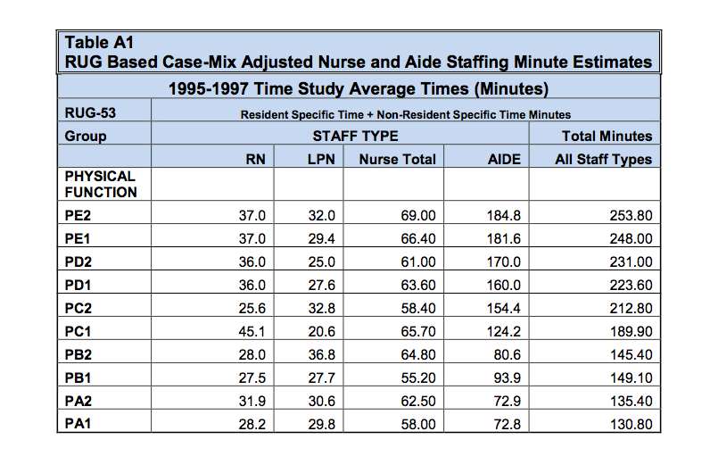

Source: https://www.cms.gov/Medicare/Provider-Enrollment-and-Certification/CertificationandComplianc/Downloads/usersguide.pdf