Supplemental Materials for Testing Theories of Threat, Individual Difference, and Ideology: Little Evidence of Personality Based Individual Differences in Ideological Responses to Threat

Table of Contents

3. Complete LISS Measures
6. LISS Results Within Person Centered Personality (Personality Varies Within Persons Over Waves)
8. Main Effects Threat Models With No Personality Terms Included
9. Multiverse Analysis LISS
16. Complete ANES Measures
18. Multiverse Analysis ANES
23. ANES Models with State Level Controls
25. ANES Models Among Only Whites
27. ANES Models with No State or Individual Level Controls

LISS Measures
All ideology measures rescored such that higher scores are more conservative responses
Ideology

- Union Support (1fully disagree – 5 fully agree)
  - Trade unions should take a much tougher political stance, if they wish to promote the workers’ interests.
  - Trade unions should advise their members to vote for those parties that best promote the workers’ interests.
- Mothers of Young Children Working (1 full time - 3 no job at all). “Do you think that women, under the circumstances described below, should be able to have a full time job, a part time job, or no job at all?”
  - If she has a baby (child younger than 1 year).
  - If she has a child that does not yet attend primary school.
  - After the youngest child starts primary school.
  - After the youngest child starts secondary school.
- Gender and childrearing (1 fully disagree – 5 fully agree). “The following statements are on marriage, the duties of husbands and wives, and about rearing boys and girls. Please read each statement and indicate to what extent you agree or disagree”
  - A woman is generally more suited for rearing young children than a man.
  - It is actually less important for a girl than a boy to get a good education.
  - Generally speaking, boys can be reared more liberally than girls.
  - It is unnatural for women in firms to have control over men.
- Fathers working (1 fully disagree, 5 fully agree)
  - Both the father and mother should contribute to the family income.
  - The father should earn money, while the mother takes care of the household and family.
  - Fathers ought to do more in terms of housework than they do at present.
  - Fathers ought to do more in terms of childcare than they do at present.
- Mothers of kids any age working. (1 fully disagree – 5 fully agree)
  - A working mother’s relationship with her children can be just as close and warm as that of a non working mother.
  - A child that is not yet attending school is likely to suffer the consequences if his or her mother has a job.
  - Overall, family life suffers the consequences if the mother has a full-time job.
- Traditional marriage (1 fully disagree – 5 fully agree)
  - Married people are generally happier than unmarried people.
  - People that want to have children should get married.
  - A single parent can raise a child just as well as two parents together.
  - It is perfectly fine for a couple to live together without marriage intentions.
  - For a couple that wants to get married, it is good to first start living together.
  - A divorce is generally the best solution if a married couple cannot solve their marital problems.
  - It is all right for a married couple with children to get divorced.
- Immigration ability (1- fully disagree – 5 fully agree)
  - It is good if society consists of people from different cultures.
  - It is difficult for a foreigner to be accepted in the Netherlands while retaining his/her own culture.
  - It should be made easier to obtain asylum in the Netherlands.
  - Legally residing foreigners should be entitled to the same social security as Dutch citizens.
  - There are too many people of foreign origin or descent in the Netherlands.
  - People of foreign origin or descent are not accepted in the Netherlands.
  - Some sectors of the economy can only continue to function because people of foreign origin or descent work there.
  - It does not help a neighborhood if many people of foreign descent move in.
IPIP
“On the following pages, there are phrases describing people's behaviors. Please use the rating scale below to describe how accurately each statement describes you. Describe yourself as you generally are now, not as you wish to be in the future. Describe yourself as you honestly see yourself, in relation to other people you know of the same sex as you are, and roughly your same age. Please read each statement carefully, and then fill in the bubble that corresponds to the number on the scale.” (1- very inaccurate, 5 – very accurate)
- Openness
  - Have a rich vocabulary
  - Have difficulty understanding abstract ideas (r)
  - Have a vivid imagination
  - Am not interested in abstract ideas (r)
  - Have excellent ideas
  - Do not have a good imagination (r)
  - Am quick to understand things
  - Use difficult words
  - Spend time reflecting on things
  - Am full of ideas
- Conscientiousness
  - Am exacting in my work
  - Follow a schedule
  - Shirk my duties (r)
  - Like order
  - Often forget to put things back in their proper place (r)
  - Get chores done right away
  - Make a mess of things (r)
  - Pay attention to details
  - Am always prepared
  - Leave my belongings around (r)
- Extraversion
  - Am the life of the party
  - Don’t talk a lot (r)
  - Feel comfortable around people
  - Keep in the background (r)
  - Start conversations
  - Have little to say (r)
  - Talk to a lot of different people at parties
  - Don’t like to draw attention to myself (r)
  - Don’t mind being the center of attention
  - Am quiet around strangers (r)
- Agreeableness
  - Make people feel at ease
  - Feel others’ emotions
  - Take time out for others
  - Am not really interested in others (r)
  - Have a soft heart
  - Am not interested in other people’s problems (r)
  - Sympathize with other’s feelings
  - Insult people (r)
  - Am interested in people
  - Feel little concern for others (r)
- Neuroticism
  - Get stressed out easily
  - Am relaxed most of the time (r)
  - Worry about things
  - Seldom feel blue (r)
  - Am easily disturbed
  - Get upset easily
  - Change my mood a lot
  - Have frequent mood swings
  - Get irritated easily
  - Often feel blue

Results Personality Within Person Centered Models

Equations Main Effects
Level 1 (Within Persons)
Ideology_{ij} = β0_{i} + β1_{i}wave_{ij} + β2_{i}homicide_{ij} + β3_{i}immigration_{ij} + β4_{i}unemployment_{ij} + β5_{i}covid_{ij} + β6_{i}open_{ij} + β7_{i}conscientiousness_{ij} + β8_{i}extraversion_{ij} + β9_{i}agreeableness_{ij} + β10_{i}neuroticism_{ij} + ε_{ij}

Level 2 (Between Persons)
β0_{i} = γ00 + u0_{i}
β1_{i} = γ10 + u1_{i}

Equations Interactions
Level1 (within person equation)
Ideology_{ij} = β0_{i} + β1_{i}wave_{ij} + β2 _{i}homicide_{ij} + β3_{i}immigration_{ij} + β4_{i}unemployment_{ij} + β5_{i}covid_{ij} + β6_{i}open_{ij} + β7_{i}conscientiousness_{ij} + β8_{i}extraversion_{ij} + β9_{i}agreeableness_{ij} + β10_{i}neuroticism_{ij} + β11_{i}homicide_{ij}*open_{ij} + β12_{i}homicide_{ij}*conscientiousness_{ij} + β13_{i}immigration_{ij}*open_{ij} + β14_{i}immigration_{ij}*conscientiousness_{ij} + β15_{i}unemployment_{ij}*open_{ij} + β16_{i}unemployment_{ij}*conscientiousness_{ij} + β17_{i}covid_{ij}*open_{ij} + β18_{i}covid*conscientiousness_{ij} + β19_{i}wave_{ij}*open_{ij} + β20_{i}covid_{ij}*conscientiousness_{ij} + ε_{ij}

Level 2 (between persons equations)
β0_{i} = γ00 + u0_{i}
β1_{i} = γ10 + u1_{i}

Figure A: Main Effects Models Within Person Centered Personality (18/44 Consistent with Conservative Shift)
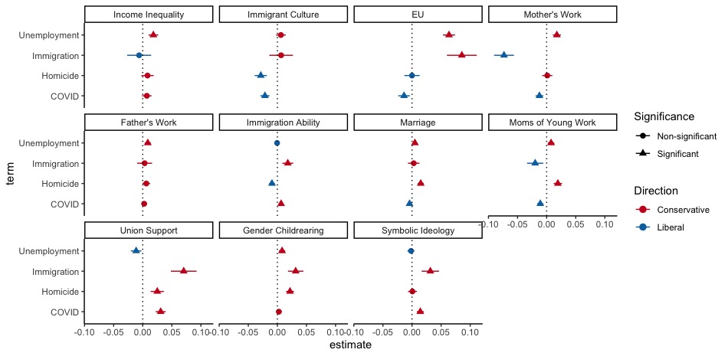

Figure B: Personality Interactions Within Person Centered Personality (0/ 44 Consistent with Modified Threat Constraint, 2/88 Consistent with Negativity Bias)
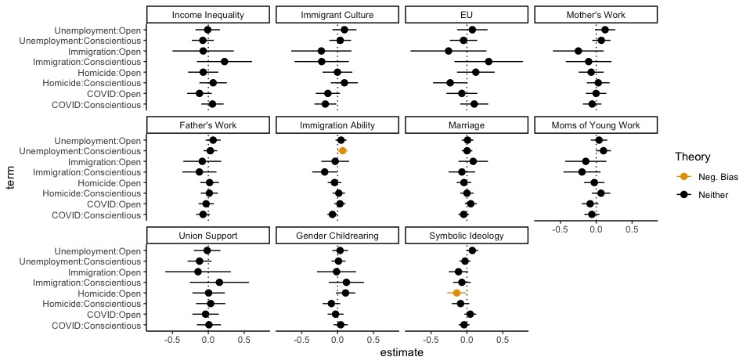

Results for Main Effects Models with No Personality Terms Included

Equations Main Effects
Level 1 (Within Persons)
Ideology_{ij} = β0_{i} + β1_{i}wave_{ij} + β2_{i}homicide_{ij} + β3_{i}immigration_{ij} + β4_{i}unemployment_{ij} + β5_{i}covid_{ij} + ε_{ij}

Level 2 (Between Persons)
β0_{i} = γ00 + u0_{i}
β1_{i} = γ10 + u1_{i}

Figure C: Threat Main Effects Models With No Personality Terms Included (21/44 Consistent With Conservative Shift)
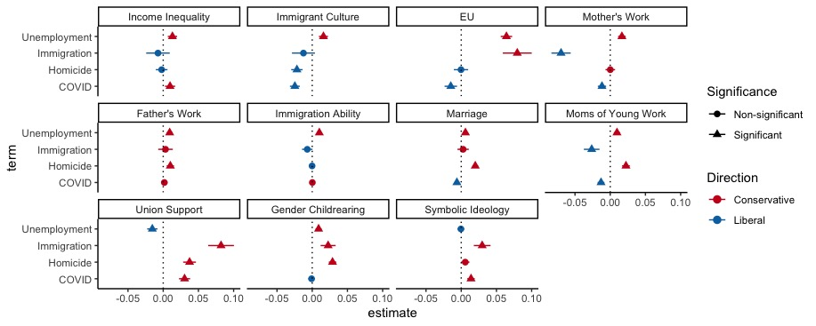
Multiverse Analysis LISS: Main Effects

This analysis was conducted to examine the robustness of our results to many plausible alternative model specifications researchers could reasonably choose to fit. Specifically, for main effects models, the specifications included threat variables both individually and in tandem, and both included and excluded personality control variables. For the main effects models, this corresponded 396 model specifications containing about 500 terms of theoretical interest. A figure depicting the results of this multiverse analysis is presented below. Results are broadly consistent with the results presented in the main text. About half of the threat coefficients across all specifications resulted in conservative shifts. Around a third of the threat coefficients indicated a significant liberal shift, and around a third of threat shift coefficients were non-significant.

Figure D
Multiverse analysis main effects of threat on ideology
Note: Figure presents the results of a multiverse analysis across many plausible alternative model specifications examining the effects of ecological threats on within person changes in political ideology. Estimates in top panel are the estimates of the threat (as indicated in the threat panel) on the ideology outcome (as indicated in the outcome panel). Models with significant liberal shifts in the top panel are color-coded blue. Models with significant conservative shifts in the top panel are color-coded red.

Multiverse Analysis LISS: Interaction Effects

This analysis was conducted to examine the robustness of our results to many plausible alternative model specifications researchers could reasonably choose to fit. Specifically, for the personality interaction effect models, we examine the robustness of findings by probing whether results generally hold when threat and personality variables are considered in isolation, and in tandem. This analysis consists of 440 possible model specifications with over 1000 terms of theoretical interest. Significant interaction terms consistent with our modified threat constraint model are coded green. Significant interaction terms consistent with the negativity bias perspective are coded orange. In line with the results presented in the main text, very few coefficients are statistically significant, suggesting that personality based individual differences in ideological responses to threat are relatively rare.

Figure E
Multiverse analysis threat by personality interaction terms
Note: Figure displays fixed effects for interaction terms between ecological threats and relevant personality variables from growth curve models examining within person changes in ideology. Estimates in top panel are the estimates of the threat (as indicated in the threat panel) × personality (as indicated in the moderator panel) on the ideology outcome (as indicated in the outcome panel). Models with significant interactions in line with threat constraint are coded green. Models with significant interactions in line with negativity bias are coded orange.

ANES Measures
All ideology measures re-scored such that higher values are more conservative positions
Economic Ideology
All economic ideology items are rescaled to range from 0-1 before composite score is calculated, α = 79.
- 1-7 scale. 1= “Government should provide many fewer services: Reduce spending a lot.” And 7 = “Government should provide many more services: Increase spending a lot.”
- Which of the following statements comes closer to your view? 1) The main reason government has become bigger over the years is because it has gotten involved in things that people should do for themselves. OR 2) Government has become bigger because the problems we face have become bigger.
- How much government regulation of business is good for society? 1- A great deal, 5- None at all.
- Which of the following two statements comes closer to your view? 1) We need a strong government to handle today’s economic problems. OR 2) The free market can handle these problems without government being involved.
- Which of the two statements comes closest to your view? 1) The less government the better. OR 2) There are more things government should be doing.
Social Ideology
- The world is always changing and we should adjust our view of moral behavior to those changes. 1- Agree strongly, 5- Disagree strongly
- The newer lifestyles are contributing to the breakdown of our society. 1- Agree strongly, 5- Disagree strongly.
- We should be more tolerant of people who choose to live according to their own moral standards. 1- Agree strongly, 5- Disagree strongly.
- This country would have many fewer problems if there were more emphasis on traditional family ties. 1- Agree strongly, 5- Disagree strongly.
TIPI (Personality)
“We’re interested in how you see yourself. Please mark how well the following pair of words describes you. Even if one word describes you better than the other.”
- Openness
  - Open to new experiences, complex
  - Conventional, uncreative (r)
- Conscientiousness
  - Dependable, self-disciplined
  - Disorganized, careless
- Extraversion
  - Extraverted, enthusiastic
  - Reserved, quiet (r)
- Agreeableness
  - Critical, quarrelsome
  - Sympathetic, warm
- Neuroticism
  - Anxious, easily upset
  - Calm, emotionally stable
Multiverse Analysis ANES: Main Effects

This analysis was conducted to examine the robustness of our results to many plausible alternative model specifications researchers could reasonably choose to fit. Specifically, for main effects models, the specifications included threat variables both individually and in tandem, and both with personality control variables included and excluded. We also tested how the inclusion and exclusion of demographic control variables impacted results. For the main effects models, this corresponded to 1344 model specifications containing 2304 terms of theoretical interest. A figure depicting the results of this multiverse analysis is presented below. Results are broadly consistent with the results presented in the main text. Most of the time, threat did not significantly predict changes in ideology. Though in some models without demographic controls coefficients did reach statistical significance. These coefficients were not consistently in a conservative or liberal direction.

Figure C
Multiverse analysis results for fixed effects of state level threat on ideology
Note: Figure displays fixed effects from multilevel models examining the effects of ecological threats on ideology across many plausible alternative model specifications. In these models, individuals are nested within states. Estimates in the top panel are the estimates of the effect of threat (as indicated in the top panel) on ideology outcomes (as indicated in the outcome panel). Models with significant liberal shifts in the top panel are color-coded blue. Models with significant conservative shifts in the top panel are color-coded red.

Multiverse Analysis ANES: Interaction Effects

This analysis was conducted to examine the robustness of our results to many plausible alternative model specifications researchers could reasonably choose to fit. Specifically, we examine the robustness of findings by probing whether results generally hold when threat and personality variables are considered in isolation, and in tandem. We also examine how the inclusion and exclusion of demographic covariates impacts results. This analysis consists of 864 possible model specifications with 1728 terms of theoretical interest. Significant interaction terms consistent with our modified threat constraint model are coded green. Significant interaction terms consistent with the negativity bias perspective are coded orange. In line with the results presented in the main text, relatively few coefficients are statistically significant, suggesting that personality based individual differences in ideological responses to threat are relatively rare.

Figure D
Results of fixed effects for interaction terms between personality moderators and ecological threats on ideology
Note: Figure displays fixed effects for interaction terms between ecological threats and relevant personality variables from multi-level models with persons nested within states. Estimates in top panel are the estimates of the threat (as indicated in the threat panel) × personality (as indicated in the moderator panel) on the ideology outcome (as indicated in the outcome panel). Models with significant interactions in line with threat constraint are coded green. Models with significant interactions in line with negativity bias are coded orange.

ANES Models with Additional State Level Control Variables
- Controls added to analyses:
  - State GINI index
  - Divorce rate
  - Proportion of population that is urban
  - Proportion of population that is male and under 25
  - Is the state a former confederate state?
  - State poverty rate
  - State GDP
- State controls are also considered individually (without the inclusion of other state controls) in multiverse analyses

Figure E
ANES Main Effects Models With State Level Control Variables Added
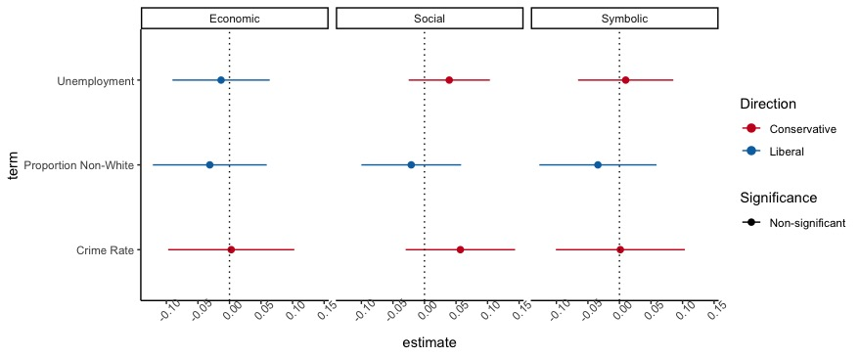
Figure F
ANES Personality Interaction Models With State Controls Added

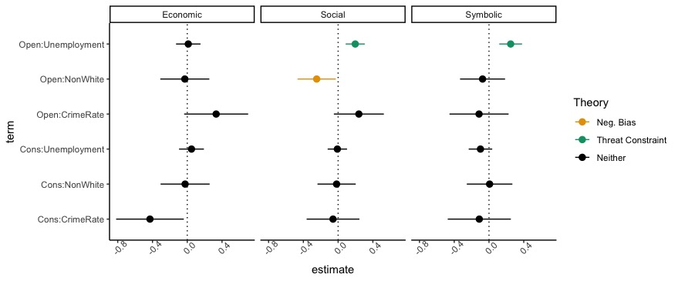

ANES Models with Binary Race Variable
- Some of our “threats” may only be threatening to Whites (e.g., greater racial diversity, see Craig & Richeson, 2014, who test their argument among Whites)
- Moreover, the studies included in meta-analyses proposing the theories we test consisted primarily of White undergraduates (e.g., Jost et al., 2003; Sibley et al., 2012)
- As such we fit our models in just the White subsample to make sure the reason we aren’t finding support for the theories is because they only predict among Whites
- Results are consistent with results from the whole sample

Figure G ANES Main Effects Models Among Whites

ANES Main Effects White Subsample

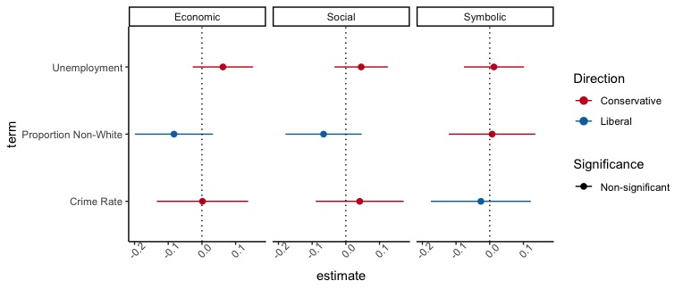

Figure H ANES Personality Models White Subsample
ANES Personality Models White Subsample
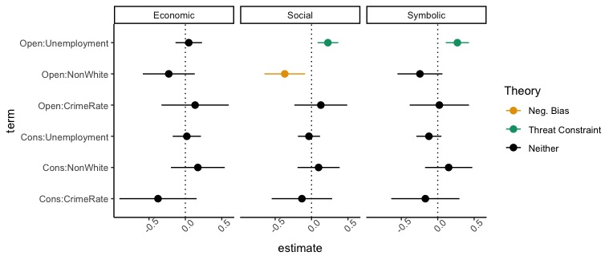

ANES Models with No Individual or State Control Variables
Figure I
ANES Main Effects with No Individual or State Level Control Variables
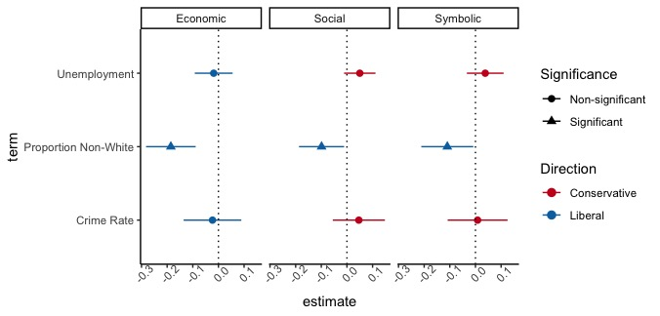

Figure J
ANES Personality Interactions With No Individual or State Control Variables
