“YouTube get search count” project

Design consideration
The script was designed due to following considerations:
- It was decided not to use ‘BeautifulSoup’ plugin for Python to make it simpler and avoid unnecessary downloads and installs which might confuse;
- It was decided not to use YouTube API, as it currently does not have API call for search results count, and it is the only scope of this script;
- Another consideration in not to use YouTube API was in authentication process, which is required for continuous use (currently only one request per hour is allowed through YouTube API without authentication) ;

Installation & configuration steps
- Please download and install Python 2.7 (not 3.0 please) from the following location http://www.python.org/getit/releases/2.7.3/;
- If you installed Python properly, all you need to do is to fill ‘strings.txt’ file with the data you want to search for, one entry per line. You are free to use any special characters, even &,<,>,etc (please see attached example)

Folder structure and file meaning
The folder has the following structure:
- Strings.txt – flat file containing keywords to be searched:
- output_<TIME>.txt – search results in the following format:
<keyword> - <count>;

Execution results:
- Execution window:
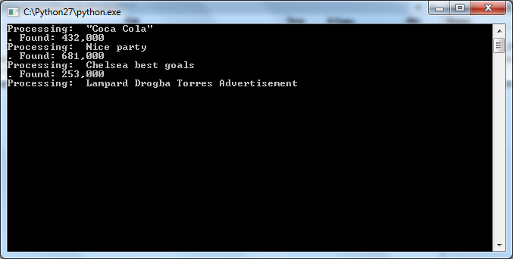
- Sampe output file:
"Coca Cola" - 432,000
Nice party - 682,000
Chelsea best goals - 254,000
Lampard Drogba Torres Advertisement - 515
Torres & Lampard - 49,900

