Paradox 4.0 performance project

Requirements
After a couple of consecutive runs, Paradox 4.0 slows down the machine and it needs to be restarted. It is required to find a solution;

Open questions
- It’s highly required to know the PC configuration;
- It’s highly required to do some health checks before and after Paradox 4.0 program execution – please see step 3 to understand how to setup some performance data collection jobs;

Performance monitor configuration
- Please set up the Windows performance monitor to log the data regarding current PC utilization. Please follow the instructions:
- Click Start → Run and then type “perfmon”:
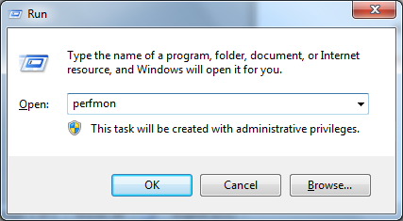
- Right click Performance Monitor option on the left panel, and choose New → Data Collector Set:
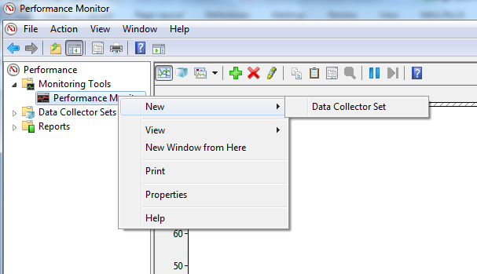
- Enter the path to the file where the data will be logged.
- Create a Data Collector within above created Data Collector Set, of type Performance Counter Data Collector:
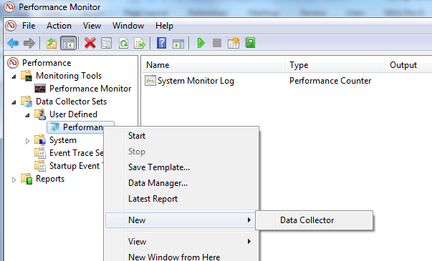
- Add performance counters:
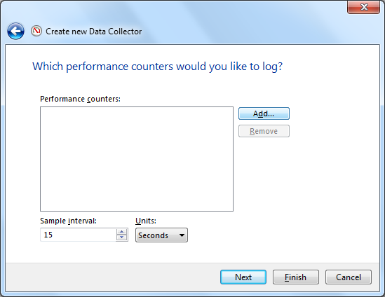
- The following performance counters should be added (Add button is at the page end):
Logical Disk;
Memory;
ID Process (Process id for Paradox 4.0 program! Please choose from the list as described below)
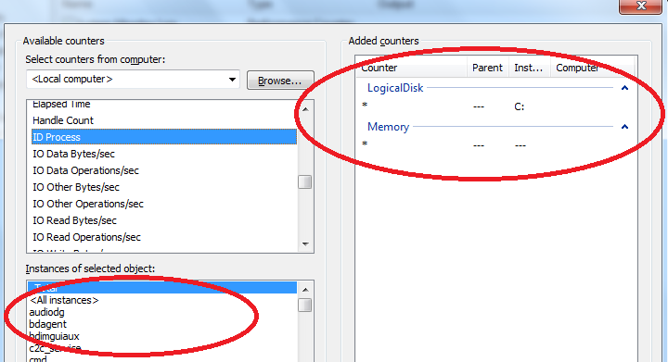
- Set sample interval for 15 seconds and press Finish button;
- Now, before first run of Paradox 4.0 program, press Start for Performance Monitor Data Collector:

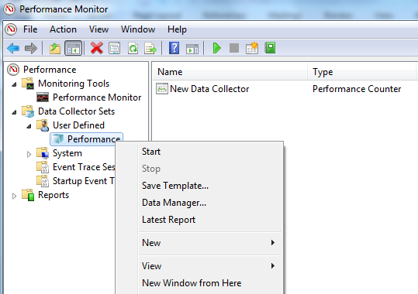
- After PC becomes slow, restart it and send me the performance log file (the path would be the one you’ve set up in step c) )
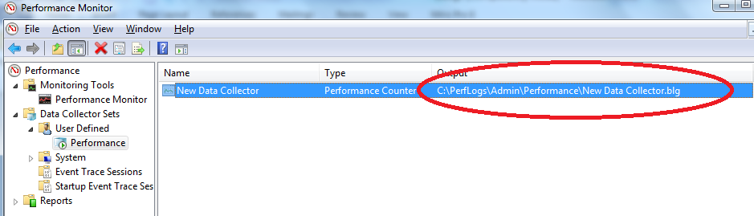

General batch file and RAM optimization
As a general cleaner, the following batch file is provided:
Code:
@echo off
del /s /f /q C:\windows\temp\*.*
rd /s /q C:\windows\temp
md c:\windows\temp
del /s /f /q %temp%\*.*
rd /s /q %temp%
call clean.vbs
It cleans temporary files, which could reduce PC performance, as well as calls to clean.vbs, which is a Visual Basic script for RAM optimization, having one line of code:
FreeMem=Space(256000000)

