MyLanguages project

Installation and configuration
For script running, you will need Python 2.7.3, please download and install it from here (in case if you don’t have it already installed)
http://www.python.org/download/releases/2.7/
Beside of Python 2.7 installation, there is an additional Python component to be installed:
- BeautifulSoup – Python module for HTTP parsing (free to use);
Please refer to the following documentation regarding downloading and installing of BeautifulSoup:
http://www.crummy.com/software/BeautifulSoup/

Usage considerations
The directory structure is following:
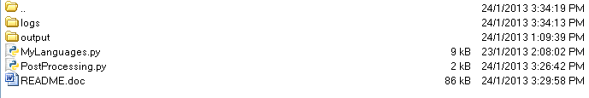
logs – logs previous execution results on files having different time stamps;
output – contains data downloaded, each language has its own directory, and each generic (Alphabet, Phrases, etc) have each own subdirectory;
MyLanguages.py – Python script which downloads data from www.mylanguages.org
PostProcessing.py – Python script, which checks whether downloaded data is consistent. This one is recommended to run after MyLanguages.py;

