AccuWeather 1.0 project

Installation and configuration
Beside of Python 2.7 installation, there are two additional Python components to be installed:
- BeautifulSoup – Python module for HTTP parsing (free to use);
- Requests – Python module for HTTP authentication (free to use);
Both above modules are provided in install directory.
For simplicity, install procedure was created for above modules - please double click the script install/install.bat, which will install both modules to your PC (it is assumed here that Python is installed on it default directory – C:\Python27).

Usage considerations
The directory structure is following:
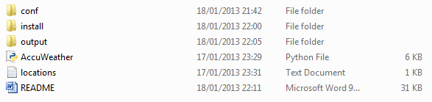
conf – contains file config.ini, where you must set up your username and password to Premium AccuWeateather account:
[accu_weather]
username = Mintel
password = XXXXXXXX
install – contains additional Python modules described in the previous section;
output – contains two files: acc-all.txt – accumulator for all weather data since script ran first time, and observed.txt – the latest data downloaded from accuweather website. All the data in both directories are sorted ascendant by date + time, so the very latest records are appended to the file end;
AccuWeather.py – Python script, which could be run on demand, or by scheduler (scheduler configuration was described in previous project)
Locations.txt – input file for AccuWeather.py script, in the format:
Barrie L9S3S1
Freehold 07728
Yonkers 10704
Vancouver V3S1V3
Windsor N9A6P6
Ottawa K1X1A3
Note: It is highly important that place and ZIP code are separated by one or multiple spaces, and all the letters in ZIP code are uppercase – that’s the only way the script could distinguish the location and Zip code.

Execution results

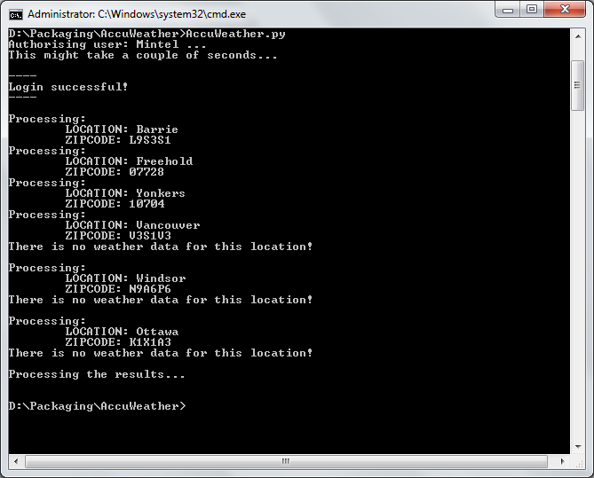
output/observed.txt:
Location,ZipCode,Report Time,Temp (F),RealFeel (F),Rel.Hum. (%),Wind Direction,Wind Spd (mph),Pressure (in),Precip (in),Vis. (Miles), Weather Cond
Yonkers,10704,01/17/2013,5:51pm,41,35,52,NW,9,30.06,0.00,10,M/CLOUDY
Freehold,07728,01/17/2013,5:55pm,39,38,44,SSW,5,30.08,0.00,10,CLOUDY
Barrie,L9S3S1,01/17/2013,6:00pm,11,N/A,65,N,7,N/A,0.00,N/A,N/A
Yonkers,10704,01/17/2013,6:51pm,41,35,50,NW,9,30.08,0.00,10,M/CLOUDY
Freehold,07728,01/17/2013,6:55pm,39,44,48,CLM,1,30.07,0.00,10,CLOUDY
Barrie,L9S3S1,01/17/2013,7:00pm,11,N/A,66,NNE,6,N/A,0.00,N/A,N/A
Yonkers,10704,01/17/2013,7:51pm,41,35,50,NNW,9,30.08,0.00,10,CLOUDY
Freehold,07728,01/17/2013,7:55pm,39,38,44,NW,5,30.09,0.00,10,CLOUDY
Barrie,L9S3S1,01/17/2013,8:00pm,10,N/A,80,N,5,N/A,0.00,N/A,N/A
Yonkers,10704,01/17/2013,8:51pm,40,31,52,N,12,30.05,0.00,10,M/CLOUDY

