Weather project

Requirements
It is required to have a script which connects to weather.noaa.gov/weather site and downloads the data for specific locations (indicated in the configuration file) to flat CSV (comma separated values) file for later use (which is not a subject of this project);

Assumptions
- The operation system where the script will run is Windows (that is required for scheduled tasks);
- The host machine has Python 2.7 interpreter installed on it(http://www.python.org/getit/releases/2.7.3/);

High level design
In case there are no special requirements, the script will be designed in Python.
The optimal solution would be to have a task scheduler job (for Windows, or Cron job in case of n-NIX systems) which will schedule the running exactly at requested time, with predefined frequency (and lots of other parameters):
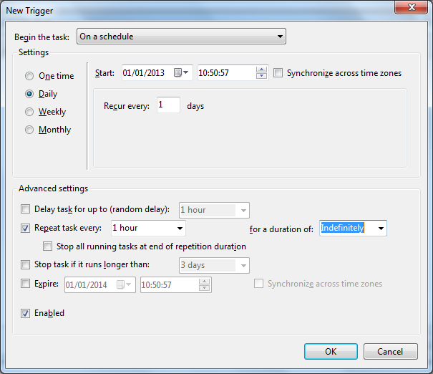

Other advantages of this approach are:
- The script won’t hang permanently in memory, using system recourses;
- User will be able to watch the logs and verify latest executions times, errors occurred, etc.
- User will control easily the parameters of script execution, and will be able to change them “on flight”
Script will store the data in “Output” directory (ex: if script weather.py is executed in C:\Scripts, the output will go to C:\Scripts\Output)
Each location will have its own file:
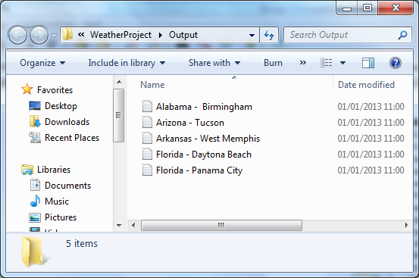
The structure and example of the CSV file are following (each missing value will contain NA):
Date,Time,Wind(mph),Vis,Weather,Sky.Cond,Temperature(Air),Temperature(Dwpt),Temperature(6h Max),Temperature(6h Min),Humidity,Wind Chill, HeatIndex,Pressure altimeter(in),Pressure sea level(mb),Precipitation(1h),Precipitation(3h),Precipitation(6h)
01,03:53,S 5,10.00,Overcast,BKN048 OVC060,53,47,NA,NA,80%,NA,NA,30.04,1017.0,NA,NA,NA
01,02:53,Vrbl 3,10.00,Overcast,FEW014 OVC050,53,46,NA,NA,77%,NA,NA,30.05,1017.5,NA,NA,NA
01,01:53,SE 9,10.00,Partly Cloudy,SCT013,53,45,NA,NA,74%,NA,NA,30.06,1017.7,NA,NA,NA

