Weather project

Installation & configuration steps
- Please download and install Python 2.7 (not 3.0 please) from the following location http://www.python.org/getit/releases/2.7.3/;
- The script can run and merge the results on demand, but if you wish to make it run in automatically mode, please follow the instructions on setting up of task scheduler in Windows (depending on version of Windows you have it might vary a bit) http://windows.microsoft.com/en-GB/windows7/schedule-a-task.
Please find following the installation details for Windows 7
- Open Task Scheduler by clicking the Start button, clicking Control Panel, clicking System and Security, clicking Administrative Tools, and then double-clicking Task Scheduler;
- Click “Create task…” on right hand toolbar;
- On General tab set task name (ex: Weather);
- On Triggers tab, click New, and under Advanced Settings panel select the frequency, starting time, expiration, etc.
- On Actions tab, click New and set the Action to “Start a program”, browse to the weather.py script, and set the starting directory to the directory where script is located – that’s highly important as otherwise script won’t be able to find it’s configuration files;

Folder structure and file meaning
The folder has the following structure:
- conf – directory contains configuration files:
dictionary.xml – contains station codes for all possible weather stations on given website;
config.xml - contains stations configurations you are interested in. In case if you want to monitor one more station, just copy the row from dictionary.xml, and paste it to config.xml. Next running of the script will download the data for new station;
- out – contains script execution results. Each file contains the data for one station, where the station code is the file name. Please note that records in the file are in oldest → newest for performance reasons ;

Execution results:
- Execution window:
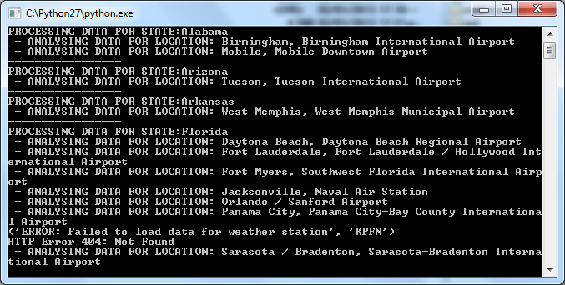
- Sampe file has the CSV structure:
Date,Time,Wind(mph),Vis,Weather,Sky Cond.,Temperature(Air),Temperature(Dwpt),Temperature(6h Max),Temperature(6h Min),Humidity,Wind Chill, HeatIndex,Pressure altimeter(in),Pressure sea level(mb),Precipitation(1h),Precipitation(3h),Precipitation(6h)
30,11:35,S 16,10.00,Fair,CLR,34,23,NA,NA,65%,24,NA,30.06,NA,NA,NA,NA
30,11:55,S 24,10.00,Fair and Breezy,CLR,37,21,NA,NA,52%,26,NA,30.02,NA,NA,NA,NA
30,12:15,S 26 G 37,10.00,Fair and Windy,CLR,41,21,NA,NA,45%,31,NA,30.00,NA,NA,NA,NA
30,12:35,S 24 G 38,10.00,Fair and Breezy,CLR,39,21,NA,NA,48%,28,NA,29.98,NA,NA,NA,NA
30,12:55,S 20 G 26,10.00,Fair,CLR,39,23,NA,NA,52%,29,NA,29.97,NA,NA,NA,NA
30,13:15,S 23 G 31,10.00,Fair and Breezy,CLR,41,23,NA,NA,49%,31,NA,29.96,NA,NA,NA,NA
30,13:35,S 23 G 30,10.00,Fair and Breezy,CLR,41,23,NA,NA,49%,31,NA,29.95,NA,NA,NA,NA
30,13:55,S 17 G 25,10.00,Fair,CLR,41,23,NA,NA,49%,33,NA,29.95,NA,NA,NA,NA
30,14:15,S 18 G 24,10.00,Fair,CLR,41,23,NA,NA,49%,32,NA,29.95,NA,NA,NA,NA

