“DNSChanger” project

Design consideration
The script was designed considering the following:
- It will be run by machine administrator, either from administrator account or by selecting “Run as administrator” from context menu;

Running steps
- In order to run the script you either need to download and install Python 2.7 (not 3.0 please) from the following location http://www.python.org/getit/releases/2.7.3/; or;
- You can run the binary located in bin directory, which was compiled using PyInstaller component (http://www.pyinstaller.org/).

Python executable creation steps
- PyInstaller has a dependency on PyWin when running on Windows platform. It must be downloaded from here: http://sourceforge.net/projects/pywin32/files/pywin32/ (please make sure you are downloading correct version for your Python (ex: 2.7)).
- Download PyInstaller from http://www.pyinstaller.org/
- Change directory to place where PyInstaller was unzipped.
- Execute the following command to generate the executable:
python pyinstaller.py –onefile <PATH_TO_YOUR_PY_FILE>
- The executable is generated under dist directory
- You can find more information on PyInstaller here: http://www.pyinstaller.org/export/v2.0/project/doc/Manual.pdf?format=raw

Directory structure
The folder has the following structure:
- bin – Contains DNSChanger.exe executable generated by PyInstaller;
- doc – Project documentation;
- src – Python src files;

Testing:
- Execution window:
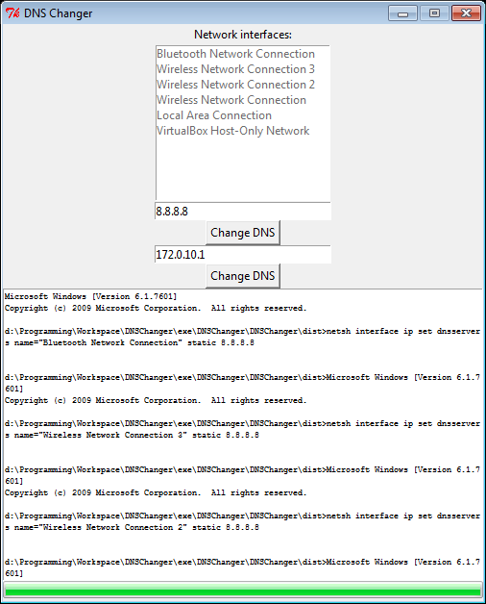
- Test results:
