TrackMaster project

Installation and configuration
Beside of Python 2.7 installation, there is one more additional Python component to be installed:
- BeautifulSoup – Python module for HTTP parsing (free to use);

Usage considerations
The directory structure is following:
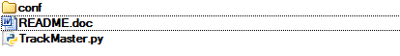
conf – contains file config.ini, where you must set up your username and password to TrackMaster account:
[trackmaster]
username = your_username
password = your_password
TrackMaster.py – Python script, which could be run on demand, or by scheduler (scheduler configuration was described in previous project)

Output
As specified in requirements, output goes to c:\pdox40\pps\<FILENAME>

Execution results
