Brisnet project

Installation and configuration
Beside of Python 2.7 installation, there is one more additional Python components to be installed:
- BeautifulSoup – Python module for HTTP parsing (free to use);

Usage considerations
The directory structure is following:
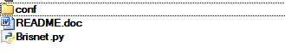
conf – contains file config.ini, where you must set up your username and password to Brisnet account:
[brisnet]
username = your_username
password = your_password
Brisnet.py – Python script, which could be run on demand, or by scheduler (scheduler configuration was described in previous project)

Output
As specified in requirements, output goes to C:\comchart\out\<TRACK_NAME>\<FILENAME>

Execution results
