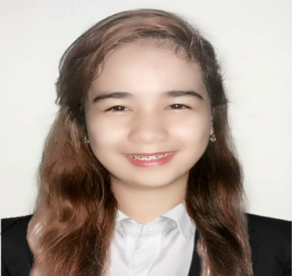**Jammaicka Kelly H. Umbay**

**Email:** **jammerhortel20@gmail.com**

**Mobile**: **(+63)9971298580**

**Address: Kassel Residences Moonwalk Sucat, Paranaque City**

**OBJECTIVE**

To be able to work in a career oriented and challenging environment, promotes customer satisfaction and loyalty. Adopt at balancing multiple task with a friendly and courteous demeanor.

**SKILLS SUMMARY**

* Participated the front office, opera training system, butler service and housekeeping seminar
* Exceptional customer services
* Excellent in guest services
* Good communication skill

­­

**EDUCATIONAL ATTAINMENT**

**Tertiary:** University of Manila (UM), S.Y. 2015-2019

Universal Colleges of Paranaque, S.Y. 2014-2015

**Secondary:** Paranaque National High School, Tambo Main, S.Y. 2011-2014

**Primary:** Dumagoc Elementary School, Pagadian City, S.Y.2006-2011

**PERSONAL INFORMATION:**

Birthdate: December 21, 1997

Birthplace: Lapu-lapu, Cebu City

Age: 22 y.o.

Gender: Female

Height: 5’0

Weight: 127 lbs.

Civil Status: Single

Religion: Roman Catholic

Language Spoken: Tagalog, English & Nihonggo

**SCHOOL EXPERIENCE:**

Year 2016

* On- The-Job Training in Shakey’s Pizza Domestic NIA Terminal 4
* Position Acquired: Waitress

Year 2017

* Maritime Training Center of the Philippines(SOLAS)

Year 2018

* On- The- Job-Training in Manila Grand Opera Hotel
* Position Acquired: Housekeeping

Year 2018

* On-The- Job Training in Emiramona Garden Hotel
* Position Acquired: Housekeeping

**CHARACTER REFERENCE**

Jewell Angellin M. Lea Cashier North Park 09267828547

John Kenneth Bautista Waiter Midas Hotel 09055799416

Audrey Maye J. Fernandez Player Support Agent 09472400431

I certify and swear that the information that I have given are correct