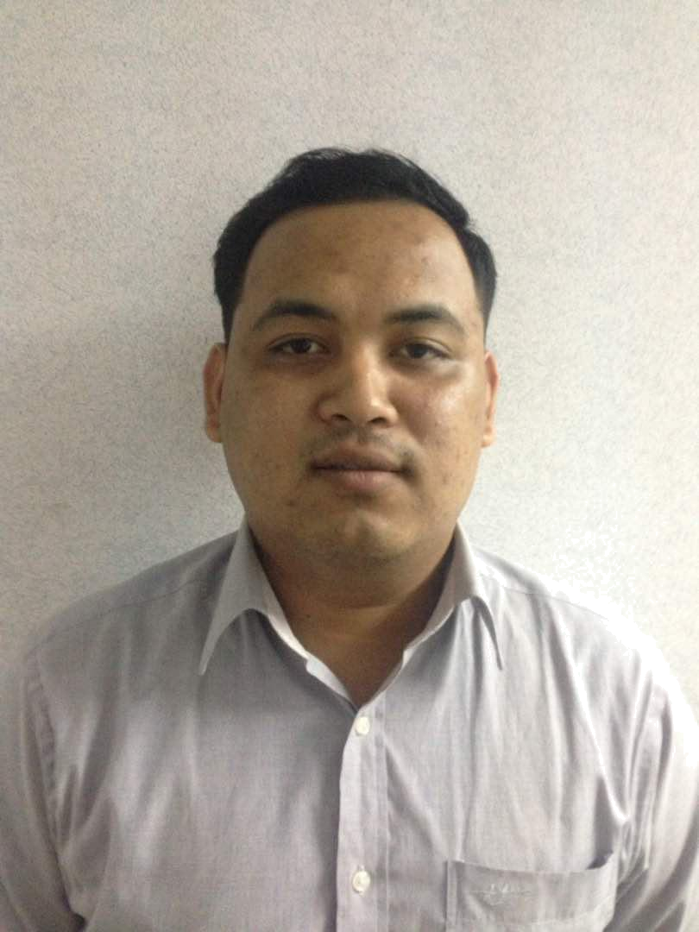

MUHAMMAD AFIQ BIN AZHAR

No. 183,
Taman Sri Tanjung,
28700 Bentong,
Pahang
Tel: 018-311 5977

Email : vcd2515@gmail.com

 |  | PERSONAL PARTICULARS
 |  | PERSONAL PART
Age |  | : 26
Sex |  | : Male
Marital Status |  | : Single
Nationality |  | : Malaysian
Language Spoken and Written |  | : Malay, English
 |  | EDUCATIONAL BACKGROUND
2017 | Vocational Training Officer (VTO)
 | Ciast Shah Alam
2013 – 2015 | Diploma Teknologi Pembuatan (Tool & Die), Institute Kemahiran Tinggi
 | Belia Negara Pagoh ( IKTBNP) Johor.
 | Grade: Level 1 – 4
2010 – 2012 | Sekolah Menengah Kebangsaan Senai, Johor Bahru
 | SPM Grade: Lulus
2007 – 2009 | Sekolah Menengah Kebangsaan Senai, Johor Bahru
 | PMR Grade : Lulus

 | CO-CURRICULAR ACTIVITIES
Player | : Represent school in Badminton
Committee Member | : Club Badminton ,Kampung Jaya Sepakat, Senai Johor
 | : Persatuan Pengangkap, Sekolah Menengah Kebangsaan
 | Senai (2010 -2012)
 | WORKING EXPERIENCE

- Technician Cleaning Machine at JKS ENGINEERING ( 1 Years )
- Houseman at GRAND HYATT HOTEL ( 9 Month )
- Internship ( 6 Month ) as Instructor Tool & Die at MIT ACADEMY Kota Kemuning
- Technician Aircond at Kulai, Johor ( 1 Years )
- Site Supervisor at Grand Medini, Gelang Patah Johor Bahru ( 1 Years )
- Partime Sales at JPO Johor Bahru

REFERENCE

- EN JASNI BIN SAMAN Pengajar

Institut Kemahiran Tinggi Belia Negara Pagoh Tel: 013-621 1313

