## Tutorial

Business Logic Sheets could be any worksheets you currently working with the business logic.

Here is a sample for adding a order record into database.

1. Add a new Excel Worksheet and rename it to ‘createOrder’

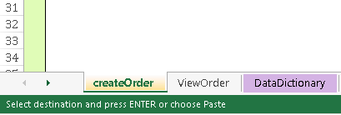

1. For this order, there has 5 input parameters. We draw a table in the worksheet with Display Name and input cells.

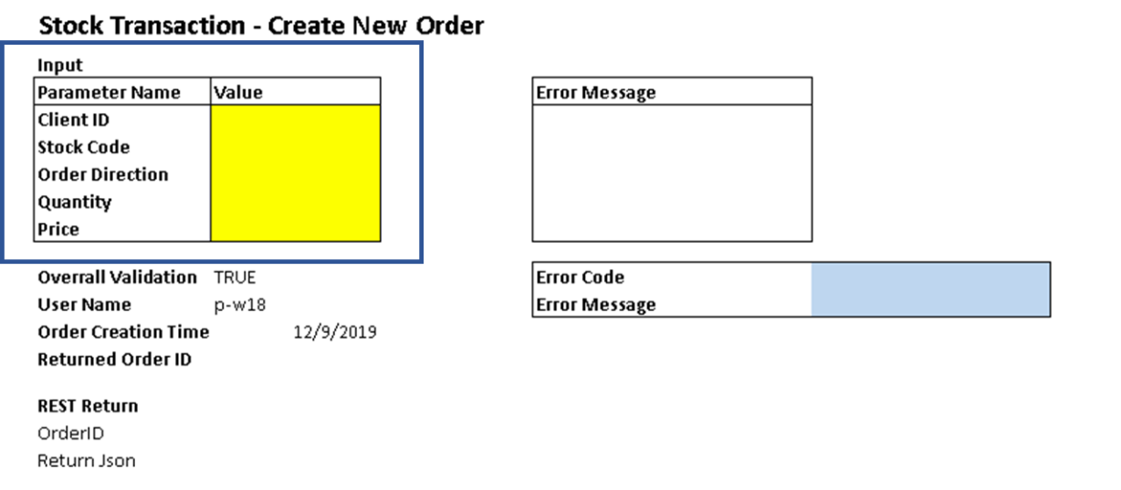

1. There are some data validation excepted for these input fields. Add Data Dictionary for Data rules and properties.

Client ID – String, Mandatory

Stock Code – String, Mandatory

Order Direction – String, Auto convert to Upper case

Quantity – Number, Mandatory

Price – Number, Mandatory

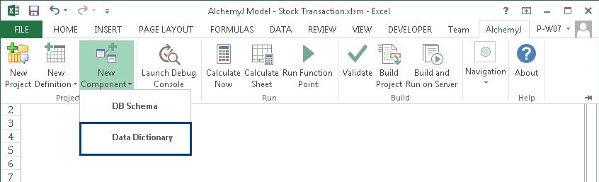

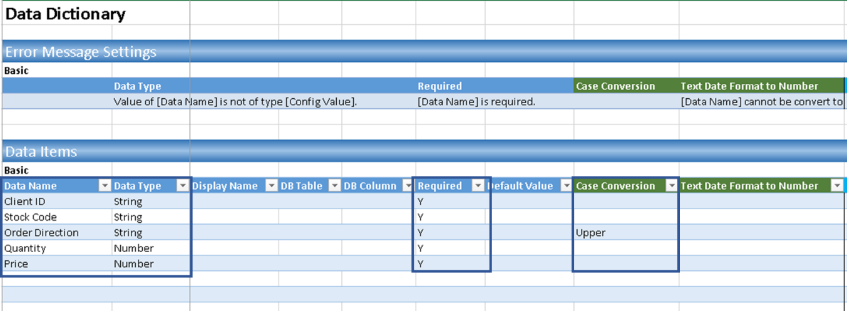

1. Use Defined rules in Data Dictionary in createOrder worksheet by DataDic Library Function =DataDict(herader,data,data_dictionary,[error_definition],[transform])

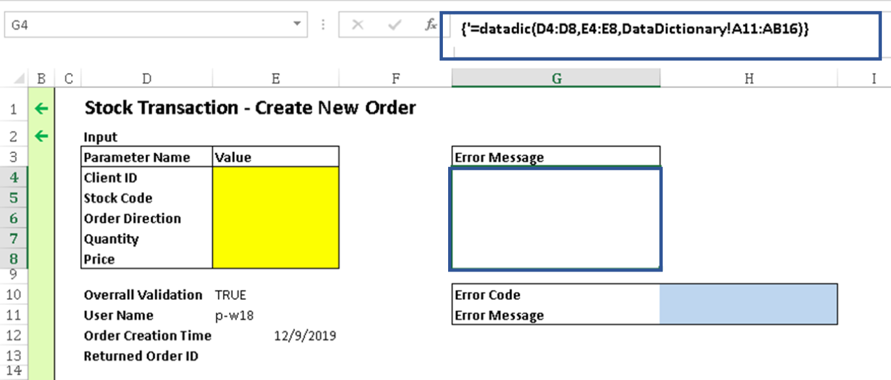

For example, we left the Stock Code is empty, the error message will be shown in Cell G5 and the Overall Validation will turn to False

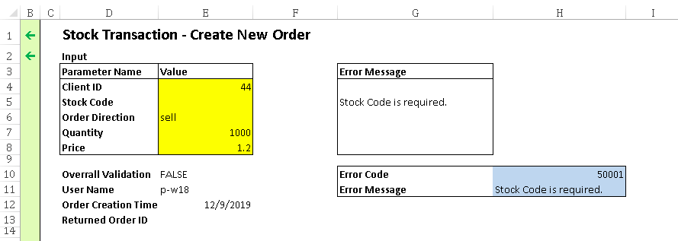

1. After completing the input fields definition, we need to define the output fields. In this sample, we expect to return the Order ID in Cell E13 after this record created successfully. The SQL statement need to be constructed in SQL before execution. Use ExecuteSQL function to insert the input fields into DB and return the Order ID.

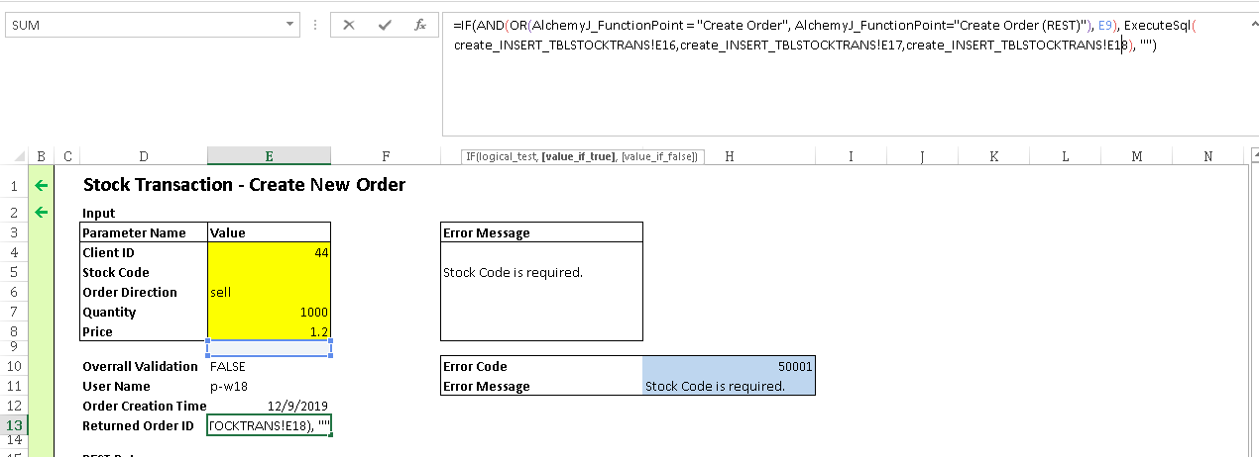

1. After defined the Bussiniess Logic Sheets, next step to add Java Package worksheets by AlchemyJ > New Definition > Java Package

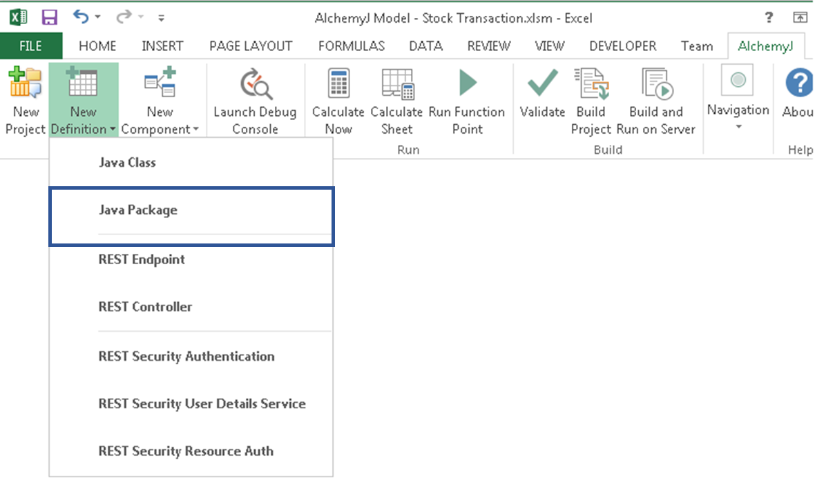

1. Input the Package Name and Version information in Basic Settings section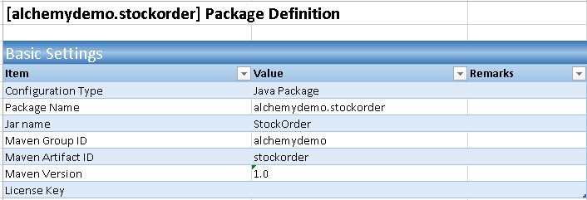
2. Input the Classes worksheets names in Class section.



1. Let’s abstract the order into an Object. Define the Order information in the Object Definition.

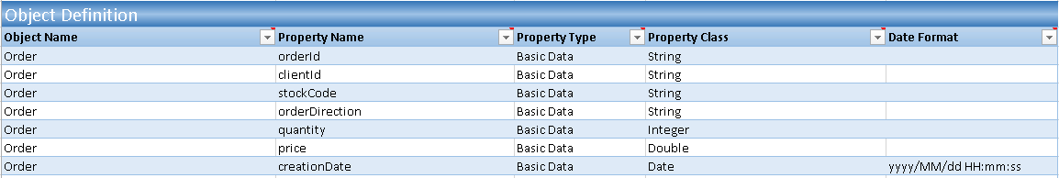

1. Add Java Class worksheets by AlchemyJ > New Definition > Java Class and the name is the same as defined in the Package Definition Sheet

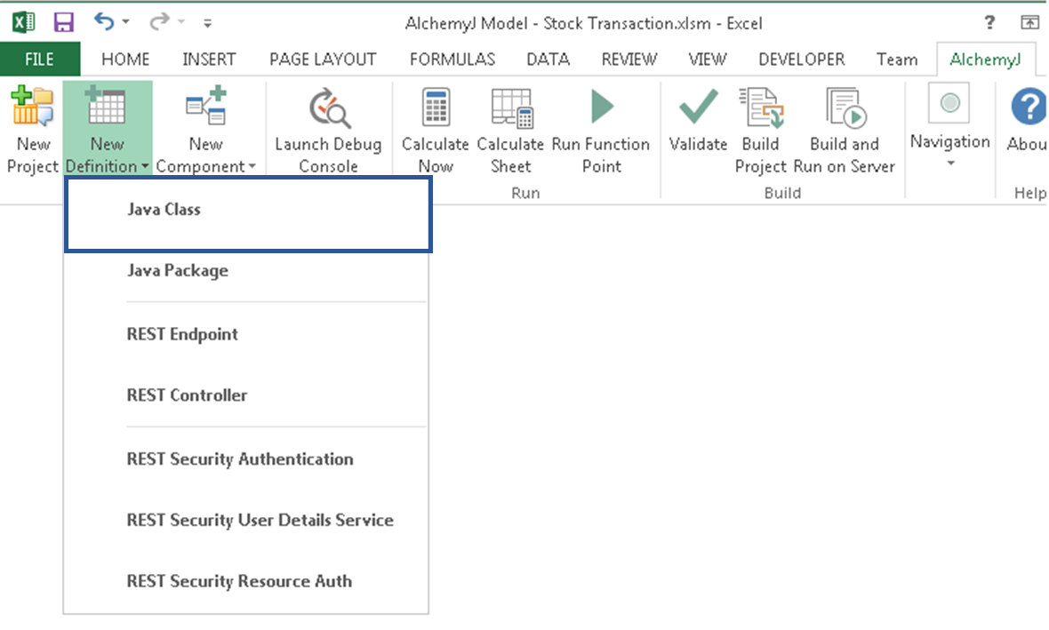

1. Provide a Class Name and Package Name for the above function and input the basic information in the ##ClassDefinition.

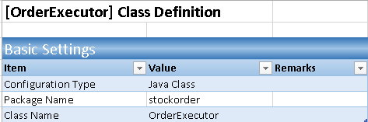

1. Define function name and the output properties, the output data is a Basic data



1. Define function input parameters. There are 5 input parameters and the parameter type is Object.

