# Theta Coding Challenge

## Prerequisite

1. To complete the challenge, you need a GitLab or GitHub account.

Please register here if you don’t have one

For GitLab: <https://gitlab.com/users/sign_in>

For GitHub: <https://github.com/>

(Just choose ONE)

1. Understand web API with NodeJS
2. Understand web UI development with any modern JavaScript framework e.g Angular (preferably), ReactJS, or Vue, etc.

## Your task

1. Creating a simple Web API that will expose data employee, see Requirement #1 for details
2. Creating a simple Web UI that support CRUD operation, see requirement #2 for details
3. Since the role is for frontend, you can focus on task #2 (creating the UI) and using mock data. Be as creative as possible, feel free to apply your own CSS style.

## Data Structure

1. Employee data type in JSON as follow

{

id: string,

name: string,

department: string

}

Example:

[

{

id: ‘E01’,

name: ‘James Fowler’,

department: ‘Finance’

},

{

id: ‘E01’,

name: ‘Jessica Simsons,

department: ‘Technology’

}

]

For now, you can use in-memory storage.

*(continue to next page)*

## Requirements #1 WEB API

1. Create a REST API using NodeJS with the following route:

1.a <http://localhost:3000/api/employee>s --> GET

this should RETURN all employee

1.b <http://localhost:3000/api/employees> --> POST

This API should be use to ADD new employee

1.c <http://localhost:3000/api/employees/:id>

This API should be use to get ONE employee base on ID

Example: <http://localhost:3000/api/employees/E01>

This will return employee with ID E01:

{

id: ‘E01’,

name: ‘James Fowler’,

department: ‘Finance’

}

API should be run under port 3000

*(continue to next page)*

## **Requirement #2 WEB UI (This is your main task, you can use mock/dummy data)**

1. Please translate below mock UI to working solution using any modern JavaScript framework (preferably Angular. Responsive UI is a plus. Feel free to apply your CSS styles. **Be creative as possible**)

2.a UI to display list of employees, when user clicks ‘+New Employee’, it should add a new employee to the list.

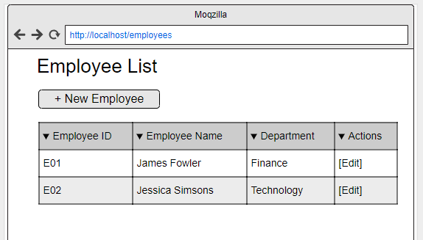

2.b When click ‘Edit’ user should be directed to edit-page where user can edit and delete employee

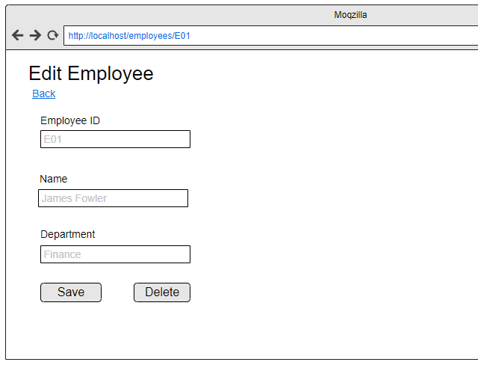

2.c The Web UI should consume the API you developed on Requirement #1

2.d Web UI should be run under port 80 or 4200

## Submission

1. Once you completed the code, please upload the code your gitlab or github account
2. Make the repository public
3. Share the repository link via email to [iusetheta@gmail.com](mailto:iusetheta@gmail.com) with subject: ‘[Your name] - Frontend Developer - Technical Test’

## Notes

| No | Submission | Notes |
| --- | --- | --- |
| 1 | Link to your github/github repository containing this code requirement | Make the repository public so that we can see it |
| 2 | README file containing how to run the application |  |
| 3 | API should be written in Javascript (NodeJS) |  |
| 4 | UI should be using Angular/ReachJS/Vue | Preferably Angular |
| 5 | Submission should be done between 3 days after you receive this challenge |  |
| 6 | Multiple commits in git will be good, so that we can see how your code evolve |  |

If you have any questions during the challenge, please do not hesitate to email us at [iusetheta@gmail.com](mailto:iusetheta@gmail.com)