**This is what it looks like when the page is loaded**

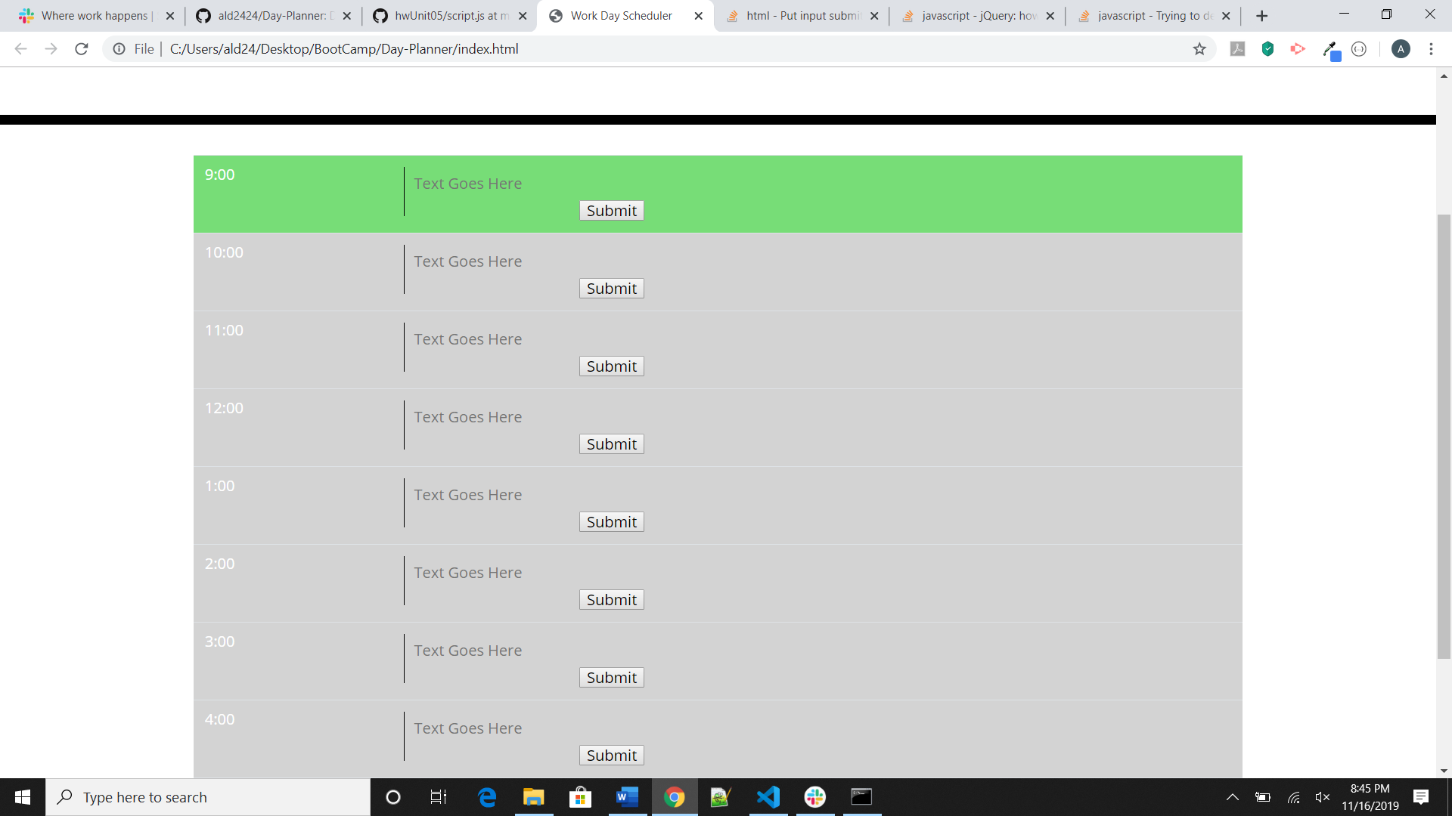

This is what it looks like after hitting submit and before refreshing the page

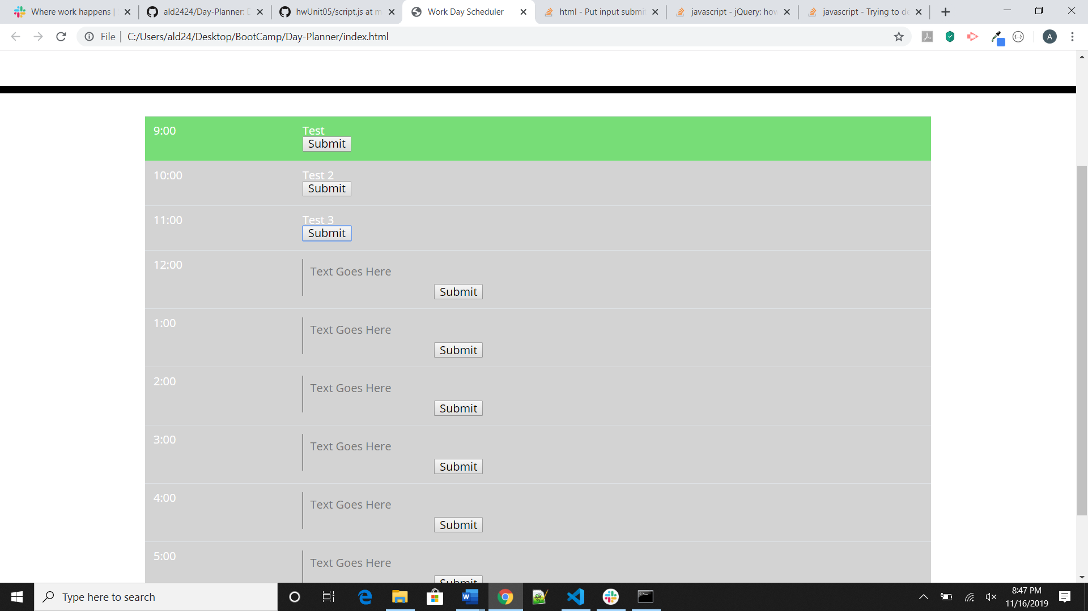

This is what it does after refreshing the page:

