Electronic Supplements
Table 1: Summary of the stochastic models, and the original weights for each branch, developed for the UK in this study
Parameter | Value or logic tree branches (with a priori weights in square brackets)
Source density (γ_{S}) (g/cm³), source velocity (β_{S}) (km/s), partition of total shear-wave energy into horizontal components (V), radiation pattern (⟨R_{ΘΦ}⟩), free-surface effect (F), reference distance (R₀) | 3.1, 3.7, 0.707, 0.55, 2.0
Depth to top of rupture | - Branch 1 [0.6]:  Z_{TOR}=1.3 max[2.673-1.136 max (M-4.970, 0), 0]²  - Branch 2 [0.4]:  Z_{TOR}=max(14-0.6 × 10{[1.5(6.07+Mw)-3.966]/3.75}/1000} for M<5.5  Z_{TOR}=max(11.760-(M-5.5)*5.884,0.0)
Source-to-site distance calculation | Assume vertically-dipping ruptures. Rupture distances, R_{RUP}, are converted to point-source distances, R_{PS}, using Boore and Thompson (2015)’s equations 1 and 2.
Source spectral shape | Brune single-corner ω² spectrum
Source stress (drop) parameter | - 20 bars [0.185]  - 80 bars [0.630]  - 140 bars [0.185]
Geometric spreading | - 1/R for R<100km  1/√R for R≥100km [0.25]  - 1/R for R<50km  no decay for 50≤R<100km  1/√R for R≥100km [0.50]  - 1/R for R<75km  1/√R for R≥75km [0.25]
Anelastic attenuation (Q) | - 230^{0.5} [0.185]  - 266^{0.53} [0.63]  - 330^{0.6} [0.185]
Source duration | 1/f_{a} where f_{a} is the corner frequency
Path duration | Piecewise linear function defined by (Boore and Thompson, 2014):  - 0km, 0s  - 7km, 2.4s  - 45km, 8.4s  - 125km, 10.9s  - 175km, 17.4s  - 270km, 34.2s  With a slope of 0.156s/km for R>270km
Site amplification | Quarter-wavelength approximation of amplification from V_{S} profile defined by:  where V_{Smin}=873m/s, V_{Smax}=3700m/s, b₁=1.1 and b₂=150 and density profile defined by Boore (2016)’s Equations 8 to 11.
Site attenuation (κ₀) | - 0.010 [0.185]  - 0.023 [0.630]  - 0.037 [0.185]

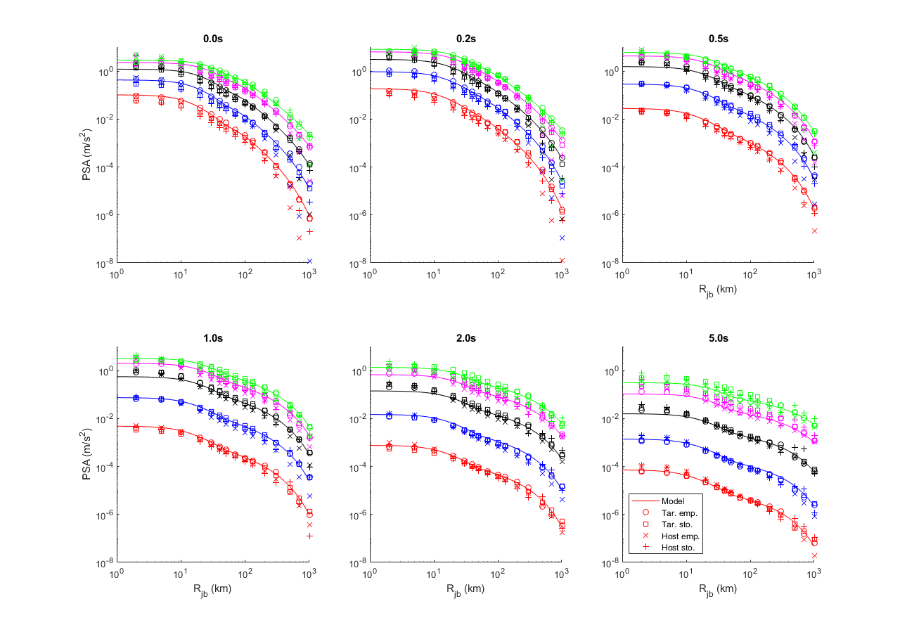
Electronic Supplement Figure 1 Comparison of the raw samples from CHEEP and the fitted functional form for an example branch of the logic tree (80bars, central geometric spreading, central Q model, 0.023s) for M 3.5 (red), 4.5 (blue), 5.5 (black), 6.5 (magenta) and 7.25 (green) and periods of 0.01s (PGA), 0.2s, 0.5s, 1.0s, 2.0s and 5.0s. The close match between the raw samples for the target empirical and the fitted model can be seen.
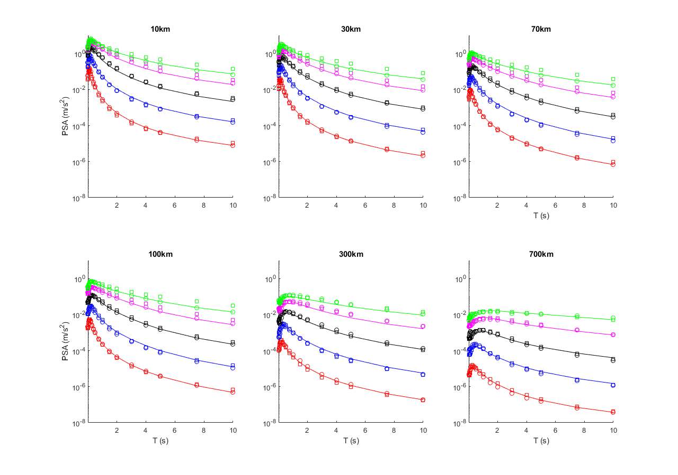
Electronic Supplement Figure 2 Comparison of the raw samples (target empirical=circles, target stochastic=squares) from CHEEP and the fitted functional form for an example branch of the logic tree (80bars, central geometric spreading, central Q model, 0.023s) for M 3.5 (red), 4.5 (blue), 5.5 (black), 6.5 (magenta) and 7.25 (green) and R_{JB} of 10km, 30km, 70km, 100km, 300km and 700km. The close match between the raw samples for the target empirical and the fitted model can be seen. Also this figure shows that the target stochastic has a different spectral shape at large magnitudes because of the assumption of the single corner.

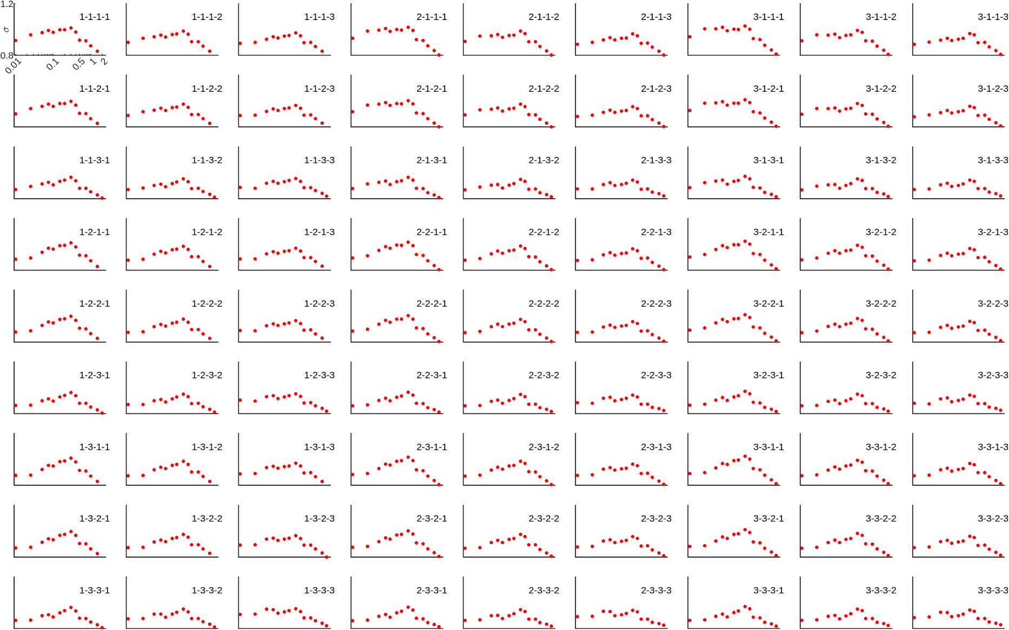
Electronic Supplement Figure 2 Standard deviations based on total residuals (red dots, in terms of natural logarithms) against spectral period for each of the 81 branches. The branch numbers are indicated in the bottom-left corner of each graph as A-B-C-D, where A is the branch for the stress drop (left-to-right), B is the branch for the geometric spreading (top-to-bottom), C is the branch for Q (top-to-bottom within each 3 × 3 square) and D is the branch for kappa (left-to-right within each 3 × 3 square).

Electronic Supplement Figure 3 Comparisons of three- (red) and five-branch (blue) reweighted models: solid lines is 50th percentile in both cases, dashed-dotted lines are for 5th and 95th percentiles for three-branch version and 3rd and 97th percentile for five-branch version and dashed lines are for 21st and 79th percentile for five-branch version. Predictions are shown for a) M 4 and 7 against R_{JB} and b) R_{JB}=10km and 100km against M, for 0.01s, 0.2s, 0.5s and 1.0s.

Electronic Supplement Figure 4 Comparison of the three-branch models derived using the a priori (blue) and adjusted (red) weights: solid lines is 50th percentile and dashed-dotted lines are for 5th and 95th percentiles. Predictions are shown for a) M 4.5 and 6.5 against R_{JB} and b) R_{JB}=30km and 100km against M, for 0.01s, 0.2s, 0.5s and 1.0s.

- Lower branch | - Central branch | - Upper branch
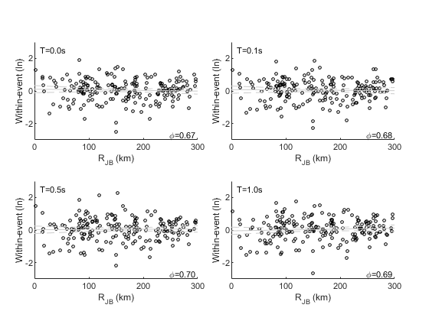 | 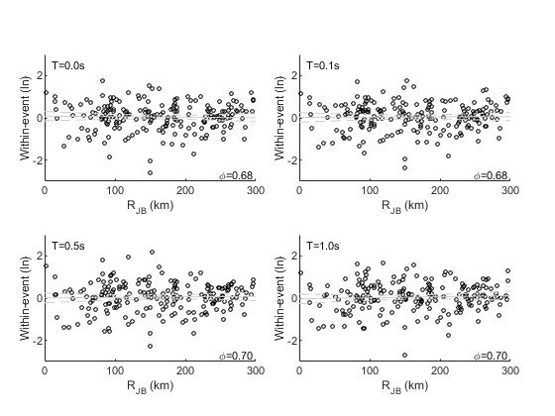 | 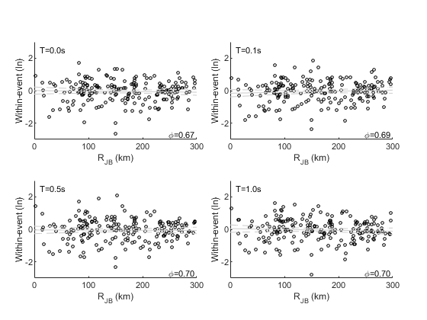

Electronic Supplement Figure 5 Between-event residuals against magnitude and within-event residuals against epicentral distance for the a) lower, b) central and c) upper branches of the three-branch parameterisation of the model. Grey lines are the linear best-fit line and its 95% confidence limits.

a)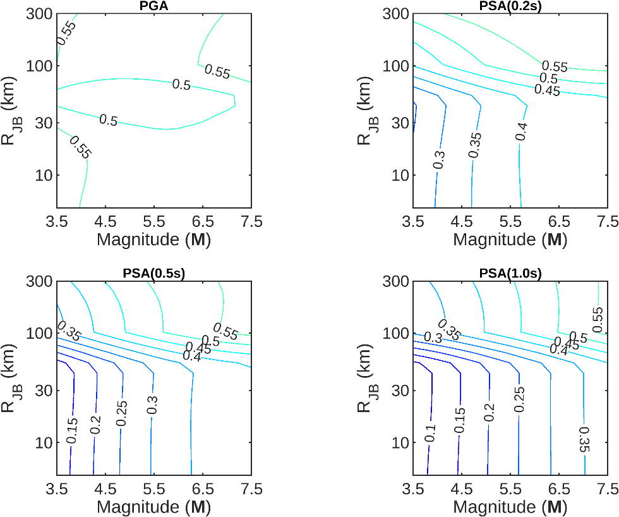

b) 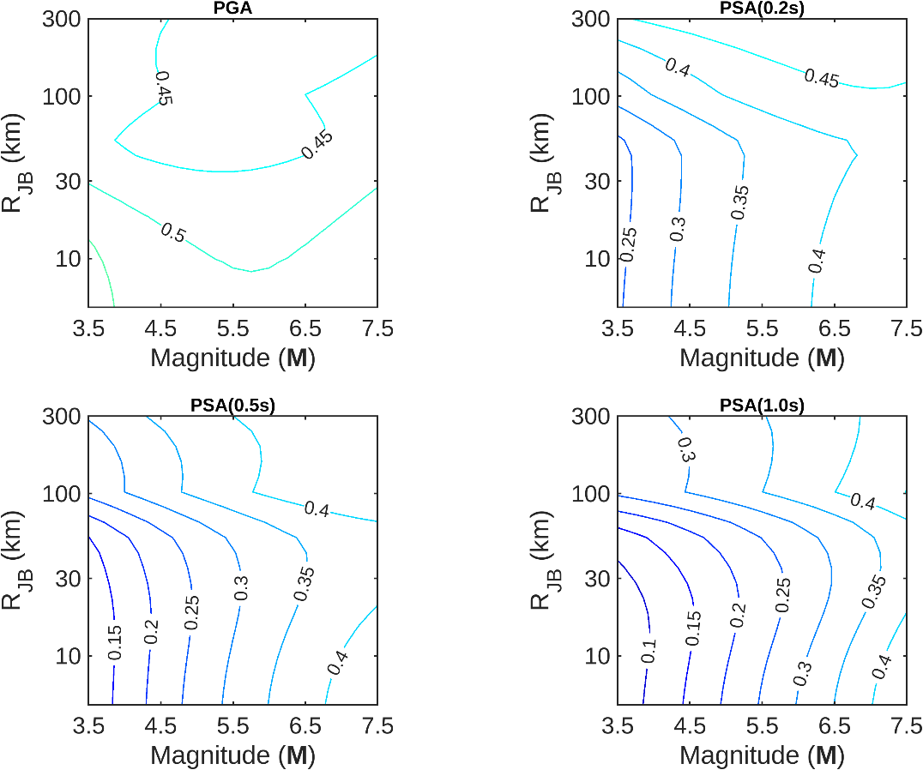
Electronic Supplement Figure 6: Contour plots of σ_{lnμ} for the five-branch backbone: a) using the a priori weights and b) using the adjusted weights, for 0.01s, 0.2s, 0.5s and 1.0s.

- 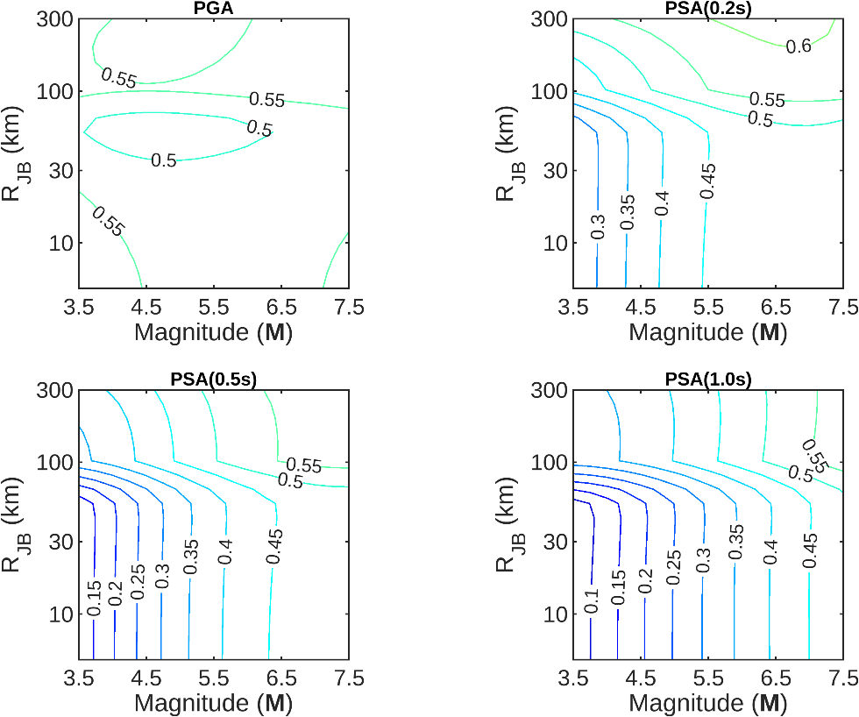

- 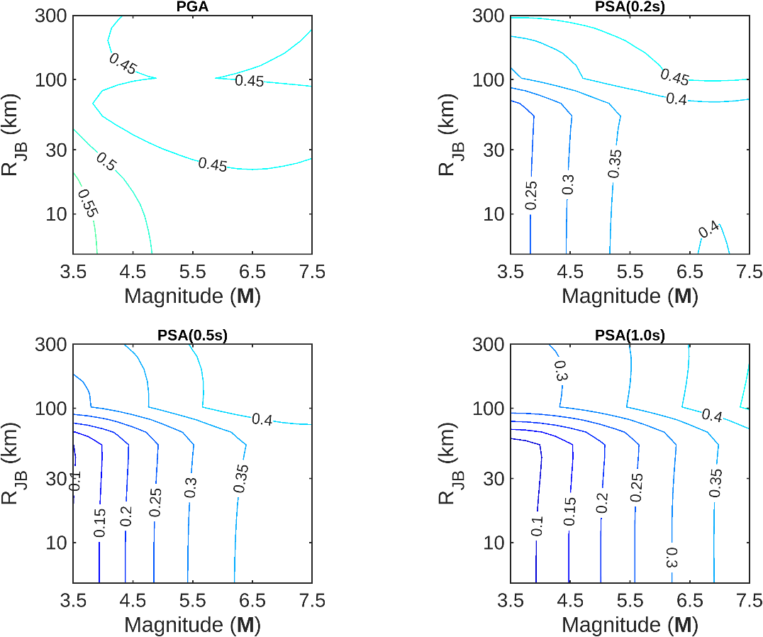
Electronic Supplement Figure 7: Contour plots of σ_{lnμ} for the complete 162 branch model: a) using the a priori weights and b) using the adjusted weights, for 0.01s, 0.2s, 0.5s and 1.0s.

