STC FINANCIAL PERFORMANCE
Board Report & Project Explanation
Saudi Telecom Company (stc) | FY2021–FY2025

Prepared for | Board / Senior Management discussion
Reporting basis | Consolidated Group figures
Currency / unit | Saudi Riyals (SAR) thousands unless otherwise stated
Document status | Independent educational and portfolio analysis

Purpose: provide a decision-oriented view of reported financial performance, key movements, and areas requiring further management review.

Contents
- 1.Board Executive Summary
- 2. Reported Financial Performance
- 3. Profitability and Cash Flow Interpretation
- 4. Financial Position, Liquidity and Leverage
- 5. Board-Level Implications and Recommended Actions
- 6. Project Explanation and Data Methodology
- Appendix A. Five-Year KPI Table
- Appendix B. Source Documents

1. Board Executive Summary
This report summarizes the five-year consolidated financial performance of Saudi Telecom Company (stc) from FY2021 to FY2025. The focus is not only on reported growth, but also on the quality of the movement across profitability, cash flow, liquidity and balance-sheet scale. The accompanying dashboard is designed to support discussion, not replace the annual reports or management accounts.

Revenue 2021–2025  23.5%  Cumulative reported growth | 2025 Net Profit  15,134.9  SAR million | 2025 Operating CF  18,283.2  SAR million; positive | 2025 Total Assets  157,476.7  SAR million

Board messages at a glance
- Top-line momentum: Revenue increased from SAR 63,008.0 million in 2021 to SAR 77,818.7 million in 2025, a cumulative increase of 23.5%.
- Profitability quality: Net profit reached SAR 24,916.2 million in 2024 and declined to SAR 15,134.9 million in 2025 even as revenue increased. The consolidated figures for 2024 and 2025 include discontinued operations as reported.
- Cash conversion: Operating cash flow was positive in every year, supporting the view that reported earnings were accompanied by operating cash generation, although cash flow and profit should be reviewed together.
- Balance-sheet scale: Total assets peaked at SAR 160,638.1 million in 2024 and were SAR 157,476.7 million in 2025. 2025 liabilities and equity were SAR 71,090.3 million and SAR 86,386.3 million, respectively.
- Decision focus: The next management review should reconcile continuing versus discontinued operations, explain the 2025 profit movement, and connect balance-sheet changes to investments, borrowings, assets held for sale and distributions.

2. Reported Financial Performance
The chart below compares the reported Revenue, Net Profit and Operating Cash Flow series. Values are shown in SAR millions for board readability; the underlying Excel model uses SAR thousands.
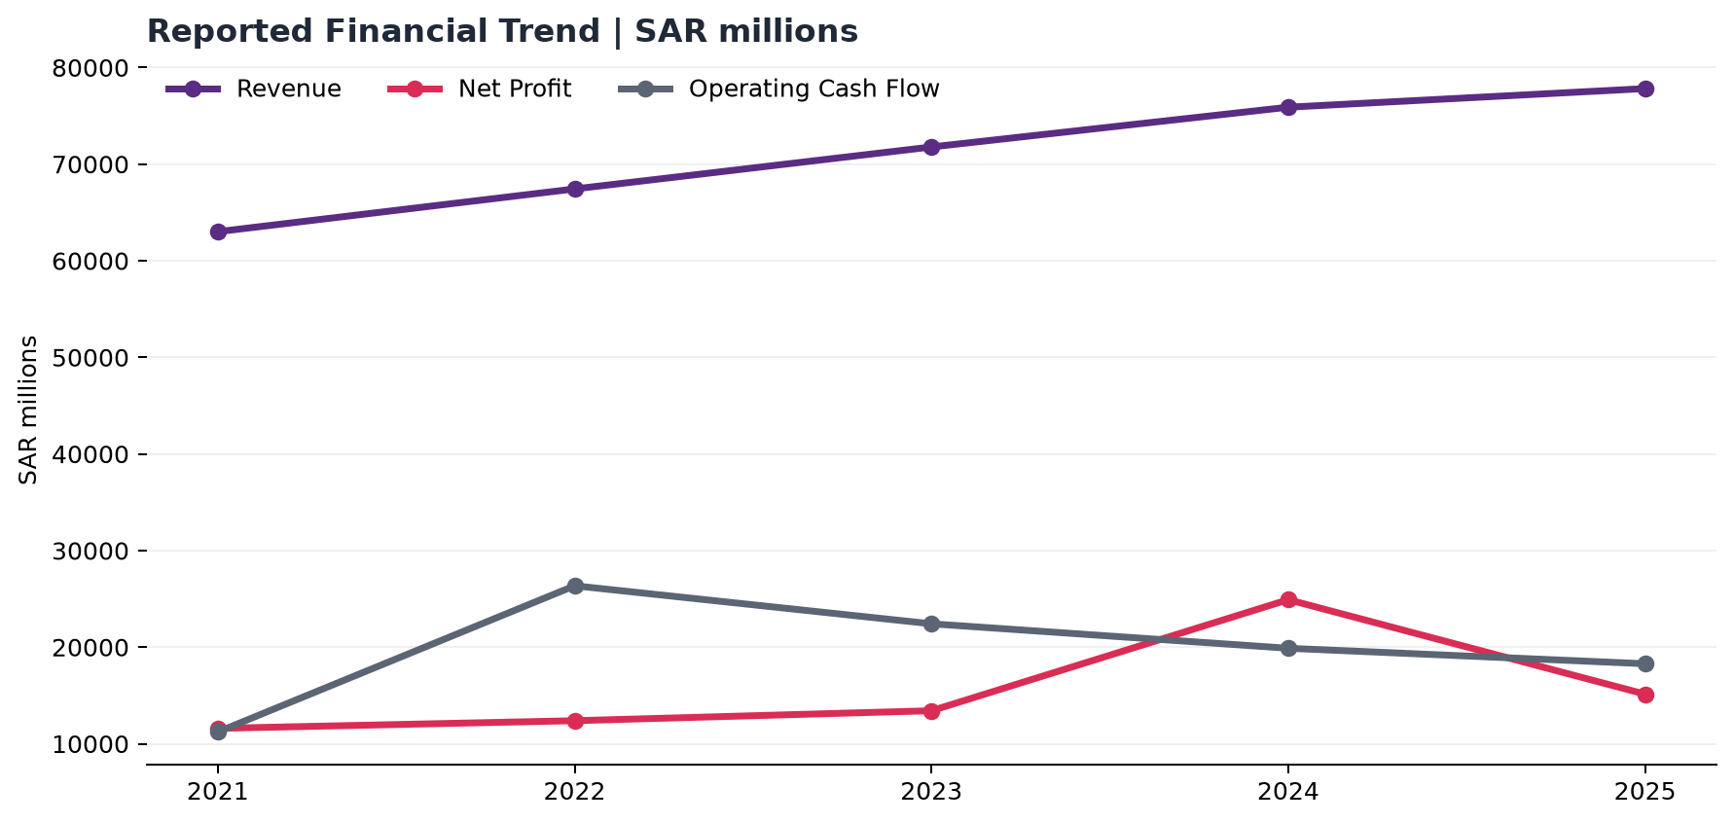

Five-year headline comparison
Metric | 2021 | 2022 | 2023 | 2024 | 2025
Revenue | 63,008.0 | 67,431.5 | 71,777.2 | 75,893.4 | 77,818.7
Gross Profit | 33,794.0 | 37,393.3 | 34,740.1 | 37,300.4 | 37,699.7
Operating Profit | 13,127.8 | 15,088.4 | 13,161.3 | 14,425.6 | 14,438.3
Net Profit | 11,594.7 | 12,386.9 | 13,419.5 | 24,916.2 | 15,134.9
Operating Cash Flow | 11,220.2 | 26,354.4 | 22,417.6 | 19,885.3 | 18,283.2
Total Assets | 121,972.1 | 137,220.0 | 159,682.8 | 160,638.1 | 157,476.7

3. Profitability and Cash Flow Interpretation

Profitability
Gross margin decreased from 53.6% in 2021 to 48.4% in 2025. Operating margin decreased from 20.8% to 18.6%. Net margin, however, was 18.4% in 2021 and 19.4% in 2025, with a significant 2024 peak.
Board interpretation: the divergence between operating profit, operating margin and consolidated net profit means that a revenue-only assessment is insufficient. The Board should review the bridge from operating profit to consolidated net profit, including other income / expense, tax, discontinued operations and any one-off items disclosed in the annual-report notes.

Cash flow
Operating cash flow remained positive in all five years, ranging from SAR 11,220.2 million to SAR 26,354.4 million. Investing cash flow was negative from 2021 through 2024 and positive in 2025; this movement should be read alongside the investing-activity notes rather than treated as free cash flow.
Important: Free Cash Flow is not calculated because Capital Expenditure is not consistently isolated and comparable for all years. Therefore, the report presents operational, investment, and financing flows as received, without the invention of FCF.

4. Financial Position, Liquidity and Leverage
The balance sheet expanded materially from 2021 to 2024 before total assets moderated in 2025. The extracted statements reconcile as Total Assets = Total Liabilities + Total Equity for each year in the model.
Balance-sheet item | 2021 | 2022 | 2023 | 2024 | 2025
Total Assets | 121,972.1 | 137,220.0 | 159,682.8 | 160,638.1 | 157,476.7
Total Liabilities | 56,705.1 | 61,194.4 | 78,167.6 | 68,153.1 | 71,090.3
Total Equity | 71,386.0 | 76,025.6 | 81,515.2 | 92,485.0 | 86,386.3
Current Assets | 51,468.1 | 60,933.2 | 71,224.1 | 72,745.1 | 58,015.8
Current Liabilities | 33,560.6 | 36,400.2 | 48,070.8 | 38,956.3 | 40,172.6

Ratio interpretation
- Current ratio was 1.44x in 2025. The ratio should be interpreted with the maturity profile, cash, undrawn facilities and operating working-capital cycle.
- Debt ratio, defined in this project as Total Liabilities / Total Assets, was 45.1% in 2025. This is not an interest-bearing debt ratio.
- Liabilities-to-equity was 0.82x in 2025. The movement should be reviewed with changes in borrowings, provisions, lease liabilities and equity distributions.

5. Board-Level Implications and Recommended Actions
The following actions are recommended for management follow-up. They are framed as questions and review priorities, not as unsupported causal conclusions.
1. Reconcile recurring profitability: Prepare a bridge from operating profit to consolidated net profit for 2024 and 2025, separating continuing operations, discontinued operations and material one-off items.
2. Explain the 2025 profit movement: Provide a concise variance analysis covering revenue, cost of revenue, operating expenses, other income / expense, tax and discontinued-operation impacts.
3. Connect cash and balance-sheet movements: Link investing cash flow, financing cash flow, ending cash, borrowings, investments and asset disposals in one liquidity view.
4. Strengthen KPI governance: Adopt one controlled KPI dictionary for revenue, profit, cash flow and ratios, with a clear distinction between reported figures and calculated indicators.

6. Project Explanation and Data Methodology
This project is an independent financial-analysis data pack and dashboard specification. It converts reported consolidated line items into a traceable fact table, calculates transparent ratios, validates core accounting relationships, and prepares the model for a Power BI dashboard.

What each deliverable does
- Excel workbook: source data, normalized Dashboard Data table, KPI Calculations, validation checks, data dictionary and source mapping.
- Power BI layer: intended to provide interactive executive pages, slicers, trend charts, ratios and drillable explanations once built and saved in Power BI Desktop.
- Board report translates the model into decision-oriented messages and recommended follow-up questions.

Core KPI definitions
- Revenue Growth % = (Current Revenue / Prior-year Revenue) - 1; 2021 is N/A.
- Gross Profit Margin % = Gross Profit / Revenue.
- Operating Profit Margin % = Operating Profit / Revenue.
- Net Profit Margin % = Consolidated Net Profit / Revenue.
- Current Ratio = Current Assets / Current Liabilities.
- Debt Ratio % = Total Liabilities / Total Assets; not interest-bearing debt.
- ROA % = Net Profit / Closing Total Assets; ROE % = Net Profit / Closing Total Equity.

Appendix A. Five-Year KPI Table
KPI | 2021 | 2022 | 2023 | 2024 | 2025
Revenue Growth % | N/A | 7.0% | 6.4% | 5.7% | 2.5%
Gross Profit Margin % | 53.6% | 55.5% | 48.4% | 49.1% | 48.4%
Operating Profit Margin % | 20.8% | 22.4% | 18.3% | 19.0% | 18.6%
Net Profit Margin % | 18.4% | 18.4% | 18.7% | 32.8% | 19.4%
Current Ratio | 1.53x | 1.67x | 1.48x | 1.87x | 1.44x
Debt Ratio % | 46.5% | 44.6% | 49.0% | 42.4% | 45.1%
Liabilities-to-Equity | 0.79x | 0.80x | 0.96x | 0.74x | 0.82x
ROA % | 9.5% | 9.0% | 8.4% | 15.5% | 9.6%
ROE % | 16.2% | 16.3% | 16.5% | 26.9% | 17.5%

Appendix B. Source Documents
The source mapping in the Excel workbook contains the official annual-report URLs and extraction notes. The report uses the following documents:
- 2021 Annual Report: https://www.stc.com/content/dam/groupsites/en/pdf/AnnualReport2021-En-new.pdf
- 2022 Annual Report: https://www.stc.com/content/dam/groupsites/en/pdf/2022stc-annual-report-english-new3.pdf
- 2023 Annual Report: https://www.stc.com/content/dam/groupsites/en/pdf/stc2023-annual-report-en-v7new.pdf
- 2024 Annual Report: https://www.stc.com/content/dam/groupsites/en/pdf/stc2024-annual-report-en-new.pdf
- 2025 Annual Report: https://www.stc.com/content/dam/groupsites/en/pdf/stc2025-annual-report-en.pdf

