**Bonus:**

1. The program has a feature of changing the text file that contains the dates. It may be a different file name. It may be located in another folder different from the location of the program file DevTest.exe. Click the Date File button and the Open File dialog window appears in order for the user select another file.

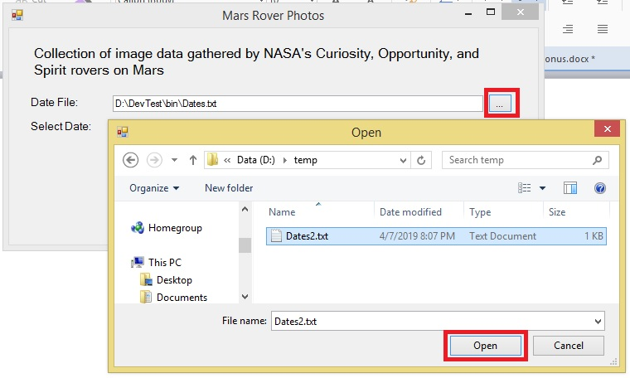

1. If the date selected is not valid, the Invalid Date message displayed after clicking “Show Images” button.

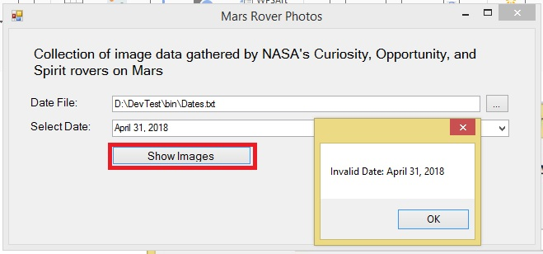

1. To organize the image files, the files are stored in its corresponding date folder with a name format of the date of "yyyy-M-d". e.g. 2018-6-2. The same format used in NASA json for the earth date.
2. To improve performance, if the folder for the date is already existed it will not be created anymore and the image files will not be downloaded too. Save processing time.

1. If the folder for the selected date is missing or accidentally deleted it will create the corresponding date folder and will download images to ensure that the files are there and can be displayed in a Web Browser.