**How To Run The Program:**

1. Click the DevTest.exe.

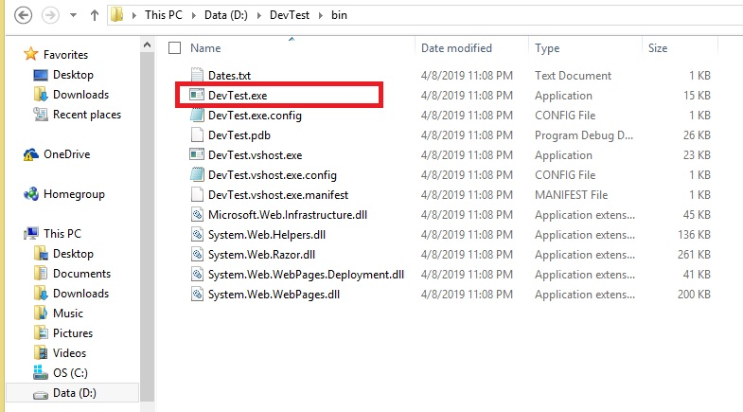

1. This will run the program and will download all images from NASA sites captured on the dates found from the text file “Dates.txt”. Each valid date creates a folder that contains these images.

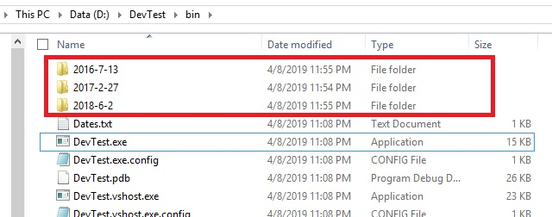

1. The filename of each images saved in the folder is the same as the original filename.

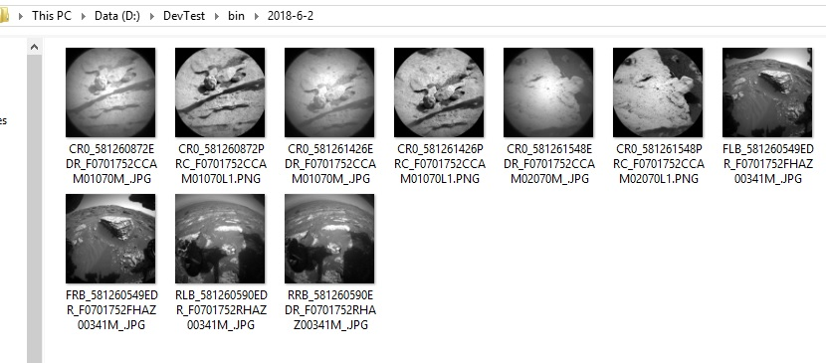

1. After downloading all the images, the following window appears and the user can select the date from the dropdown list which was read from the Date File.

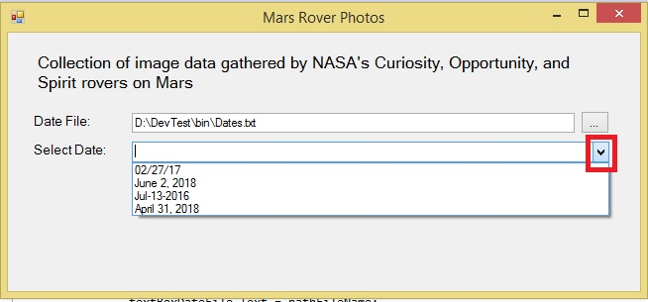

1. If the date selected is valid, each image of the date is displayed in a web browser.

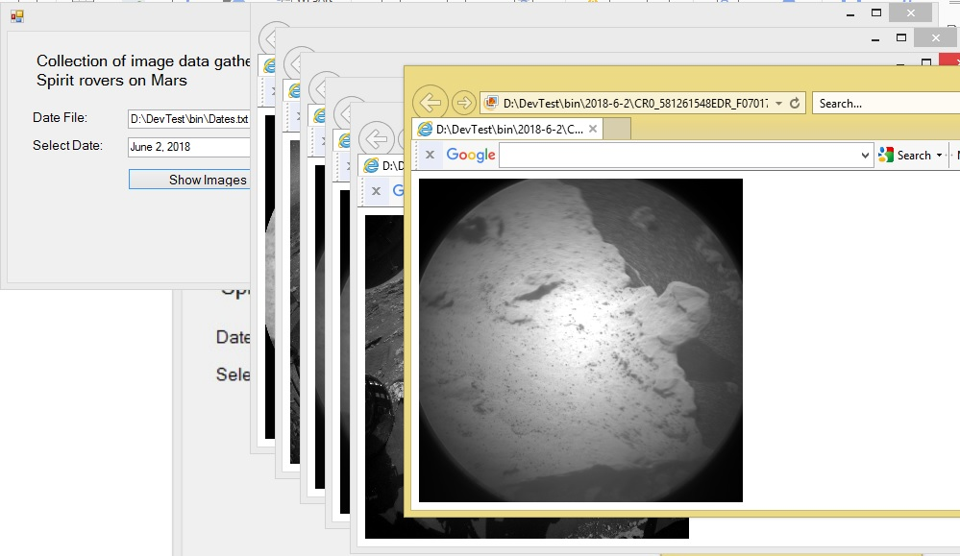

1. Thank you!