Processing steps for classification

# Data preparation and quick execution

Organize the folders with waveform ogg files and the software (with file execute_all.py) in the same folder.

Edit the file execute_all.py to choose the options.

Execute:

python execute_all.py

# DNN steps for mel spectrogram assuming Prof. Meyer’s dataset

1) Start with ogg folder called train_audio and src in the same folder.

2) The train_audio folder has the files in format ogg and named as:

3) Choose the name for a general folder in a parent folder. The default is “../outputs”. Create the file with list of ogg files and their labels. Also, note the histograms.

C:\github\birds_dnn\src>python create_label_file.py ../train_audio ../outputs/

Created output folder ../outputs/

Found 1048 files with extension ogg in folder ../train_audio

Wrote file ../outputs/wavs_labels.csv

Wrote file ../outputs/labels_dictionary.json

The files ../ outputs/ wavs_labels.csv and ../outputs\labels_dictionary.json will be used in all simulations, with different frontends and ML models.

4) Choose the features (magnasco, mel, stft) and the dimensions D (frequency) and T (time), compose the output folder name with them and the name of the file with the features. For instance:

python feature-extraction\general_frontend.py …

Files are written in the output folder

commandline_args.txt has the command that was used.

You can observe the features being processed in the main 4 stages using the --show_plot option. For instance:

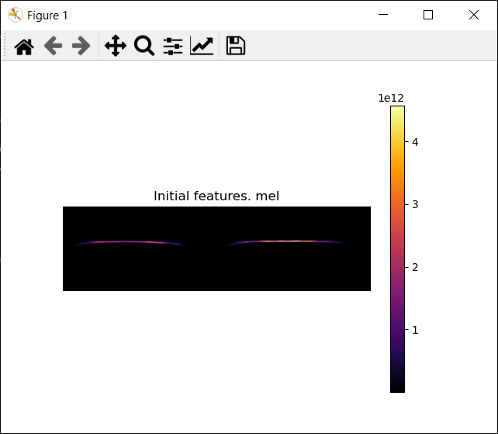

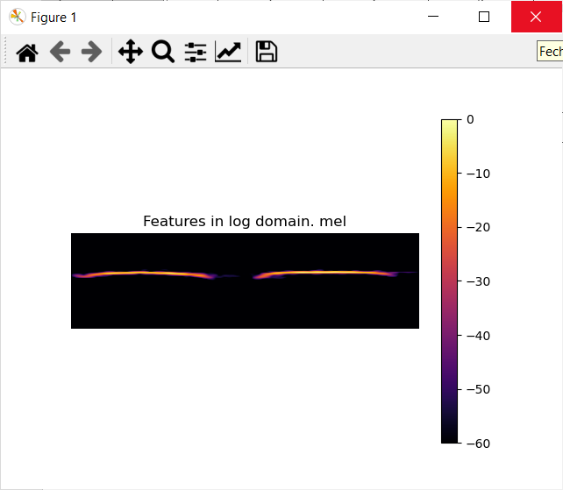

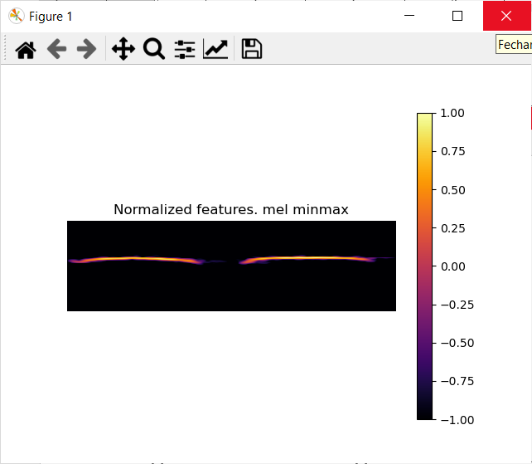

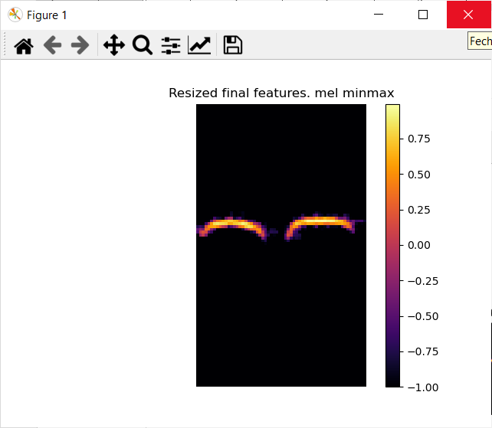

5) Now train the ML model with mixed speakers:

python train_lstm.py