 | UNIVERSIDADE FEDERAL DO PARÁ (UFPA)  INSTITUTO DE TECNOLOGIA  PROGRAMA DE PÓS-GRADUAÇÃO EM ENGENHARIA ELÉTRICA  LASSE – www.lasse.ufpa.br  ALDEBARO KLAUTAU

ModuRatC

This is Matlab code for automatic modulation classification (AMC) and radio access technology (RAT) classification (RATC). AMC refers to identifying the modulation among QAM, PSK, etc., while RATC identifies the RAT among GSM, LTE, etc.

Download and installation
The ModuRatC code can be found at Github: https://github.com/aldebaro/moduratc
You will also need some functions from https://github.com/aldebaro/dsp-telecom-book-code
(obs: you will later need to edit script setSimulationVariables.m to inform the folders corresponding to the two repositories above)
If you want to run the classification experiments, you will also need Weka (https://www.cs.waikato.ac.nz/ml/weka/) . But if the goal is just to process radio signals, you do not need Weka.

After ModuRatC installation, 4 subdirectories are created:
generalFunctions - general functions. This folder will be included in your path (or must be)
simulation_amqam - an example of a complete modulation classification front end simulation
simulation_gsmcdmalte - an example of a complete radio access technology (RAT) classification front end simulation
simulation_digmods – digital modulation

Each of the 3 folders starting with simulation_XX has a runMain.m scrit, which is the main script and a script setSimulationVariables.m. Before running runMain.m, edit setSimulationVariables.m to inform your folders.

Some theory

Concepts about Classification
Any classification process can be split into two stages: a) feature extraction or front end (where sensible parameters are obtained to represent the signal) and b) classification algorithm. The ModuRatC package generates features organized in ARFF files to be used by the Weka machine learning package. In this sense, ModuRatC is the front end and Weka is used for the classification stage. When using ModuRatC, the class can be AM, QAM, etc. in modulation classification, or LTE and GSM in RAT classification.

IMPORTANT: make sure that no file is shared by both training and test lists. These lists must be disjoints in order to have only test files never seen during training. If you need to perform model validation (choose parameters of your classifier, such as number of neurons in a neural network), use a third “validation” file, but do not repeatedly use the test files to perform model selection. If that happens, your model will be biased by the test data and the error rate you observe after modifying the classifier model many times is not a good indication of the performance of your classifier on “unseen” data. In other words, the test data must be used one single time along the whole process, and this result is then an estimate of the “generalization capability” of your classifier. Because of this, ModuRatC generates 3 ARFF files: train, test and validation.

The radio signals are organized as a multiplex of complex envelopes using FDM (frequency division multiplex). This is briefly discussed in the next paragraphs. A digital communication textbook can explain the concept of complex envelope and intermediate frequencies (IF).

Signals, Simulations and Scenarios
Complex envelopes are used for representing the signals in baseband or IF. They are stored in binary files with extension “cenvbb” or “cenvif”, respectively.

- Complex envelopes in intermediate frequencies (IF)
The spectrum sensing block in ModuRatC works in a way similar to a spectrum analyzer, where a local oscillator (LO) brings the signal of interest from its original radio frequency (RF) to an intermediate frequency (IF). When planning the experiment, the user must specify the IF bandwidth to be enough to accommodate all signals of interest. The signal in IF can be complex-valued, i.e., it is assumed to be obtained by an IQ sampling processing using a sampling frequency Fs_if. In this case, the IF signal has a bandwidth BW = Fs_if.
Important: the IF frequencies are assumed to vary from -Fs_if/2 to Fs_if/2, not from 0 to Fs_if.

The files cenvif with complex envelopes in IF are stored in the simulation output folder, specified by variable myOutputDir, which must be initialized.

- Complex envelopes in baseband frequencies (BB)
The files cenvbb with complex envelopes in baseband are located in a folder with default name “complexBasebandEnvTimeDomain”. All these files must have the same sampling frequency Fs_bb, which may be smaller than Fs_if to save storage space. If an original baseband signal is not sampled at Fs_bb, it should be converted (for example, with the resample function, but be aware that resampling creates attentuated replicas of the original signal).

It is not mandatory but it is suggested to name the baseband files according to the following convention: IDFsXXXkHzBwYYYkHz_ZZZ.cenvbb, where ID is an identifier (qam, gsm, etc.), XXX / YYY inform the sampling frequency Fs_bb and the BW of this specific complex envelope, both in kHz, and ZZZ is an index to distinguish the file. For example:
amFs500kHzBw7.5kHz_2.cenvbb
amFs500kHzBw7.5kHz_3.cenvbb
amFs500kHzBw7.5kHz_4.cenvbb

How to read/write complex envelopes and observe their PSDs
The scripts read_complex_binary.m and write_complex_binary.m show the format of the binary files holding complex envelopes. The files with the complex envelopes are little-endian float values, real and imaginary interleaved: xreal[0],ximag[0],xreal[1],ximag[1],xreal[2],ximag[2].

One can observe a PSD by going to its folder and issuing the commands:
x=read_complex_binary('gsmltecdma_1.cenvif'); %read the file at IF
Fs_if=8e6; %Fs at IF is 8 MHz
ak_psd(x,Fs_if); %calculate and plot the PSD
that will generate the plot below.
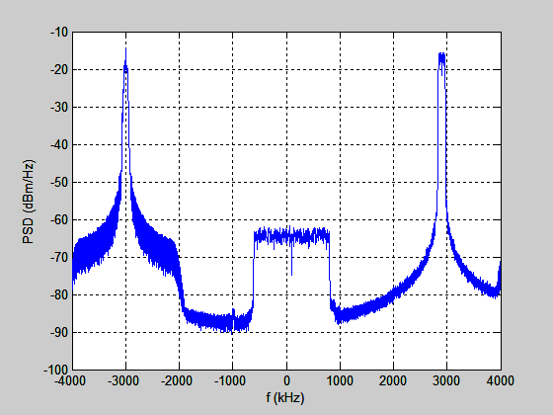

ModuRatC is based on the following concepts:

- Simulation: represents a complete experiment, with several scenarios. It generates three ARFF files for Weka, for training, testing and validation. It organizes parameters that are global, in the sense that are used for all scenarios, are the sampling frequency Fs, the class labels (RATs or modulations that can occur in scenarios), etc.

The “global” variables of a Simulation are stored in a file inside the simulation folder. This file is called setSimulationVariables.m. All scripts can then invoke
run('setSimulationVariables')
to setup the variables.

- Scenario: each scenario is composed by a receiver and a subset of RATs or modulations defined in the Simulation. The RATs and receiver can implicitly have their positions in a plane, and the channel distances taken in account, for example. Each RAT or modulation sends a signal through its channel, at the specified center frequency in this specific scenario, and the output is the complex envelop of a multiplex signal representing the band BW_IF. This signal is then converted to frequency domain via the pwelch PSD estimation algorithm and written as binary files with extension “psdif”. For simplicity, all “psdif” files of a Simulation correspond to the same BW_IF. By mimicking the tuning of a LO, they may correspond to distinct bandwidths in RF. Each Scenario has a single description specified in a file scenarioDescription.m located in the scenario's folder. Each scenario can have several instances, each instance is described by a script .m file (e.g. simulation_amqam\scenarioSimple\simpleMuxSignals_train1.m) generating a multiplex file in time domain (“cenvif” file), which is later converted to a “psdif” file. These instances can be seen as distinct random realizations of a Scenario and use different and more than one baseband complex envelopes, etc.

Folders and files used and generated in Simulations
Folders:
1- complexBasebandEnvTimeDomain: folder where the baseband complex envelopes are stored.
2- variable myOutputDir, example “output”: folder where the baseband IF envelopes are stored.
3- each Scenario has its own folder, examples: scenarioSimple and scenario3Classes in the Simulation example simulation_amqam.
4- externalFiles: is the suggested folder name for the place to store files generated by third-party programs. These files are typically baseband signals, eventually at frequencies different than Fs_bb. In this case, it is needed to convert these files to baseband complex envelopes sampled at Fs_bb and store them at complexBasebandEnvTimeDomain.

Files that the user must create or edit:
scenarioDescription.m
simpleMuxSignals_train1.m and others, describing instances of Scenarios
setSimulationVariables.m has all variables that need to be set
“cenvbb” files to be stored in folder "complexBasebandEnvTimeDomain"

Some text files that are created by simulation:
The first element is for “training” and the second for “test”
nameListWithTrainScriptsPerScenario{1}='trainScriptsPerScenarioList.txt';
nameListWithTrainScriptsPerScenario{2}='testScriptsPerScenarioList.txt';
listWithPSDAndAssociatedLabels{1}='trainPSDsAndScenariosList.txt';
listWithPSDAndAssociatedLabels{2}='testPSDsAndScenariosList.txt';

How to run a simulation
Go to folder simulation_amqam. Edit the file setSimulationVariables.m to reflect your file system folder and options, and execute
runMain.m
It will then create two ARFF files in the output directory, the training and test.

How to prepare a new Simulation
Create a directory for your simulation and give it an identifier. Here it will be assumed to be “mysimul” and the name of the root directory should be simulation_mysimul. Copy the file setSimulationVariables.m and runMain.m from the amqam simulation example to your new folder and edit the first one.
Important: if you have several setSimulationVariables.m files in your computer, make sure the current one is the first in your Matlab path. It will be constantly invoked.

Inside the folder simulation_mysimul, create and populate a folder named "complexBasebandEnvTimeDomain" with “cenvbb” files, with baseband complex envelopes.

The files that describe Scenarios can be calculated automatically or manually. For an example on calculating automatically, see the script moduratc_generateTrivialScenarioFiles.m in folder simulation_gsmltecdma. In the sequel, it is assumed a manual creation.

Define the Scenarios. For each Scenario, create a folder inside the folder simulation_mysimul with the Scenario name. The convention is to use the prefix scenario in the folder's name. Among these, the Scenarios to be included in your simulation will be informed via their folder names in the file setSimulationVariables.m as for example, the two scenarios:
directoriesWithScenarios{1}='scenarioSimple';
directoriesWithScenarios{2}='scenario3Classes';

Hence, edit setSimulationVariables.m to list your new scenarios. Now it comes a tedious part that you can make automatic via scripts: populate each scenario with the necessary information:
1) create, inside each scenario folder, a file called scenarioDescription.m with three arrays:
centerFrequencies, ratBandwidths and labels. For example, when 5 RATs or modulations are present:
centerFrequencies=[10 25 45 70 85]*1e3; %center frequencies
ratBandwidths=[10 7.5 10 7.5 15]*1e3;
labels=[1 2 1 2 3]; %AM QAM AM QAM DSB-SC
where the label indices are based on classLabels in setSimulationVariables.m. In this case,
classLabels = {'AM','QAM','DSBSC','noRAT'}.

2) create several scripts with specific realizations of the scenario. A typical .m file has the following information:
inputPath = complexBasebandEnvTimeDomain;
outputFileName = [myOutputDir 'simpleTest_1'];
complexEnvelopes{1}=[inputPath 'amFs500kHzBw5kHz_3'];
complexEnvelopes{2}=[inputPath 'qamFs500kHzBw7.5kHz_6'];

These scripts are not created as simple ASCII text files because a script can have comments to document everything.

3) then create the files that list the baseband complex envelopes for train, test and validation. The names of these list files are the same for all Scenarios. You specified this name in setSimulationVariables.m, for example with:

nameListWithTrainScriptsPerScenario{1}='trainScriptsPerScenarioList.txt';
nameListWithTrainScriptsPerScenario{2}='testScriptsPerScenarioList.txt';
nameListWithTrainScriptsPerScenario{3}='validationScriptsPerScenarioList.txt';

Hence, each Scenario included in your simulation must have three files, which in the previous example must be named trainScriptsPerScenarioList.txt, testScriptsPerScenarioList.txt and validationScriptsPerScenarioList.txt.

Pay attention to the number of features of your chosen front end:
It is time to review all variables in setSimulationVariables.m. For example, you can choose the front end changing frontEndIndex below:
%% Front ends
allFrontEnds{1}='rat_frontendPSD'; %simply calculates PSD
allFrontEnds{2}='rat_frontendDCT'; %takes the DCT of the PSD
allFrontEnds{3}='rat_frontendBWAndOtherMeasurements'; %measures BW
numFeatures{1}=16; %number of features of each front end
numFeatures{2}=15;
numFeatures{3}=3;
frontEndIndex = 3; %index of chosen front end

The first front end is implemented in rat_frontendPSD.m in folder generalFunctions.
You can implement your own front end. Recall that changes in parameters will change the numFeatures{frontEndIndex} of a front end. The error message in the simulation informs the number of parameters that was returned by the function and you can use this to update setSimulationVariables.m.

For example, below is an error message saying that, after changing parameters, the software calculated 26 features while 33 were expected. Then, the script moduratc_initializeBottomUpPSDBasedFrontEnd.m should be edited to indicate the correct number is 26:

6) Extract features and labels
moduratc_generateAllFeaturesAndLabels
Processing D:\github\moduratc\simulation_digmods\output\scenario3ClassesTrain_1.cenvif
#### Command line was: x=moduratc_frontendPSD(psdS,k); ####
#### Front end calculated 26 features ####
### instead of 33
#### Update this value at: moduratc_initializeBottomUpPSDBasedFrontEnd.m ####
Error using moduratc_bottomupPSDFeaturesAndLabelsExtractor (line 86)
Number of features does not match numFeatures{frontEndIndex}

Error in moduratc_generateAllFeaturesAndLabels (line 62)
eval(frontEndCommand);

How to delete all output information from a simulation?

Simply delete the output folder. All the generated files are created there.

Depending on the simulation, you may want to delete the folder complexBasebandEnvTimeDomain, in case they were generated automatically. But be careful! This folder may contain files that were obtained with other software packages. The same applies to Scenario folders.

Run Weka after the ARFFs were created

This is optional. For the example of simulation_gsmltecdma, it was possible to obtain:
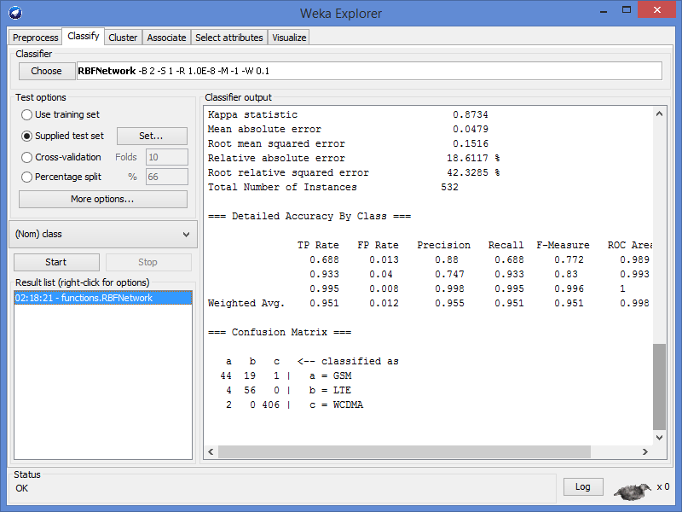

Other information
All the baseband signals are stored in files cenvbb in folder complexBasebandEnvTimeDomain. Note that all these files should have the same sampling frequency, specified as
Fs = 8e6; %sampling frequency in Hz
at setSimulationVariables.m.

One important thing is that the bandwidths are not defined in setSimulationVariables.m because they are not associated to each RAT. In different scenarios, a RAT with the same label (e.g. LTE) can have distinct bandwidths. Hence, the bandwidths are defined in each Scenario, through the scenarioDescription.m file.

Because digital signal processing is used, the IF bandwidth is in fact mapped to frequencies in radians. Hence, using [-Fs/2, Fs/2] or [0, Fs] should lead to the same result. But to enable checks such as
if min(centerFrequencies-ratBandwidths/2) < minIFFreq
error([thisScript 'has too small centerFrequencies'])
end
in rat_generateTrainTestSequences.m, the convention is to use [-Fs/2, Fs/2].

Using the example of simulation_gsmltecdma, let us investigate how to define the center frequencies. In this case, Fs is 8 MHz. In each scenarioDescription.m of the scenarioTrivial folder, the information is the one below (recall that these files are automaticall created by
rat_generateTrivialScenarioFiles.m):
%recall that Fs=8e6 and IF bandwidth is counted from -Fs/2 to Fs/2
fprintf(fp2,'%s\n',['centerFrequencies=[-3000 100 2900]*1e3; %center frequencies']);
fprintf(fp2,'%s\n',['ratBandwidths=[200 1400 200]*1e3;']);

End all directories with filesep (which will be translated to '/' or '\' depending if you are using Windows or Linux, otherwise concatenation of paths and file names may go wrong.

References
[1] http://www.wiley.com/WileyCDA/WileyTitle/productCd-0470727853.html

[2] http://www.mcs.edu.pk/wcms08/lectures/august62008lec6mainconcepts.pdf

[3] http://www.spec.gmu.edu/~pparis/classes/resources_732/printed_channel.pdf

[4] http://channelmodels.eit.lth.se/tiki-index.php?page=Okumura-Hata

Appendix - Regarding Matlab channels

- One Matlab multipath fading channel is COST 207. You can find it from Matlab’s stdchan followed by an AWGN channel. Read about “Fading channels” in Matlab’s documentation (see screenshot below or http://www.mathworks.com/help/comm/examples/multipath-fading-channel.html) and play with the Simulink model commmultipathfading to learn more.
- One can construct and visualize these channels with:
Fs=2e6; ts = 1/Fs; fd = 200;
chan = stdchan(ts, fd, 'cost207RAx4');
chan.NormalizePathGains = 1;
chan.StoreHistory = 1; %use for visualization, but disable for actual simulations
y = filter(chan, ones(1,5e4));
plot(chan);

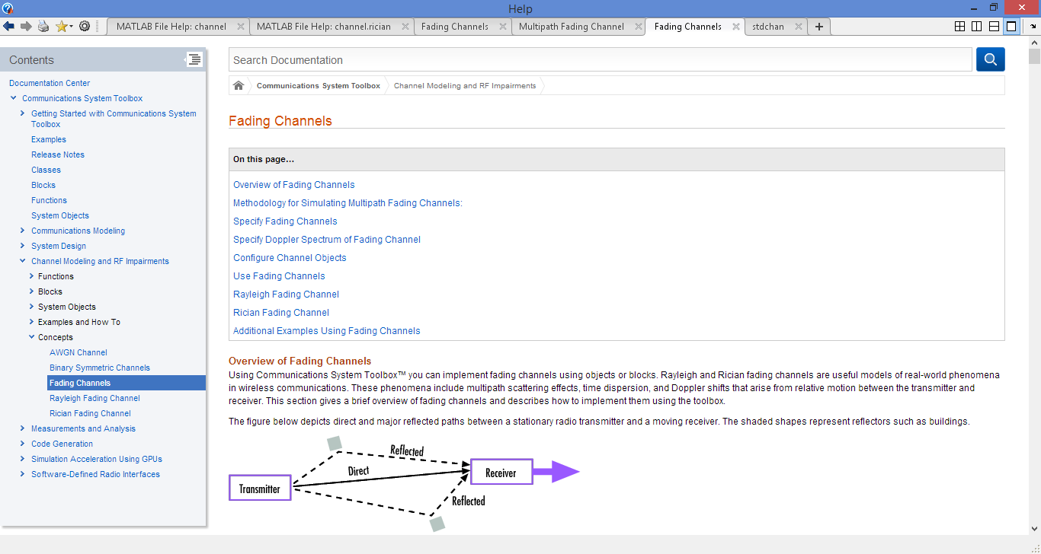

For path loss, one can use the Okumura-Hata model [4] (e.g., at http://www.mathworks.com/matlabcentral/fileexchange/39311-okumura-hata-model) for a typical or open rural area.

