TySOM-M-MPFS250T
Linux Guide
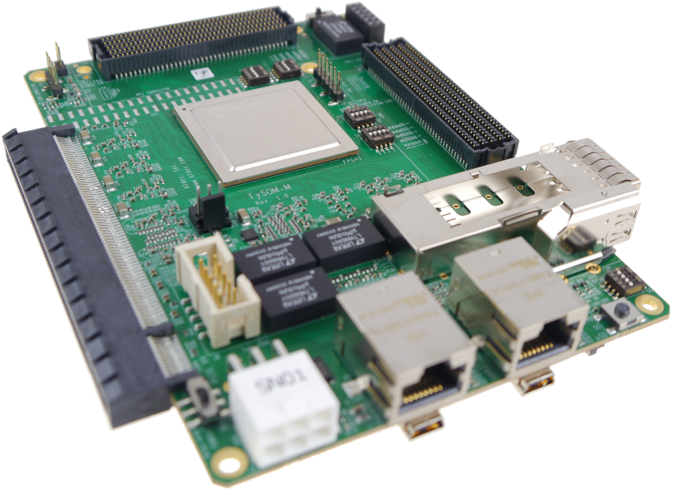
Aldec® Disclaimer: The information provided in this document is provided in connection with Aldec’s Hardware products. All solutions, designs, schematics, drawings, boards or other information provided by Aldec to Customer are intellectual property of Aldec, Inc. No license, express or implied, by estoppel, or otherwise, to any intellectual property right is granted to Customer by this document or in connection with the sale of Aldec products.

Export Restriction
Aldec, Inc. Hardware is not to be exported or re-exported, including reference images or accompanying documentation in any form without the appropriate government licenses, if required, and the expressed consent of Aldec, Inc. Purchaser warrants that it is not prohibited from receiving the Hardware under U.S. export laws and that it is not a national of a country subject to U.S. trade sanctions. Purchaser will not use the Hardware in a location that is the subject of U.S. trade sanctions that would cover the Hardware. Purchaser warrants that it is not subject to the U.S. Department of Commerce's table of deny orders or otherwise prohibited from obtaining goods of this sort from the United States.
Resale Restriction
Aldec, Inc. Hardware is not to be resold except within their assigned territory by distributors with a valid written distribution agreement with Aldec, Inc. Purchasers of the Hardware agree not to transfer the Hardware to any third party without express written consent of Aldec, Inc.
2/25/2010

Table of Contents
1 Introduction 4
2 Building Linux OS using Yocto Project 4
3 Generating HSS 5
4 HW generation and programming the board 5
5 Running Linux OS on the board 7
5.1 Preparing an SD card 7
5.2 Programming the internal eMMC memory 7
Appendix A: 12
About Aldec, Inc. 13

Table of Figures
Figure 1: Libero ‘Execute Script…’ command location 6
Figure 2: Programming the board 7
Figure 3: HSS boot interrupted 8
Figure 4: Running the ‘usbdmsc’ command 8
Figure 5: Running the ‘dmesg’ command in the host terminal 8
Figure 6: Running the ‘zcat’ command 9
Figure 7: Interrupting the usbdmsc command 9
Figure 8: HSS console output of the ‘boot’ command 10
Figure 9: Successfully booted Libero Linux OS 11

Introduction
The following document details the process of booting Linux OS on the TySOM-M-MPFS250T board. The project, along with all the necessary source files, is available on https://github.com/aldec. Additional information on the board’s setup and connections is available in the TySOM-M-MPFS250T Quick Start Guide document. The project’s structure is available in Appendix A.
Described steps:
- building Linux OS image using Yocto Project
- generating HSS (Hart Software Services)
- HW generation with HSS loaded in
- uploading a drive image to the eMMC memory
- booting the OS from the memory
Used abbreviations:
- TOP_DIR – location of the main package directory (named ‘TySOM-M-MPFS250T’)

Building Linux OS using Yocto Project
The Linux OS drive image is generated using the Yocto Project.
- Move into a directory where you keep utilities and make sure it is in the PATH environment variable:
cd ~/bin/

- Download the repo script and make it executable:
curl https://storage.googleapis.com/git-repo-downloads/repo > repo
chmod a+x repo

- Test if the script is working:
repo --help

- Download the yocto-dev repository:
mkdir yocto-dev
cd yocto-dev
repo init -u https://github.com/polarfire-soc/meta-polarfire-soc-yocto-bsp.git -b refs/tags/v2021.04 -m tools/manifests/riscv-yocto.xml
repo sync
repo rebase

- (Optional) For older OS, prepare build tools in proper versions (tar 3.x and gcc 10.x):
cd ./openembedded-core/scripts
./install-buildtools --with-extended-buildtools --url http://downloads.yoctoproject.org/releases/yocto/yocto-3.0.2/

- Setting the environment for Yocto:
cd ~/bin/yocto-dev
(optional if step 5 was taken) source ../openembedded-core/buildtools/environment-setup-x86_64-pokysdk-linux
source ./meta-polarfire-soc-yocto-bsp/polarfire-soc_yocto_setup.sh

- Adding the TySOM-M BSP layer to Yocto configuration:
cd ./build
cp -r <TOP_DIR>/BSP/yocto/2021.04/meta_TySOM-M-MPFS250T_yocto_bsp ~/bin/yocto-dev
bitbake-layers add-layer ../meta_TySOM-M-MPFS250T_yocto_bsp

- Generate the files:
bitbake files
MACHINE=tysom-m-mpfs250t bitbake mpfs-dev-cli

Once the process is finished, a mpfs-dev-cli-tysom-m-mpfs250t.wic.gz Linux image file should be available in the build directory.

Generating HSS
HSS needs to be generated before building the hardware design because it will be embedded in the bitstream.
- Go to the project’s hss directory and run the hss.sh script – it will download the HSS repository, checkout a necessary commit and apply the Aldec HSS patch:
cd <TOP_DIR>/BSP/hss/v1_0
./hss.sh

- Go to the newly created hart-software-services directory and copy the board’s configuration file:
cd hart-software-services
cp boards/tysom-m-mpfs250t/def_config ./.config

- Build the HSS:
make BOARD=tysom-m-mpfs250t

Once generation is finished the hss.hex and hss.elf files can be found in the Default directory.

HW generation and programming the board
In order to load a Linux OS image into the eMMC drive, FPGA hardware needs to be generated with HSS instead of a bare-metal application embedded in it. It allows to mount the drive as USB storage on a host PC and copy the necessary files.

- Navigate to <TOP_DIR>/BSP/designs/libero2021.1/tysom_m_mpfs250t_ref_design
- Run Libero and select Project → Execute Script…
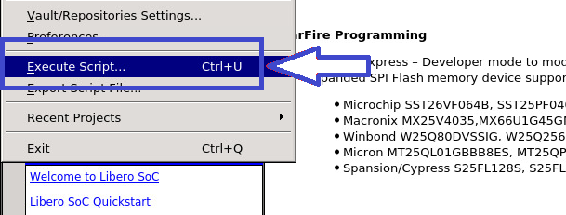Figure 1: Libero ‘Execute Script…’ command location

- Choose either TySOM-M-MPFS250T_SD.tcl or TySOM-M-MPFS250T_eMMC.tcl script and run it. The former will generate a design which uses the SD card slot, while the latter will utilize internal eMMC memory. This generates a block design suitable for the TySOM-M-MPFS250T board. Once the process finishes, an appropriate message will be displayed in the Report window.
- In the Design Flow tab double click the ‘Generate FPGA Array Data’ option and wait for it to finish.
- Double click the ‘Configure Design Initialization Data and Memories’ option, and select the eNVM tab. Press ‘Add→Add Boot Mode 1 Client’ and select the hss.hex file build in Chapter 3, in the hss directory.
- Generate the bitstream.
- To program the board, double-click the ‘Run PROGRAM Action’ option in the ‘Design Flow’ part of Libero. The board is programmed through a Flash PRO programmer, verify if one is connected.

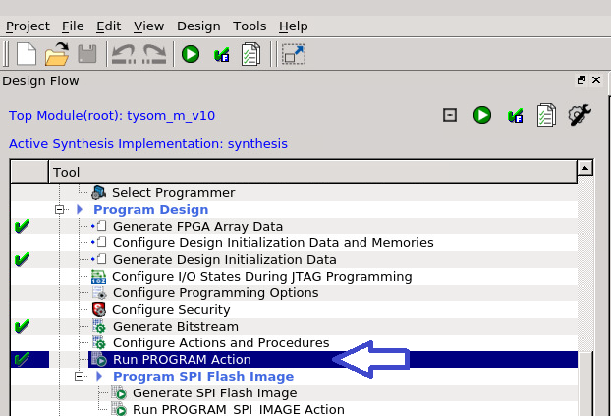Figure 2: Programming the board

Running Linux OS on the board
Linux OS can be loaded either from an SD card, or internal eMMC memory – dependent on which hardware design variant was generated.

Preparing an SD card
- Insert the SD card into an appropriate card reader and connect it to the workstation
- Check the SD card’s label with the dmesg command and use it instead of sdX in the following command:
zcat ./tmp-glibc/deploy/images/tysom-m-mpfs250t/mpfs-dev-cli-tysom-m-mpfs250t.wic.gz | sudo dd of=/dev/sdX bs=4096 iflag=fullblock oflag=direct conv=fsync status=progress

- Once the transfer is completed plug the SD card into the TySOM-M-MPFS250T board, connect the PMOD-UART and power the board on. Linux console should be available under UART1, and the HSS console under UART0.

Programming the internal eMMC memory
Before Linux can be booted, it’s image must be copied into the eMMC memory on the board. The HSS software embedded in the bitstream exposes it as a USB mass storage device which can be mounted on the host PC.
- Connect to the HSS console using any terminal emulation program. For this guide, picocom has been used:
picocom -b 115200 /dev/ttyACMX

- Once HSS selects the eMMC memory and starts a 5 second timeout countdown press any key to enter the command line interface.
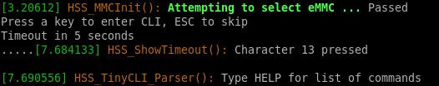Figure 3: HSS boot interrupted
- Run the ‘usbdmsc’ command in the HSS console.
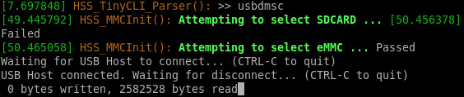Figure 4: Running the ‘usbdmsc’ command
- On the host PC use ‘dmesg | tail’ command to verify if a mass storage device was mounted:
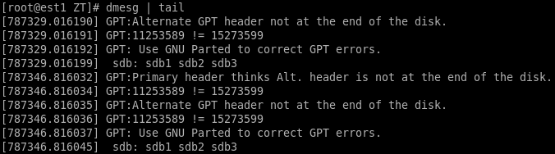Figure 5: Running the ‘dmesg’ command in the host terminal
- Run the following command to copy the image to the mounted drive, using the appropriate drive label instead of sdX (the image is approximately 5GB in size so it may take up to 30 minutes to load, dependent on the transfer speed):
zcat mpfs-dev-cli-tysom-m-mpfs250t.wic.gz | dd of=/dev/sdX bs=4096 iflag=fullblock oflag=direct conv=fsync status=progress

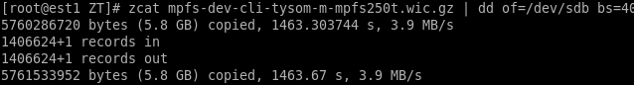Figure 6: Running the ‘zcat’ command
- Once the ‘zcat’ command finishes copying the OS image to the eMMC memory on the board, return to the HSS terminal opened previously using picocom. It should display a number of bytes written to the mounted drive.
- Press Ctrl+C in order to interrupt the mass storage device mount command.
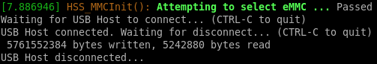Figure 7: Interrupting the usbdmsc command

- In order to verify which handle is used for the Linux OS terminal, connect to every other /dev/ttyACMX using picocom. Once the next step finishes, each will display a ‘hartX setup completed’ message – the Linux OS terminal will be available on the ‘hart1’ one.

- Run ‘boot’ command.
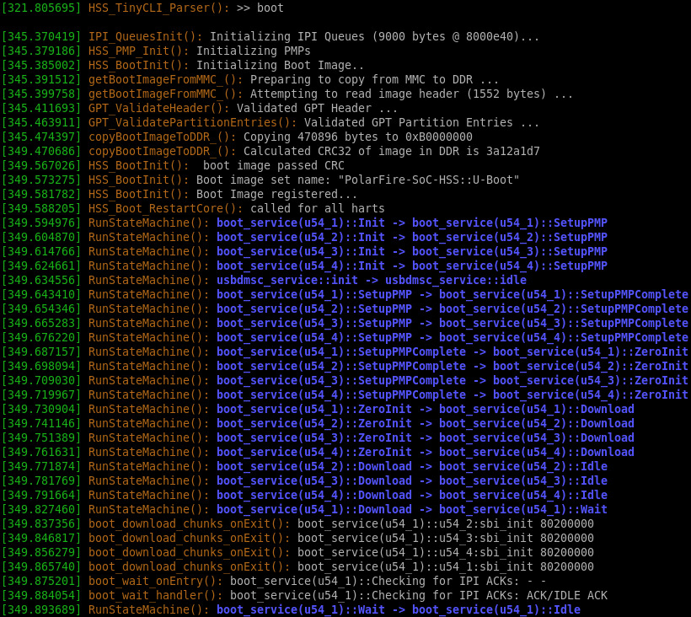Figure 8: HSS console output of the ‘boot’ command

- It may be necessary to power-cycle the board for the Linux OS to boot properly. Use ‘root’ login and no password:
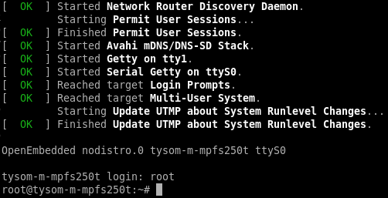Figure 9: Successfully booted Libero Linux OS

Appendix A:

Project directory hierarchy:
- TySOM-M-MPFS250T → Main directory
  - BSP → Board Support Package
    - designs → Libero design for the board
    - doc → Documentation
    - hss → Hart Software Services generation
    - mss → Polarfire SOC MSS Configurator
    - yocto → Yocto Project for building Linux OS

About Aldec, Inc.
Established in 1984, Aldec Inc. is an industry leader in Electronic Design Verification and offers a patented technology suite including: RTL Design, RTL Simulators, Hardware-Assisted Verification, Design Rule Checking, IP Cores, DO-254 Functional Verification and Military/Aerospace solutions. Continuous innovation, superior product quality and total commitment to customer service comprise the foundation of Aldec’s corporate mission. For more information, visit www.aldec.com.

Contact:
2260 Corporate Circle
Henderson, NV 89074
USA
Tel: (702) 990-4400
Fax: (702) 990-4414
E-mail: sales@aldec.com
Website: www.aldec.com

