Name-Surname:
Student ID:

EEE 501 – Applied Digital Image Processing
CE 490 – Introduction to Digital Image Processing

Assignment Report #1

- MATLAB Code (Please paste below all your MATLAB code including scripts and functions in a neat manner)
x = im2double(imread('lightPollen.jpg'));

pixel_count=size(x,1)*size(x,2);%get pixel count

hist=zeros(1,256);%create for histogram array
x=x.*256;%orginal photo opeened double so that times 256

for i = 1:size(x,1)%go to photo matrix first dimention
for j =1:size(x,2)%go to photo matrix first dimention
hist(1,round(x(i,j)))= hist(1,round(x(i,j)))+1 ; %write hist go to pixel and which colour increase 1
end
end

hist_size = 1:1:256;%for plot i create matrix

%plot histogram
subplot(3,2,1)
plot(hist_size,hist)
title('Histogram')

pdf_version= hist./pixel_count%pdf version is only diveded each element by each

%plot pdf
subplot(3,2,3)
plot(hist_size,pdf_version)
title('PDF')

cdf_version = zeros(1,256);%create matrix for cdf

for i = 1:length(hist)%
total =0;
for j =1:i
total = total + pdf_version(1,j); %add before all cell
end
cdf_version(1,i)= total; %and write to cell
end

transfer_version=cdf_version*255;%cdf version is only multiply each element by each
transfer_version=round(transfer_version);%transfer funcion should be integer numbers

%show cdf
subplot(3,2,4)
plot(hist_size,transfer_version)
title('CDF')

%for final photo matrix
final_photo = zeros(size(x,1),size(x,2));

for i = 1:size(x,1)
for j =1:size(x,2)
final_photo(i,j) = transfer_version(round(x(i,j)));%go pixel get colour and get for this value's transfer function and write new matrix
end
end

%plot again
subplot(3,2,5)
imshow(uint8(x));
title('Orginal Photo')

subplot(3,2,6)
imshow(uint8(final_photo));
title('Final Photo')

- Plots, Figures, Images and Comments (Please paste below all required plots, figures and images together with the comments of each plot/figure/image)
- get photos pixels
- go every pixel and count the pixel values and write this data
- diveded by total pixels count of pixel

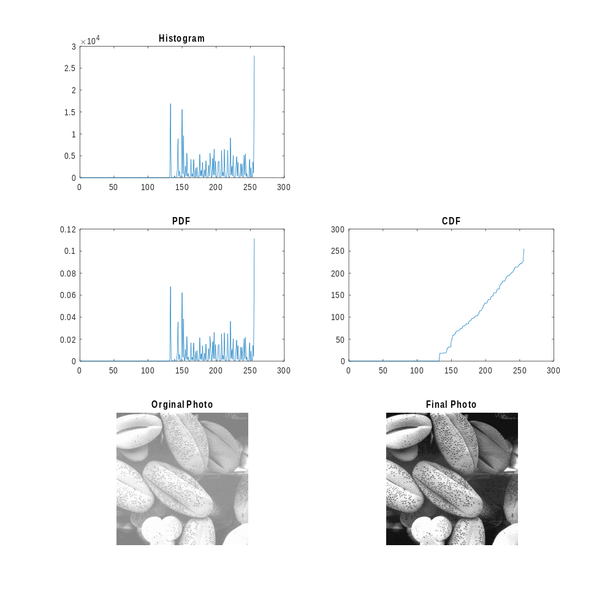
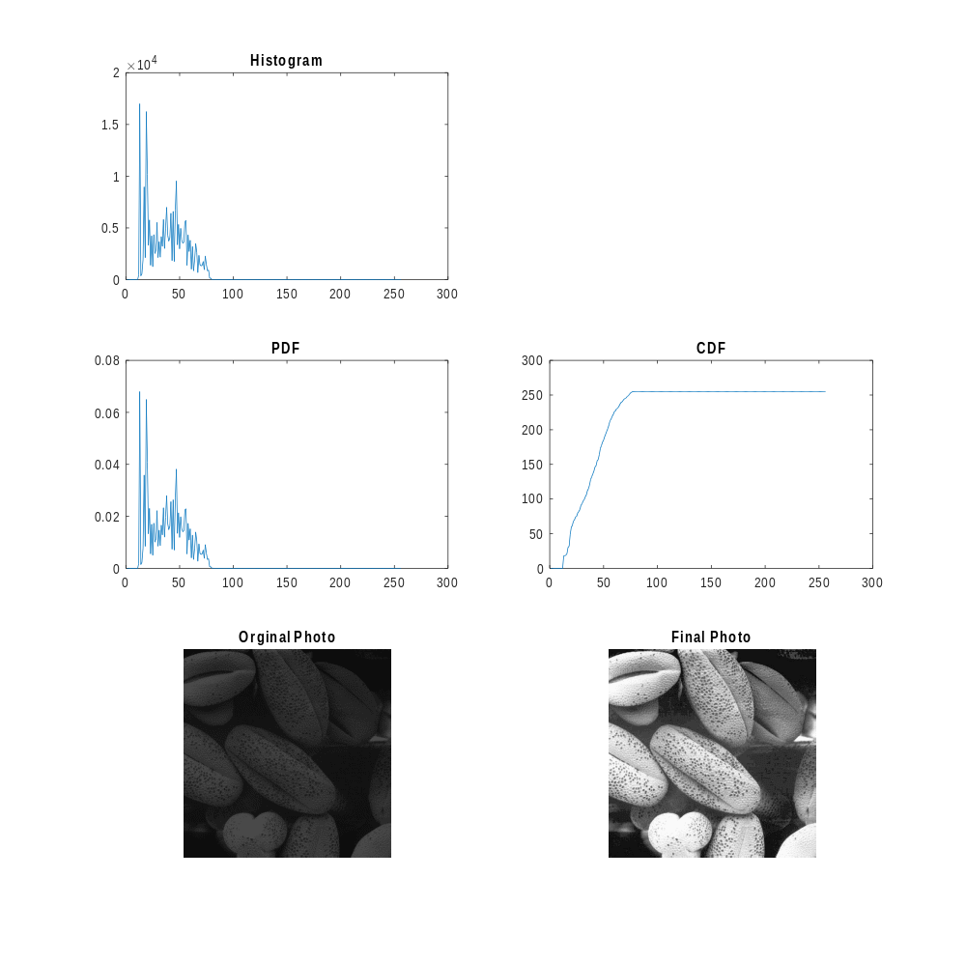

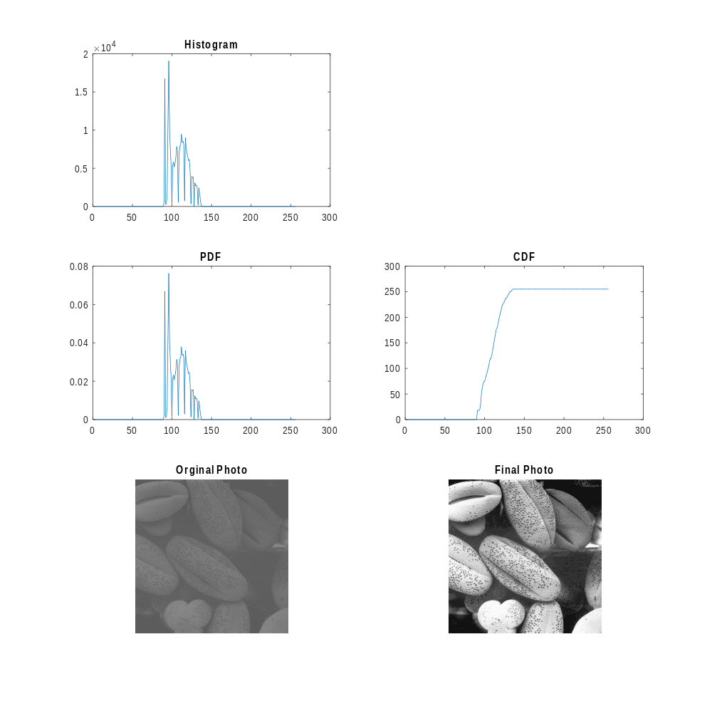

- Conclusion (Please summarize to conclude what have you learned in this assignment)
I learned histograms and PDF and CDF.
Histogram is count of same value of pixel .
PDF is rate of histogram and CDF is integrate PDF basically.
Multiply the CDF matrix 255 and write for orginal photo pixels values and show the image.

