Azure KB Agent Setup Guide
This guide covers the setup and configuration of the Azure Knowledge Base Agent for local development and Azure deployment. For more information, see Azure AI Search documentation.

Prerequisites
- Python 3.11+
- Azure CLI with active subscription
- Azure Developer CLI (azd)
- Docker Desktop

Architecture Overview
The following diagram shows the deployment architecture:
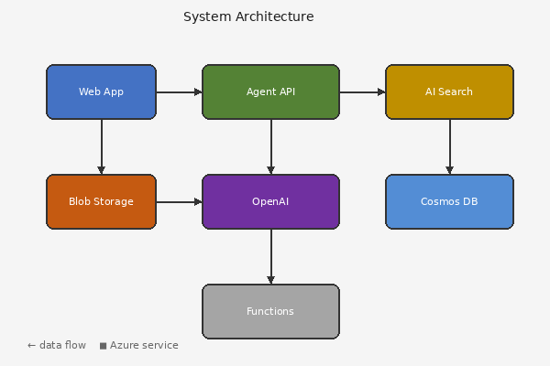

Performance Comparison
The chart below compares conversion latency across different backends:
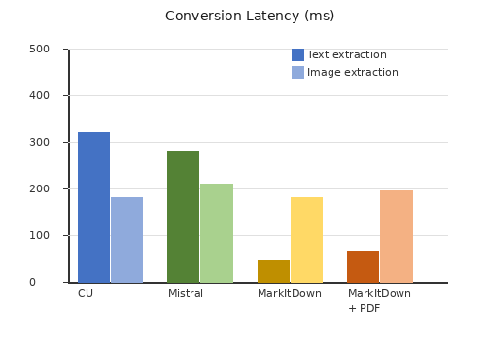

Photo Extraction Test
Photo-like images with complex gradients and organic shapes test whether extraction preserves color fidelity and detail:


Environment Variables
Variable | Required | Description
AI_SERVICES_ENDPOINT | Yes | Azure AI Services endpoint URL
SEARCH_ENDPOINT | Yes | Azure AI Search endpoint URL
SERVING_BLOB_ENDPOINT | Yes | Blob storage endpoint for serving
COSMOS_ENDPOINT | No | Cosmos DB endpoint for memory

Deployment Steps
- Run azd up to provision and deploy all resources.
- Configure environment with azd env get-values.
- Run make test to verify the deployment.

Azure Resource Inventory (Long Table)
The following table lists all Azure resources deployed for the KB Agent system. This table is intentionally long (30 rows) to test cross-page table handling.
# | Resource Name | Type | Region | Status | Monthly Cost
1 | kb-agent-container-app-01 | Container App | East US 2 | Running | $45.00
2 | kb-agent-cosmos-db-02 | Cosmos DB | West US 3 | Provisioned | $120.50
3 | kb-agent-ai-search-03 | AI Search | Central US | Scaling | $89.99
4 | kb-agent-openai-04 | OpenAI | North Europe | Updating | $210.00
5 | kb-agent-blob-storage-05 | Blob Storage | West Europe | Healthy | $15.75
6 | kb-agent-key-vault-06 | Key Vault | East US 2 | Running | $32.40
7 | kb-agent-app-insights-07 | App Insights | West US 3 | Provisioned | $8.50
8 | kb-agent-log-analytics-08 | Log Analytics | Central US | Scaling | $55.20
9 | kb-agent-container-registry-09 | Container Registry | North Europe | Updating | $178.00
10 | kb-agent-virtual-network-10 | Virtual Network | West Europe | Healthy | $0.00
11 | kb-agent-container-app-11 | Container App | East US 2 | Running | $45.00
12 | kb-agent-cosmos-db-12 | Cosmos DB | West US 3 | Provisioned | $120.50
13 | kb-agent-ai-search-13 | AI Search | Central US | Scaling | $89.99
14 | kb-agent-openai-14 | OpenAI | North Europe | Updating | $210.00
15 | kb-agent-blob-storage-15 | Blob Storage | West Europe | Healthy | $15.75
16 | kb-agent-key-vault-16 | Key Vault | East US 2 | Running | $32.40
17 | kb-agent-app-insights-17 | App Insights | West US 3 | Provisioned | $8.50
18 | kb-agent-log-analytics-18 | Log Analytics | Central US | Scaling | $55.20
19 | kb-agent-container-registry-19 | Container Registry | North Europe | Updating | $178.00
20 | kb-agent-virtual-network-20 | Virtual Network | West Europe | Healthy | $0.00
21 | kb-agent-container-app-21 | Container App | East US 2 | Running | $45.00
22 | kb-agent-cosmos-db-22 | Cosmos DB | West US 3 | Provisioned | $120.50
23 | kb-agent-ai-search-23 | AI Search | Central US | Scaling | $89.99
24 | kb-agent-openai-24 | OpenAI | North Europe | Updating | $210.00
25 | kb-agent-blob-storage-25 | Blob Storage | West Europe | Healthy | $15.75
26 | kb-agent-key-vault-26 | Key Vault | East US 2 | Running | $32.40
27 | kb-agent-app-insights-27 | App Insights | West US 3 | Provisioned | $8.50
28 | kb-agent-log-analytics-28 | Log Analytics | Central US | Scaling | $55.20
29 | kb-agent-container-registry-29 | Container Registry | North Europe | Updating | $178.00
30 | kb-agent-virtual-network-30 | Virtual Network | West Europe | Healthy | $0.00

References
- Azure AI Search documentation
- Azure OpenAI Service
- MarkItDown on GitHub
- Azure Container Apps
- Bicep documentation

