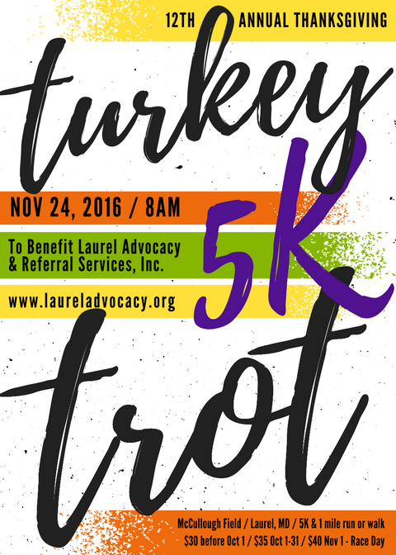

*Completed registration forms and payment can be mailed or dropped off to:*

**LARS / 311 Laurel Ave / Laurel, MD 20707**

First Name: Last Name:

Address:

City: State: Zip:

Phone: ( ) - Email:

**Birthdate:** / / **T-Shirt Size:** S M L XL XXL(+$5)

**Event:** □ 5K Run □ 1 Mile Walk □ Sleepwalker **Sex:** M F

*Waiver & Release: In consideration of your accepting my entry, I, intend to be legally bound for myself, my heirs, my executors, and administrators, do hereby release and discharge Laurel Advocacy and Referral Services, Inc. and all other contributors from any and all liability arising from illness, injury, and damages that I may suffer as a result of my participating in this event. I also understand that any sponsors may use for publicity of the 5K/1 Mile Walk for LARS, my name and/or picture without any obligation or liability to me.*

Signature: Date:

(Parent or guardian must sign for participants under 18)

***BRING A FRIEND!***

First Name: Last Name:

Address:

City: State: Zip:

Phone: ( ) - Email:

**Birthdate:** / / **T-Shirt Size:** S M L XL XXL(+$5)

**Event:** □ 5K Run □ 1 Mile Walk □ Sleepwalker **Sex:** M F

*Waiver & Release: In consideration of your accepting my entry, I, intend to be legally bound for myself, my heirs, my executors, and administrators, do hereby release and discharge Laurel Advocacy and Referral Services, Inc. and all other contributors from any and all liability arising from illness, injury, and damages that I may suffer as a result of my participating in this event. I also understand that any sponsors may use for publicity of the 5K/1 Mile Walk for LARS, my name and/or picture without any obligation or liability to me.*

Signature: Date:

(Parent or guardian must sign for participants under 18)