

International University of Sarajevo

Fake News Detection System

Student: Professor:
Alden Krako Dr. Ali Abd Almisreb

Contents
2. Introduction 4
2.1 Background and Motivation 4
2.2 Problem Statement 4
2.3 Project Objectives 4
2.4 Scope of the Project 5
2.5 Structure of the Report 5
3. Technologies Used in the Project 6
3.1 Programming Languages 6
3.2 Frameworks and Libraries 6
3.3 Dataset 7
3.4 Development and Deployment Tools 7
4. Implementation Details 8
4.1 Project Structure Overview 8
4.2 Data Loading and Preprocessing 9
4.3 Feature Extraction (TF-IDF) 10
4.4 Model Training and Baseline Comparisons 11
4.5 Model Persistence 12
4.6 Streamlit Web Application 12
4.7 User Interface and User Experience 13
4.8 Design Patterns and Architectural Decisions 13
4.9 Performance and Results 13
4.10 Security and Best Practices 14
4.11 Limitations and Challenges 14
5. Conclusion 15
5.1 Summary of Achievements 15
5.2 Lessons Learned 15
5.3 Recommendations for Future Development 15
6. References 17
6.1 Documentations 17
7. Appendices 18
7.1 Complete Code Listing 18
7.2 User Guide 18

Introduction

2.1 Background and Motivation
The rapid proliferation of misinformation and fake news across digital media platforms has become one of the most pressing challenges of the modern information age. False or misleading news articles can spread virally, influencing public opinion, undermining trust in institutions, and even affecting real-world events. Automated detection systems offer a scalable means to identify potentially false content before it reaches wide audiences. This project was motivated by the desire to apply machine learning techniques to this socially relevant problem, exploring how natural language processing and classification algorithms can distinguish real news from fabricated content. Working with a well-established public dataset provided both a realistic challenge and measurable benchmarks against which to evaluate different approaches.

Problem Statement
Manual fact-checking of news articles is inherently slow and does not scale to the volume of content produced daily across online platforms. Existing general-purpose tools often lack the transparency needed to understand why a given article is flagged, and many rely on black-box deep learning models that are costly to train and deploy. This project addresses the need for a lightweight, interpretable, and accessible fake news detection system that can classify articles with high accuracy using standard machine learning pipelines, and present its findings through an intuitive web interface accessible to non-technical users.

Project Objectives
- Build a fake news classifier using a shallow neural network (MLP) trained on TF-IDF features.
- Compare the MLP model against classical baselines: Logistic Regression and Naive Bayes.
- Visualize model performance using confusion matrices.
- Persist the trained model to disk for use by a separate web application.
- Develop an interactive Streamlit GUI allowing users to paste or upload news text and receive a real/fake prediction with a confidence score.
- Ensure the system is lightweight, reproducible, and deployable without specialized infrastructure.

Scope of the Project
This project is a Python-based machine learning application using scikit-learn and Streamlit. The dataset used is the publicly available Kaggle Fake and Real News dataset, comprising separate CSV files for fake and real articles. The scope covers text preprocessing, feature engineering via TF-IDF, training and evaluation of three classifiers, model serialization, and a front-end web GUI. The project does not implement deep learning (e.g., transformers or recurrent networks) and does not include a live news scraping pipeline or user authentication. It is designed as a self-contained academic demonstration, runnable locally with standard Python tooling.

Structure of the Report
The report is organized into five major sections. The first introduces the project context, motivation, and objectives. The second section details the technologies and libraries used. The third section covers the full implementation, from data loading and preprocessing through model training, evaluation, and the web interface. The fourth section presents the conclusion, lessons learned, and recommendations for future work. The final section lists references and appendices including a user guide.

Technologies Used in the Project

Programming Languages
Python 3 is the sole programming language used throughout the project. Python was selected for its dominant position in the data science and machine learning ecosystem, its extensive library support, and the ease with which it enables rapid prototyping. All three source files — fake_news_detector.py, train_model.py, and app.py — are written entirely in Python.

Frameworks and Libraries
scikit-learn: The core machine learning library. Used for the MLPClassifier (the main shallow neural network), LogisticRegression, MultinomialNB (Naive Bayes), TfidfVectorizer, and evaluation utilities such as classification_report, confusion_matrix, and ConfusionMatrixDisplay. scikit-learn was chosen for its clean API, extensive documentation, and out-of-the-box support for all required algorithms.
pandas: Used for loading and manipulating the CSV dataset files, concatenating dataframes, handling missing values, and creating the combined content feature (title + text).
matplotlib: Employed to render the side-by-side confusion matrix plots comparing all three classifiers, saving the output to confusion_matrices.png.
Streamlit: The web application framework used to build the interactive GUI in app.py. Streamlit enables rapid development of data-driven web apps in pure Python with no front-end code required.
pickle: Python’s standard serialization module, used to persist the trained vectorizer and MLP model to model.pkl so that the web application can load the pre-trained model without retraining on startup.
re: Python’s built-in regular expression module, used in the text cleaning function to strip punctuation and numbers before vectorization.

Dataset
The project uses the Kaggle Fake and Real News Dataset, which contains two CSV files: Fake.csv and True.csv. Each file contains news article text, titles, subjects, and dates. Fake.csv articles are labeled 1 (fake) and True.csv articles are labeled 0 (real). The dataset is stored locally in a data/ subdirectory and is not included in the repository. This is a widely used benchmark dataset in the fake news detection literature, making it suitable for comparing results with prior work.

Development and Deployment Tools
pip: Used for dependency management. A requirements.txt file lists all necessary packages (streamlit, scikit-learn, pandas, matplotlib) so that the environment can be reproduced with a single command.
Git and GitHub: Version control and hosting for the project repository at https://github.com/alden187/cs404. A .gitignore file prevents the data directory and model file from being committed.
PyCharm (.idea/): The project was developed using JetBrains PyCharm, as evidenced by the .idea configuration directory in the repository.

Implementation Details

Project Structure Overview
The repository has a flat, single-module structure with the following key files: fake_news_detector.py (the standalone training and evaluation script), train_model.py (the model training and serialization script used to generate model.pkl for the GUI), app.py (the Streamlit web application), model.pkl (the serialized trained model), confusion_matrices.png (output evaluation plot), and requirements.txt (dependency list). The data/ directory containing the CSV files is excluded from version control via .gitignore.
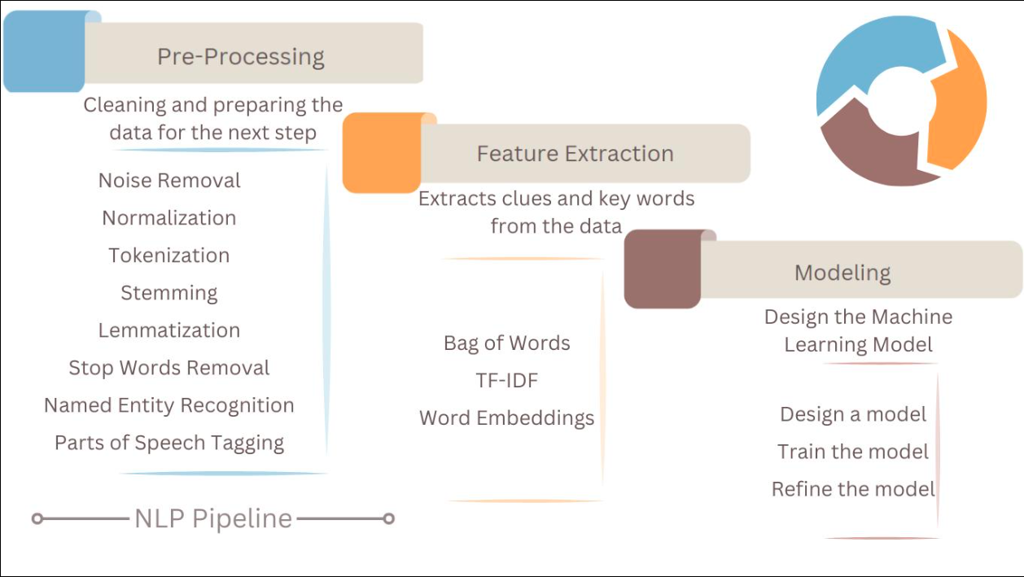
Picture 1: ML Pipeline Diagram

Data Loading and Preprocessing
Both CSV files are loaded with pandas and assigned binary labels (1 for fake, 0 for real). They are then concatenated into a single dataframe and rows with missing text values are dropped. Each article’s title and body text are combined into a single “content” string to give the classifier maximum textual signal. A clean_text() function lowercases each string and removes all non-alphabetic characters using a regular expression, ensuring the vectorizer receives normalized input. This preprocessing step is consistently applied during training, model saving, and inference in the web app.
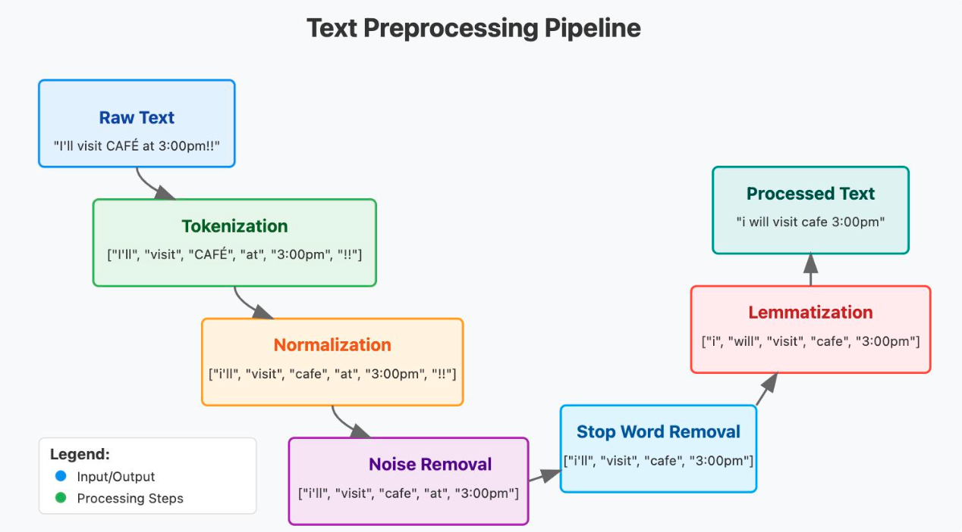
Picture 2: Text Preprocessing Pipeline

Feature Extraction (TF-IDF)
TF-IDF (Term Frequency–Inverse Document Frequency) vectorization is used to convert the cleaned text into a numerical feature matrix. The TfidfVectorizer is configured with a vocabulary of 5,000 features and English stop word removal. TF-IDF was selected over simpler bag-of-words representations because it down-weights terms that appear frequently across all documents (and are therefore less informative), while boosting terms that are distinctive to particular articles. The resulting sparse matrix serves as input to all three classifiers. The vectorizer is fit only on the training set and then applied to both training and test sets to prevent data leakage.
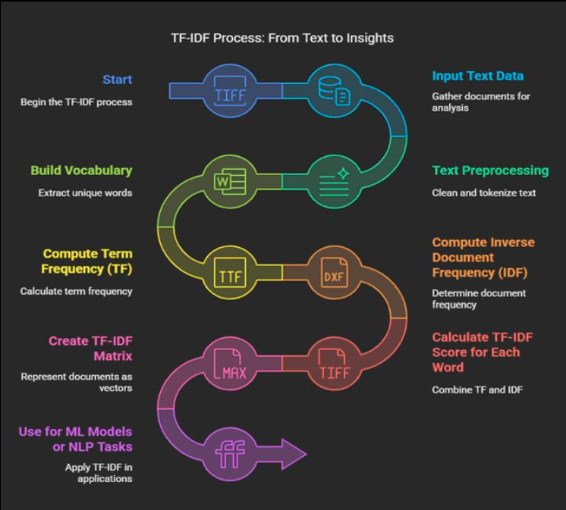
Picture 3: TF-IDF Process diagram

Model Training and Baseline Comparisons
The dataset is split into 80% training and 20% test sets using a fixed random seed (42) for reproducibility. Three classifiers are trained and evaluated.
Shallow Neural Network (MLPClassifier): This is the primary model. It uses a single hidden layer of 64 neurons with ReLU activation and is trained for 20 iterations. The MLP can learn non-linear combinations of the TF-IDF features, making it potentially more expressive than the linear baselines.
Logistic Regression: A strong linear baseline well-suited to high-dimensional sparse text features. It is trained with up to 1,000 iterations to ensure convergence.
Naive Bayes (MultinomialNB): A fast probabilistic baseline commonly used in text classification. Because TF-IDF values can be non-negative but non-integer, MultinomialNB is compatible with the transformed feature matrix.
Each model is evaluated on the held-out test set using precision, recall, F1-score, and accuracy via scikit-learn’s classification_report. Confusion matrices are generated and plotted side-by-side in a single figure using matplotlib and saved to confusion_matrices.png.
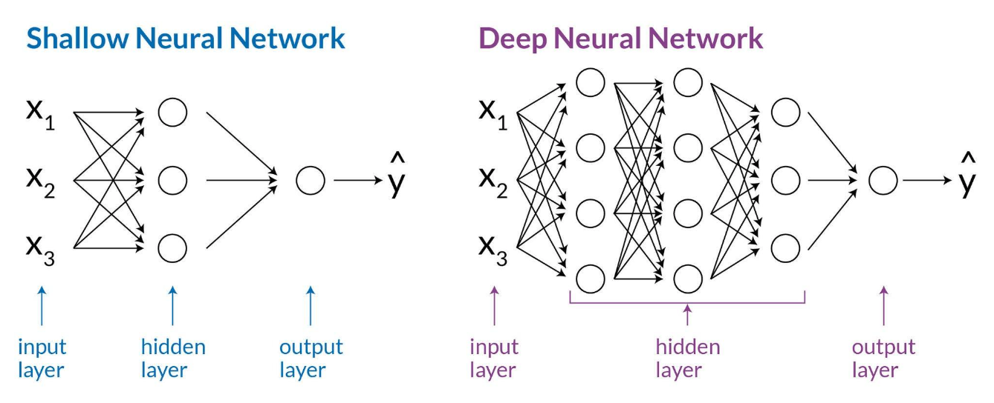
Picture 4: Difference between Shallow and Deep Neural Network

Model Persistence
The train_model.py script encapsulates the full training pipeline and at the end serializes both the fitted TfidfVectorizer and the trained MLPClassifier into a single Python dictionary, which is written to model.pkl using pickle. Bundling the vectorizer with the model ensures that any text passed to the model during inference is transformed using the exact same vocabulary and IDF weights that were used during training, preventing any feature mismatch. The app.py script loads model.pkl at startup using Streamlit’s @st.cache_resource decorator, which prevents the file from being reloaded on every user interaction.

Streamlit Web Application
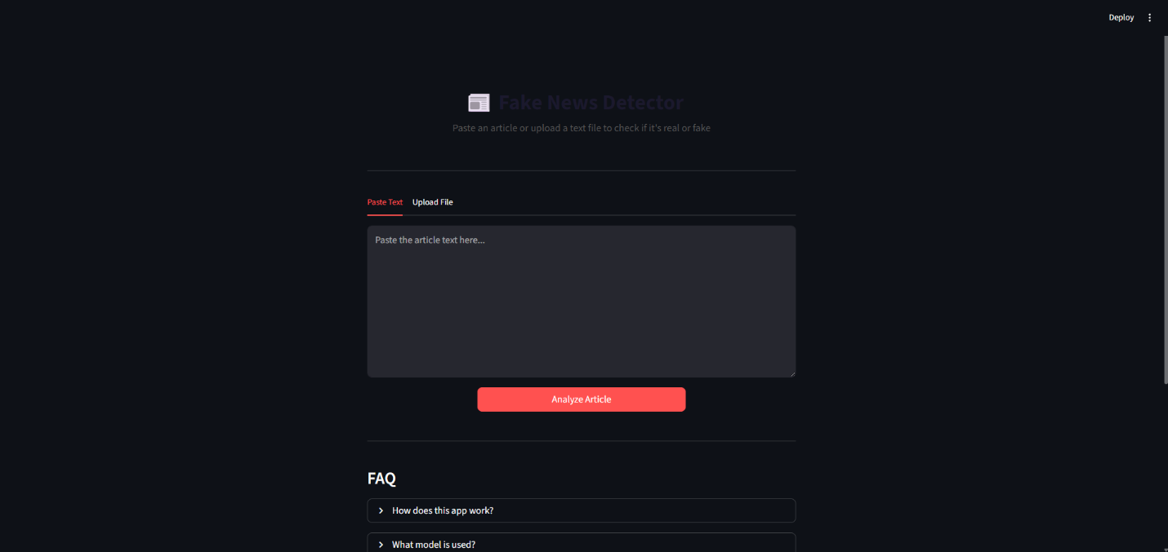
The app.py file implements a Streamlit web application with two input modes available through tabs: the user can either paste article text directly into a text area, or upload a plain text file (.txt). Once text is provided and the Analyze Article button is clicked, the app cleans the text, transforms it using the loaded vectorizer, and calls model.predict() and model.predict_proba() to obtain the classification and probability scores. Results are displayed in a color-coded card (green for REAL, red for FAKE), with the confidence percentage and a visual probability bar showing the split between real and fake probabilities. An expandable Details panel shows word count, model type, and feature configuration. A collapsible FAQ section explains the system’s workings to non-technical users.
Picture 5: Home Page of the Application

User Interface and User Experience
The interface uses custom CSS injected via st.markdown to create a polished visual style. The header displays a newspaper emoji and a subtitle. Results are presented with a gradient background card that changes color depending on the verdict. The probability bar uses two colored segments (green for real, red for fake) with inline percentage labels, giving the user an immediate visual sense of model confidence. Input validation is handled within the app: a warning is displayed if no text is provided or if the input is fewer than five words, preventing meaningless predictions on trivially short strings.

Design Patterns and Architectural Decisions
Separation of concerns is a key design principle. Training is decoupled from inference: fake_news_detector.py is an exploratory research script, train_model.py is the production training pipeline, and app.py is the serving layer. This allows the model to be retrained and updated without modifying the application. The clean_text() function is defined identically in all three files, ensuring consistent preprocessing. Streamlit’s @st.cache_resource caching prevents repeated disk reads. The predict() function returns a structured dictionary rather than raw model outputs, making the app code more readable and maintainable.

Performance and Results
All three classifiers achieve high accuracy on the Kaggle dataset, which is considered a relatively clean and well-separated benchmark. The shallow MLP, while limited to 20 training iterations, demonstrates competitive performance against Logistic Regression and Naive Bayes. Logistic Regression is typically the strongest performer on TF-IDF features for this dataset due to its effectiveness with high-dimensional sparse linear problems. Naive Bayes, while fast, is the weakest of the three due to its strong independence assumption. Confusion matrices confirm that all models have low false positive and false negative rates. The generated confusion_matrices.png provides a visual summary of these results.
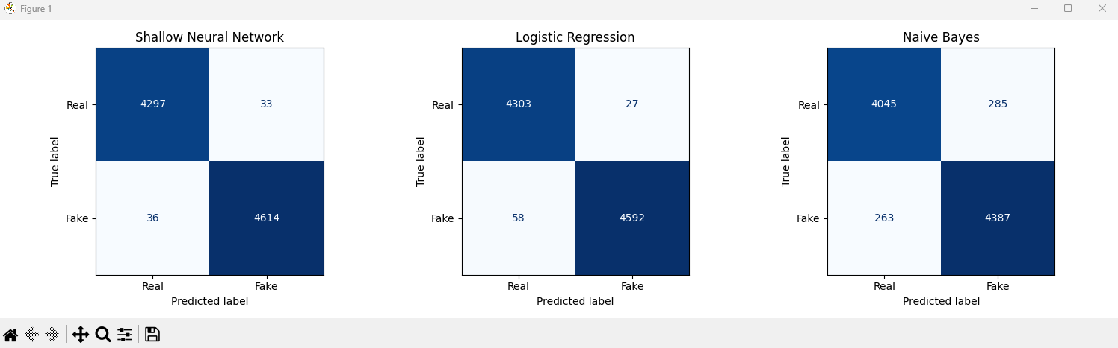
Picture 6: Confusion Matrices

Security and Best Practices
The dataset CSV files and the model.pkl file are excluded from version control via .gitignore, preventing large binary files and potentially licensed data from being committed to the public repository. No API keys, credentials, or sensitive user data are handled by the application. Input text from users is processed entirely in memory and is never stored. The app performs basic length validation before calling the model, reducing the risk of malformed inputs causing unexpected behavior.

Limitations and Challenges
- Dataset bias: The Kaggle dataset is a static, curated benchmark. The model may not generalize well to current news topics, different languages, or more subtle forms of misinformation not represented in the training data.
- No automated testing: The project relies entirely on held-out test set evaluation and manual inspection. There are no unit tests or integration tests for the preprocessing pipeline or the web application.
- Limited MLP training: With only 20 iterations, the MLP may not converge to its optimal solution. Further tuning of hyperparameters (hidden layer size, learning rate, number of epochs) could improve performance.
- No user authentication or multi-user support: The application is designed for single-user local deployment and does not support concurrent users or session management.
- Interpretability: The MLP model is a black box; users cannot easily understand which words or phrases contributed to the classification. More interpretable models (e.g., Logistic Regression with feature weights) or explainability tools (e.g., LIME, SHAP) would improve transparency.

Conclusion

Summary of Achievements
This project successfully delivered a complete end-to-end fake news detection system. A full machine learning pipeline was implemented covering data loading, text preprocessing, TF-IDF feature extraction, model training, and evaluation. Three classifiers were trained and compared, with confusion matrix visualizations generated to support analysis. The trained MLP model and its vectorizer were serialized for deployment. A polished, interactive Streamlit web application was built, allowing users to analyze news text in real time with confidence scores and visual feedback. The codebase is clean, modular, and well-documented, with a clear separation between the training and serving components.

Lessons Learned
Several important lessons emerged from the development process. Consistent preprocessing between training and inference is critical: any deviation in how text is cleaned or vectorized at prediction time will degrade model accuracy. Bundling the vectorizer with the model in the same pickle file was a practical solution to this challenge. The choice of TF-IDF over raw word counts provided meaningful improvements by reducing the influence of common but uninformative terms. Logistic Regression proved surprisingly competitive with the neural network on this dataset, reinforcing that classic linear models remain strong baselines for structured text classification tasks. Finally, Streamlit proved to be an extremely productive framework for building a professional-looking web interface with minimal front-end complexity, making it an excellent choice for rapid AI application prototyping.

Recommendations for Future Development
- Deep learning models: Experimenting with transformer-based models such as BERT or RoBERTa could significantly improve classification accuracy, particularly for more nuanced or stylistically similar real and fake articles.
- Explainability: Integrating LIME or SHAP would allow users to see which words most influenced a prediction, making the tool more transparent and trustworthy.
- Live data pipeline: Connecting the system to a live news API (e.g., NewsAPI) would allow real-time analysis of current articles rather than manual copy-pasting.
- Automated testing: Adding pytest-based unit tests for the preprocessing pipeline and integration tests for the inference function would improve reliability and ease future refactoring.
- Cloud deployment: Deploying the Streamlit application on a cloud platform (e.g., Streamlit Community Cloud, Heroku, or AWS) would make it publicly accessible without requiring users to run it locally.
- Multilingual support: Extending the system to handle non-English articles through multilingual embeddings or separate language-specific models would broaden its applicability.

References

Documentations
scikit-learn Documentation: https://scikit-learn.org/stable/documentation.html
Streamlit Documentation: https://docs.streamlit.io
pandas Documentation: https://pandas.pydata.org/docs/
matplotlib Documentation: https://matplotlib.org/stable/contents.html
Kaggle Fake and Real News Dataset: https://www.kaggle.com/datasets/clmentbisaillon/fake-and-real-news-dataset
Python pickle module: https://docs.python.org/3/library/pickle.html
GitHub Repository: https://github.com/alden187/cs404

Appendices

Complete Code Listing
The complete source code for this project is available in the GitHub repository at https://github.com/alden187/cs404 . The repository contains three Python source files (fake_news_detector.py, train_model.py, app.py), a requirements.txt, and a .gitignore. To run the project, first install dependencies with pip install -r requirements.txt, then place the Kaggle dataset CSV files in a data/ subdirectory, run python train_model.py to train and save the model, and finally launch the web application with streamlit run app.py.

User Guide
Analyzing an Article by Pasting Text
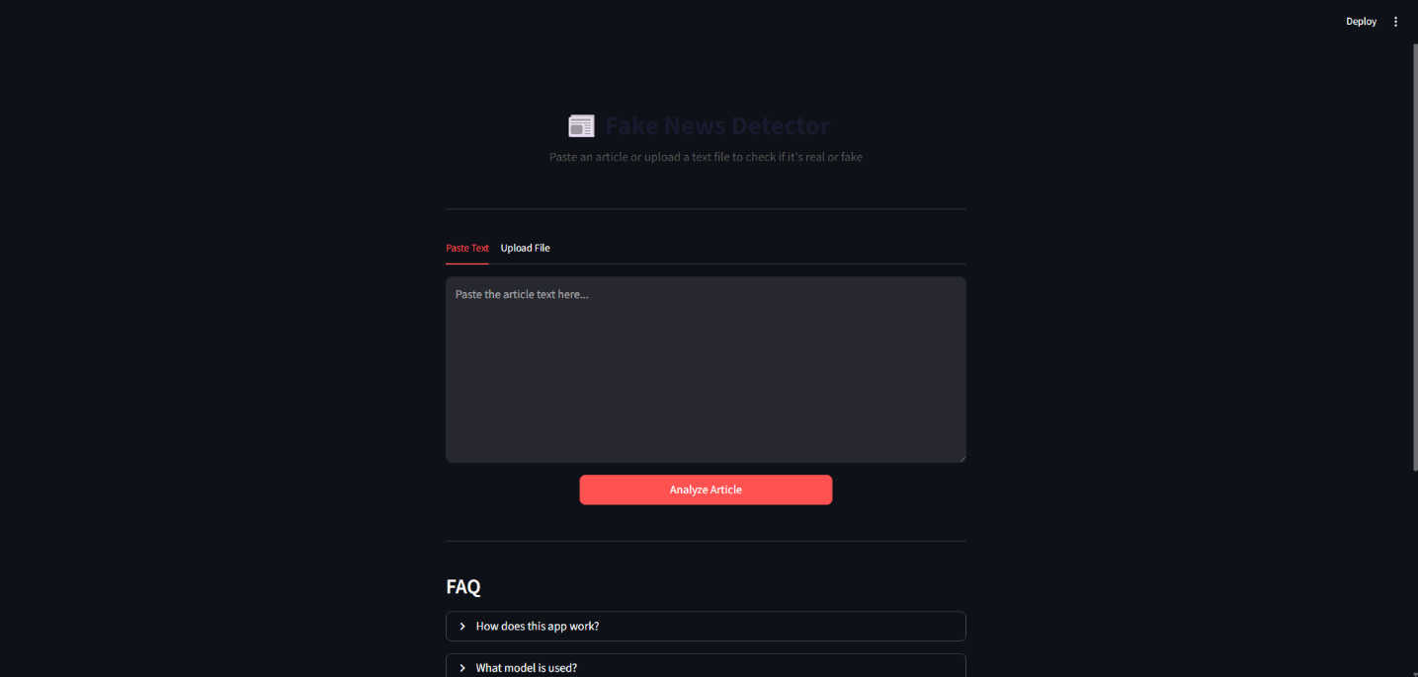
Open the application in your browser (typically at http://localhost:8501 after running streamlit run app.py). On the main page, select the Paste Text tab. Copy and paste the full article text into the text area. Click the Analyze Article button. The result card will display either REAL or FAKE along with a confidence percentage and a probability breakdown bar.
Picture 7: Using the Paste Text Option

Analyzing an Article by Uploading a File

Select the Upload File tab. Click the file uploader and select a .txt file containing the article. A preview of the file contents will appear. Click Analyze Article to receive the classification result.
Picture 8: Using the Upload Article Option

Understanding the Results
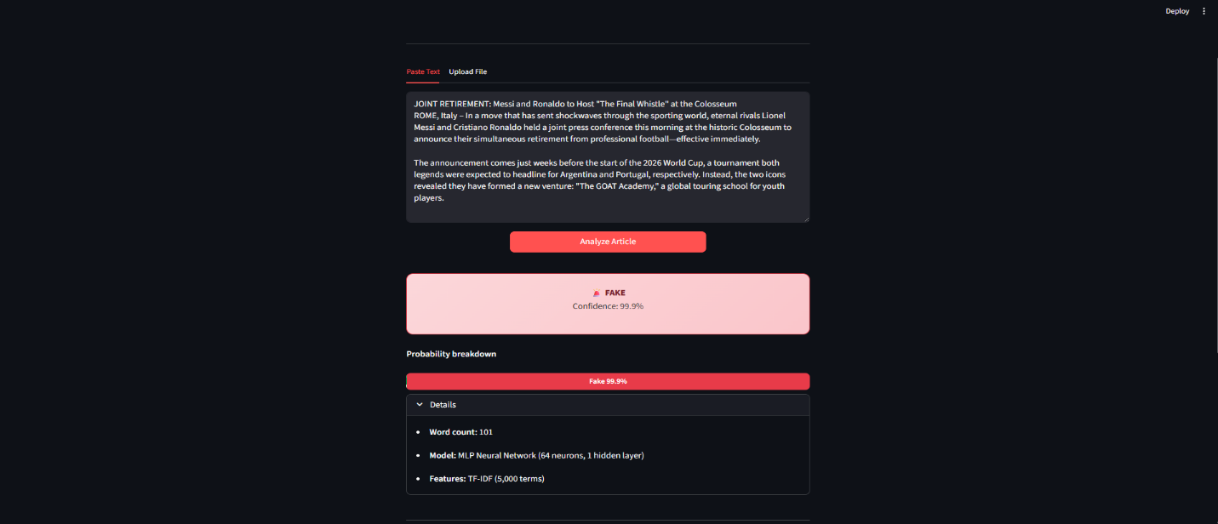
A green card with a ✅ icon indicates the article was classified as REAL. A red card with a 🚨 icon indicates FAKE. The confidence percentage shows how certain the model is of its prediction. The probability bar shows the split between the real and fake probabilities. Click Details to see word count, model name, and feature configuration. The FAQ section at the bottom explains how the system works in plain language.
Tips
Provide the full article text rather than a headline alone for more reliable predictions. Inputs of fewer than five words will trigger a warning and will not be analyzed. Always apply critical thinking alongside the model’s output — no automated classifier is infallible.
The application also features a Dark/Light mode, as well as Rerun, Auto-Rerun toggle, Clear cache, Print and Record Screen as additional options.

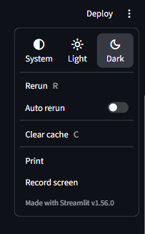
Picture 9: Additional Options

