Alden Kane

CSE 40535

Dr. Adam Czajka

12 December 2019

CSE 40535 Semester Project: Deliverable 3

**Project Objective:** DDS (Drowning Detection System) - Detection of swimmers from an underwater camera in a swimming pool.

**Project Application:** Drowning detection utility for autonomous lifeguarding, monitoring of pools with no lifeguards (e.g. apartments, hotels, fitness centers), and redundancy of human lifeguards.

**1. Report**

1. **Description of Test Database**

The test database is comprised of approximately 25 minutes (4.30 GB) of underwater footage, collected by me on a GoPro Hero 7 Black at Notre Dame’s Rockne Memorial pool.

I collected the train and validation databases at Notre Dame’s Rolf’s Aquatic Center. With the test database, I wanted to test the robustness of DDS to changes in local conditions (e.g. pool illumination, depth, shape, etc.). Rolf’s Aquatic Center and Rockne Memorial vary heavily in local conditions –– this will be relevant to my commentary of the accuracy of DDS. This will be sufficient to measure DDS’s ability to generalize between pools –– as someone that has swam in countless distinct indoor pools in my lifetime, Rolf’s represents the upper quartile of pool illumination, while Rockne Memorial Represents the lower quartile of pool illumination.

In Deliverable 2, I mentioned that I intended to test DDS on swimmers of different skin pigments to measure the robustness of the color detection feature. I was not able to find any good test subjects, as my friends were getting busy with end-of-term work. I only tested on myself for Deliverable 3. Testing on myself at Rockne Memorial gives a better picture of how DDS performance degrades with local conditions, as I was the primary test subject in the train and validation databases. However, if I were to test varying skin pigment, it would be best to perform this test at Rolf’s Aquatic Center to give a more accurate description of how DDS performance varies with swimmer skin pigment –– I wouldn’t want to perturb two variables (swimmer skin pigment, pool conditions) at a time without first knowing how perturbations to each variable affect the system.

1. **Classification Accuracy of Test Set:**

Accuracy for DDS was defined by the calculation of Intersection over Union (IoU) for random samples from the test set.

For three test videos, 30 frames were random selected and written to a file. I then drew ground truth bounding boxes in Preview, such that I could calculate the intersection over union of each video. I defined the ground truth bounding box as the smallest bounding box that encompasses the whole swimmer. As all videos were of length 30s and filmed at 30 FPS, my script was choosing 30 frames at random from 900 frames per video. The IoU was only calculated for selected frames that had swimmers in them.

These methods mirror those used in Deliverable 2.

For the test set, I observed a mean IoU of 0.525 with a standard deviation of 0.196 (0.525 ± 0.196). The three training samples that I calculated IoU for had means and standard deviations of 0.501 ± 0.196, 0.466 ± 0.077, and 0.599 ± 0.158.

A tabulation of the IoU for the test videos is shown below, in Table 1:

**Table 1.** IoU for Test

|  |  |  |  |  |
| --- | --- | --- | --- | --- |
| **Data Set** | **Video 1 IoU** | **Video 2 IoU** | **Video 3 IoU** | **Overall IoU** |
| **Test** | 0.501 ± 0.196 | 0.466 ± 0.077 | 0.599 ± 0.158 | 0.525 ± 0.161 |

Below are samples that have IoUs roughly one standard deviation above the mean, close to the mean, and one standard deviation below the mean:

**Figure 9.** IoU about 1 STDEV above Mean, IoU = 0.680

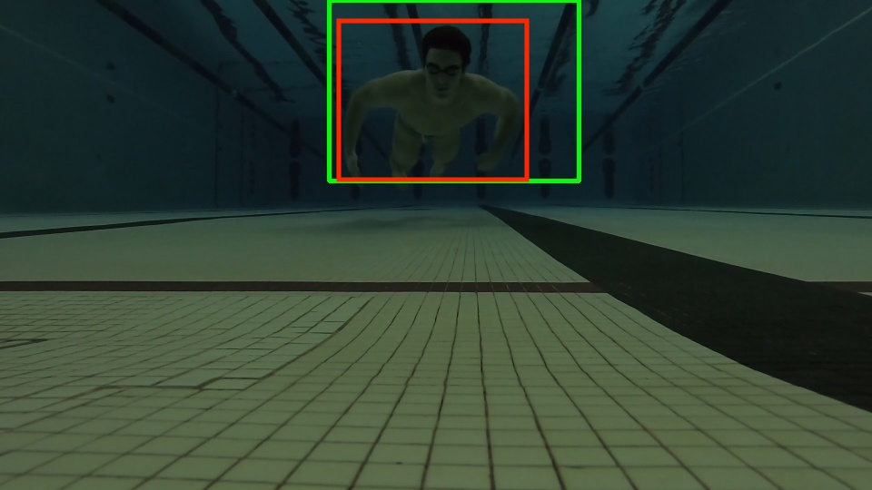

**Figure 10.** IoU Close to Mean, IoU = 0.542

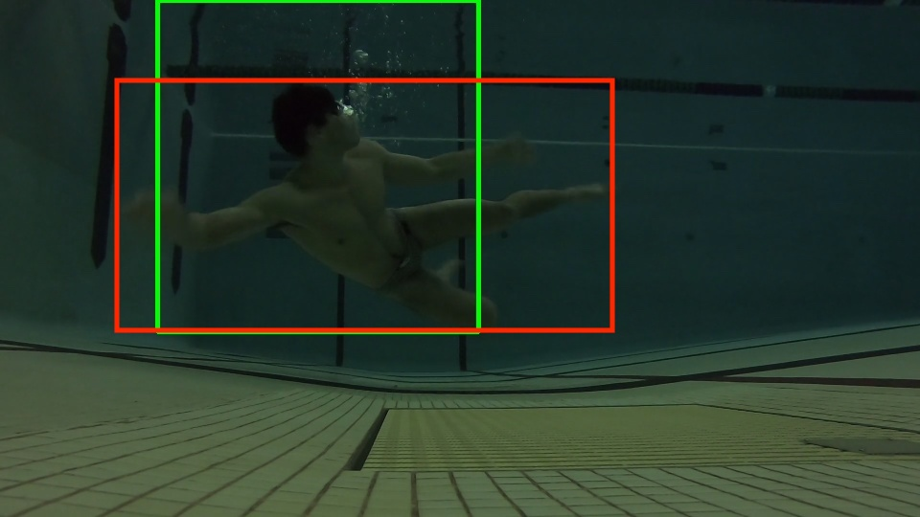

**Figure 11.** IoU about 1 STDEV below Mean, IoU = 0.386

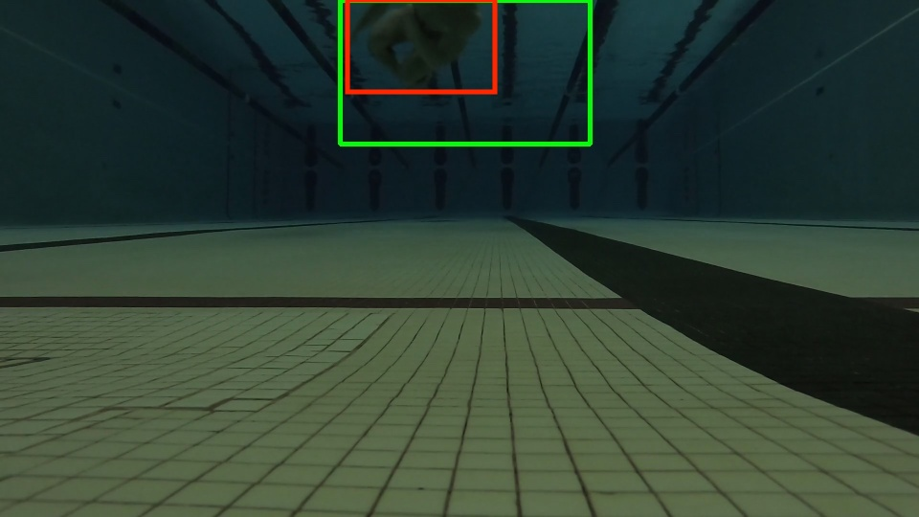

All calculations for the accuracy of DDS can be found in deliverable_3 <

int_Over_Union_accuracy.xlsx. My IoU datasets were not uploaded due to

size, but are available upon request.

1. **Commentary on Accuracy**

In Table 2, the IoU of DDS is shown for the test, train, and validation datasets and can be seen to decrease significantly from the validation/train datasets to the test dataset.

**Table 2.** Comparison of IoUs for Test, Validation, Train

|  |  |  |  |  |
| --- | --- | --- | --- | --- |
| **Data Set** | **Video 1 IoU** | **Video 2 IoU** | **Video 3 IoU** | **Overall IoU** |
| **Test** | 0.501 ± 0.196 | 0.466 ± 0.077 | 0.599 ± 0.158 | 0.525 ± 0.161 |
| **Validation** | 0.846 ± 0.118 | 0.781 ± 0.108 | 0.782 ± 0.151 | 0.797 ± 0.134 |
| **Train** | 0.813 ± 0.128 | 0.840 ± 0.110 | 0.812 ± 0.089 | 0.825 ± 0.111 |

As expected, the accuracy of DDS degraded as the pool was changed. The primary reason that this occurred was due to a poor response from the color detection feature, as illustrated by Figure 4:

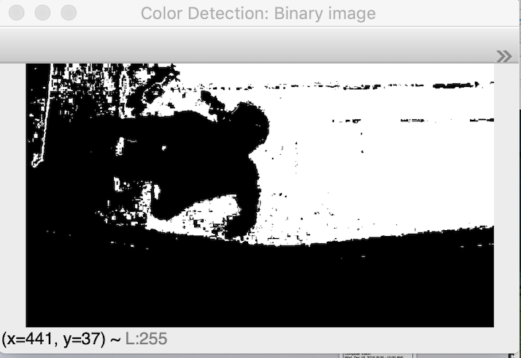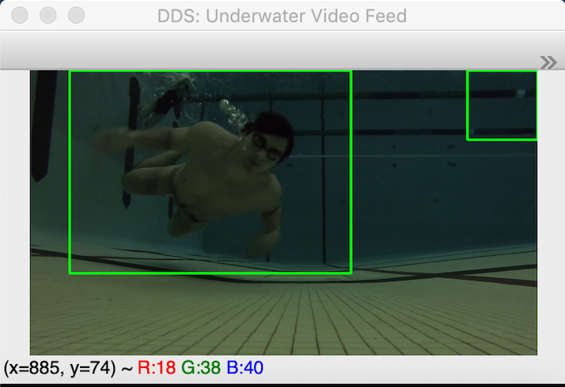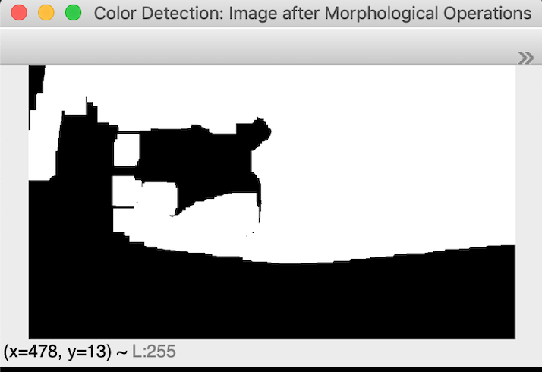

**Figure 4.** Color Detection Feature at Rockne Memorial

Figure 4 demonstrates that due to the drastic variations in illumination between Rockne Memorial and Rolf’s Aquatic Center, the color detection feature does not recognize my HSV profile well. Rather, it detects the back wall of the pool to be a human skin tone (as these were tuned with data collected at Rolf’s Aquatic Center and from YouTube underwater hockey games). However, the motion detection feature saves the functionality of the system and still provides a decent classification (although there is a false positive box here).

Rockne Memorial was built in 1937 and lacks bright overhead lighting, unlike many pools. As a result, the water is darker and all colors are muted. In contrast, Rolf’s Aquatic Center was constructed in 1985 and has excellent overhead illumination that penetrates the surface of the water, creating clear water. Rolf’s Aquatic Center is more representative of most pools used today, in terms of water clarity and hue. A contrast between conditions in the two pools is shown in Figure 5:

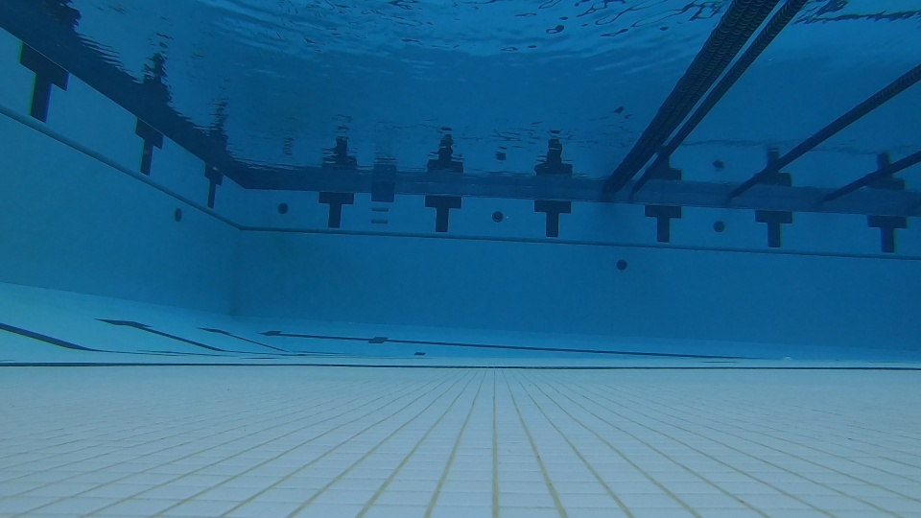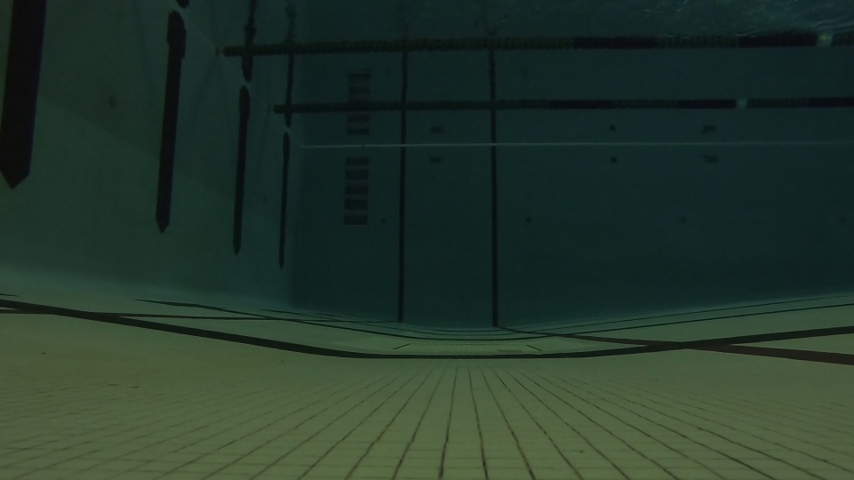

**Figure 5.** Illumination at Rolf’s (Left) and Rockne Memorial (Right)

To improve the performance of the system, I could add additional features to DDS and create a majority voting system to classify swimmers. Integrating a neural network as the third feature is the logical next step; I expect this would improve DDS’s performance and ability to generalize.

Moreover, I could maintain the architecture of DDS, but locally tune it to pool conditions. If I were a systems engineer deploying DDS in pools, this would be sensible. I would want to collect the HSV profiles of a wide swath (50-100) different swimmers in the pool DDS is being implemented in, and then change the HSV values in uw_swimmer_detection.py based on this information. This would improve DDS’s performance in a specific pool, but not its ability to generalize. Also, this solution is only relevant to pools where the illumination is constant –– to expand the market of DDS to outdoor pools, where the illumination varies with the time of day, additional features would provide better system performance.

Overall, DDS appears to have a professional feel and look when run with the train and validation sets. Boxes are usually stable with a good IoU. However, drastic changes in pool conditions, as seen in the test set, causes oscillating boxes, false positives, false negatives, and a worse IoU.

I believe that future work on DDS could drastically improve its ability to generalize, ultimately creating a system that is ready to deploy as a redundant lifeguard for pools.

1. **Presentation**

Video demonstration of DDS is housed on YouTube at: <https://www.youtube.com/watch?v=dr5E5heM_BU&t=45s>