

**BUSINESS CASES FOR DATA SCIENCE**

**MASTER DEGREE PROGRAM IN DATA SCIENCE AND ADVANCED ANALYTICS**

BUSINESS CASE 3

Gift-A-Lot

Recommender System

GROUP I

Emanuele Aldera, m20210617

Robin Schmidt, m20210602

Muhammad Abdullah, m20210655

Rui Ramos, m20210640

**INDEX**

Summary

1. Introduction and Business Understanding 3

2. Data Exploration 4

3. Data Transformation 6

4. Basket Market Analysis 6

4.1. Association rules 6

4.2. Association Rules Metrics 7

4.3. Apriori Algorithm 7

4.4. United Kingdom 7

4.5. Netherlands 8

4.6. Italy 8

5. Recommender Systems 9

5.1. Train Test Split 9

5.2. Popularity Model as Baseline 9

5.3. Collaborative Filtering Model 9

6. Evaluation 10

7. Deployment 11

# Introduction and Business Understanding

With the growing volume of online information, recommender systems have been an effective strategy to overcome information overload.

The utility of recommender systems cannot be overstated, given their widespread adoption in many web applications, along with their potential impact to ameliorate many problems related to over-choice.   These choices can really make a difference and lead to an increase in sales. As an example, 35% of Amazon sales come from recommendations.

With the data, the company expects us to produce a recommender system that can facilitate user choices by recommending items that the user likes and enhances user experience when making purchases on its website.

Gift-a-Lot is a UK-based and registered non-store online retailer with about 80 members of staff. The company was established in 1981, selling unique all-occasion gifts.

For this project we received a dataset with 542K observations and 8 features characterizing the invoice by customer and country with timeline date, quantity, unit price and product description, from the company “Gift a lot” that contract our company to help them to build a recommender system.

The following ABC analysis was constructed to help understand which products were the most important ones and proved to be profitable for the company, we can see that around the 80% of the profits made by the company via web purchases regard only 844 products.

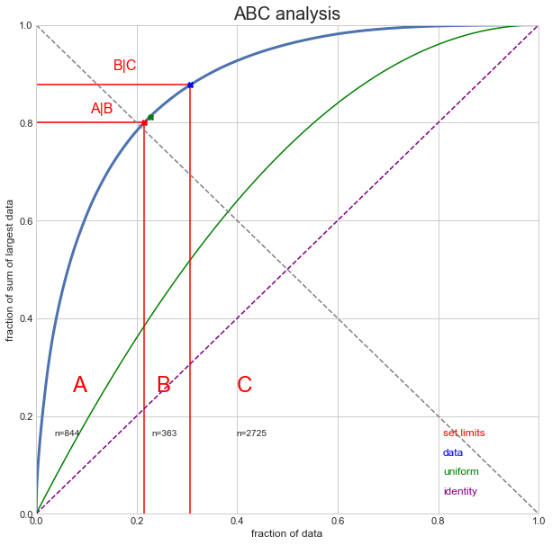

By doing the same analysis for customers, we can conclude that around 75% of the same profits regard only 900 customers; this second analysis, however, is less accurate since, as it will be shown in the later chapters, we have some missing values regarding customers.

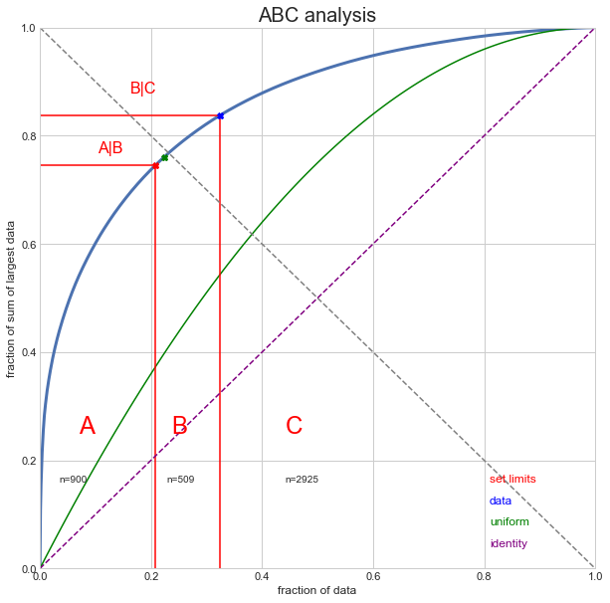

# Data Exploration

The dataset contained 541909 rows and 8 rows: 2 of them are float variables (“*UnitPrice*” and “*CustomerID*”), 5 are string variables (“*InvoiceNo*”, “*StockCode*”, “*Description*”, “*InvoiceDate*” and “*Country*”) while the last variable, “Quantity”, is an int64 type.

Analysing the data, we could see that the data recorded for two years transactions, 2010 & 2011 respectively, we found the transactions to be in 38 countries 4223 types of products and 4372 customers.

Visualizing the sales by country we understand that we could cluster the countries by sales performance, to simplify the process we could simply compare the purchase behaviors and access the segments. However, for this case we had a high discrepancy between countries and their total sales, so another approach could be comparing sales evolution.

When we compare sales by year we have a distinct perspective, with the histogram we can see that our biggest country in sales is UK which has a flat evolution. This could be investigated and implemented in the recommender analysis. If we could add good recommendations to the country with more sales, certainly it would impact and drive the sales positively.

Also, the relevant countries with low sales but with a good increasing sales ratio like Australia, Channel Islands, Italy, Eire, and Norway will be insightful to further explore. It can be very opportunistic if the company is able to drive the growth of sales by implementing the recommender system. Netherlands too could be an interesting target and contributor towards the growth, if we understand and capitalize on what kind of products to recommend. Contrarily, for a few other countries which had a growth in sales like Cyprus, France, and Switzerland, we noted that the growth in sales ratio was low. For a starting point we will analyse 3 to 4 countries.

Our dataset also presents many canceled orders: they can be found by filtering by negative *Quantity*, and the invoice Number contains a “C” character. In total we found 9200 canceled records, corresponding to 3754 different invoices. To understand the dataset consistency, we checked whether for a cancelation there would be also the record of the order before it was canceled, realizing this was not the case.

After exploring the missing values within the dataset, we found out that only two variables; *CustomerID* and *Description* had missing entries of 133274 and 592, respectively. We tried to recover some values using the invoice number, however invoices containing missing values for the *CustomerID* had a missing value for all records.

After checking the dataset consistency, each invoice must contain only one unique *CustomerID*, we also checked whether for each product (*StockCode*) only one description was allocated; the result shows how some products contain different descriptions. After exploring those differences in descriptions, however, it was decided not to take care of this issue given the nature of the different descriptions; from now on we would consider products with the same Stock Code to be equal.

Furthermore, we found some Stock Codes not related to actual products: they could be filtered since the length of the string was less than 5 digits. In addition to that, 1163 records related to 675 products having *UnitPrice* equal to 0.

By checking duplicated records on the subset of *InvoiceNo* and *StockCode*, around 2.02% of records would appear as duplicated, meaning that for some invoices the ordered products would appear singularly instead of adding up on the *Quantity* variable.

# Data Transformation

Starting from our original dataset, we created some features to better understand purchasing behaviours from the customers. We focused especially on getting information regarding the invoice’s date: first we cast the *InvoiceDate* to *datetime* type, and after we created variables such as *Year, Month, Day, Weekday, WeekdayName, IsWeekend, Time, Hour* and *Daytime* (this last one has 6 unique values corresponding to what period of the day it is : 'Late Night', 'Early Morning', 'Morning', 'Noon', 'Eve', 'Night').

Cancelations were removed from our dataset before applying the models since the orders they could create a bias. Stock codes not related to products were also removed from the dataset.

Duplicated records on the subset *InvoiceNo* and *StockCode* were grouped together into a single record containing the sum of all individual quantities. After having done that, the variable *TotalPrice* was added for containing the product of *Quantity* and *UnitPrice.* A similar variable, *Sales,* was created before all feature engineering to have a look into information for Business Understanding.

We also decided to reduce the cardinality of the variable *Country,* by grouping the ones appearing in less than 500 records into a “Others” category.

# Basket Market Analysis

## Association rules

The applications of Association Rule Mining are found in Market Basket Analysis, which is a key technic used by large retailers like Amazon, to analyze customer buying habits by finding associations between the different items that customers place in their “shopping baskets”.

Taking in account the big differences in sales from countries and to give some perspective outside UK the main country we also select Netherlands and Italy to apply this technique.

There is a difference between association rules and Recommendation that we need to have in account, but they could be seen as complementary.

Association rules doesn’t extract an individual’s preference, rather find relationships between sets of elements of every distinct transaction.

## Association Rules Metrics

#### *'support' 🡪 How frequently the combination occurs*

support(A→C)=support(A∪C),range: [0,1]

#### *'confidence' 🡪 The strength of an association*

confidence(A→C)=support(A→C)support(A),range: [0,1]

#### *'lift' 🡪 Increase in the sale of A when you sell B*

lift(A→C)=confidence(A→C)support(C),range: [0,∞]

## Apriori Algorithm

To implement the apriori algorithm we used the mlxtend library, and here are the following steps we took:

1. Group by country
2. Create a matrix to understand which products are bought together for each invoice
3. We tested the algorithm with two levels of minimum support: 0.05 and 0.03
4. For the lift metric the min threshold consider was 1 (100% confidence)
5. Sort values by high confidence and lift to see the products who are more often bought together and the opposite for substitutes.

## United Kingdom

Table 1 – UK products with higher confidence and lift (Complementary)

We can consider logical this associations because of the English culture of drinking tea, they bought together Teacup and saucer of different colors maybe to be able to serve the tea with different sets each day or in specific occasions.

Table 2 – UK products with Lower confidence and lift (Substitutes)

## Netherlands

Table 3 – Netherlands products with higher confidence and lift (Complementary)

In the Netherlands we see association between card Dolly girl food container and space boy pen products of primary school it seems logical that they are bought together. Graphical user interface, text, application
Table 4 – Netherlands products with Lower confidence and lift (substitutes)

## Italy

Table 4 – Italy products with higher confidence and lift

Here we have combinations about chocolate and valentines' gifts that also makes sense taking in account that Italian likes to offer and to show affection. Also, what looks home decoration and Christmas products are the most who are bought together. It shows more mix in their buying behavior in Italy this could identify some important information from marketing perspective.

Table 5 –Netherlands products with Lower confidence and lift (substitutes)

# Recommender Systems

With the growing volume of online information, recommender systems have been an effective strategy to overcome information overload.

The utility of recommender systems cannot be overstated, given their widespread adoption in many web applications, along with their potential impact to ameliorate many problems related to over-choice.

## Train Test Split

Splitting the data into training and testing sets is an important part for evaluating our predictive collaborative filtering models. We used an 80:20 ratio for our train-test set size. Our training portion will be used to develop a predictive model, while the other to evaluate the model’s performance.

## Popularity Model as Baseline

The popularity model takes the most popular items for recommendation. These items are products with the highest number of sells across customers. Three different approaches were chosen and evaluated: the total quantity (purchase_count), the number of transactions (purchase_dummy) and the normalized quantity across users.

## Collaborative Filtering Model

In collaborative filtering, we would recommend items based on how similar users purchase items. For instance, if customer 1 and customer 2 bought similar items, e.g. 1 bought X, Y, Z and 2 bought X, Y, we would recommend an item Z to customer 2. First, we created a user-item matrix, where index values represent unique customer IDs and column values represent unique product IDs. As a next step, we created an item-to-item similarity matrix. The idea is to calculate how similar a product is to another product. We used ‘cosine’ and ‘pearson’ for the similarity measurement. For each customer, we then predict his likelihood to buy a product (or his purchase counts) for products that he had not bought. Again, three different approaches were chosen and evaluated: the total quantity (purchase_count), the number of transactions (purchase_dummy) and the normalized quantity across users (purchase_norm).

# Evaluation

For evaluating recommendation engines, we used the concept of RMSE and precision-recall. The RMSE (Root Mean Squared Errors) measures the error of predicted values and therefore, the lesser the RMSE value, the better the recommendations. The recall indicates what percentage of products that a user buys are actually recommended. If a customer buys 5 products and the recommendation decided to show 3 of them, then the recall is 0.6. The precision indicates how many, out of all the recommended items, the customer actually liked. If 5 products were recommended to the customer out of which he buys 4 of them, then precision is 0.8. The corresponding score tables can be found in the Appendix.

|  |  |  |  |
| --- | --- | --- | --- |
| **Mean Precisicion** | Count | Dummy | Normalized |
| Popularity | 0.000 | 0.002 | 0.000 |
| Cosine | 0.016 | **0.133** | 0.013 |
| Pearson | 0.000 | 0.002 | 0.000 |

|  |  |  |  |
| --- | --- | --- | --- |
| **Mean Recall** | Count | Dummy | Normalized |
| Popularity | 0.000 | 0.001 | 0.000 |
| Cosine | 0.013 | **0.091** | 0.011 |
| Pearson | 0.000 | 0.001 | 0.000 |

**Popularity vs. Collaborative Filtering:** For purchase counts, we observed that collaborative filtering algorithms outperform the popularity model. Indeed, the popularity approach does not provide any personalization, as each user receives the identical list of recommended goods.

**Precision and recall:** Looking at the scores we detected that purchase_dummy > purchase_norm > purchase_count.

**RMSE:** Since RMSE is higher using pearson distance than cosine, we would choose model the smaller mean squared errors, which in this case would be cosine.

Therefore, our final selected model was purchase_dummy with cosine distance.

**Cold Start:** For the Cold Start we selected the outcome of the Popularity Count Engine, which is based on the purchase count of each product. The 20 most popular products are presented in the table below.

|  |  |  |
| --- | --- | --- |
| StockID | Purchase Count | Description |
| 85123A | 2203 | WHITE HANGING HEART T-LIGHT HOLDER |
| 85099B | 2092 | JUMBO BAG RED RETROSPOT |
| 22423 | 1989 | REGENCY CAKESTAND 3 TIER |
| 47566 | 1686 | PARTY BUNTING |
| 20725 | 1565 | LUNCH BAG RED RETROSPOT |
| 84879 | 1455 | ASSORTED COLOUR BIRD ORNAMENT |
| 22197 | 1392 | SMALL POPCORN HOLDER |
| 22720 | 1387 | SET OF 3 CAKE TINS PANTRY DESIGN |
| 21212 | 1320 | PACK OF 72 RETROSPOT CAKE CASES |
| 22383 | 1285 | LUNCH BAG SUKI DESIGN |
| 20727 | 1273 | LUNCH BAG BLACK SKULL. |
| 22457 | 1249 | NATURAL SLATE HEART CHALKBOARD |
| 22386 | 1218 | JUMBO BAG PINK POLKADOT |
| 22469 | 1202 | HEART OF WICKER SMALL |
| 21931 | 1184 | JUMBO STORAGE BAG SUKI |
| 22411 | 1175 | JUMBO SHOPPER VINTAGE RED PAISLEY |
| 22961 | 1162 | JAM MAKING SET PRINTED |
| 22086 | 1160 | PAPER CHAIN KIT 50'S CHRISTMAS |
| 22382 | 1157 | LUNCH BAG SPACEBOY DESIGN |
| 20728 | 1150 | LUNCH BAG CARS BLUE |

# Deployment

After having analyzed in depth the market basket analysis and the different recommender systems, it is now important to understand how these models can be deployed to be able to create some value to the company Gift-A-Lot.

The objective of the company is to build a recommender system that can facilitate user choices by recommending items the user likes and improve user experience when making purchases on its website.

To do that, we strongly suggest to the company to change their website to be able to add the recommendations engine; after the customer has added to the virtual basket the items he’s interested in and before the payment website, a page will appear with the items the engine recommends for that specific order. It is important that we combine Market Basket Analysis together with the Recommender Systems; by doing that, we can suggest complementary products and avoid substitute products to the ones in the basket and aggregate this information with the one provided us by the engine.

These models allow us also a way to interact and hopefully re-attract customers by sending them suggestions of items they might be interested in, based on their purchasing history, via e-mail; in some cases, we can offer them a small discount to encourage them to purchase the items we are suggesting them.

The models will keep improving themselves after each purchase, meaning that with time they’ll keep being more accurate and providing more insights and value to the company.

We are confident that deploying these models will have positive benefits to the company since it will increase sales. This will come with some challenges and costs however: first of all, the cost of maintaining those models and changing the front end of the website. On top of that, the challenge of “cold start” also must be addressed: what can we suggest to new customers we don’t have information about? We suggest a two-way approach: when a costumer signs up to the website, it is presented a page in which there’s a list of keywords and he can select the ones he’s most interested in; a similar approach is taken for example by some streaming platform, such as Netflix, to have a general idea of the customer’s preferences. It is important that this questionnaire to fill is very simple and fast to not lose customer’s interest. If the customer decides to fill this information, the suggestions will be suited to the keywords he selected; after the customer has made some sales, we’ll be able to suggest him products more suited to him/her. In the case the customer decides to skip the questionnaire, the suggestions to face the cold start problem will be a mix of the most popular products and the ones that are more profitable to the company.

1. **Appendix**

Figure 1 Scores Count Popularity

Figure 2 Scores Count Cosine

Figure 3 Scores Count Pearson

Figure 4 Score Dummy Population

Figure 5 Scores Dummy Cosine

Figure 6 Scores Dummy Pearson

Figure 7 Scores Norm Popularity

Figure 8 Scores Norm Cosine

Figure 9 Scores Norm Pearson