HURUF “O” | Ovaldy | 161111062

1. #include <windows.h>
2. #include "GL/glut.h"
3. #include "math.h"

6. **void** initGL()
7. {
8. glClearColor(1.0f, 1.0f, 1.0f, 1.0f);
9. glClearDepth(1.0f);
10. glEnable(GL_DEPTH_TEST);
11. glDepthFunc(GL_LEQUAL);
12. glShadeModel(GL_SMOOTH);
13. glHint(GL_PERSPECTIVE_CORRECTION_HINT, GL_NICEST);
14. }
16. **void** timer(**int** value)
17. {
18. glutPostRedisplay();
19. glutTimerFunc(15, timer, 0);
20. }
22. **void** reshape(GLsizei width, GLsizei height)
23. {
24. **if** (height == 0)
25. height = 1;
26. GLfloat aspect = (GLfloat)width / (GLfloat)height;
27. glViewport(0, 0, width, height);
28. glMatrixMode(GL_PROJECTION);
29. glLoadIdentity();
30. gluPerspective(45.0f, aspect, 0.1f, 100.0f);
31. }
33. **void** display()
34. {
35. glClear(GL_COLOR_BUFFER_BIT | GL_DEPTH_BUFFER_BIT);
36. glMatrixMode(GL_MODELVIEW);
37. glLoadIdentity();
39. glTranslatef(0.0, 0.0, -6.0);
40. glBegin(GL_LINES);
41. glColor3f(1,0,0);// red
42. glVertex3f(1,1.5,0);
43. glVertex3f(-1,1.5,0);
45. glVertex3f(-1,1.5,0);
46. glVertex3f(-1,-0.5,0);
48. glVertex3f(-1,-0.5,0);
49. glVertex3f(1,-0.5,0);
51. glVertex3f(1,-0.5,0);
52. glVertex3f(1,1.5,0);
54. glVertex3f(0.5,1,0);
55. glVertex3f(-0.5,1,0);
57. glVertex3f(-0.5,1,0);
58. glVertex3f(-0.5,0,0);
60. glVertex3f(-0.5,0,0);
61. glVertex3f(0.5,0,0);
63. glVertex3f(0.5,0,0);
64. glVertex3f(0.5,1,0);
65. glEnd();
67. glFlush();
68. glutSwapBuffers();
69. }
71. **int** main(**int** argc, **char** **argv)
72. {
73. glutInit(&argc, argv);
74. glutInitDisplayMode(GLUT_DOUBLE | GLUT_DEPTH);
75. glutInitWindowSize(640, 480);
76. glutInitWindowPosition(50, 50);
77. glutCreateWindow("praktikum 1");
78. glutDisplayFunc(display);
79. glutReshapeFunc(reshape);
80. initGL();
81. glutTimerFunc(0, timer, 0);
82. glutMainLoop();
83. **return** 0;
84. }

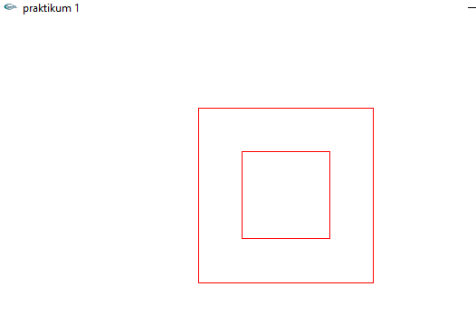

GL LINE STRIP “O”

1. glBegin(GL_LINE_STRIP);
2. glColor3f(1,0,0);// red
3. glVertex3f(1,1.5,0);
4. glVertex3f(-1,1.5,0);
5. glVertex3f(-1,-0.5,0);
6. glVertex3f(1,-0.5,0);
7. glVertex3f(1,1.5,0);
9. glVertex3f(0.5,1,0);
10. glVertex3f(-0.5,1,0);
11. glVertex3f(-0.5,0,0);
12. glVertex3f(0.5,0,0);
13. glVertex3f(0.5,1,0);
14. glEnd();

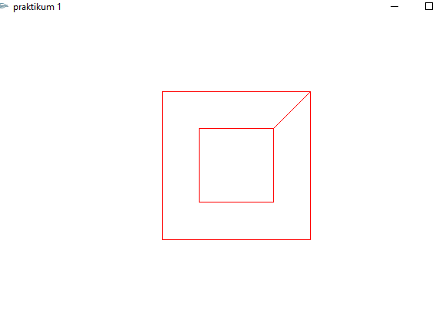

GL Line Loop “O”

1. glBegin(GL_LINE_LOOP);
2. glColor3f(1,0,0);// red
3. glVertex3f(1,1.5,0);
4. glVertex3f(-1,1.5,0);
5. glVertex3f(-1,-0.5,0);
6. glVertex3f(1,-0.5,0);

9. glEnd();
10. glBegin(GL_LINE_LOOP);
11. glColor3f(1,0,0);// red
12. glVertex3f(0.5,1,0);
13. glVertex3f(-0.5,1,0);
14. glVertex3f(-0.5,0,0);
15. glVertex3f(0.5,0,0);
16. glVertex3f(0.5,1,0);
18. glEnd();

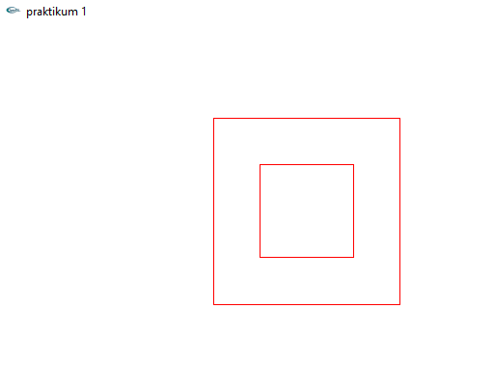

Perbedaan GL_LINE, GL_LINE_STRIP, GL_LINE_LOOP

1. glTranslatef(0.0, 0.0, -6.0);
2. glBegin(GL_LINES);
3. glColor3f(1,0,0);// red
4. glVertex3f(1,1.5,0);
5. glVertex3f(-1,1.5,0);
7. glVertex3f(-1,1.5,0);
8. glVertex3f(-1,-0.5,0);
10. glVertex3f(-1,-0.5,0);
11. glVertex3f(1,-0.5,0);
13. glVertex3f(1,-0.5,0);
14. glVertex3f(1,1.5,0);
15. //HARUS MEMASANGKAN 2 TITIK
16. glEnd();
17. glTranslatef(0.0, 0.0, 0.0);
18. glBegin(GL_LINE_LOOP);
19. glColor3f(1,0,1);// red
20. glVertex3f(0.5,1,0);
21. glVertex3f(-0.5,1,0);
22. glVertex3f(-0.5,0,0);
23. glVertex3f(0.5,0,0);
24. //LANGSUNG MEMBUAT TITIK YANG AKAN DIHUBUNGKAN SECARA LANGSUNG DAN YANG TERAKHIR AKAN MENGARAH KE TITIK PERTAMA SECARA OTOMATIS
25. glEnd();
26. glTranslatef(0.0, 0.3, 1.0);
27. glBegin(GL_LINE_STRIP);
28. glColor3f(0,0,1);// red
29. glVertex3f(0.5,1,0);
30. glVertex3f(-0.5,1,0);
31. glVertex3f(-0.5,0,0);
32. glVertex3f(0.5,0,0);
33. glVertex3f(0.5,1,0);
34. //LANGSUNG MEMBUAT TITIK YANG AKAN DIHUBUNGKAN SECARA LANGSUNG DAN YANG TERAKHIR HARUS DIARAHKAN KE TITIK PERTAMA SECARA MANUAL
35. glEnd();

