**Ujian Minggu 4**

**MySQL**

1. Tampilkan data Name, Region, Population pada tabel Country dan Language berdasarkan Country Population diatas rata-rata
2. Tampilkan data Name, District, Population pada tabel City dan Name Country berdasarkan City Population diatas rata-rata
3. Tampilan data Name, Region, Population pada tabel Country berdasarkan IndepYear null
4. Tampilkan data jumlah Country berdasarkan Region yang memiliki Jumlah Country diatas 5

**Answer :**

1. **Query Code**

SELECT Name , Region , Population, countrylanguage.Language FROM country

INNER JOIN countrylanguage

ON country.Code = countrylanguage.CountryCode

WHERE Population > (SELECT AVG(Population) FROM country);

**Screenshot**

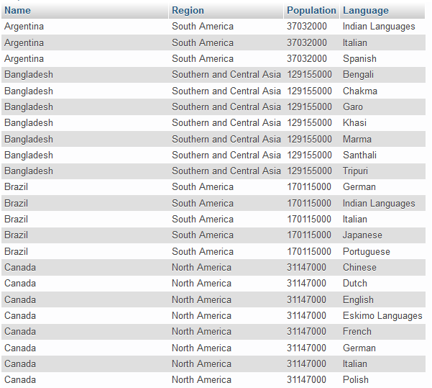

1. **Query Code**

SELECT city.Name, city.District, city.Population, country.Name AS 'Name Country' FROM city

INNER JOIN country ON

city.CountryCode = country.Code

WHERE city.Population > (SELECT AVG(Population) FROM city);

**Screenshot**

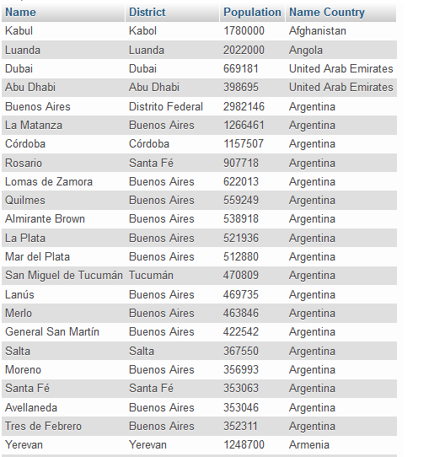

1. **Query Code**

SELECT Name, Region, Population FROM country WHERE IndepYear IS NULL;

**Screenshot**

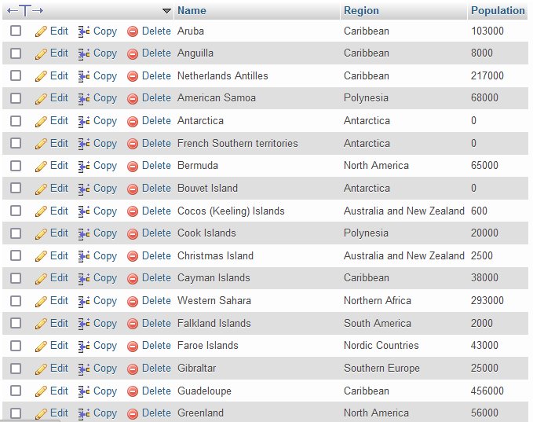

1. **Query Code**

SELECT Region , COUNT(Name) AS 'Jumlah Country'

FROM country GROUP BY Region HAVING COUNT(Region) > 5 ;

**Screenshot**

