Report
Students: Amangeldi Aldiyar, Madiyar Kenzhebayev, Aliya Gallidulaeva
Group: SE-2407

Part 1
1. Web3.js vs Ethers.js
1. Fundamental Architectural Differences
Web3.js and Ethers.js represent two distinct design philosophies in Ethereum client-side libraries. Web3.js, originally developed by the Ethereum Foundation, follows a monolithic and mutable object-oriented architecture. It exposes a large web3 object that aggregates providers, accounts, utilities, and contract logic into a single namespace. This design simplifies early adoption but leads to tight coupling between components.
Ethers.js, by contrast, adopts a functional, immutable, and modular architecture. Objects such as Provider, Signer, and Contract are deliberately separated, promoting composability and predictability. State mutation is minimized, which aligns with functional programming principles and reduces unintended side effects in complex dApps.

2. Provider Abstraction Models
In Web3.js, the provider is loosely abstracted and often implicitly shared across the entire application:
const web3 = new Web3(window.ethereum);

This approach makes it difficult to reason about provider scope and lifecycle. Ethers.js enforces explicit provider injection, ensuring every component knows exactly which network context it operates in:
const provider = new ethers.JsonRpcProvider(RPC_URL);
const signer = await provider.getSigner();

This explicitness improves testability and avoids hidden dependencies, which is critical in large-scale dApps.

3. Signing, ABI Parsing, and Contract Interaction
Web3.js delegates signing responsibilities to either injected wallets (e.g., MetaMask) or its own eth.accounts module, which historically encouraged unsafe patterns such as client-side private key storage.
Ethers.js enforces a Signer abstraction, separating read-only access (Provider) from state-changing actions (Signer). ABI parsing in Ethers.js uses a strict Interface class that validates function signatures at runtime, reducing silent failures:
const contract = new ethers.Contract(address, abi, signer);
await contract.transfer(to, amount);

This strict ABI enforcement results in clearer runtime errors and safer contract interaction.

4. Advantages of Ethers.js v6 Modular Design

Ethers.js v6 introduces tree-shakable ES modules, significantly reducing bundle size for frontend applications. Developers can import only what they need:
import { JsonRpcProvider, Contract } from "ethers";

This modularity aligns with modern frontend tooling (Vite, Rollup, Webpack) and improves load performance—an increasingly critical metric for Web3 UX.

5. Security Implications of Private Key Handling
Web3.js historically normalized direct private key usage via:
web3.eth.accounts.privateKeyToAccount(pk);

This pattern increases the attack surface, especially in browser contexts. Ethers.js discourages this by default and emphasizes hardware wallets, injected providers, or isolated backend signers. The immutability of Wallet instances also prevents accidental key mutation.

Academic consensus increasingly supports explicit signer isolation as a best practice for client-side cryptography (Bonneau et al., 2015).

6. Gas Estimation and Error Propagation
Web3.js relies heavily on RPC node behavior for gas estimation, often returning opaque errors. Ethers.js performs local call simulations and provides structured error objects:
try {
await contract.someFunction();
} catch (error) {
console.log(error.reason);
}

This dramatically improves developer debugging and enables more robust frontend error handling.

7. Migration Trends: Why dApps Prefer Ethers.js
Modern dApps migrate to Ethers.js due to:
- Smaller bundle sizes
- Deterministic behavior
- Better TypeScript support
- Clear separation of concerns
- Improved security defaults
Frameworks like Hardhat, Foundry, and Wagmi officially standardize on Ethers.js, accelerating ecosystem-wide adoption.

8. Debugging UX Comparison
Debugging Web3.js often involves tracing nested promises with limited context. Ethers.js offers human-readable error messages, ABI-aware stack traces, and consistent async behavior. This improves mean-time-to-resolution (MTTR) during smart contract integration.
Conclusion: Ethers.js represents a mature evolution aligned with modern software engineering and cryptographic safety principles.
Sources:
- Buterin, V. Ethereum Whitepaper
- Ethers.js Documentation (Moore, R.)
- Bonneau et al., SoK: Research Perspectives on Cryptocurrencies, IEEE

2. Connecting to the Ethereum Network
1. JSON-RPC Structure and Core Methods
Ethereum nodes expose a JSON-RPC 2.0 interface, where clients send stateless HTTP or WebSocket requests. Common methods include:
- eth_call (read-only execution)
- eth_sendRawTransaction
- eth_getBalance
- eth_getTransactionReceipt
Each request specifies a method, parameters, and an ID, ensuring deterministic responses.

2. Local vs Testnet vs Mainnet RPC Endpoints
Local networks (Ganache, Hardhat) provide instant finality and zero-cost gas, ideal for development. Testnets (Sepolia, Holesky) simulate real economic conditions without real value. Mainnet endpoints enforce real gas fees, congestion dynamics, and adversarial conditions.

3. Node Types and Their Roles
- Full nodes validate blocks and transactions.
- Archive nodes store full historical state (critical for analytics).
- Light nodes verify headers only.
- RPC proxy nodes abstract infrastructure complexity for clients.
Each node type trades storage, latency, and trust assumptions.

4. Rate Limiting and Frontend Architecture
RPC providers enforce rate limits to prevent abuse. This forces frontend architects to:
- Batch requests
- Cache reads
- Offload indexing to subgraphs
Failure to account for rate limits results in degraded UX under load.

5. RPC Virtualization Services
Providers like Alchemy, Infura, and QuickNode introduce RPC virtualization, offering load balancing, caching, and enhanced APIs. This shifts dApp architecture from self-hosted decentralization toward infrastructure-as-a-service, raising debates about Web3’s trust model.
Sources:
- Ethereum JSON-RPC Spec
- Alchemy & Infura Architecture Papers

3. Transaction Lifecycle
1. Local Signing
Transactions are first constructed and signed locally using ECDSA (secp256k1). The private key never leaves the client, preserving cryptographic ownership.

2. Nonce Management
Each account maintains a strictly increasing nonce. Incorrect nonce handling results in dropped or stuck transactions, requiring replacement or cancellation logic.

3. Mempool Propagation
Signed transactions enter the mempool and propagate peer-to-peer. Nodes prioritize transactions based on gas fees and local policies.

4. Validator Selection
Under Proof-of-Stake, validators are pseudo-randomly selected based on stake and epoch rules. This replaces energy-intensive PoW mining.

5. Block Inclusion
The selected validator proposes a block containing prioritized transactions. Other validators attest to its validity.

6. Reorganization (Reorg) Risk
Short-lived forks can invalidate recently included transactions. Applications typically wait for multiple confirmations to mitigate this risk.

7. Finality: PoW vs PoS
PoW offers probabilistic finality, while PoS (Ethereum ≥ The Merge) introduces economic finality via slashing conditions.

8. Gas Fee Markets (EIP-1559)
EIP-1559 splits gas into:
- Base fee (burned)
- Priority fee (validator incentive)
This stabilizes fees and reduces auction volatility.

Transaction Lifecycle Diagram
[User Wallet]
|
v
[Local Signing]
|
v
[Mempool]
|
v
[Validator Selection]
|
v
[Block Inclusion]
|
v
[Confirmations]
|
v
[Finality]

Part 2
Task A
GitHub link: https://github.com/aldik1607/blockchain_assi3
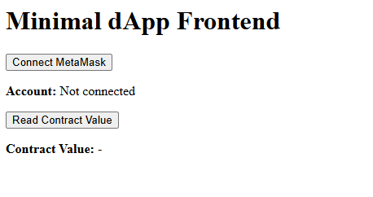
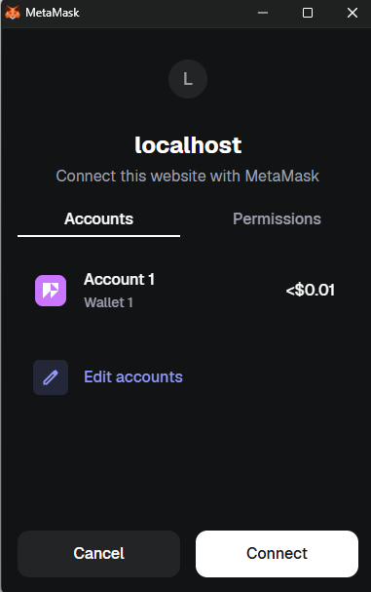

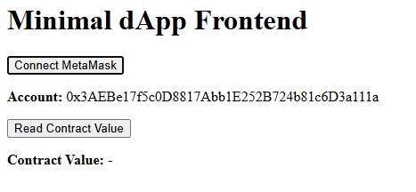

Task B — Security Discussion
1. Why Direct RPC Exposure is Dangerous
Directly exposing a blockchain node's RPC endpoint (for example, via HTTP or WebSocket) can be extremely risky. RPC endpoints allow clients to send arbitrary JSON-RPC requests to the node, which includes operations like sending transactions, querying balances, and deploying contracts. If an endpoint is publicly accessible without proper authentication, an attacker could:
- Send unauthorized transactions on behalf of users.
- Manipulate contract state or invoke sensitive functions.
- Launch denial-of-service attacks by spamming requests.
For instance, a malicious actor could exploit an unprotected Ethereum node to drain funds or perform replay attacks. Therefore, dApps should never directly expose RPC endpoints to end users. Instead, they should rely on wallet providers like MetaMask or WalletConnect, which handle signing locally and safely transmit only signed transactions to the network.

2. XSS Risks in dApps
Cross-Site Scripting (XSS) is a critical vulnerability in web applications, and dApps are no exception. If a dApp allows user-generated input to be injected into the DOM without proper sanitization, attackers can inject malicious JavaScript that:
- Accesses the window.ethereum object.
- Requests users to sign transactions or messages unknowingly.
- Reads sensitive information displayed in the browser, such as contract state or transaction history.
Because Ethereum dApps interact directly with users’ wallets, XSS attacks can have immediate financial consequences.
Mitigation strategies include:
- Properly sanitizing and escaping all user input.
- Using frameworks that automatically prevent XSS (like React with JSX).
- Implementing Content Security Policy (CSP) headers to restrict script execution.

3. Signature Replay Risks
Signature replay attacks occur when a valid signed message or transaction is intercepted and reused maliciously. In Ethereum, a signature without proper nonce or chain ID validation can be executed multiple times on the same or different networks. This can allow attackers to:
- Transfer funds multiple times.
- Manipulate contract state by resubmitting previous instructions.
Prevention mechanisms include:
- Using nonces for each transaction to prevent duplicate execution.
- Including the chain ID in the signed message to prevent cross-chain replay.
- Relying on modern wallet providers to enforce these checks automatically.

4. Private Key Extraction via Malicious Web3 Injection
If an attacker can inject a malicious Web3 script into a dApp (for example, through compromised third-party libraries or XSS), they might attempt to extract users’ private keys. Potential consequences include:
- Full control of the user’s wallet and funds.
- Unauthorized signing of transactions.
Modern wallet providers, such as MetaMask, mitigate this risk by:
- Never exposing private keys to the web page.
- Requiring the user to manually approve each transaction.
- Isolating signing operations within a secure environment, inaccessible to JavaScript running on the page.

5. How Modern Wallet Providers Mitigate Risks
Modern Ethereum wallet providers (MetaMask, Ledger, Trust Wallet) implement multiple layers of security to protect users:
- Local Signing: All transaction signing happens inside the wallet. Private keys never leave the device.
- User Confirmation: Any transaction or message signature requires explicit user approval.
- Replay Protection: Wallets include nonce and chain ID to prevent signature replay attacks.
- Network Awareness: Wallets check that transactions are sent to the correct network, preventing accidental execution on the wrong chain.
- Isolation: Malicious scripts on the dApp cannot directly access the wallet’s private keys.
These mechanisms allow dApps to interact with blockchain safely while minimizing the risks of compromised endpoints, XSS attacks, or signature theft.

Summary:
In conclusion, dApp security relies not only on the smart contract code but also heavily on the frontend and wallet integration. Risks such as direct RPC exposure, XSS, signature replay, and private key extraction are mitigated through careful architecture, local signing, nonces, and explicit user confirmations. Modern wallet providers serve as a trusted layer between the user and potentially unsafe web applications, making Ethereum dApps usable without exposing sensitive secrets.

