Movie Rental Data Warehouse
Design and ETL Implementation
From OLTP Schema to Dimensional Model and ETL Design

Student Name | Izz Aldeen Mansour
Student ID | 12217386
Course | Data Warehousing / Data Architecture
Database | Sakila Movie Rental OLTP
Tools | MySQL Server, MySQL Workbench, Python, Pandas, SQLAlchemy, Jupyter Notebook
Submitted Report

Prepared by
Izz Aldeen Tayseer Mansour (عز الدين تيسير منصور)
Mona Tayseer Nazzal (منى تيسير نزال)
Mahmoud Abdel Haleem (محمود عبد الحليم)

Table of Contents
1. Introduction
2. OLTP System Overview
3. Business Questions
4. Dimensional Modeling Approach
5. Selected Business Processes
6. Fact Tables Design
7. Dimension Tables Design
8. Data Warehouse Implementation Results
9. ETL Design and Implementation
10. Data Quality Considerations
11. Analytical Queries
12. Dimensional Model Diagram
13. Tools and Technologies
14. Conclusion
15. References

1. Introduction
This project presents the design and implementation of a data warehouse for a movie rental business. The source system is the Sakila movie rental OLTP database, which supports operational activities such as customer registration, film management, inventory tracking, rental transactions, payment processing, staff management, and store management.
Although the OLTP database is suitable for daily transaction processing, it is not optimized for analytical reporting. Managers need a data warehouse that can support analysis of rental activity, revenue, customer behavior, film popularity, store performance, staff performance, inventory availability, and trends over time. Therefore, this project reorganizes the OLTP schema into a dimensional model and implements an ETL pipeline using Python and Pandas.

2. OLTP System Overview
The source database is a normalized OLTP movie rental schema. The main source tables used in the ETL process are shown below.
Source Table | Purpose
rental | Stores rental transactions.
payment | Stores payment transactions and revenue amounts.
customer | Stores customer profile information.
film | Stores film attributes and rental rules.
inventory | Stores available copies of films in stores.
store | Stores store information.
staff | Stores staff information.
address, city, country | Provide location details for customers, stores, and staff.
language, category, film_category | Provide film language and category context.

3. Business Questions
The data warehouse was designed to answer a focused set of analytical business questions:
- Which films are rented most frequently?
- Which films generate the highest revenue?
- How does revenue change by month?
- Which stores have the highest number of rentals?
- Which customers generate the highest revenue?
- Which film categories have the most late returns?
These questions cover film popularity, revenue analysis, time trends, store performance, customer behavior, and rental return behavior.

4. Dimensional Modeling Approach
A star-like dimensional model was selected. In this model, fact tables store measurable business events, while dimension tables provide descriptive context for analysis. The design does not copy the OLTP schema directly. Instead, related operational tables are joined into business-friendly dimensions such as customer, film, store, staff, and date.
- The model is easy to understand and explain.
- It reduces the number of joins required for reporting.
- It supports common business intelligence queries.
- It organizes data around measurable business processes.

5. Selected Business Processes
Business Process | Description | Fact Table
Film rental transactions | Tracks each rental transaction made by customers. | fact_rental
Payment transactions | Tracks each customer payment and revenue amount. | fact_payment
Inventory availability | Tracks the number of film copies available per film and store. | fact_inventory_snapshot

6. Fact Tables Design
Fact Table | Business Process | Grain | Measures | Related Dimensions
fact_rental | Film rental transactions | One row per rental transaction | rental_count, rental_duration_days, expected_rental_duration, late_return_flag, late_days | dim_date, dim_customer, dim_film, dim_store, dim_staff
fact_payment | Payment transactions | One row per payment transaction | payment_count, payment_amount | dim_date, dim_customer, dim_film, dim_store, dim_staff
fact_inventory_snapshot | Inventory availability | One row per film per store | inventory_count | dim_film, dim_store

6.1 fact_rental
This fact table supports analysis of rental behavior, rental duration, late returns, film popularity, customer activity, store activity, and staff rental processing.
Column / Measure | Description
rental_count | Always 1 for each rental transaction.
rental_duration_days | Actual number of days between rental_date and return_date.
expected_rental_duration | Expected duration from the film table.
late_return_flag | True when a film was returned after the expected duration.
late_days | Number of days late; negative values are converted to 0.

6.2 fact_payment
This fact table supports revenue analysis by film, category, customer, staff, store, and date.
Column / Measure | Description
payment_count | Always 1 for each payment transaction.
payment_amount | The payment amount made by the customer.

6.3 fact_inventory_snapshot
This periodic snapshot-style table summarizes the number of film copies available in each store.
Column / Measure | Description
inventory_count | Number of inventory copies per film per store.

7. Dimension Tables Design
Dimension | Source Tables | Purpose | Rows Loaded
dim_date | rental, payment | Supports time analysis for rental, return, and payment dates. | 90
dim_customer | customer, address, city, country | Provides customer and location context. | 599
dim_film | film, language, film_category, category | Provides film, language, and category context. | 1000
dim_store | store, address, city, country | Provides store and location context. | 2
dim_staff | staff, address, city, country | Provides staff context and location details. | 2

8. Data Warehouse Implementation Results
A new MySQL database named movie_rental_dw was created. The final row counts after the Pandas ETL load are shown below.
Table Name | Row Count
dim_date | 90
dim_customer | 599
dim_film | 1000
dim_store | 2
dim_staff | 2
fact_inventory_snapshot | 1521
fact_rental | 16044
fact_payment | 16044

The fact quality check showed that all main dimension keys were mapped successfully.
Fact Table | Total Rows | Missing Customer Key | Missing Film Key | Missing Store Key | Missing Staff Key
fact_rental | 16044 | 0 | 0 | 0 | 0
fact_payment | 16044 | 0 | 0 | 0 | 0

9. ETL Design and Implementation
The ETL process was implemented using Python, Pandas, SQLAlchemy, and MySQL. The process follows three stages: Extract, Transform, and Load.

9.1 Extract
The required OLTP tables were extracted from the Sakila database into Pandas DataFrames using pd.read_sql. The extracted tables included rental, payment, customer, film, inventory, store, staff, address, city, country, language, category, and film_category.
rental_df = pd.read_sql("SELECT * FROM rental", oltp_engine)
payment_df = pd.read_sql("SELECT * FROM payment", oltp_engine)
customer_df = pd.read_sql("SELECT * FROM customer", oltp_engine)

9.2 Transform
The raw OLTP data was transformed into business-friendly dimensional structures. The main transformations included:
- Joining customer with address, city, and country to build dim_customer.
- Joining film with language, film_category, and category to build dim_film.
- Combining first_name and last_name into full_name.
- Creating date_key values using the YYYYMMDD format.
- Calculating rental_duration_days, late_return_flag, and late_days.
- Grouping inventory by film and store to calculate inventory_count.
- Mapping OLTP IDs to warehouse surrogate keys before loading fact tables.

9.3 Load
The transformed DataFrames were loaded into MySQL data warehouse tables using df.to_sql with append mode. Dimensions were loaded first, followed by fact tables, because facts reference dimension surrogate keys.
dim_customer.to_sql(name="dim_customer", con=dw_engine, if_exists="append", index=False)
fact_rental.to_sql(name="fact_rental", con=dw_engine, if_exists="append", index=False)

10. Data Quality Considerations
Pandas was used to inspect row counts, missing values, and duplicates before loading data into the data warehouse.
Table | Rows | Duplicate Rows | Missing Values | Explanation
rental | 16044 | 0 | 183 | Missing return_date values; kept as active/not-yet-returned rentals.
payment | 16044 | 0 | 0 | No missing values found.
customer | 599 | 0 | 0 | No missing values found.
film | 1000 | 0 | 1000 | original_language_id is null and not required for the DW model.
inventory | 4581 | 0 | 0 | No missing values found.
store | 2 | 0 | 0 | No missing values found.
staff | 2 | 0 | 2 | Unused staff picture data; not needed in the model.

The ETL process kept valid business events and did not remove rental rows with missing return dates. Instead, return_date_key and rental_duration_days remain null for those records.

11. Analytical Queries
Six analytical questions were implemented in the Jupyter Notebook using SQL queries executed against the data warehouse. These queries demonstrate that the dimensional model supports reporting and business analysis.
Business Question | Implementation Summary
Q1. Which films are rented most frequently? | Joins fact_rental with dim_film and ranks films by total_rentals.
Q2. Which films generate the highest revenue? | Joins fact_payment with dim_film and ranks films by total_revenue.
Q3. How does revenue change by month? | Joins fact_payment with dim_date and summarizes revenue by year and month.
Q4. Which stores have the highest number of rentals? | Joins fact_rental with dim_store and summarizes total rentals by store.
Q5. Which customers generate the highest revenue? | Joins fact_payment with dim_customer and ranks customers by revenue.
Q6. Which film categories have the most late returns? | Joins fact_rental with dim_film and summarizes late returns by category.

Sample Analytical SQL
SELECT f.title, f.category_name, SUM(r.rental_count) AS total_rentals
FROM fact_rental r
JOIN dim_film f ON r.film_key = f.film_key
GROUP BY f.title, f.category_name
ORDER BY total_rentals DESC
LIMIT 10;

12. Dimensional Model Diagram
The diagram below shows the implemented data warehouse structure. The fact tables are connected to shared dimensions through warehouse keys.
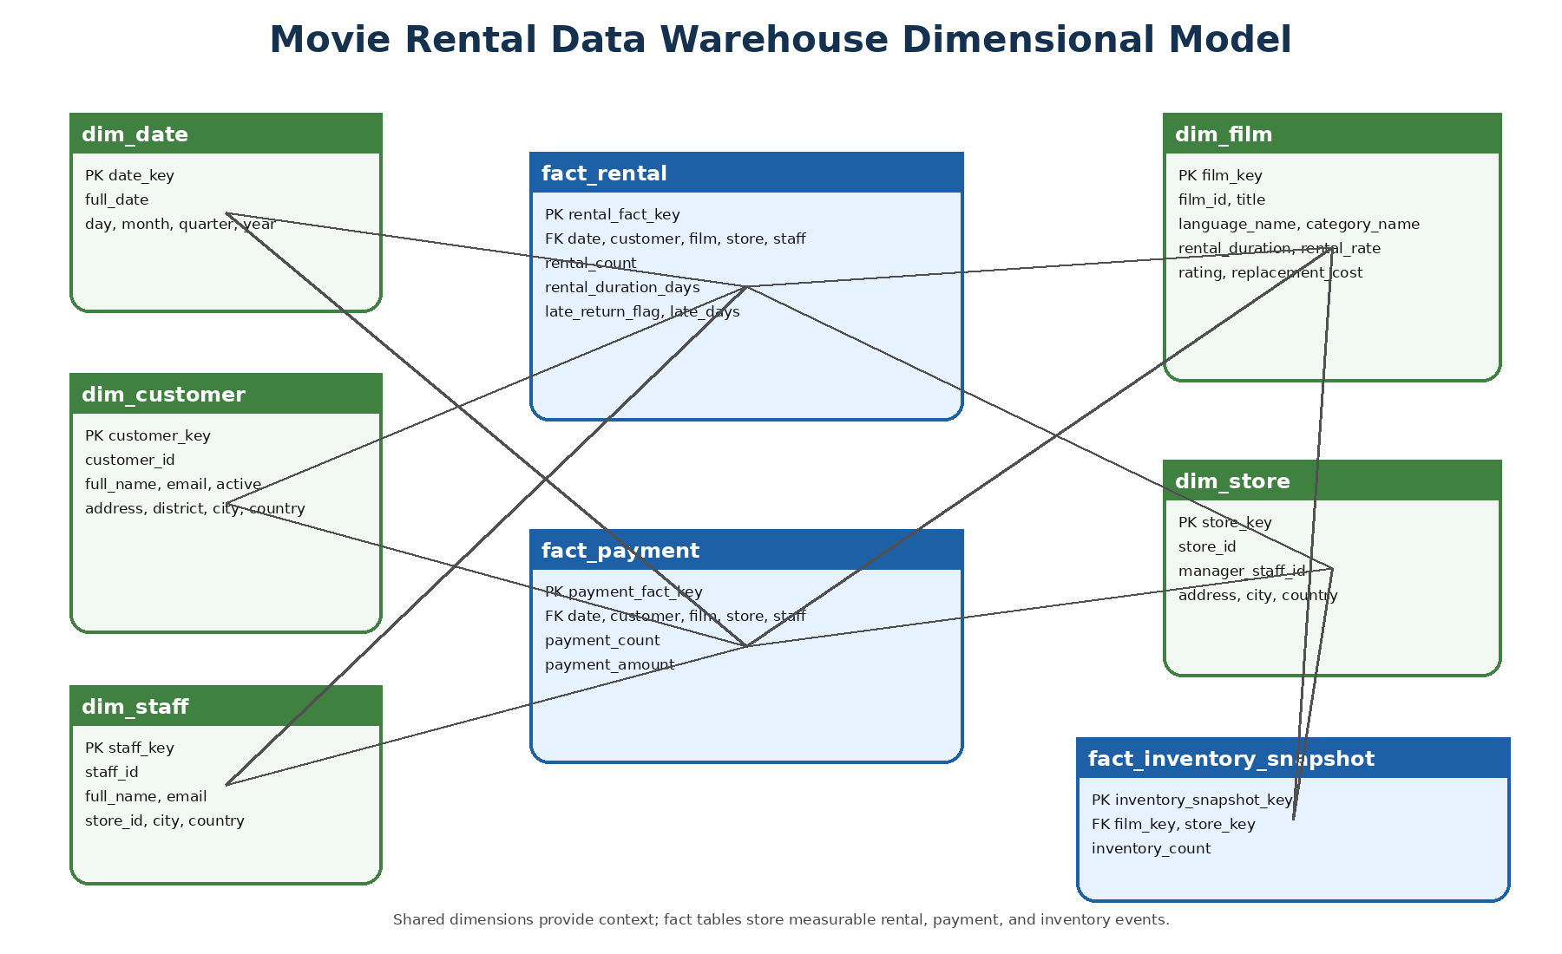
Figure 1. Movie Rental Data Warehouse dimensional model.

13. Tools and Technologies Used
Tool | Purpose
MySQL Server | Hosting the source OLTP and target data warehouse databases.
MySQL Workbench | Importing the SQL dump, creating schemas, and inspecting tables.
Python | Programming the ETL process.
Pandas | Reading, exploring, transforming, and preparing data.
SQLAlchemy / PyMySQL | Connecting Python to MySQL.
Jupyter Notebook | Step-by-step ETL documentation and execution.
VS Code | Development environment.
GitHub | Repository for code, documentation, diagrams, and report.

14. Conclusion
This project successfully transformed a normalized OLTP movie rental database into a dimensional data warehouse suitable for reporting and analysis. The source Sakila database was imported into MySQL, and a new data warehouse named movie_rental_dw was created. The warehouse contains five dimension tables and three fact tables.
The ETL process was implemented using Python and Pandas. Data was extracted from OLTP tables, transformed through joins, cleaning, calculated measures, and key mapping, then loaded into MySQL data warehouse tables. Validation checks confirmed that all dimensions and fact tables were loaded successfully and that the fact tables contain no missing customer, film, store, or staff keys.
The final data warehouse supports analysis of film popularity, revenue, time trends, customer behavior, store performance, inventory availability, and late returns. Therefore, the solution provides a strong foundation for business decision-making and future dashboards.

15. References
1. Data Warehousing Assignment - Movie Rental Data Warehouse Design.
2. Dr. Moamin Abughazala, Dimensional Modeling Lecture.
3. Dr. Moamin Abughazala, ETL Process Lecture.
4. MySQL Sakila Movie Rental Database.
5. Python Pandas Documentation.
6. SQLAlchemy Documentation.

