**BIT302**

**Software Engineering**



**ASSIGNMENT 1**

**Project Proposal**

**“Web-based Information System for MicroHousing System in Kuala Lumpur”**

**Team Leader:**

**Luh Wulandari Maharani**

**E1700873 / 170030401**

**luhwulandari@gmail.com**

**Member:**

**Rivaldo Bagus Soepardhy**

**E1700882 / 170030400**

**aldobagus@hotmail.co.id**

Table of Content

Introduction 2

Project Background 3

Project Aims 3

Project Objectives 3

Project Scope 4

Project Schedule 6

Work Breakdown Structure 7

Milestones 8

Gantt Chart 8

Development Platform 9

Demonstration Platform 10

Risk Management Plan 11

References 12

Introduction

For almost a decade, Internet has been rapidly developed and it pushes for more development of advanced technology, helping individuals to do work better. Businesses, companies, industries is trying to take advantage of technology development to enhance and improve their operations on daily basis. This has been done by industrials in order to provide better product & services to customer and attract for more benefits.

Most of businesses nowadays will rely on a web-based or web application information system. Information systems are combinations of hardware, software, and telecommunications networks that people build and use to collect, create, and distribute useful data, typically in organizational settings (Valacich & Schneider, 2010). A web application (or "web app" for short) is any computer program that performs a specific function by using a web browser as its client (Nations, 2019).

Project Background

With nowadays-human population that is greatly (and rapidly) increases, house and land is component that start to become a problem. This is happened due to inequality of economy (common sense) between people. With that said, certain people will have to live in a temporary living place (Apartment, hotels, etc.), while others have their permanent house. The problem that, as population increases, it is starting to be very hard to get a land and build a house, or even rent a temporary living place. Some says because old people have too much house, that makes young people hard to get one (Anderssen, 2018). Some says because either of minimum wages they have that cannot even pay a rent (Anderssen, 2018), (Regan, 2018), or even because there are no more place for rent. Even youths who are looking for boarding house couldn’t even afford to pay rent because of low wages (or inadequate economy), or also because there’s almost no place that is available to rent. (Carney, 2018), (Babulal & Athirah, 2019).

This problems turns out also hitting youths in Malaysia. Therefore, Kuala Lumpur City Hall has proposed a scheme to help youths to rent accommodation or boarding houses at affordable prices (Babulal & Athirah, 2019). With this, we want to take the advantage of web-based information system, hoping to help government to accommodate youths in more proper and better way while we can also help youths to get the accommodation in a more efficient, easier, and faster ways.

To build this system, we have to know the features of the boarding house, the cost and how many it can accommodate. We also need personal information (Name, email, rent duration, etc.) of applicants that will register themselves for the boarding house. With this system, the housing officer will have easier & efficient way to maintain & monitor applicants that are living in the micro houses, applicants that already pay rents or not yet, etc.

We will put the data of personal information & rent bill in a database handled by Housing Officer. Housing Officer will be given password to access the system to add, delete and update the data. Each applicant will get a user ID and password to see their personal information, rent bill, duration, contact details of housing officers, etc. The desired outcome will be a web – based information system that allows applicants to see their information in real time.

Project Aims

* To change the traditional way of transaction & interaction between government and people about micro housing.
* To provide easier way for government to manage house rent for youths with low wages.
* To provide efficient and convenient way of youths in search of boarding house with affordable price.

Project Objectives

1. Conducting a research about type of micro house that will be rented.
2. Determining how many people can be accommodated into a micro house.
3. Listing features that will be available for each houses.
4. Select tools and programming language that are most suitable to develop the information system.
5. Produce deliverables related to the project.
6. Decide the design of UI.
7. Creating database and input all the data that are needed.
8. Integrating database and web design to produce a complete application.

Project Scope

|  |
| --- |
| * **Project Title:** Web-based Information System for Micro Housing System in Kuala Lumpur * **Date:** February 7th 2020 * **Prepared by:** Luh Wulandari Maharani, Team Leader, luhwulandari@gmail.com |
| **Project Summary and Justification:**  This information system is made to help government in terms of the development of DBKL Micro Housing Scheme, while also helping youths to find a more affordable price for boarding house. Through the system, we are integrating database system and website design. The system will be managed by Housing Officer to add, delete and update data. In the end, Housing Officer can maintain & monitor activities & accommodation (availability, management etc.), while youths (college or high school students) can live in a proper boarding house with affordable price. Youths can also monitor their rent bill during their stay, checking their duration, personal information, and contact details of regarding parties. |
| **Product Characteristics and Requirement:**   1. Research on government for DBKL Micro Housing Scheme to know specific requirements, models, types, features, etc. 2. Research on common property that applied web-based information system for their business. 3. Providing content that suitable to solve problems or making things easier and efficient. The web-based information system should be informative and helpful by showing all data that are applicants and Housing Officer need to see. 4. The web application will be tested with different browsers to make sure it is accessible and does not have any display problem. 5. The entire link will be tested, to see if the link work properly or not. |
| **Summary of Project Deliverables**  **Project management-related deliverables:** Project aims, project objectives, scope statement, WBS, schedule, requirements specification document, design and testing documentation, working web-based information system, final project presentation, and other documents required to manage the project.  **Product-related deliverables:**   1. Web-based information system that can be accessed by any registered applicants. 2. The content of the web allows applicants to know what type of micro housing they are going to have, features, capacity, duration, availability of the micro housing. 3. Ability to manage communication and coordination between Housing Officer and applicants regarding accommodation & availability of boarding house. |
| **Project Success Criteria:** Our goal is to complete this project within three months. The project will be considered successful if it meets the entire product characteristic and requirement listed above, and does not misaligned with the project scope. The project team will succeed if they can follow team contract and stay on track of WBS and Gantt Chart that has been created. |

Project Schedule

|  |  |  |  |  |
| --- | --- | --- | --- | --- |
| **Schedule** | **Start Date** | **End Date** | **Estimate Days** | **Responsible** |
| **Initiating** | | | | |
| Identifying Topic | Fri,7/2/2020 | Fri,7/2/2020 | 1 day | All |
| Conducting Research | Mon, 10/2/2020 | Wed,12/2/2020 | 3 days | All |
| Identifying Project Aims and Background | Thu,13/2/2020 | Fri,14/2/2020 | 2 days | All |
| Identifying Non Functional and Functional Requirements | Mon,17/2/2020 | Wed,19/2/2020 | 3 days | All |
| Complete Initiating Task | Wed,19/2/2020 | Wed,19/2/2020 | 0 day | All |
| **Planning** | | | | |
| Determining Project Scope | Fri,7/2/2020 | Fri,7/2/2020 | 1 day |  |
| Determining WBS | Fri,7/2/2020 | Fri,7/2/2020 | 1 day | Wulan |
| Project Schedule | Fri,7/2/2020 | Fri,7/2/2020 | 1 day | Wulan |
| Baseline Gantt Chart | Fri,7/2/2020 | Fri,7/2/2020 | 1 day | Wulan |
| Development and Demonstration Platform | Mon, 10/2/2020 | Wed,12/2/2020 | 3 days |  |
| Risk Management Plan | Thu,13/2/2020 | Fri,14/2/2020 | 2 days | Aldo |
| Use Case Diagram and Class Diagram | Mon,17/2/2020 | Wed,19/2/2020 | 3 days | Wulan |
| Expanded Use Cases | Thu,20/2/2020 | Fri,21/2/2020 | 2 days | Wulan |
| Analysis Class Diagram | Mon,24/2/2020 | Tue,25/2/2020 | 2 days |  |
| **Executing** | | | | |
| Web Page Basic Design | Thu,27/2/2020 | Wed,25/3/2020 | - | All |
| Prototype Developing Process | Thu,27/2/2020 | Wed,25/3/2020 | - | All |
| System Finishing | Fri,24/4/2020 | Fri,24/4/2020 | - | All |
| **Monitoring and Controlling** | | | | |
| Update the Gantt Chart | Thu,27/2/2020 | Fri,24/4/2020 | - | Wulan |
| Testing the Prototype | Thu,26/3/2020 | Fri,27/3/2020 | - |  |
| Testing the Complete System | Fri,28/2/2020 | Fri,28/2/2020 | - |  |
| **Closing** | | | | |
| Final Report | Tue,3/3/2020 | Tue,3/3/2020 | 0 day |  |

Work Breakdown Structure

1. Initiating Tasks
2. Identifying Topic
3. Conducting Research
4. Identifying Project Aims and Background
5. Identifying Non Functional and Functional Requirements
6. Complete Initiating Task
7. Planning Tasks
8. Determining Project Scope
9. Determining WBS
10. Project Schedule
11. Baseline Gantt Chart
12. Development and Demonstration Platform
13. Risk Management Plan
14. Use Case Diagram and Class Diagram
15. Expanded Use Cases
16. Analysis Class Diagram
17. Executing Tasks
18. Web Page Basic Design
19. Prototype Developing Process
20. System Finishing
21. Monitoring and Controlling Tasks
22. Update the Gantt Chart
23. Testing the Prototype
24. Testing the Complete System
25. Closing
26. Final Report

Milestones

* Complete Initiating Task
* Testing the Prototype
* Testing the Complete System
* Final Report

Gantt Chart

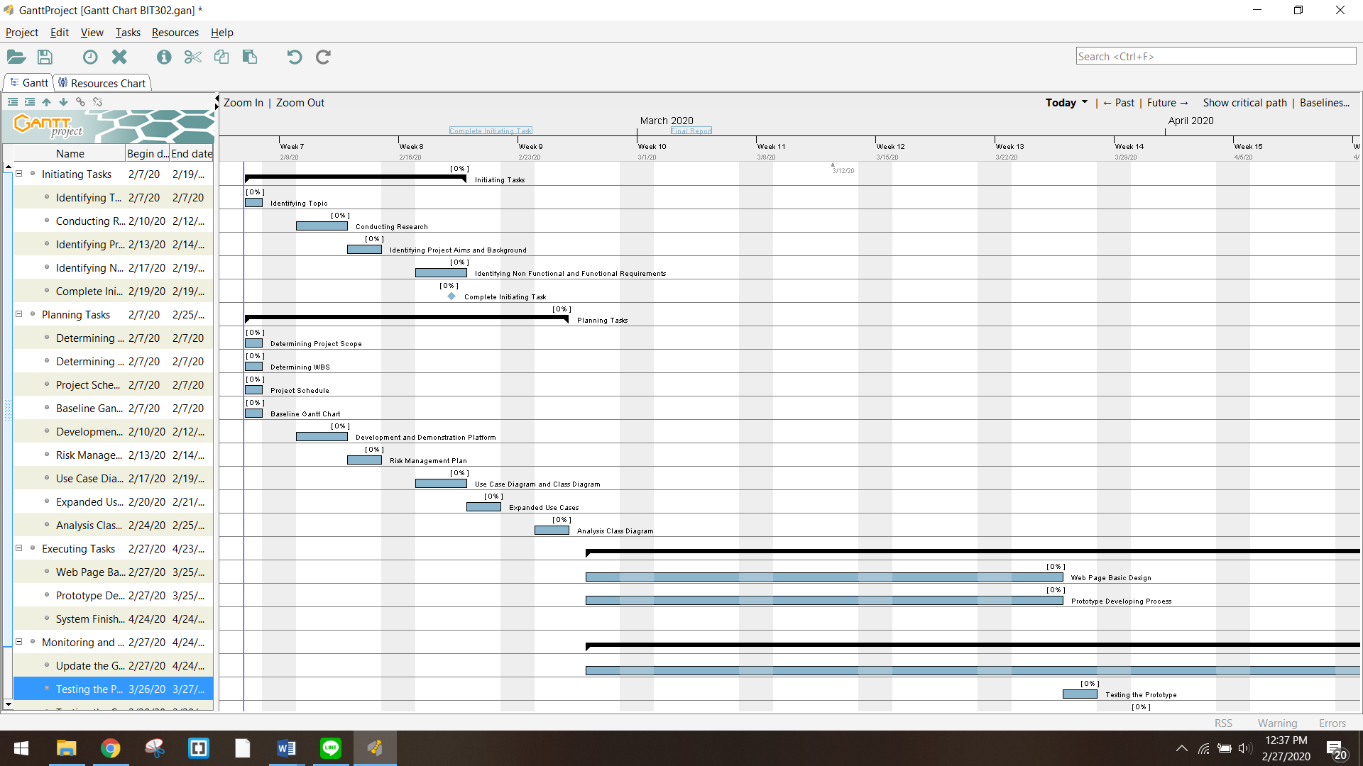

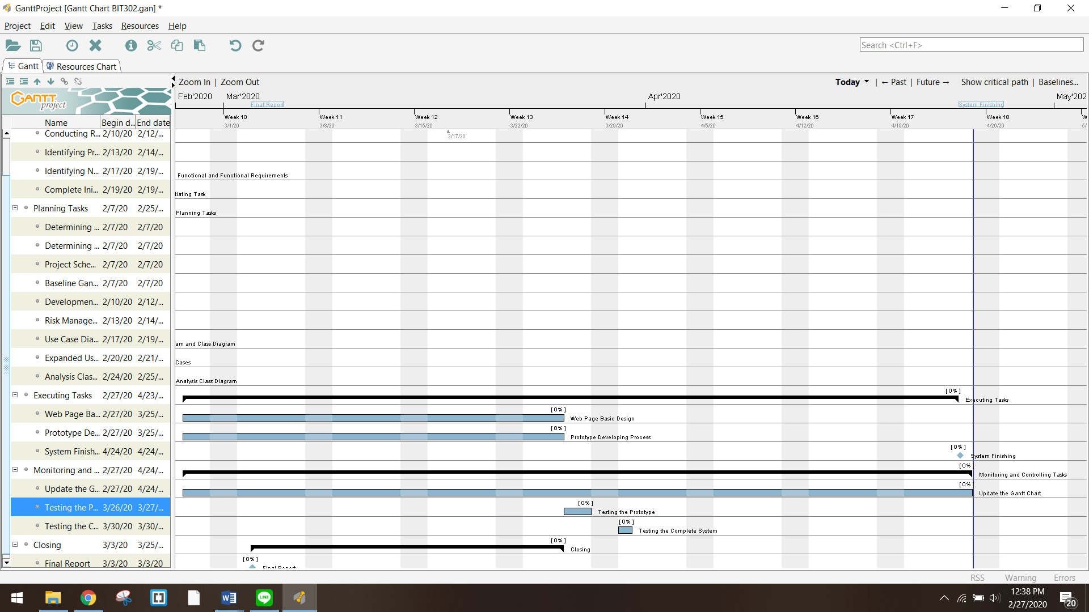

Development Platform

**Software/tools:**

1. **Microsoft Excel**

We will use Excel to store data and formula that we have collected before inputting them to database in MySQL.

1. **Microsoft Word**

We will use Word to produce documents and reports related to this project.

1. **Microsoft Power Point**

Power Point will be used to create presentation to show the design of our system and what went right or wrong during the development of the system.

1. **Microsoft Visio**

We will use this tool to create use case diagram, class diagram and sequence diagram.

1. **MySQL**

We choose MySQL as our relational database management system because it is open – source and has many features to help us managing our database.

1. **Visual Studio Code**

Visual Studio Code will be used to write our codes to design the interface for our web application.

1. **phpMyAdmin**

**We choose this tool because it is open – source and it can be connected to our database in MySQL. phpMyAdmin** provides a convenient graphical user interface to work with and it also has all common functions that we need to develop a MySQL-based application or website.

1. **GanttProject**

GanttProject is an open – source project management software that we use to create Gantt chart which help us in scheduling works for this project.

**Hardware:**

1. **Laptop**

All the for developing this application will be done using laptops that run on Windows operating system.

Demonstration Platform

**Software:**

1. **Web browser – Google Chrome and Mozilla Firefox**

Because we are developing web based application, this application will be opened through a web browser. We choose Google Chrome and Mozilla Firefox to open our application because those are the most common browsers used nowadays. We also want to make sure our design and the data being displayed are consistent in both browsers.

**Hardware:**

1. **Laptop and PC**

Our application is intended to be opened through web browsers from laptop and personal computer.

Risk Management Plan

|  |  |  |  |  |  |  |  |  |  |  |  |
| --- | --- | --- | --- | --- | --- | --- | --- | --- | --- | --- | --- |
| Risk Management Plan for Development of  Web-based Information System for Micro Housing System in Kuala Lumpur | | | | | | | | | | | |
| Prepared by: Luh Wulandari Maharani & Rivaldo Bagus Soepardhy | | | | | | Date: Monday 30th February 2020 | | | | | |
| No | **Rank (1-5)** | **Risk** | **Description** | **Category** | **Root Cause** | **Triggers** | **Potential Responses** | **Risk Owner** | **Probability** | **Impact** | **Status** |
| R1 | 4 | Lack of understanding (or misunderstanding) of all the requirement in the project. | When requirements are not fully understood or when the deliverables are not according to the project scope, the system produced may not match what the users need. | Process Risk | Lack of research and understanding about the purpose / scope of the project. | Not enough time to carry out or poor brainstorming of the project’s scope. | Spare some times to conduct more research about similar application to learn about requirements that needed to be fulfil | Wulan | **High** | **Medium** | We thought to have a more commercialized information system (market place) while the project only need to have a sophisticated information system for the sake of management. It is resolved now. |
| R2 | 5 | The project working duration may be exceeded from the planned. | Team member may be overwhelmed with the project or busy agenda. | Process Risk | Each team member is busy with other activities. | Another project from other subject, Sudden personal agenda (Undeniable family occasion, etc.) | Do online discussion if it is not possible to physically conduct a meeting, tighten the work days to catching up missed days | All | **Medium** | **Medium** | Wulan needs to do ceremony due to religion obligation. Although so, we can still catchup through online platform and pushing work until now. |
| R3 | 4 | The system may possibly have some malfunctions. | The system might having bugs, crashes, or errors. | System Risk | Bad coding structure, logical error, software bugs. | Coding carelessly, not enough prototype / final testing. | Catching up by doing more intense testing, more thorough checking | Aldo | **Medium** | **High** | This issue has not happened yet. |
| R4 | 3 | Lack of communication that may lead to misunderstanding between team members. | Unclear task delegation, misunderstanding / miscommunication can cause different opinion or even conflict | People Risk | Each team member is busy with other activities. | Have different schedules that make it difficult to have same spare time to meet and communicate about the project. | Do online discussion if it is not possible to physically conduct a meeting, make a meeting schedule from the beginning of the project. | Wulan | **High** | **High** | It is common to have misunderstanding. In order to prevent this, we often communicate working in physical or online platform. |

***Probability and Impact Matrix***

|  |  |  |  |
| --- | --- | --- | --- |
| **High** |  | R1 | R4 |
| **Medium** |  | R2 | R3 |
| **Low** |  |  |  |
| ***Probability***  ***Impact*** | **Low** | **Medium** | **High** |

# References

Anderssen, E. (2018, July 19). *Seniors have too much house. Millennials have none. And a business model is born*. Retrieved from The Globe And Mail: https://www.theglobeandmail.com/canada/article-seniors-have-too-much-house-millennials-have-none-and-a-business/

Babulal, V., & Athirah, F. (2019, April 16). *B40 youths can soon rent DBKL micro-homes for RM100 a month*. Retrieved from NewStraitTimes: https://www.nst.com.my/news/nation/2019/04/480032/b40-youths-can-soon-rent-dbkl-micro-homes-rm100-month

Carney, J. (2018, April 20). *Six ways to solve Hong Kong housing problem – from water pipes to plastic bottles*. Retrieved from South China Morning Post: https://www.scmp.com/lifestyle/article/2142632/six-ways-solve-hong-kong-housing-problem-water-pipes-plastic-bottles

Nations, D. (2019, December 19). *What Exactly Is a Web Application?* Retrieved from Lifewire.com: https://www.lifewire.com/what-is-a-web-application-3486637

Regan, R. (2018, May 30). *Stanford Social Innovation Review*. Retrieved from A New Approach to Solving the US Housing Crisis: https://ssir.org/articles/entry/a_new_approach_to_solving_the_us_housing_crisis#

Valacich, J., & Schneider, C. (2010). *Managing in the Digital World: Fourth Edition.* Prentice Hall.

**BIT302**

**Software Engineering**



**ASSIGNMENT 1**

**Requirement Document**

**“Web-based Information System for MicroHousing System in Kuala Lumpur”**

**Team Leader:**

**Luh Wulandari Maharani**

**E1700873 / 170030401**

**luhwulandari@gmail.com**

**Member:**

**Rivaldo Bagus Soepardhy**

**E1700882 / 170030400**

**aldobagus@hotmail.co.id**

Table of Content

Functional Requirements 1

Non – functional Requirements 2

Use Case Diagram 3

Use Cases 4

Expanded Use Cases 5

Analysis Class Diagram 11

System Sequence Diagram & Team Contract 12

Tasks Division 27

Functional Requirements

**HousingOfficer requirement:**

1. HousingOfficer has login menu that can be filled with user ID and password to go directly to HousingOfficer homepage.
2. HousingOfficer can change the password if HousingOfficer forget their password.
3. HousingOfficer must have “edit menu” which is can edit residence detail.
4. HousingOfficer must have “add menu” which is can set up new residence.
5. HousingOfficer must have “delete menu” which is can delete applicant and residence detail.
6. HousingOfficer must have “view menu” which is can view applications and residence details.
7. Payment menu to display payment details for applicant, which is designed by HousingOfficer.
8. Logout Menu to exit from the application.

**Applicant Requirement:**

1. Applicant will register where the form has been given.
2. Applicant has login menu that can be filled with user ID and password so that the applicant can access the system without confusion, and will be directed to the home page.
3. Applicant can change the password if applicant forget their password.
4. The system has a menu with buttons or icons that applicants can choose from view application, view residences, wish list, submit applications and payment.
5. Logout Menu to exit from the application.

Non – functional Requirements

1. Security requirement: using login system for authorization to prevent unauthorized access of certain parties.
2. Usability: the system should be easy to access for Housing Officer and Applicant.
3. Integrity: Data inside the system will be keep as it is untampered and unharmed.
4. Modifiability: Data can only be change by authorized user (HousingOfficer).

Use Case Diagram

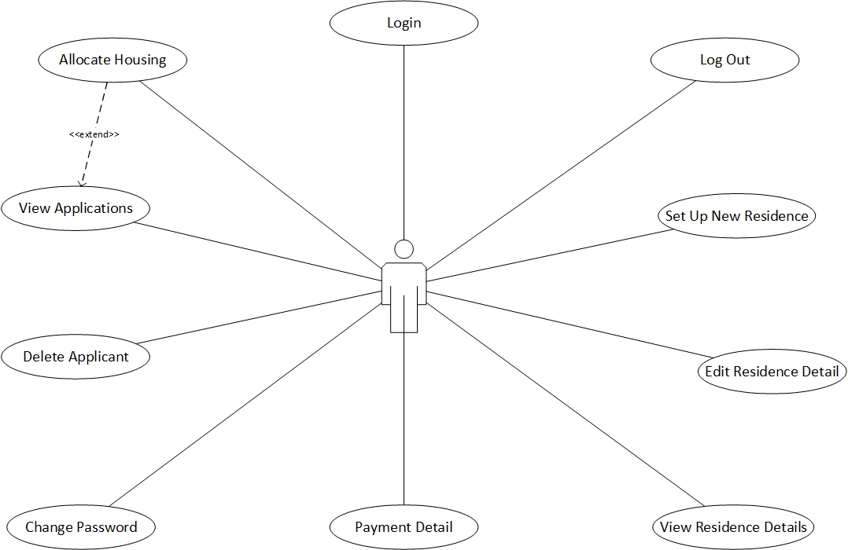

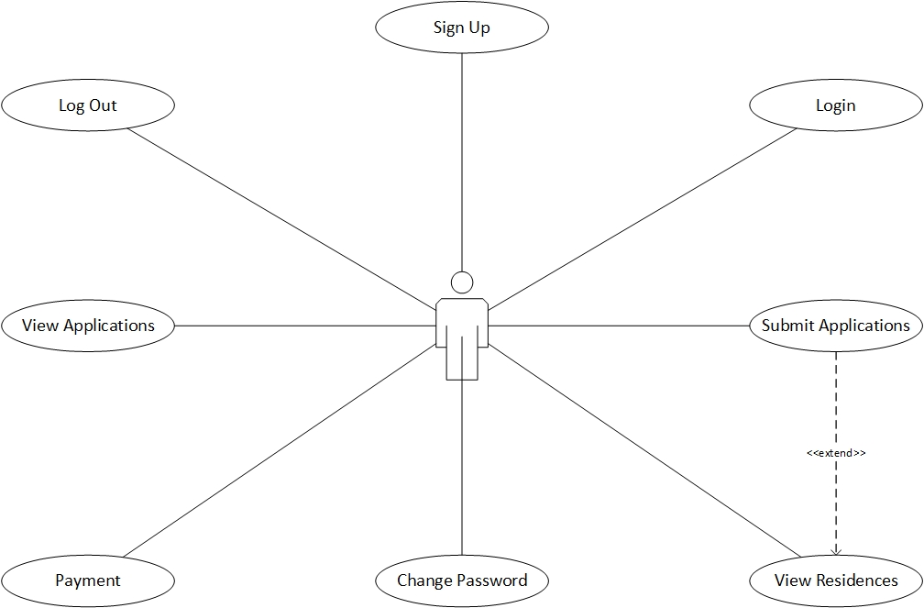

Use Cases

|  |  |  |
| --- | --- | --- |
| Requirement | Actor | Use Case |
| Login page created for HousingOfficer and applicants to login | HousingOfficer  Applicant | Login |
| HousingOfficer and Applicant can access the system and login with the new password | HousingOfficer  Applicant | Change Password |
| HousingOfficer dan Applicant can exit the application through the system | HousingOfficer  Applicant | Log Out |
| Applicant will create account and saved by the sytem | Applicant | Sign Up |
| The system displays a page where that can display Applications and validation for the applicant | HousingOfficer | View Applications |
| The system displays a page where that can display residence details | HousingOfficer | View Residence Detail |
| The system allocates housing where the applicant has ordered a slot for a long time but will be verified by HousingOfficer | HousingOfficer | Allocate Housing |
| HousingOfficer can input several new residences to the system | HousingOfficer | Set Up New Residence |
| Residence details will be changed for some data and will be recorded in the system by HousingOfficer | HousingOfficer | Edit Residence Detail |
| Applicants can be removed if needed on the system by the HousingOfficer | HousingOfficer | Delete Applicant |
| Residence Detail can be removed if needed on the system by HousingOfficer | HousingOfficer | Delete Residence Detail |
| Payment Details will display the payment form which is done by the system and designed by HousingOfficer | HousingOfficer | Payment Detail |
| The system has a page which will display applications that can be seen by applicant | Applicant | View Applications |
| The system has a page which will display residence details that can be seen by applicant | Applicant | View Residences |
| The submit page will display a form to be filled by the applicant and will be saved by the system | Applicant | Submit Applications |
| The payment page will automatically be display by the system and the applicant can see the payment details | Applicant | Payment |

Expanded Use Cases

1. Login

|  |  |
| --- | --- |
| Use Case | Login |
| Goal in Context | Allow HousingOfficer and Applicant access the main page |
| Primary Actor  Secondary Actor | HousingOfficer and Applicant  - |
| Typical Course of Events | |
| Actor Actions | **System Response** |
| 1. The process starts when the user input their ID user and password and press the login button | 1. The system will validate the information received |
|  | 1. System will display the homepage for HousingOfficer or Applicant |
| Alternative Course | |
| If the HousingOfficer or Applicant inputs an incorrect user ID or password then the system will display notification if the information entered is incorrect, and HousingOfficer or Applicant must fill in with correct user ID and password. | |

1. Change Password

|  |  |
| --- | --- |
| Use Case | Change Password |
| Goal in Context | Allow HousingOfficer and Applicant changed their password |
| Primary Actor  Secondary Actor | HousingOfficer and Applicant  - |
| Typical Course of Events | |
| Actor Actions | **System Response** |
| 1. Process occurs when the HousingOfficer or Applicant login |  |
| 1. HousingOfficer or Applicant will select the chang Password button | 1. System will display a form for change password that must be filled with a new password |
| 1. HousingOfficer or Applicant will fill in with new password and one – time validation |  |
| 1. HousingOfficer or Applicant will press the submit button |  |
|  | 1. System will save the update in the database |
| Alternative Course | |
| If there is a third of mismatch password event, then a message will appear and the new password will not be submitted | |

1. Log Out

|  |  |
| --- | --- |
| Use Case | Log Out |
| Goal in Context | Allow HousingOfficer and Applicant exit from the application |
| Primary Actor  Secondary Actor | HousingOfficer and Applicant  - |
| Typical Course of Events | |
| Actor Actions | **System Response** |
| 1. The process starts when the user clicks the Log Out button | 1. System will exit the user from the main page |
| Alternative Course | |
|  | |

1. Sign Up

|  |  |
| --- | --- |
| Use Case | Sign Up |
| Goal in Context | Allow Applicant create account for login to application |
| Primary Actor  Secondary Actor | Applicant  - |
| Typical Course of Events | |
| Actor Actions | **System Response** |
| 1. The process start when applicant click the sign up button | 1. System will redirected to the sign up form |
| 1. Applicant will fill the form with all the information |  |
| 1. Applicant submit all personal information | 1. System will save new information to the database |
| Alternative Course | |
| If the username already used by another user the applicant will make new username | |

1. View Applications

|  |  |
| --- | --- |
| Use Case | View Applications |
| Goal in Context | Allow HousingOfficer to see the whole applications form |
| Primary Actor  Secondary Actor | HousingOfficer  Applicant |
| Typical Course of Events | |
| Actor Actions | **System Response** |
| 1. HousingOfficer can access the page where there is a list of applicants | 1. System will display page that containing the applicant |
| Alternative Course | |
|  | |

1. View Residence Detail

|  |  |
| --- | --- |
| Use Case | View Residence Detail |
| Goal in Context | Allow HousingOfficer to see the whole residence detail form |
| Primary Actor  Secondary Actor | HousingOfficer  - |
| Typical Course of Events | |
| Actor Actions | **System Response** |
| 1. HousingOfficer can access the page where there is a list of residence | 1. System will display page that containing the residence detail |
| Alternative Course | |
|  | |

1. Allocate Housing

|  |  |
| --- | --- |
| Use Case | Allocate Housing |
| Goal in Context | Allow HousingOfficer to book applicant who have booked slots that have long been ordered and will be sorted again |
| Primary Actor  Secondary Actor | HousingOfficer  - |
| Typical Course of Events | |
| Actor Actions | **System Response** |
| 1. HousingOfficer will check the applicants one by one |  |
| 1. HousingOfficer will select the applicant who has chosen the residence first | 1. The system will save the information that has been entered by HousingOfficer |
| Alternative Course | |
|  | |

1. Set Up New Residence

|  |  |
| --- | --- |
| Use Case | Set Up New Residence |
| Goal in Context | Allow HousingOfficer to input new residence information |
| Primary Actor  Secondary Actor | HousingOfficer  - |
| Typical Course of Events | |
| Actor Actions | **System Response** |
| 1. The process occurs when HousingOfficer input new residence information | 1. The system will save new data |
| Alternative Course | |
|  | |

1. Edit Residence Detail

|  |  |
| --- | --- |
| Use Case | Edit Residence Detail |
| Goal in Context | Allow HousingOfficer to change the information about the residence |
| Primary Actor  Secondary Actor | HousingOfficer  - |
| Typical Course of Events | |
| Actor Actions | **System Response** |
| 1. HousingOfficer checks the residence that want to change |  |
| 1. HousingOfficer will choose which residence to change | 1. The system will display the residence page |
| 1. HousingOfficer will input ne data that change and selected by HousingOfficer | 1. System will save changes and will update the information that will be displayed in residence detail page |
| Alternative Course | |
| HousingOfficer akan | |

1. Delete Applicant

|  |  |
| --- | --- |
| Use Case | Delete Applicant |
| Goal in Context | Allow HousingOfficer to delete information about the Applicant |
| Primary Actor  Secondary Actor | HousingOfficer  - |
| Typical Course of Events | |
| Actor Actions | **System Response** |
| 1. HousingOfficer will select the Applicant that they want delete | 1. System will receive information which will be deleted |
|  | 1. System will update information and will be updated in the database |
| Alternative Course | |
| - | |

1. Delete Residence Detail

|  |  |
| --- | --- |
| Use Case | Delete Residence Detail |
| Goal in Context | Allow HousingOfficer to delete information about the Residence |
| Primary Actor  Secondary Actor | HousingOfficer  - |
| Typical Course of Events | |
| Actor Actions | **System Response** |
| 1. HousingOfficer will choose which residence they want delete | 1. System will receive information which will be deleted |
|  | 1. System will update information and will be updated in the database |
| Alternative Course | |
| - | |

1. Payment Detail

|  |  |
| --- | --- |
| Use Case | Payment Detail |
| Goal in Context | Allow HousingOfficer to make a detailed payment form |
| Primary Actor  Secondary Actor | HousingOfficer  - |
| Typical Course of Events | |
| Actor Actions | **System Response** |
| 1. HousingOfficer will edit the payment form details that have been made | 1. The system will save all information that has been entered by the applicant |
| Alternative Course | |
| - | |

1. View Applications

|  |  |
| --- | --- |
| Use Case | View Applications |
| Goal in Context | Allow Applicant to see the whole other applicants |
| Primary Actor  Secondary Actor | Applicant  HousingOfficer |
| Typical Course of Events | |
| Actor Actions | **System Response** |
| 1. Applicant can access the entire Applications page | 1. The system will display the Applications page |
| Alternative Course | |
|  | |

1. View Residences

|  |  |
| --- | --- |
| Use Case | View Residences |
| Goal in Context | Allow Applicant to see the whole other applicants |
| Primary Actor  Secondary Actor | Applicant  HousingOfficer |
| Typical Course of Events | |
| Actor Actions | **System Response** |
| 1. Applicant can access the entire residences page | 1. The system will display the Residences page |
| Alternative Course | |
|  | |

1. Submit Applications

|  |  |
| --- | --- |
| Use Case | Submit Applications |
| Goal in Context | Allow Applicant to enter information about the new applicant |
| Primary Actor  Secondary Actor | Applicant  HousingOfficer |
| Typical Course of Events | |
| Actor Actions | **System Response** |
| 1. Applicant will choose which Residence you want to occupy |  |
| 1. Applicant will fill in the form provided | 1. The system will save all information that has been filled |
| Alternative Course | |
| If the information entered by the applicant an incorrect, the applicant will refill it again | |

1. Payment Detail

|  |  |
| --- | --- |
| Use Case | Payment Detail |
| Goal in Context | Allow Applicant to see payment details |
| Primary Actor  Secondary Actor | Applicant  - |
| Typical Course of Events | |
| Actor Actions | **System Response** |
| 1. The process occurs when the applicant has finished entering all the information that has been submitted | 1. The system will check all information that has been submitted |
|  | 1. The system will display the payment in detail |
| 1. Applicants will choose their payment method | 1. The system will direct the applicant to make a transaction |
|  | 1. The system will validate |
| Alternative Course | |
| If the Applicant incorrectly enters information or chooses the payment method, the transaction will not occur. | |

Analysis Class Diagram

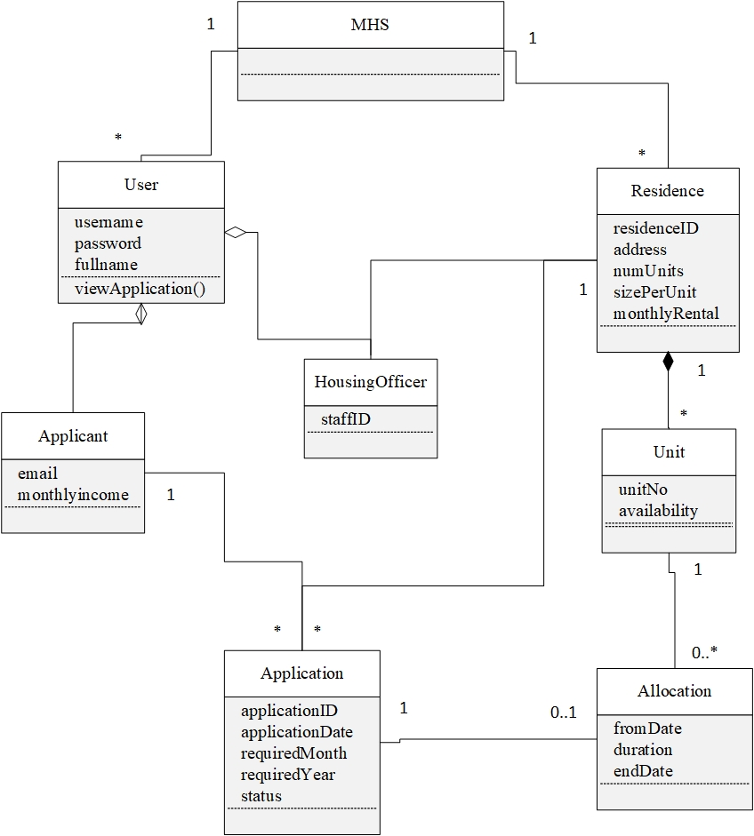

System Sequence Diagram & Team Contract

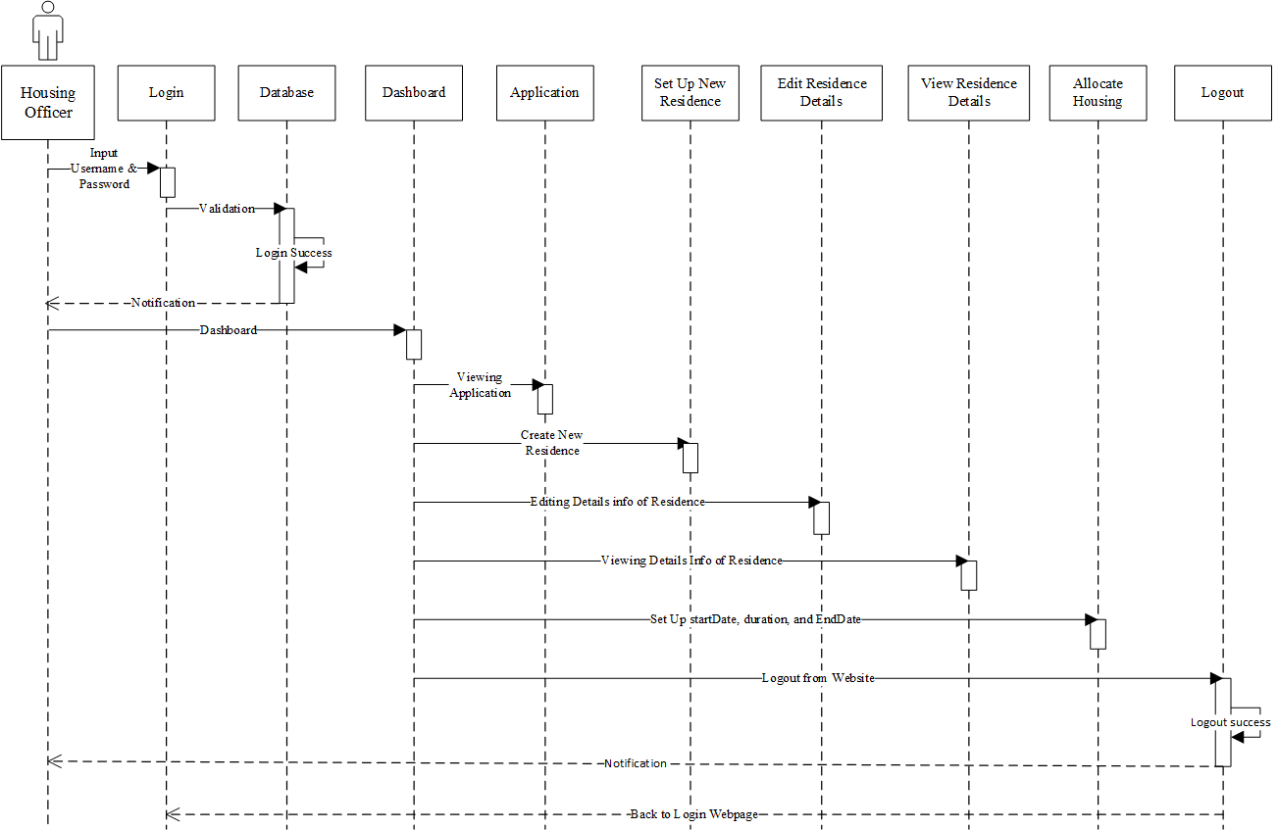

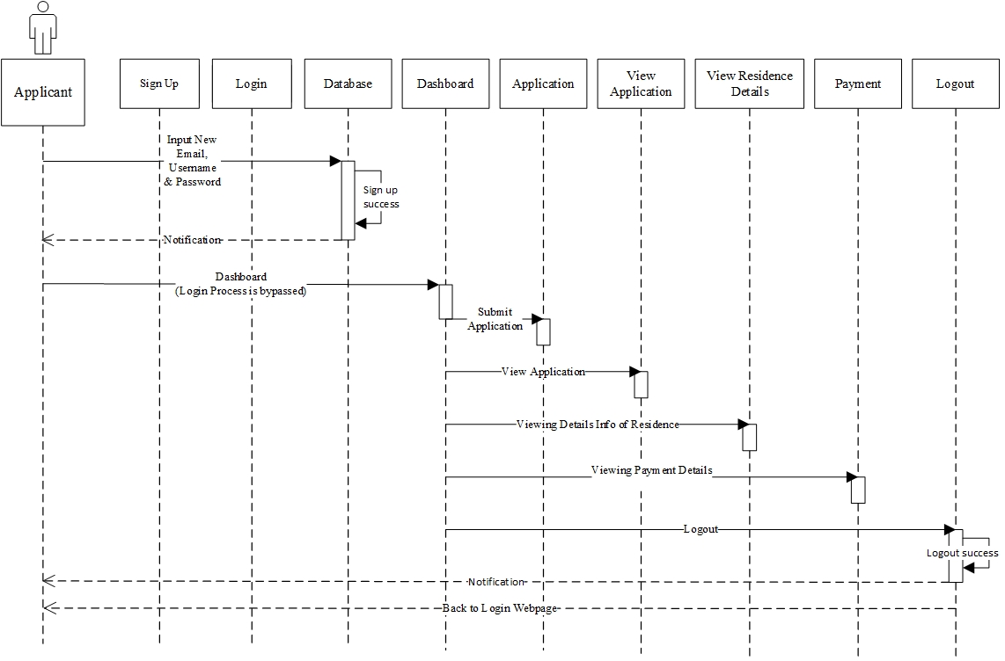

1. **Login**

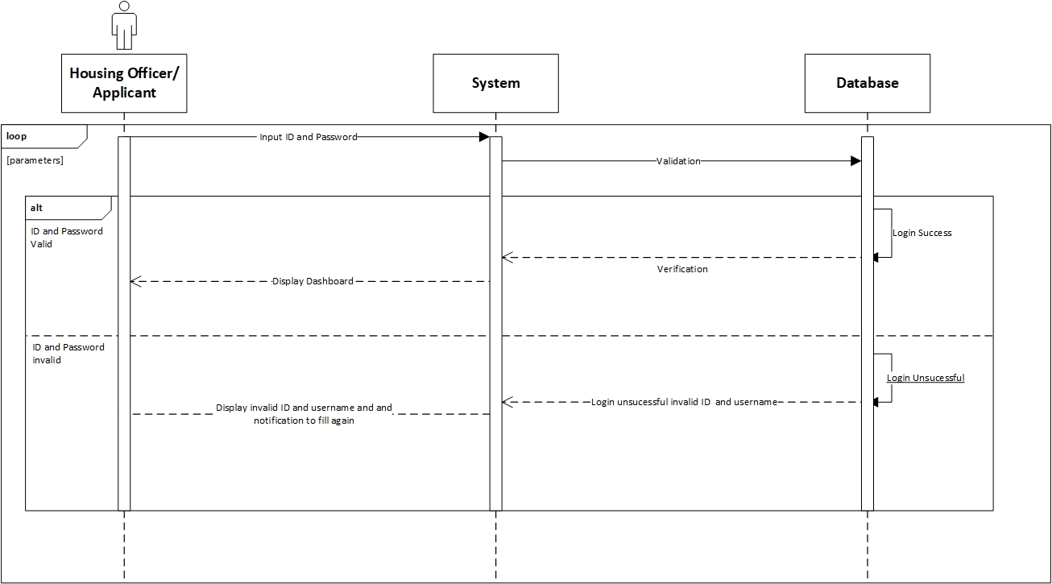

**Prepared by: Luh Wulandari Maharani**

|  |  |
| --- | --- |
| **Cross References** | **Login** |
| Operation | Login with ID and username |
| Responsible | To access the main page |
| Pre-conditions | * Username must be available * Password must be available |
| Post-conditions | * Username is matched * Password must be match based on user’s password input * Display dashboard |

1. **Change Password**

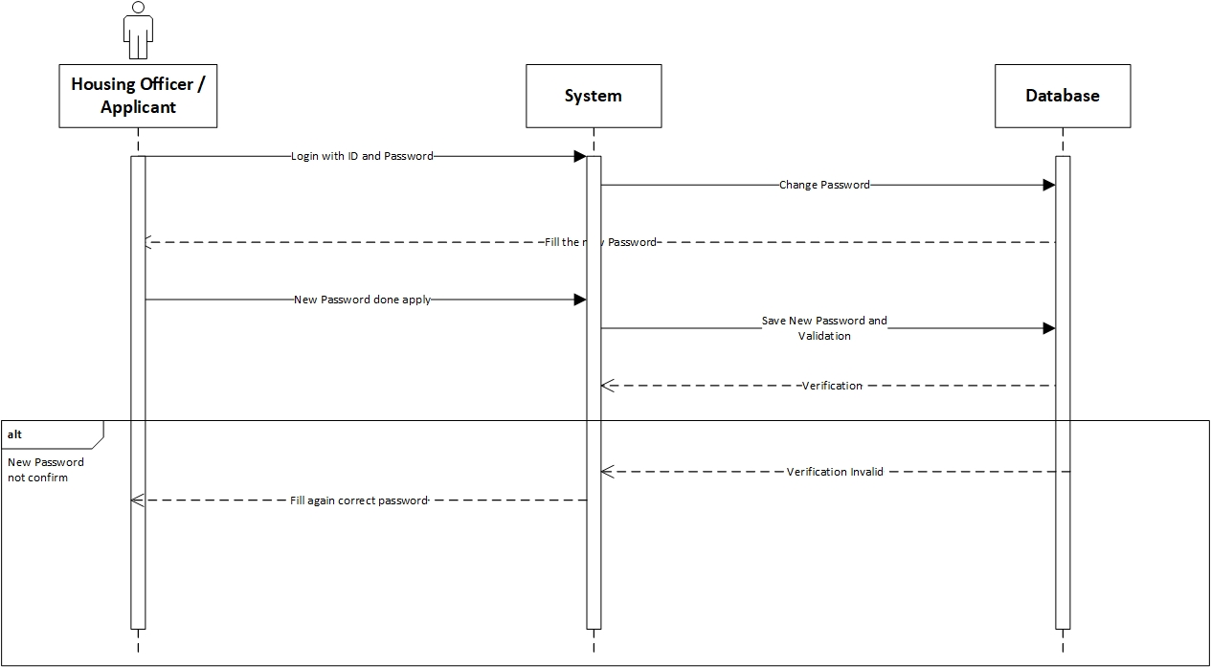

**Prepared by: Luh Wulandari Maharani**

|  |  |
| --- | --- |
| **Cross References** | **Change Password** |
| Operation | Enter current password |
| Responsible | To change the password |
| Pre-conditions | The new password must be available |
| Post-conditions | Successfully changed password |
| **Cross References** | **Change Password** |
| Operation | Enter current password |
| Responsible | To change the password |
| Pre-conditions | The user must be enter the new password again to confirm |
| Post-conditions | Fill again the form with the new password |

1. **Log Out**

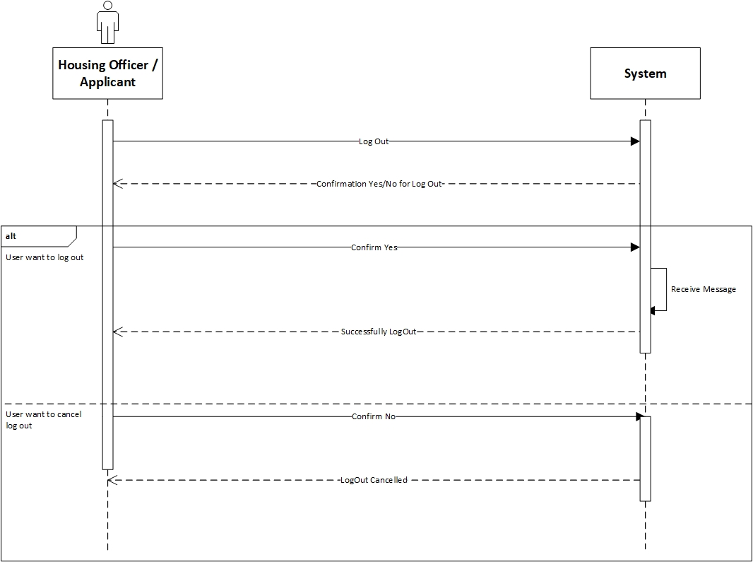

**Prepared by: Luh Wulandari Maharani**

|  |  |
| --- | --- |
| **Cross References** | **Log Out** |
| Operation | User want to log out |
| Responsible | To log out from the system |
| Pre-conditions | The user accepts that they want to log out |
| Post-conditions | Successfully log out |
| **Cross References** | **Log Out** |
| Operation | Cancel to log out |
| Responsible | To cancel log out from the system |
| Pre-conditions | The user cancel log out by click the “No” option |
| Post-conditions | Log out cancelled |

1. **View Applications**

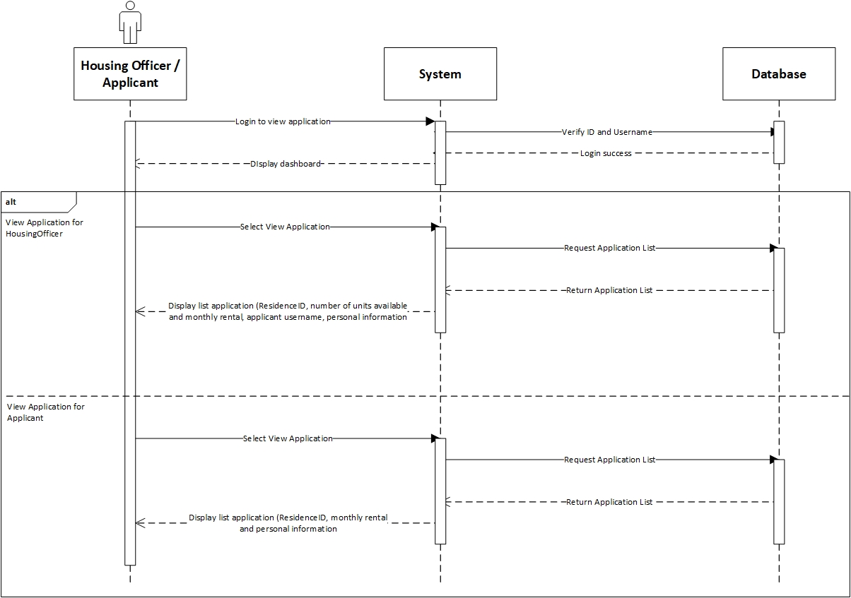

**Prepared by: Luh Wulandari Maharani**

|  |  |
| --- | --- |
| **Cross References** | **View Applications** |
| Operation | Login with username and password |
| Responsible | To get access to view the applications |
| Pre-conditions | * Username must be available * Password must be available |
| Post-conditions | * Username is matched * Password must be match based on user’s password input * Display dashboard |
| **Cross References** | **View Applications** |
| Operation | View Application in Housing Officer |
| Responsible | To view a list for the Residence that Housing Officer is responsible |
| Pre-conditions | The application object must be available |
| Post-conditions | The list of application with status for the Residence that the Housing Officer is responsible, showing the residence ID, number of units available, monthly rental, application username and personal information |

|  |  |
| --- | --- |
| **Cross References** | **View Applications** |
| Operation | View Application in Applicant |
| Responsible | To view a list of application that have been made for applicant |
| Pre-conditions | The application object must be available |
| Post-conditions | The list of application that have been made by the applicant, showing the residence ID, monthly rental and personal information |

1. **View Residences**

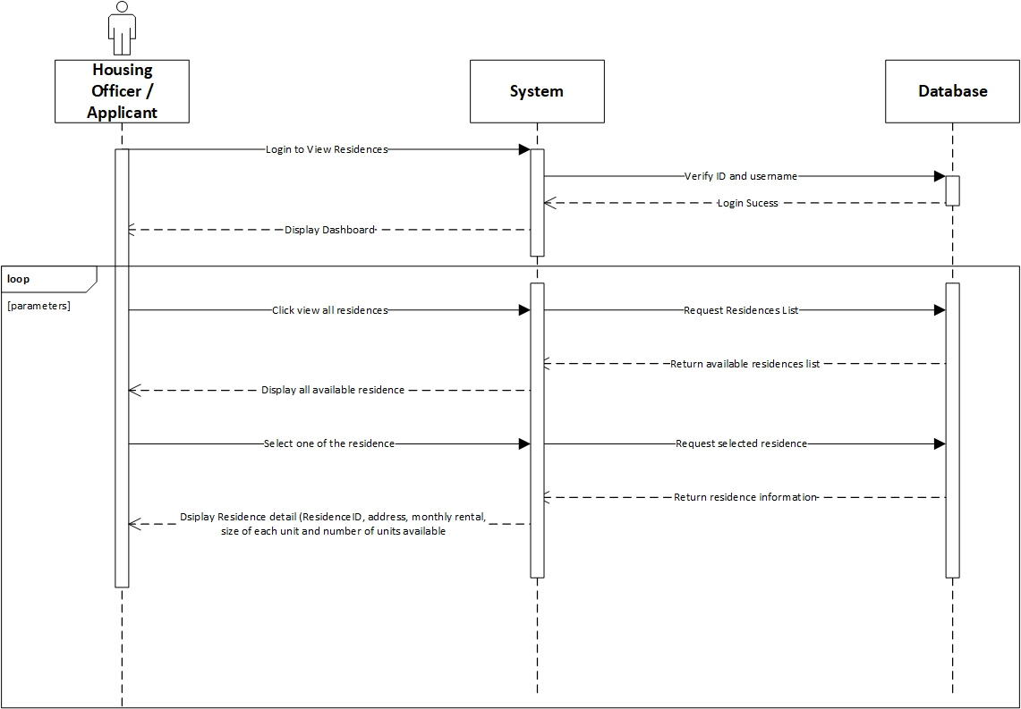

**Prepared by: Luh Wulandari Maharani**

|  |  |
| --- | --- |
| **Cross References** | **View Residences** |
| Operation | Login with ID and username |
| Responsible | To access the main page |
| Pre-conditions | * Username must be available * Password must be available |
| Post-conditions | * Username is matched * Password must be match based on user’s password input * Display dashboard |

|  |  |
| --- | --- |
| **Cross References** | **View Residences** |
| Operation | Click view all residences |
| Responsible | To get all list of the residences |
| Pre-conditions | The residence object must be available |
| Post-conditions | Success to display all residences of all residences |
| **Cross References** | **View Residences** |
| Operation | Select the residence to view |
| Responsible | To get information about selected residences |
| Pre-conditions | The residence ID must be available |
| Post-conditions | Success to display detail information about the selected residences |

1. **Set Up New Residences**

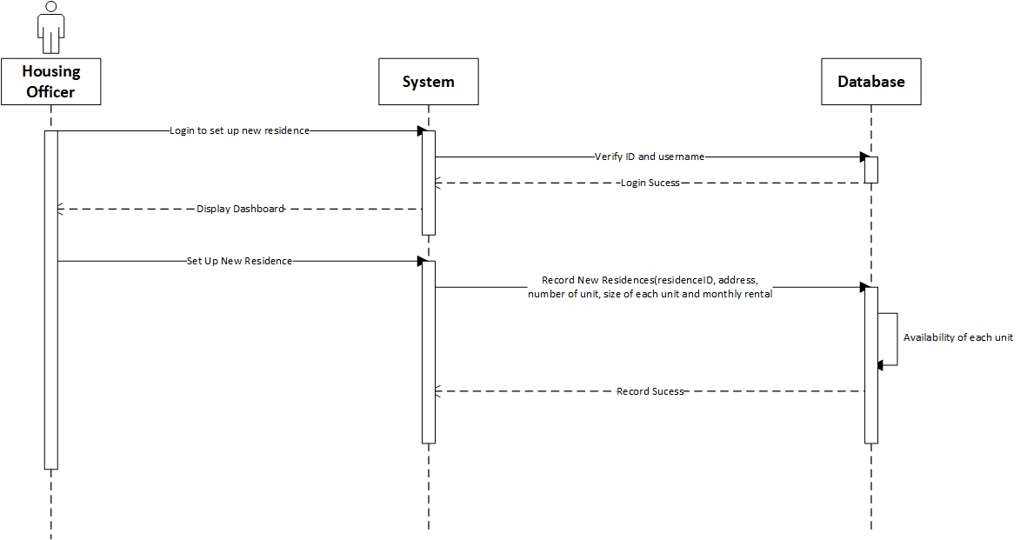

**Prepared by: Luh Wulandari Maharani**

|  |  |
| --- | --- |
| **Cross References** | **Set Up New Residences** |
| Operation | Login with ID and username |
| Responsible | To access the main page |
| Pre-conditions | * Username must be available * Password must be available |
| Post-conditions | * Username is matched * Password must be match based on user’s password input * Display dashboard |

|  |  |
| --- | --- |
| **Cross References** | **Set Up New Residences** |
| Operation | Set up new residences |
| Responsible | To set up the new residences by input the residenceID, address, number of units available, size of each unit and monthly rental |
| Pre-conditions | Object residenceID, address, number of units available, size of each unit and monthly rental must be available |
| Post-conditions | New residences was successfully added to the system |

1. **Allocate Housing**

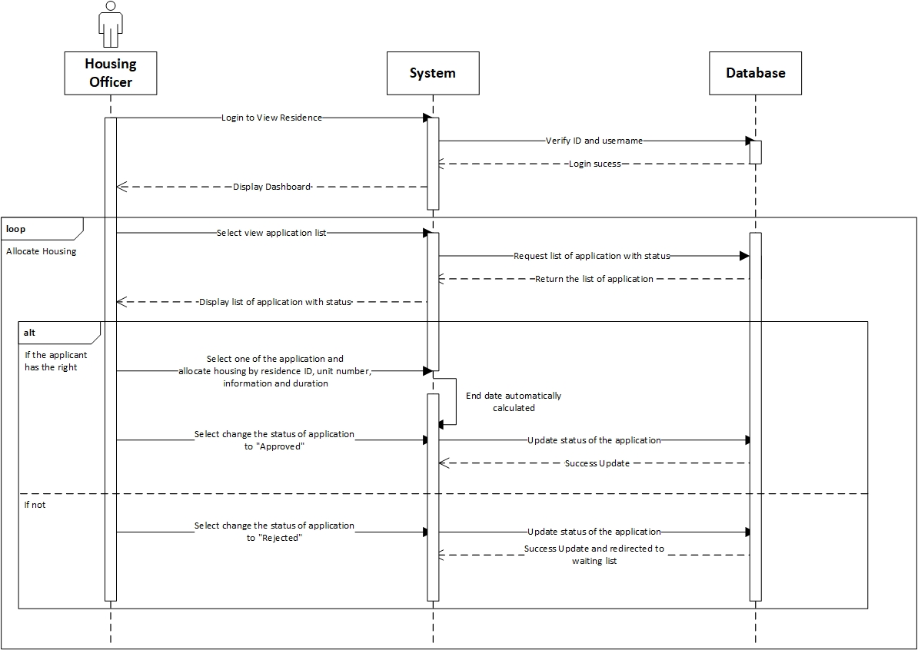

**Prepared by: Luh Wulandari Maharani**

|  |  |
| --- | --- |
| **Cross References** | **Allocate Housing** |
| Operation | Login with ID and username |
| Responsible | To access the main page |
| Pre-conditions | * Username must be available * Password must be available |
| Post-conditions | * Username is matched * Password must be match based on user’s password input * Display dashboard |

|  |  |
| --- | --- |
| **Cross References** | **Allocate Housing** |
| Operation | Select view application list |
| Responsible | To get the list of all application |
| Pre-conditions | The application object must be available |
| Post-conditions | Success displayed list of all application with status |
| **Cross References** | **Allocate Housing** |
| Operation | Select one of the application and allocate the housing |
| Responsible | To allocate the housing for an application |
| Pre-conditions | Object residenceID, unit number, from date and duration must be available |
| Post-conditions | Success create allocation object based on data input |
| **Cross References** | **Allocate Housing** |
| Operation | Select to changed status of to be “Approved” |
| Responsible | To change the status to “Approved” |
| Pre-conditions | Application object must be available |
| Post-conditions | Success changed the application status |
| **Cross References** | **Allocate Housing** |
| Operation | Select to changed status of to be “Rejected” |
| Responsible | To change the status to “Rejected” |
| Pre-conditions | Application object must be available |
| Post-conditions | Success changed the application status and redirected to waiting list |

1. **Sign Up Applicant**

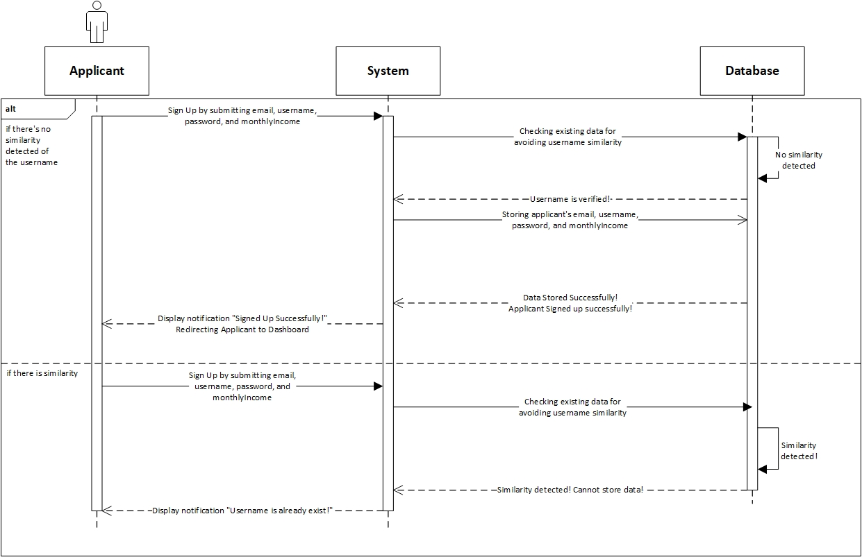

**Prepared by: Rivaldo Bagus Soepardhy**

|  |  |
| --- | --- |
| **Cross References** | **Sign up Applicant** |
| Operation | Sign up with email, username, password, and monthlyIncome |
| Responsible | To be registered in system and able to access the main page |
| Pre-conditions | * Email must be available * Username must be available * Password must be available * MonthlyIncome must be available |
| Post-conditions | * Username is verified (no similarity detected) * Registered in System * Display dashboard |
| **Cross References** | **Sign up Applicant** |
| Operation | Sign up with email, username, password, and monthlyIncome |
| Responsible | To be registered in system and able to access the main page |
| Pre-conditions | * Email must be available * Username must be available * Password must be available * MonthlyIncome must be available |
| Post-conditions | * Username is not verified (already existed in system) * Applicant must re-enter new username. |

1. **Edit Residence Detail**

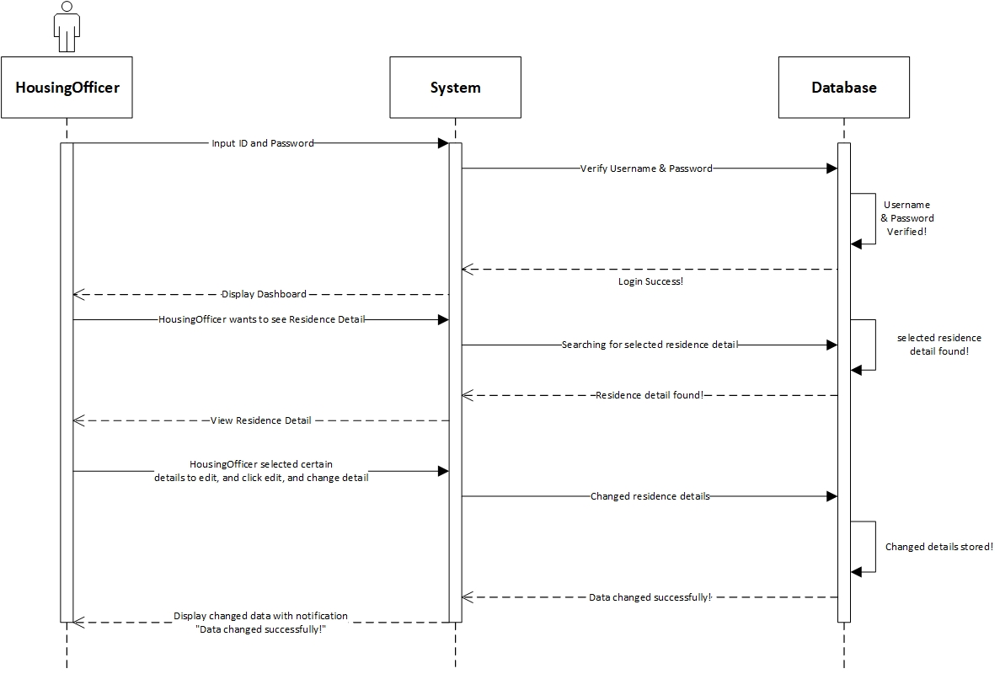

**Prepared by: Rivaldo Bagus Soepardhy**

|  |  |
| --- | --- |
| **Cross References** | **Edit Residence Detail** |
| Operation | Login with username and password |
| Responsible | To get access to view the applications |
| Pre-conditions | * Username must be available * Password must be available |
| Post-conditions | * Username is matched * Password must be match based on user’s password input * Display dashboard |
| **Cross References** | **Edit Residence Detail** |
| Operation | Edit residenceID, address, numUnits, sizePerUnit, monthlyRental |
| Responsible | To change certain Residence Detail |
| Pre-conditions | We will need **one of** or **all of** the details below:   * Email must be available * Username must be available * Password must be available * MonthlyIncome must be available |
| Post-conditions | Residence Detail changed successfully |

1. **Payment Detail**

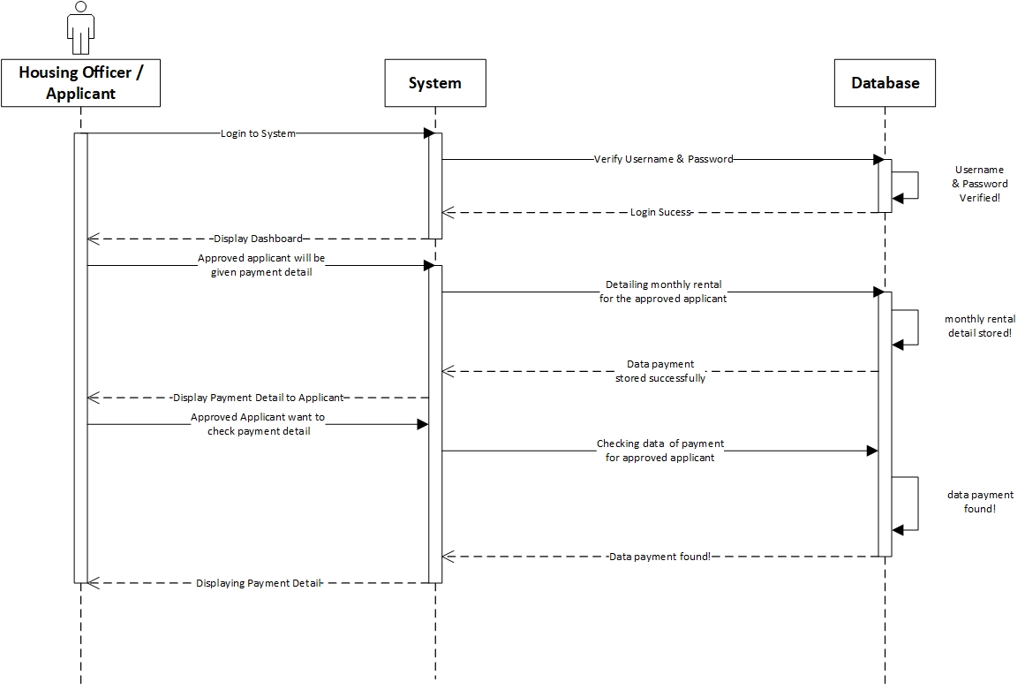

**Prepared by: Rivaldo Bagus Soepardhy**

|  |  |
| --- | --- |
| **Cross References** | **Payment Detail** |
| Operation | Login with username and password |
| Responsible | To get access to view the applications |
| Pre-conditions | * Username must be available * Password must be available |
| Post-conditions | * Username is matched * Password must be match based on user’s password input * Display dashboard |
| **Cross References** | **Payment Detail** |
| Operation | Entering Payment Detail (payment rent) |
| Responsible | To store payment detail of applicants monthly rent |
| Pre-conditions | * HousingOfficer must already have the exact amount of monthly rent to be entered * Applicants has already live in the residence |
| Post-conditions | Payment Detail stored Successfully, and HousingOfficer can preview the result immediately. |

|  |  |
| --- | --- |
| **Cross References** | **Payment Detail** |
| Operation | View Payment Detail |
| Responsible | To see applicants amount of monthly rent payment |
| Pre-conditions | * HousingOfficer must already enter the payment detail * Applicants has already live in the residence |
| Post-conditions | Applicants can see exactly amount of payment rent they need to pay. |

1. **Submit Application**

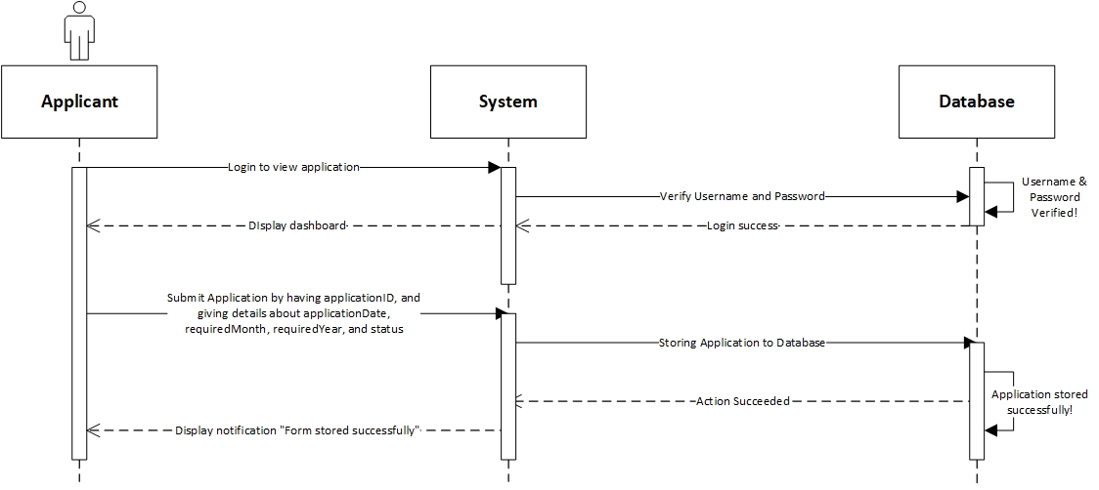

**Prepared by: Rivaldo Bagus Soepardhy**

|  |  |
| --- | --- |
| **Cross References** | **Submit Application** |
| Operation | Login with username and password |
| Responsible | To get access to view the applications |
| Pre-conditions | * Username must be available * Password must be available |
| Post-conditions | * Username is matched * Password must be match based on user’s password input * Display dashboard |
| **Cross References** | **Submit Application** |
| Operation | Submit applicationID, applicationDate, requiredMonth, requiredYear, and status |
| Responsible | To submit applicant’s application to the database |
| Pre-conditions | We will need **all of** the details below:   * applicationID will be given by system automatically * applicationDate must be available * requiredMonth must be available * requiredYear must be available * status will be given by system automatically |
| Post-conditions | Application will be stored successfully, and will be on waiting list for the approval & arrangement by HousingOfficer. |

1. **Delete Applicant**

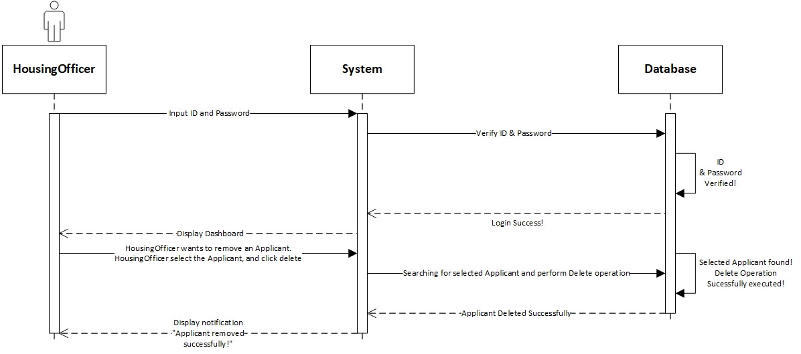

**Prepared by: Rivaldo Bagus Soepardhy**

|  |  |
| --- | --- |
| **Cross References** | **Delete Applicant** |
| Operation | Login with ID and username |
| Responsible | To access dashboard, and delete applicant |
| Pre-conditions | * Username must be available * Password must be available |
| Post-conditions | * Username is matched * Password must be match based on user’s password input * Display dashboard |
| **Cross References** | **Delete Applicant** |
| Operation | Delete Applicant |
| Responsible | To remove an applicant |
| Pre-conditions | The applicant object must be available, and the applicant is no longer in place (checkout) |
| Post-conditions | Applicant object will be removed successfully |

Tasks Division

|  |  |
| --- | --- |
| Required Behaviour | Member’s Name |
| HTML and CSS script for design the website menu | Aldo |
| PHP script for login and logout | Aldo |
| PHP script for sign up | Wulan |
| PHP script to change password | Aldo |
| HTML and CSS script for how the data display | Wulan |
| PHP script for edit residence detail, delete the applicant and residence detail | Aldo & Wulan |
| PHP script for payment detail | Aldo & Wulan |
| PHP script for wishlist menu | Wulan |