Omar Aldohami ,Orhun Özcan, Fusun Cemre Karaoglan Yazici, and Andres Hurtado

BIM-Integrated Cost Management Practices in Construction

Abstract

The construction industry represents an important part of the global GDP, thus putting cost management in a key role in nowadays building projects. By understanding important concepts such as quantity take-off, cost estimation and cost control throughout various construction phases, this paper intends to analyze the state of the art in cost management and potential improvement points in the field. Especially, using cost management in coordination with Building Information Modelling (BIM) holds the potential to provide significant improvements in the avoidance of major delays and budget overspendings. The research is based on a literature review of research on similar topics, a survey applied to industry players, and a software analysis of the current solutions in the market. Even though there are many solutions regarding pre-construction cost management processes, only a few studies are focusing on cost control. Therefore, the study aims to discuss possible solutions that can be implemented in the industry and respond to the challenges discovered through a flexible and user-friendly interface. Two different approaches are presented, one with open-source tools and one with private tools. Different from the previous studies the integrated open-source solution focuses on the visualization of the cost status of building elements through colourization. In future studies, the approaches will be further developed with the data of existing construction projects.

**Keywords:** Cost Management, Earned Value Analysis, Cost Control, Construction Management.

1. Introduction

The construction industry has a share of 13% of the global Gross Domestic Product (GDP) and accommodates 7% of the working population [1]. Considering its impact on the world economy, the construction industry must adopt meticulous cost management approaches. By analysing the state of the art in cost management, this study aims to discuss possible solutions in various construction phases through BIM (Building Information Modelling) applications. Especially improvements in cost control can potentially be helpful for managers to analyze a project’s performance and to be more proactive in making prompt decisions and timely adjustments. This could consequently result in the avoidance of major delays and budget overspendings.

When major delays and budget overspendings are the issues, it is possible to find many examples from the past. Some of the budget overrun examples are listed below, showing the scale of the problem:

* Pune Metro in 2009, estimating project cost to be 1.2B $. Revised to 1.7B $ [2].
* 332 facility projects funded by the US Air Force: 72% were not completed within time [3].
* Whole complex construction projects in the UK are likely to be finished more than six months late [4].
* Road construction in Norway: Mean cost overrun as 7.88% [5].
* Government and private building projects in Hong Kong: Time overrun of 9% and 17% [6].
* Nigeria: Average time overrun of building projects could range from 59.23% to 92.64% depending on the value of the project [7].
* A survey of 359 completed projects in Malaysia found that 55% experienced cost overruns [8].

Looking at these examples it is possible to assert that cost management is a significant tool that can aid the shareholders in the construction industry ranging from architects, planners, and engineers to clients. For this reason, this paper focuses on the possible use of BIM-integrated systems in cost management processes.

Quantity take-off, cost estimation and cost control are the main phases of a cost management system. Quantity Take-off, cost estimation (cost analysis, budgeting, cost breakdown structure) and cost control (Earned Value Analysis) will be introduced and discussed in depth in the following sections. State-of-art in this field and the current solutions will be discussed. Then, the results of the survey conducted with construction company representatives regarding cost management will be presented. As result, this research promotes driving all findings toward a solution that can be flexible and user-friendly to be implemented in real projects covering most of the difficulties discovered in the last section.

1. Research Methods
   1. Literature Review (Concepts)

As the aim of the research is to implement cost management practices in automated and digitalized ways, the first thing we need to do is to understand and explain cost management and concepts related to it. Cost management is one of the core processes of project management combined with scope and time management [9]. According to the Project Management Institute (PMI), cost management can be divided into four domains namely, planning cost management, estimating costs, budget determination and cost controlling [10]. Planning cost management is a phase of cost management that it is described how to estimate costs, determine budgets, monitor, and control the costs of the project. Estimation of the costs is the phase where the project’s monetary resources to complete work are approximated. The third phase is where the estimated costs are structured in a way to be tracked. It is important because structures of planned values and actual costs should match each other to be aggregated and compared. This is called budgeting of the project. And in the cost control phase, the budgeted costs are controlled and the status of the project in terms of costs is determined.

### Cost Estimation

Cost estimation is the process of quantifying and costing the resources needed to complete a work or project [11]. For cost estimation there are various tools and techniques, also there are different classes of estimation for different goals. Cost estimation can be classified into 5 classes concerning their estimation detail and ranges [11]. For control purposes, class 1 and class 2 estimates are being used where there are detailed unit costs and take-offs.

Cost estimation has three main processes which are quantity take-off, costing of the works and budgeting. For more effective and detailed cost control, the costs should be estimated bottom-up. To make a bottom-up estimation, a detailed work breakdown structure (WBS) should be created from the scope of work, to determine the resource requirements of each specific activity to complete the total work. These works include the direct works and indirect works to complete the total scope. To determine those requirements, unit price analysis is done for each work item in the WBS. The resources can be divided into groups according to their types. These types are labour, material, equipment, and subcontractor and sometimes it can be currency.

Quantity Take-off

Quantity take-off is the process of quantifying and measuring the work to be performed. It is the starting point of cost estimation as it provides the quantity information of a project. The set of quantities produced by quantity take-off is called the ‘Bill of Quantities’. Bill of quantities is an important part of a construction contract as it is used for tendering, cost estimation, progress payments etc. Because of this, quantity take-off should be done according to agreed terms and rules by the contracting parties. There are many measuring rules published by different organizations around the world which can be used as guides and standards for quantity take-off. Quantity take-off is an activity which is used throughout the lifecycle of a construction project (see Figure 1).

#### Cost Analysis of Work Items

The quantities measured in the quantity take-off process are installed by some work items called activity or task. In other words, the Bill of Quantities of items are elaborated with activities to install that specific item. These activities and tasks also have their own quantities to be measured or calculated according to the BOQ item. For each activity unit price analysis is done and required resource amounts are estimated. For a BOQ item, the activities listed below that BOQ item is used for estimating the unit price of that item. When each cost information is aggregated, the total cost of the project can be estimated in detail.

#### Budgeting

Budgeting is the next step to convert cost estimate into a controllable and manageable breakdown. This is because the structure which is used for tracking costs mostly differs from the structure of the cost estimate [12]. With budgeting, the budgets can be created where the costs of the project can be controlled and accounted for. Cost elements (resources) listed under WBS are cost-coded according to different attributes. These attributes can be owning a department, resource type, work section etc. Total resource requirements can be summarized in the desired level by cost codes and summarized in that coding structure for the budgets.

**Fig. 1.** Quantity take-off in the project life cycle [13].

#### Cost Codes and Cost Breakdown Structure

Cost codes can be given at any level of WBS, including the activities and resources listed below them. Coding is for classifying the cost elements in a structured way to make it easy for actual cost tracking and cost performance measurements. It is ideal to have a CBS like WBS to make it easier to track costs and assign the costs to a schedule [12]. As it has been told CBS can be at any level, so it is better to have a CBS and cost codes in the resource level to track resources and see budget variances.

### Cost Control

The concepts in cost management are interrelated. It means any activity being performed for cost estimation and budgeting directly affects the cost control system. According to PMI controlling cost is the process of monitoring the cost status of the project and change management of the cost baseline produced in the budgeting phase [10]. To do this, the costs of the project should be summarized in a cost breakdown structure and actual costs can be easily allocated to the elements of the cost breakdown structure via cost codes. There are many tools and techniques for cost control, however, one of the most efficient and successful techniques is Earned Value Management. In this report earned value management will be discussed. Another aspect of cost control is related to changes in the project.

#### Earned Value Management

Earned Value Management is a cost and schedule control technique to measure the schedule and cost performance of the project. It compares actual costs or values with the earned values of the budget or schedule and gives performance insight for the project with respect to progress. Earned values of a budget can be determined in various ways. For example, by integrating budget values into tasks via CPM (critical path method) scheduling tools, earned values of each budget can be determined with a cut-off date. Or installed quantities of works can be tracked to measure progress and calculate earned values. The percentage of the variance between planned values and actual values gives the performance indexes of budget and schedule. Applying earned value management in a project can give early warning for budget variances and lets the project management team take early decisions for these variances. Therefore, earned value management is an important part of cost control. According to AACEI [11] for a complete earned value system the followings are required:

* Organization of the program
* Work Breakdown Structure (WBS)
* Organizational Breakdown Structure (CBS)
* Responsibility Assignment Matrix (RAM)
* Work Authorization
* Planning, Scheduling, and Budgeting
* Performance Measurement Baseline (PMB)
* Control Accounts (CA)
* Risk Management
* Work Packages (WP)
* Planning Package (PP)
* Management Reserve (MR) and Contingency
* Earned Value Definitions
* Variance Reporting
* Change Management
* Performance Review

#### Change Control

Changes in a construction project have time and cost impacts on the project. Therefore, it is important to reflect those impacts on the budget to properly measure cost performance. These changes are tracked separately and integrated into the budget with forecast revisions.

Setting up an effective project cost management system is vital for avoiding cost overrun which remains a key risk of construction. Hence, the use of digital tools and technologies has fostered new solutions and potential improvements in terms of efficiency, quality, and precision during cost management processes. This research method is based on a systematic review which is carried out to find relevant papers and reports concerning the latest trends in cost management. The strategy follows this sequence: (1) finding all relevant publications, (2) classifying papers for in-depth study, and (3) synthesizing the literature. This flow serves to build up for the proposed approach, by thoroughly conducting market research, highlighting important concepts, and reaching upon the benefits and limitations of the latest trends. Academic databases such as Google Scholar were used for conducting the search by typing-in relevant keywords. The findings are classified based on applications and are summarized in the proceeding sections.

**Fig. 2.** Planned, Actual, Earned Values (PMI, 2017).

1. The State of the Art
   1. Cost Management Using BIM

One of the most prominent technologies in AEC is the use of Building Information Modelling, BIM, which contains not only geometric data but can accommodate a great amount of engineering data over the lifecycle of a building [14]. There exists a growing interest in the use of BIM for coordinated, consistent, and computable building information/knowledge management from design and construction to maintenance and the operation stages of a building’s life cycle [15]. It was reported that 87% of expert users are experiencing a positive return on investment with BIM; while 93% believe that even more return can be achieved for the potential value of BIM [16]. Nowadays exist numerous tools and technologies in the rapidly emerging BIM domain which may promote massive opportunities for project cost management professionals to dramatically improve the quality, speed, accuracy, value, and complexity of their cost management services and consequently ensure the future as key players in the BIM world. Nonetheless, the current paradigm is slow to embrace and evolve with the full potential that these technologies can provide.

### Quantity Take-off and Cost Estimation

Quantity take-off and cost estimation represent a basis for cost management. The efforts and results of cost estimation practices are interconnected with controlling the costs. Therefore, they cannot be considered separately for cost control.

Quantity take-off and cost estimation can be partly automated with various commercial tools on the market. These processes are done by in-house algorithms and individual results in terms of quantity take-off. Hence the outputs can be used to a certain extent and require tailoring to be used in the cost management of a project. Also, cost estimation practices can be varied according to many factors. For example, measuring and surveying rules and estimation structure can change according to countries and even organizations. Therefore, research about quantity take-off is mostly focusing on these interoperability issues and standards-programs compliance. Forgues et.al. [17] studied a potential approach using various tools including REVIT and databases like Timberline to automate cost estimation workflows. It is discussed that connecting the software and their data is a tricky process which is an obstacle to automating cost estimation workflow. Parameters of one software are usually different from other software. As a result, a huge amount of effort should be given to establishing an automated workflow. Another issue is the differences between data schemas of BIM and industrial standards. Industry Foundation Classes (IFC) is a data schema for data exchange between BIM applications. The objects in a 3D model are represented by entities in the schema. However, the mapping between entities and the breakdown of industry standards are not readily available. This issue has been covered by Lee et.al [18] by using ontological inference of work items according to BIM data. There are also other studies for matching IFC objects with standards. Zhiliang et.al. [19] investigated the possibility of using IFC standards for tendering in China complied with Chinese practices. They concluded that IFC entities can be mapped and used for tendering in China, however it doesn’t cover everything needed for tendering and should be extended and studied more. This situation is most possibly the same for all other countries.

### Integrated BIM & Lean Construction for cost management

Lean construction is an alternative contemporary construction management method influenced by lean production techniques applied by Toyota Company. The main philosophy of lean construction is the reduction of waste and improvement of productivity [20]. In this manner, BIM functionalities can be used along with Lean Construction with synergy. Visualization, automation of document and design generation, the collaboration between design and construction, planning evaluations, object-oriented data communication and information for computer-aided fabrication are these functionalities which can be used for lean construction management [20]. Exploiting BIM functionalities with lean construction has many benefits in terms of cost management. Predictive performance analysis, simulation of construction, decreasing changes, reduction of risk, collaboration, and structured data flow are some of the benefits of BIM lean construction synergy [21].

### BIM 5D Visualization

It is believed that one of the main features of BIM is visualization, by adding another dimension to monitor and control deviations which can be detected and solved early by acquiring proper decisions. Elbeltagi [22] developed a mathematical model for evaluating construction performance with respect to cost by deriving a set of equations based on EVA. Furthermore, a BIM-based visualization system was introduced to facilitate tracking and monitoring of construction progress by enabling 5D visualization of the construction progress along with the geographical conditions by adopting colour coding which helped in pinpointing the areas that need immediate corrective actions. However, the model lacked a view to concurrently see the resources cost variances for activity along with the overall cost variance which would have added more functionality that comes along with BIM visualization capabilities.

Another BIM visualization application was the synergy of EVA and BIM by Mushamalirwa [23], which enables the user to clearly visualize the cost and time performance of each element based on an Optimistic/Pessimistic assessment with the aid of a colour code system. This was made possible by the interoperability between Excel and Revit, and Dynamo for linking data. However, this Optimistic/Pessimistic approach might be naive since in the reality there exist more uncertainties in construction and the reality is more complex.

* 1. Cost Control

Cost control solutions with BIM focusing on the structuring of a system, are scarce. The use of BIM tools and automation for quantity take-off and estimations is researched commonly and has various applications in the industry. However, cost control still depends on spreadsheets, customized tools, and human effort mostly since it is a. dynamic process. As cost control needs a big amount of data flow from different parties, and the strategy for cost control can differ even for different projects, establishing a successful cost control system is not an easy task. The issues regarding cost-controlling practices themselves are also a factor which makes the processes harder. Interoperability of the software and quality of data and information are counted as some of the issues of BIM implementation [24]. Also lacking standards and software compatibility, and accuracy problems are other important issues [25]. Different practices, lack of standard compatibility and issues in implementing BIM require flexible solutions for different user requirements in digital cost management. Therefore, solutions such as spreadsheets, macros, plugins, and add-ins are mostly proposed for cost control in construction projects.

There are several studies on cost control and BIM integrations. Bejanaro [26] integrated earned value management into BIM connecting the Revit model with Excel via Dynamo plug-in. The author concluded the study by showing the benefits of BIM integration and visualization. Similarly, Chen et.al [27] described BIM practices for cost management throughout the life of a project starting from the preconstruction stage and conducted a case analysis for budget control with earned value analysis. Elbeltagi et.al [22] proposed a comprehensive solution for cost estimation and monitoring using the synergy of various software including Excel, Ms Project, Access, and Revit, discussing BIM and visualization provides useful information and benefits for cost control. Marzouk and Hisham [28] used bridge information modelling for earned value analysis specific for bridge construction, using BrIM methodology with Tekla Structures. In another study by Lee et.al [29] labour productivity data is acquired and monitored with BIM tools, by matching data with a 3D model object. Even though the study focuses on labour performance the principles in the study can be used for any other resource management applications.

BIM carries a huge potential for cost control integration with possible solutions to cost-controlling issues like system incompatibilities, non-collaborative works, the workload of low-tech documentation etc. [24]. The studies related to cost control varies according to approaches, tools used, type of construction, and level of required detail. Different estimation methods and techniques are used for the cost control systems. The variety of approaches can be attributed to the cost control having different practices, tools, techniques, and needs of the users. Therefore, proposed methods and solutions for cost control integration are flexible and configurable, which addresses that variety.

1. Cost Management Survey

Apart from the state of the art of cost management in construction, a qualitative survey is also a strong tool in forming a better idea about the practical applications in the field. It can also aid in determining the challenges in the industry and the shortcomings of the existing approaches in that regard. For these reasons, a survey with 17 questions was formed. It is composed of two parts, namely QTO/cost estimation, and cost control. In total 20 responses are gathered. The formation of the survey and the results are presented below.

* 1. Forming the survey and application

Firstly, when forming the questionnaire, it is significant to have an introductory section that can give us an idea about the participant profile. Therefore, the first three questions are aiming to gather the contact information (email) of the participant, the domain, and the scale of the company that they are employed. This way, it is possible to assess the methods and tools in relation to the company profile.

Secondly, the questionnaire is divided into two main parts. Similar to the chronology of the application in the industry, the first part focuses on the tools, methods and problems related to QTO and cost estimation prior to the construction site, whereas the second part is focused on the cost control during the construction phase. By asking the participants about the tools and methods, it is possible to understand the level of digitalization and automation in this field, and the problems related to this issue. Each of these sections is then further divided into conventional applications and BIM, thus giving further information about the possible shortcomings of BIM applications in cost management. BIM here is used to describe a digital 3D model and the information embedded in the geometry.

The questionnaire is distributed through a QR code, and it is presented to the company representatives at Digital Bau Köln and Karrieretag Bauwirtschaft Wuppertal.

* 1. Results of the survey

In total 20 responses are gathered from various company representatives. The participant profile is shown below (see Figure 3). 52% of participants are working at companies with more than 1000 employees. Such construction enterprises are compelled to form internal systems to ensure team collaboration in different locations. Especially due to the regulations in place since 2017, companies are compelled to use BIM systems for projects with a budget over €100 million [30]. So, hypothetically the use of BIM integrated systems can be more commonly found in enterprises compared to smaller companies. However, the results do not show parallelism to this hypothesis.

Selected questions regarding QTO, and the cost estimation phase are presented below with the distribution of responses (see Figure 4). It can be seen that most of the participants are still working with PDF documents and 2D CAD interfaces that they receive from planning offices. This is a clear indication of the lack of digitalization in the construction industry as 2D drawings are not well suited to be used within automized QTO systems.

Another striking result is the most significant issues that need addressing according to the participants. The top three issues are listed (see Figure 5):

* Human errors due to manual processes,
* Quality of data exchange,
* The contradiction between documents and/or drawings.

These issues are all rooted in the lack of an automized system such as BIM.

**Fig. 3.** Participant profile in relation to the domain of the company and the size of the company.

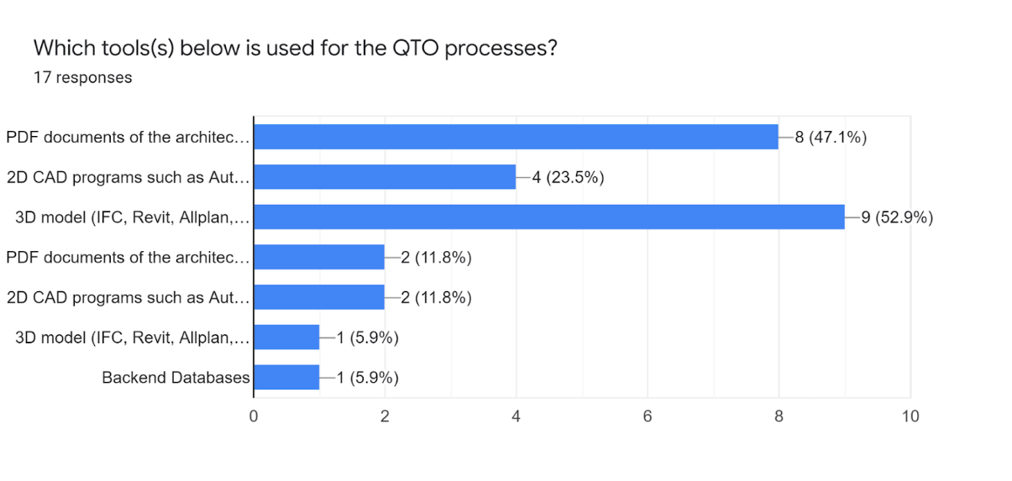

**Fig. 4.** Distribution of tools used for QTO processes according to the participants.

When asked if data extracted from 3D models / BIM models could be a solution to the problems above, 52% of the participants strongly agreed, signalling the existing motivation to benefit from digital tools in the long run (see Figure 6).

More than half of the participants indicated that they are not using any BIM software(s) for QTO or cost estimation (see Figure 7 and Figure 8). When combined with the previous questions, it is clear that there is still a large gap in the industry for BIM tools in QTO and cost estimation.

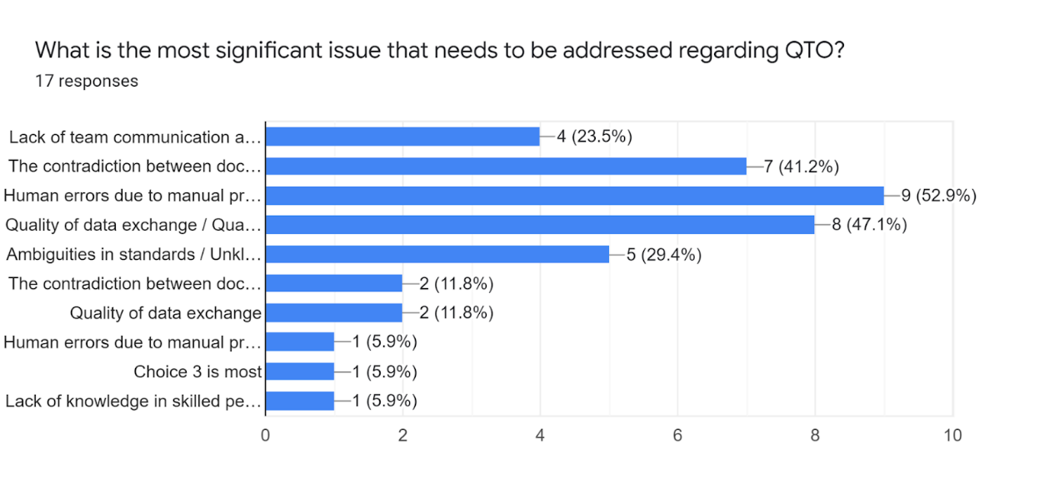

**Fig. 5.** Most significant issues that need to be addressed regarding QTO according to the participants.

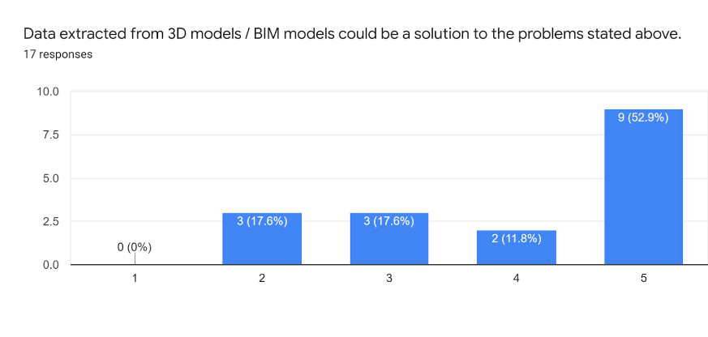

**Fig. 6.** Participants' opinion regarding BIM as a solution to QTO and cost estimation.

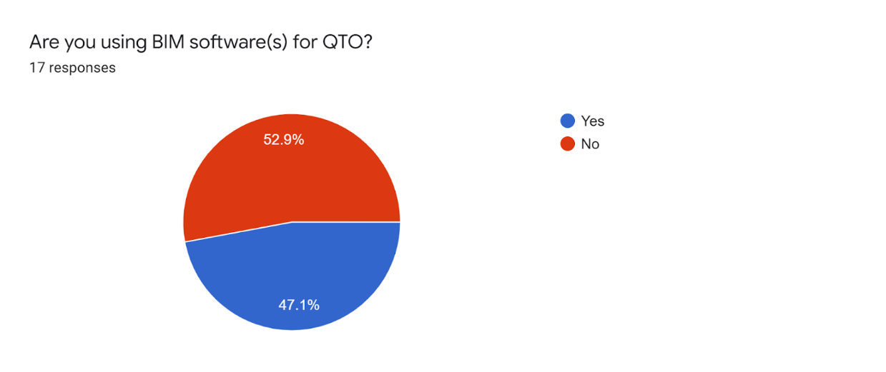

**Fig. 7.** Use of BIM in QTO according to the participants.

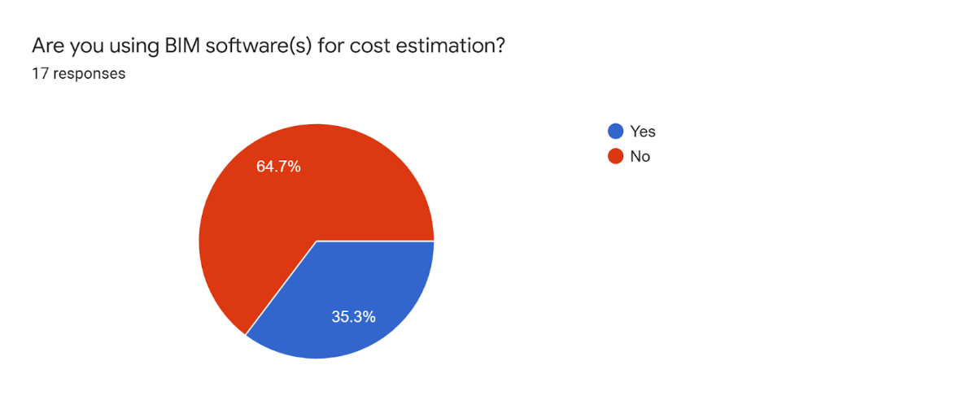

**Fig. 8.** Use of BIM in cost estimation according to the participants.

The following section is based on the results of the cost control part. In this section similar questions regarding tools, methods and problems in the cost control phase are asked of the participants. Selected results are presented below. The top three issues that need to be addressed regarding cost control are (see Figure 9):

* Disruptions in the process,
* Changes in the duration of the project,
* Lack of collaboration and isolated decision-making.

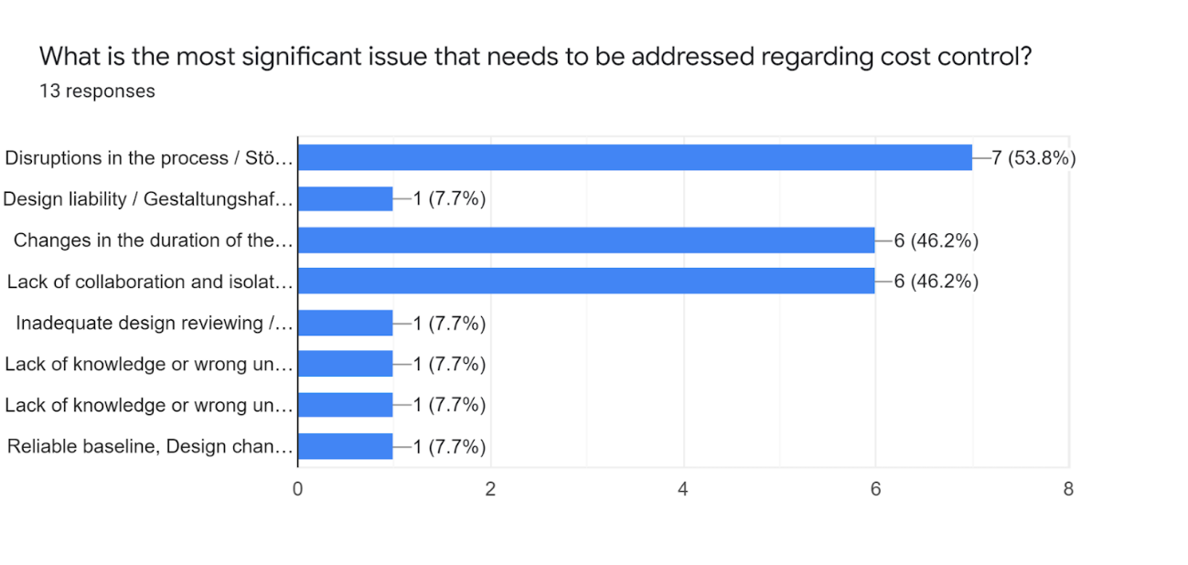

**Fig. 9.** Most significant issues that need to be addressed regarding cost control according to the participants.

Different from the previous section of the survey on QTO and cost estimation, BIM is not mainly viewed as the solution to these problems (see Figure 10). This may be due to the scarcity of BIM use in cost control processes (see Figure 11). 92% of the participants state that they are not using any BIM software(s) for cost control in their company. It is not possible to comprehend the benefits of automatization and to feel the lack of such tools without seeing the practical use.

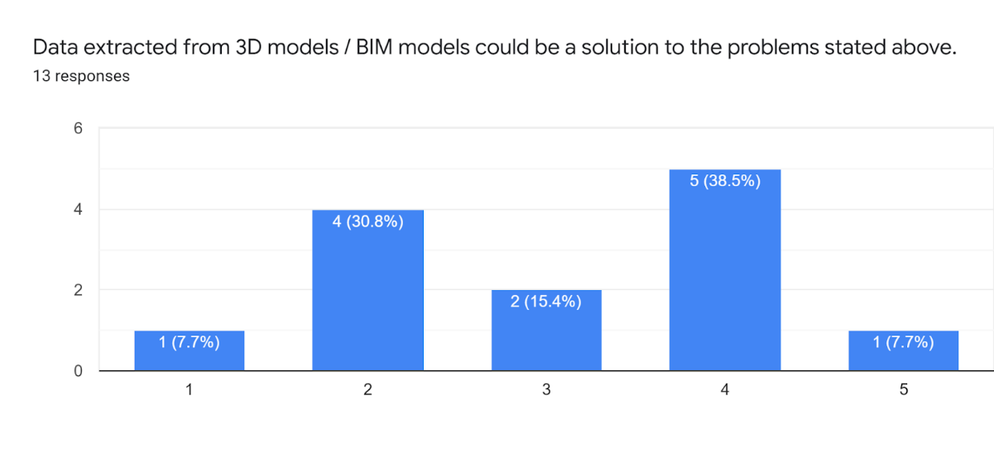

**Fig. 10.** Participants' opinion regarding BIM as a solution to cost control.

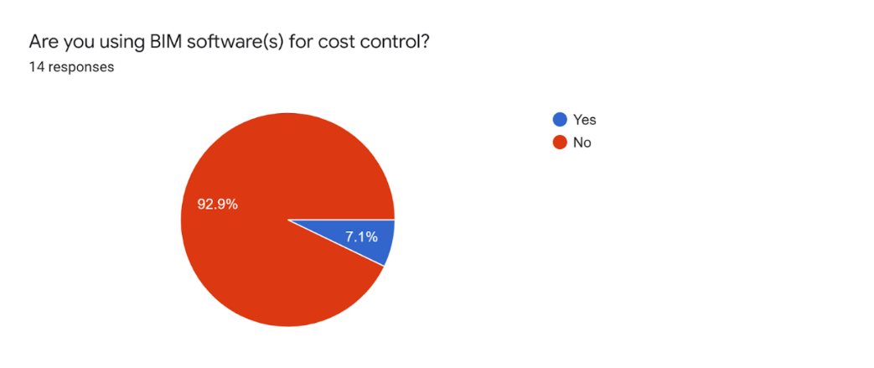

**Fig. 11.** Use of BIM in cost control according to the participants.

* 1. Discussion of the survey results

Looking at the graphs in the previous sections, it is possible to make some deductions regarding cost management in the construction industry:

* Along the process, use of 3D/BIM models and viewing them as solutions to current problems decreases.
* There is no correlation between the size of the company and automation in cost management.
* VOB standard is used for QTO but no common standard or methodology is found for the next steps.
* PDF files are still used commonly for Quantity Take-off.
* Excel is still heavily used in cost control processes.
* Problems regarding cost control are well defined and agreed upon by the participants.
* The main problems regarding working with BIM are:

Lack of skilled workers,

Model quality,

Lack of a common library for varying companies,

Lack of specialists working on cost control.

* It is not easy to collect answers to such a specialized poll as there are not many people focused on cost management, especially the cost control part.
* There are many solutions focused on QTO and cost estimation, but very few solutions on cost control.

1. Software Analysis
   1. **Aim**

While being aware of the current technology advancement rate, this chapter intends to update software comparisons regarding BIM 5D cost control solutions directly related to facilitating the connection between 3D building models and the budget during the construction phase.

The final objective is to understand the existing solutions in the market and the similarities and differences between them through the key features.

* 1. **Definition of criteria**

Based on past BIM 5D software analysis, a more compact amount of criteria parameters were defined to evaluate the scope of all chosen software.

These criteria parameters comprehend helpful uses across the pre-construction and construction phase which is the focus of this research.

### Criteria parameters description

* Field input interface: Capacity to retrieve information from the ongoing construction in a user-friendly interface.
* Model sharing data: Information flow between model, budget, and cost control sheets.
* Support cloud applications: connection to an online database
* Interoperability: Facility of format software exchange.
* Value of completed activities: Capacity to display cost progress per activity.
* Cost overrun alert system: Feature to automatically generate a message to people in charge regarding cost control in the field and offices.
* Monitoring use of resources: Cost breakdown tracking included.
* Automatic changes cost estimation: Real-time quantification and updating from the model to the budget.
* Dashboard interface: Complete business intelligence reports in real-time.

### Criteria parameters evaluation

According to the completion of the criteria parameters those who met 100% of the requirement, are graded by “1”, partially implemented with a mean of “0.5” and no feature inside of the software related to the criteria parameter is graded with “0”.



**Fig. 12.** Software comparison table.

It is important to understand that many of this software also need a plan of implementation to accurately reach the desired performance in each parameter because often the input and output information comes from different professionals and standards which must be synchronized with these digital tools to provide a unique database which serves construction managers and cost managers to act and adjust more precisely the project parameters in order to generate savings as a return of the investment of the application of such software.

As the total sum of points shows BEXEL manager is the most complete option for private providers to companies that want to implement BIM 5D software in the construction phase. Despite the large list of features, it has a price for the single user of 2.400 € which means just a single part of investment besides professional capacitation, other necessary licenses, and extra time invested in change management for new workflows.

Finally, a tool that can meet all the requirements in the parameters analysed in the table above and still can be simple (user-friendly), flexible and affordable for any construction company regardless of its earning size is still missing in the market. The next chapter intends to show several approaches which can fill this space.

1. Approach

As an outcome of the literature review, the software comparison and the poll results, a project is proposed. There are much fewer existing solutions based on cost control compared to QTO and cost estimation. Therefore, the project focuses on a flexible workflow that creates a solution regarding cost control processes. The workflows of the two approaches (private and open-source) are presented below (see Figure 13 and Figure 14).

**Fig. 13.** Open-source project workflow.

**Fig. 14.** Private software project workflow.

The flow aims for a user-friendly input and output interface that connects the cost engineer working on the construction site and the client or project manager. This way, it will be possible to create intuitive displays that visualize the cost data on an IFC model or on a Revit model.

* 1. Database

Open-Source Approach

The data plugged in by the engineer is then transferred to the database (see Appendix 1). Excel and SQL are the best options for such a task. However, SQL is chosen as it works much more efficiently with relational tasks. The database can later be used for further applications when several project data are embedded.

Private Approach

The data plugged in by the engineer is going to be imported into Revit as Excel files.

* 1. Parameter assignment to the model

To display the cost status of the building elements in a 3D model, it is necessary to assign a new parameter to these objects. As the cost parameter is not an existing IFC entity, a custom property assignment is needed. Currently, there are two working systems in this regard, the first done using open-source tools and the second using licensed tools.

Open-Source Approach

Cost status is assigned according to the comparison of “Actual Cost” and “Estimated Cost” in the database. After assigning the cost parameters, each IfcBuildingElement is given a colour representing its cost status. Building elements are coloured green if they are “under budget”, blue if they are “on budget” and red if they are “over budget” (see Appendix 2).

Private Approach

Through the graphical programming tool Dynamo, the parameter for cost status is filled from imported Excel tables.

* 1. Output interface

The final step of the project is to create an output interface that the end user can utilize easily. Such an output interface comes in the form of a BIM-enabled dashboard which allows the user to easily visualize the model and corresponding cost-status to each element of the building. The main goal was to embed an IFC-viewer into the browser, which could display the cost status in colours. For this sake, a systematic approach was implemented to list probable software alternatives. Final filtering process lead to three alternatives: (1) PowerBI as an interactive data visualization environment + SeveUp as a BIM platform to import IFC data, (2) IfcOpenShell as an open source software library which allows working on IFC schema + Jupyter Notebook as a web-based interactive computing platform + Voilà which turns Jupyter notebooks into standalone web applications for making a dashboard, and (3) Autodesk Revit + Dynamo + Excel. Each of the three alternatives are thoroughly discussed and investigated within the following sections and eventually the decision upon the optimal alternative is taken.

* + 1. Alternative I: PowerBI + SeveUp

Power BI service is a secure Microsoft hosted cloud service that lets users view dashboards, reports, and other Power BI apps. The idea was to embed an IFC-viewer into a BIM dashboard created on Power BI. To achieve such a goal, SeveUp App is an online platform allowing BIM actors to simply access and exploit BIM data and processes with data visualization. A new project was created containing the dashboard named “RDP BIM DASHBOARD”, and the IFC model named “SoftSkills_cost_color.ifc” was imported as IFC 4 Reference View version for architecture. Now the model is ready to be exported as pbit. Extension which is supported by Power BI.

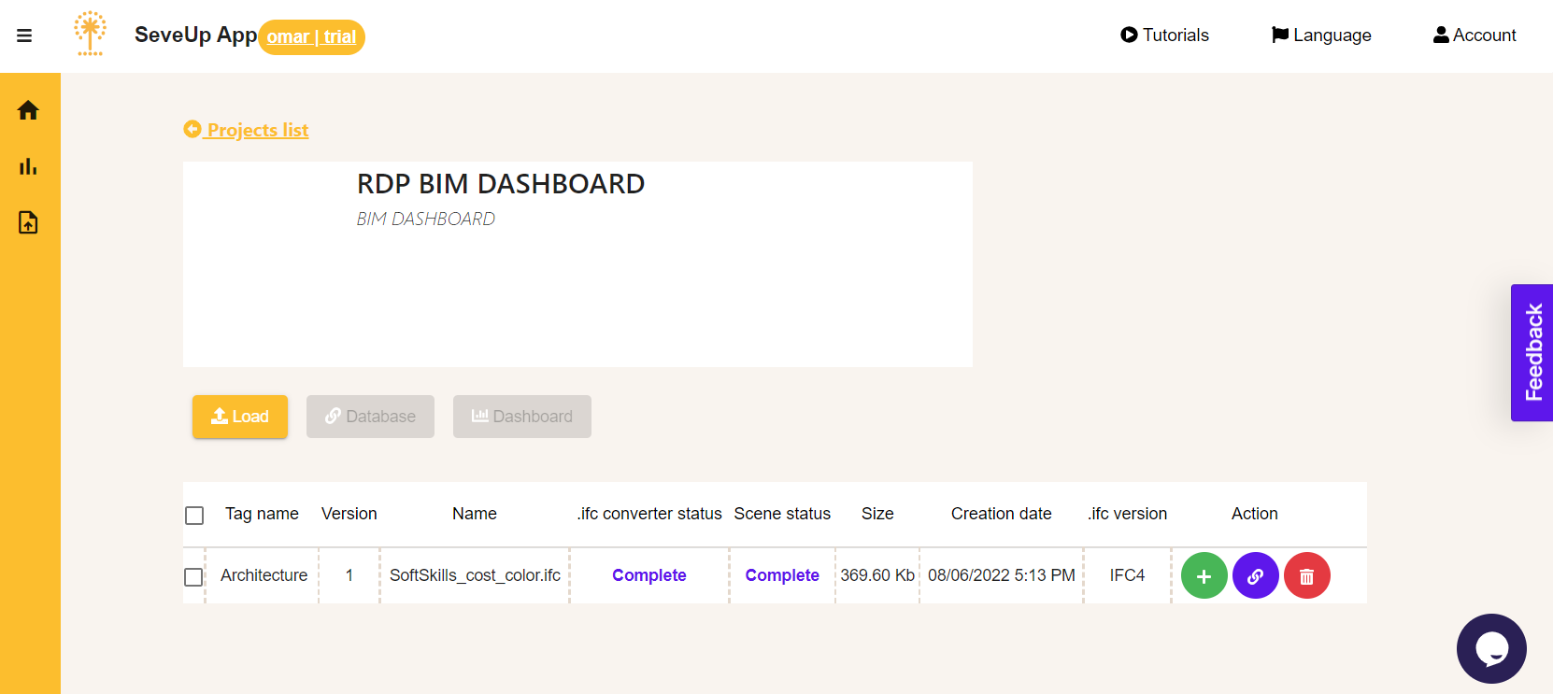

**Fig. 14:** RDP BIM DASHBOARD created on SeveUp App Platform.

The file was then downloaded with the name “Viewer-assets”, and opened with PowerBI. After all properties, assets, asset tree, QTO, and data service URL are evaluated and loaded automatically, the model was imported to the template.

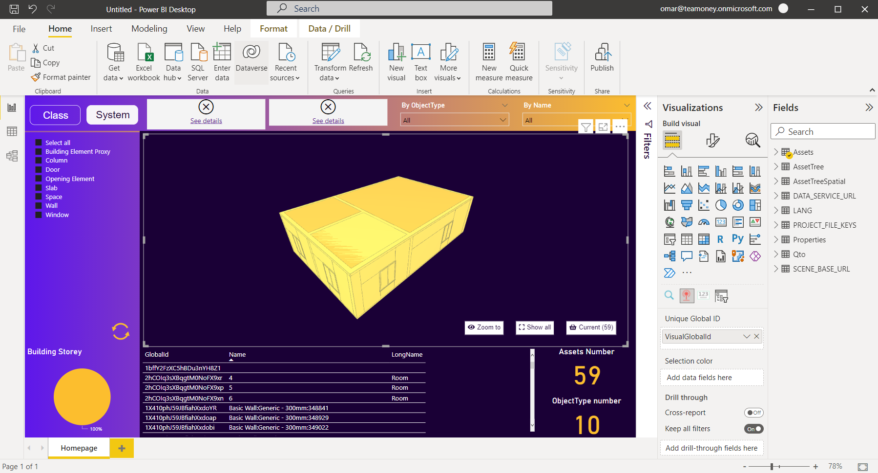

**Fig. 15:** RDP BIM dashboard imported to Power BI.

After the model was loaded in Power BI desktop, the following shortcomings were observed:

1. Faulty in automatically importing queries such as AssetTreeSpatial which is the core for the IFC spatial hierarchical structure for the model according to BuildingSMART, as shown in the figure below.

**Fig. 16:** IFC Spatial Tree showing model hierarchy.

1. Colours assigned according to cost status were not shown in the viewer.

After realizing these problems, it became clear the necessity to look for another alternative which can correctly import IFC Schema and show the colours assigned to each element according to cost status, which is the main aim of this approach.

* + 1. Alternative II: Jupyter Notebook + IfcOpenShell

Jupyter Notebook is a web-based interactive computing platform which promotes using IfcOpenShell as an open source software library which allows working on IFC schema. Jupyter Notebook was installed using Anoconda, and by using Anconda Powershell Prompt it was set to run via localhost. After installing Pandas package and other required packages, IfcOpenShell library was added. The interactive viewer for IFC models has been extended from Thomas Paviots' JupyterRenderer and offeres a number of functionalities. The viewer component is used to import and show the IFC model.

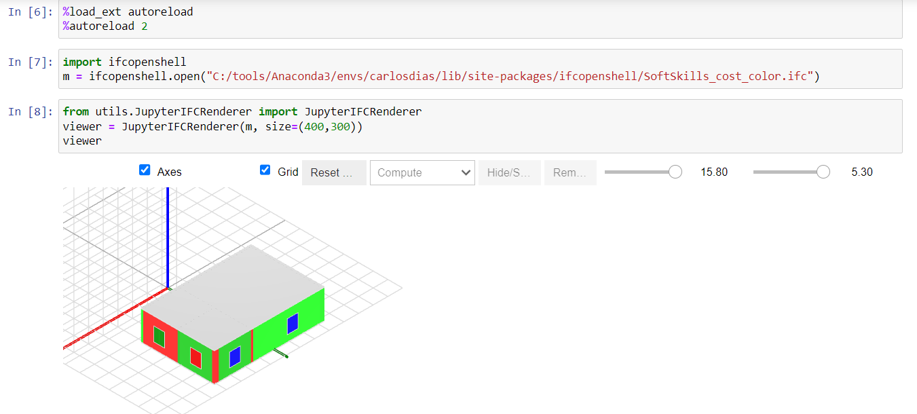

**Fig. 17:** IFC viewer showing the model with colors denoting cost-status of each element.

As can be seen from the above figure, the model is displayed with colours corresponding to cost status. Furthermore, cost data were imported as JSON format and are ready to be tabulated and accessed in the dashboard.

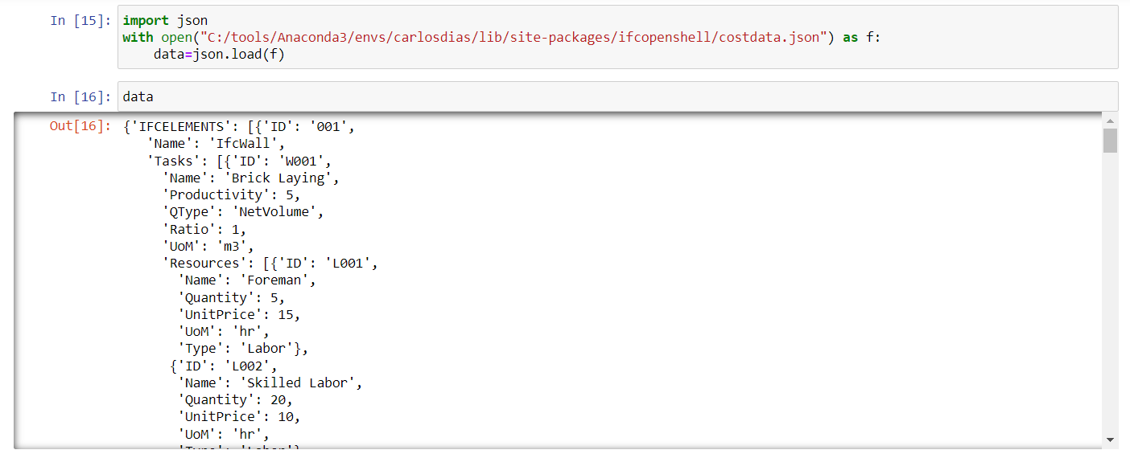

**Fig. 18:** JSON file for cost data imported to the dashboard.

Using Folium made it possible to visualize data in Python by generating an interactive leaflet map. It enabled us pass rich vector/raster/HTML visualizations as markers on the map showing the location of the building. The location was set to the RWTH Construction and Robotics Reference Site.

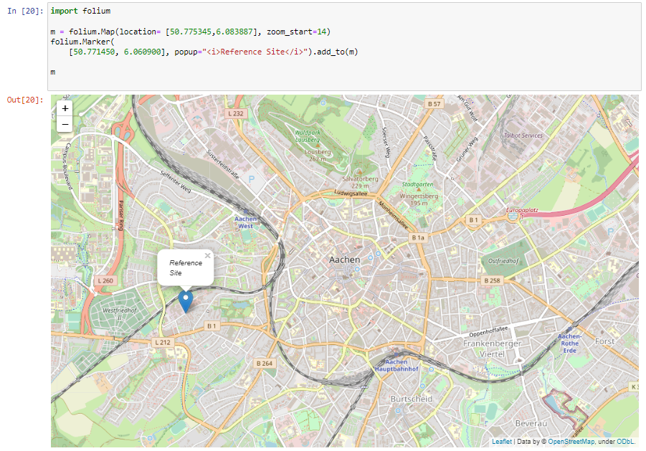

**Fig. 19:** An interactive map was generated to show the location of the building.

Moreover, HTML header tags were added to make the dashboard more appealing and user friendly.

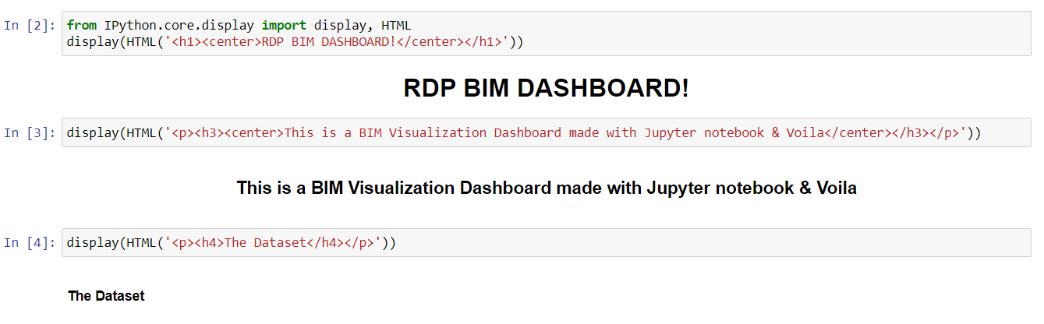

Fig. : Adding HTML headers.

Using Voila enabled turning Jupyter notebooks into standalone web applications for making the dashboard. The output is shown in the next figure.

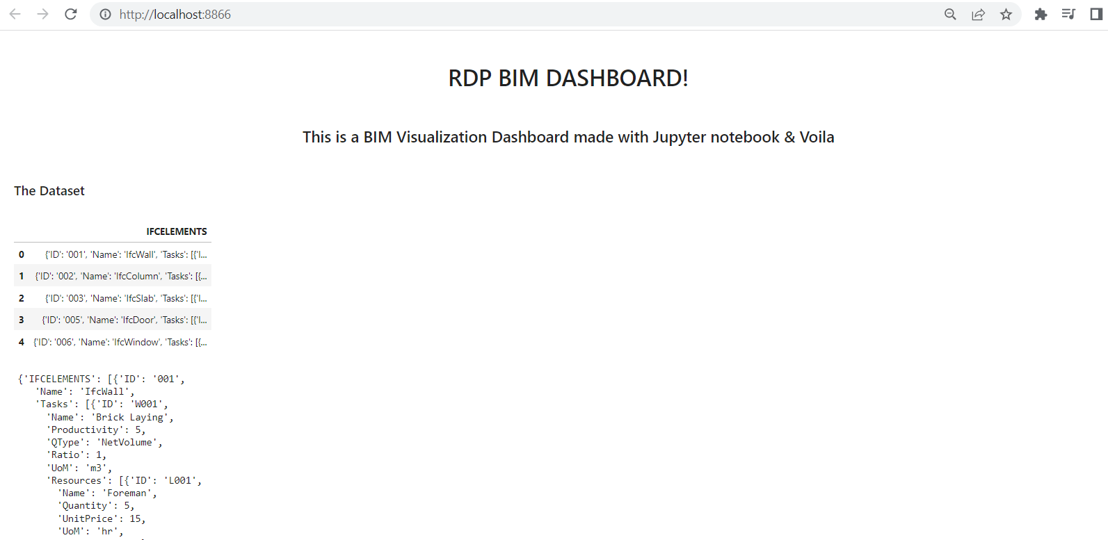

**Fig. 20:** Voilà was used to convert a Jupyter Notebook into an interactive dashboard and display it in a separate browser.

From this point onwards, it became clear how this alternative satisfied all the requirements by being able to show the IFC model with intended colours and having all data easily manipulated by Python. The rest is a matter of styling and fixing the layout for ease of accessibility for the user.

* + 1. Alternative III: Excel + dynamo + Archi-lab_Mandrill package

Using excel as a user input interface and database simultaneously, all information needed is summarized in collums where later on a dynamo script will take that data to fill the Revit model parameters to transform the model into a real-life database. Then, with the available filters for Revit visualization model can be alerted with colours of overrun, underrun or on budget legend. Finally using the same data imported to the model with help of a dynamo package called “Archi-lab_Mandrill” the information is transformed into the shape of a chart to be displayed in a comfortable dashboard which shows the principal stats of the advanced status of the sample project.

**Fig. 22:** Model displayed with dashboard charts with dynamo script included.

* 1. Results

As a result of this study, the initial aim was to achieve an open-source and flexible tool that can be used by the shareholders in a construction project. Currently, it is focused on the cost control phase and the visualization of cost status on an IFC model. However, it can be further developed to encompass various workflows. Additionally, with the private software approach, it can be concluded that a flexible tool such as Excel can be connected to industry standard BIM tools to generate a holistic and simple workflow for a construction company of any scale.

The softskills approach has introduced new means for exploiting BIM data and facilitating a flexible workflow which creates a solution regarding cost management processes. It was clear from the first alternative for creating a dashboard, section 6.3.1, the need for certified IFC software wherein robust implementation and correct applications for IFC2x3 and Coordination View 2.0 and IFC Reference view. It was clear how some software were not capable of importing the correct IFC Schema. There raises the necessity for standardization to enable the entire built asset industry to improve the sharing of information throughout the lifecycle of a building, and to boost interoperability between different disciplines, which is the core aim of BIM and IFC.

It became obvious how the use of IfcOpenShell library helped in building a digital platform and tools for the built environment. It allowed us to read, write and modify BIM models using IFC and we expanded beyond incorporating cost management and adding another dimension to the BIM spectrum, and by integrating other tools such as Jupyter Notebook and Voila, the dashboard was made possible and is to be even more improved in the near future by analysing more data and making it more user-friendly. It is then decided upon Alternative II as the optimal and most feasible, considering the points stated above.

1. Conclusion

A meticulous cost management approach is essential for construction, given the impact the construction industry has on the world economy. Through an analysis of the state of the art in cost management, this study presents possible solutions in various construction phases with BIM. It is a necessity to improve the cost management processes of construction projects to make quicker decisions and make timely adjustments to the project's performance. By doing so, major delays and overspending can be avoided. For this reason, concepts related to cost management in construction are introduced, poll results conducted with construction firm representatives are presented, the state of the art is discussed, and an approach is derived accordingly.

Even though there are many solutions for the pre-construction cost management phases of QTO and cost estimation, there are only a few solutions regarding cost control. Therefore, the application phase of this study focuses on cost control solutions, and it aims to create a mutual interface for construction site cost engineers and the end users such as clients or project managers. There are several studies are focusing on cost control, but it is possible to observe the lack of an integrated open-source solution with a flexible and user-friendly interface. As a result of the approach in this paper, an integrated system that can present the required information for decision-making in a single dashboard is created. The dashboard includes a 3D model coloured according to the cost status of the building elements in the database. Additionally, a private software approach is also applied to experiment with two different methodologies. As both of them are still in progress, there is ample room for improvement.

One of the main challenges was finding participants for the poll, especially engineers or architects who could answer the questions related to cost control. This is due to the fact that there are fewer professionals specializing in this particular field. The number of participants must be increased in future studies so that more solid deductions can be made.

Another challenge was the acquisition of realistic data that can represent all the aspects of a project in the industry. A sample BOQ is obtained from a German construction company alongside an IFC model. However, BOQ has turned out to be very complicated (1000 pages long only for shell construction) and often independent of the building elements in the IFC models, making it inefficient to use it for the approach in this paper. Therefore, a simpler sample project is considered to be adequate for the purposes of this study at this stage.

The third biggest challenge was visualizing the model with the desired colours. It has been possible to display the model in the assigned colours only after removing the "IfcSurfaceStyleRendering" entity from the model as it overrides any visual preference.

In the future, a real-life project with a detailed BOQ, construction site receipts and a connected IFC model needs to be obtained from a contractor company. This way, a further prototype can be derived using a more realistic database.

1. References

|  |  |
| --- | --- |
| [1] | F. Barbosa, J. Woetzel, J. Mischke, M. J. Ribeirinho, M. Sridhar, M. Parsons, N. Bertram and S. Brown, "Reinventing construction through a productivity revolution," McKinsey Global Institute, 2017. |
| [2] | Delhi Metro Corporation Ltd, "Delhi Metro Rail," [Online]. Available: https://www.delhimetrorail.com/. [Accessed 10 07 2022]. |
| [3] | G. J. Hoffman, A. E. Thal Jr, T. S. Webb and J. D. Weir, "Estimating performance time for construction projects," *Journal of Management in Engineering,* vol. 23, no. 4, pp. 193-199, 2007. |
| [4] | CIOB, "CIOB," 2008. [Online]. Available: https://www.ciob.org/sites/default/files/CIOB%20research%20-%20Managing%20the%20Risk%20of%20Delayed%20Completition%20in%20the%2021st%20Century.pdf. [Accessed 10 07 2022]. |
| [5] | J. Odeck, " Cost overruns in road construction—what are their sizes and determinants?," *Transport policy,* vol. 11, no. 1, pp. 43-53, 2004. |
| [6] | M. M. Kumaraswamy and D. W. Chan, "Contributors to construction delays," *Construction Management & Economics,* vol. 16, no. 1, pp. 17-29, 1998. |
| [7] | A. A. Aibinu and G. O. Jagboro, "The effects of construction delays on project delivery in Nigerian construction industry," *International journal of project management,* vol. 20, no. 8, pp. 593-599, 2002. |
| [8] | Z. Shehu, I. R. Endut, A. Akintoye and G. D. Holt, "Cost overrun in the Malaysian construction industry projects: A deeper insight.," *International journal of project management,* vol. 32, no. 8, pp. 1471-1480, 2014. |
| [9] | P. Georgas and G. Vallance, "Cost Management," *PM Network,* vol. 1, no. 3, pp. 29-32, 1987. |
| [10] | A Guide, "Project management body of knowledge (Pmbok® Guide)," Project Management Institute, 2001. |
| [11] | M. Hastak, "Skills and knowledge of cost engineering," in *AACE International*, Morgantown, WV, 2015. |
| [12] | W. J. Del Pico, Project control: Integrating cost and schedule in construction, John Wiley & Sons, 2013. |
| [13] | A. Monteiro and J. P. Martins, "A survey on modeling guidelines for quantity takeoff-oriented BIM-based design.," in *Automation in construction*, 2013. |
| [14] | Z. Xudong and T. Jie, "Building Information Modeling based on Intelligent Parametric Technology," *Frontiers of Architecture and Civil Engineering in China,* vol. 1, no. 3, pp. 367-370, 2007. |
| [15] | C. Eastman, P. Teicholz, R. Sacks and K. Liston, BIM Handbook: A Guide to Building Information Modeling for Owners, Managers, Designers, Engineers and Contractors, NY: John Wiley and Sons, 2008. |
| [16] | N. W. Young, S. A. Jones, H. M. Bernstein and J. Gudgel, The business value of BIM-getting building in-formation modeling to the bottom line, NY: The McGraw-Hill Companies, 2009. |
| [17] | D. I. I. V. F. Forgues and S. Staub-French, "Rethinking the Cost Estimation Process through 5D BIM: A Case Study," in *Construction Research Congress (ASCE)*, 2012. |
| [18] | S. Lee, K. Kim and J. Yu, "Ontological Inference of Work Item based on BIM Data, 19(3):538-549," *KSCE Journal of Civil Engineering,* vol. 19, no. 3, pp. 536-549, 2015. |
| [19] | M. Z. W. Zhiliang, S. Wu and L. Zhe, "Application and extension of the IFC standard in construction cost estimating for tendering in China," *Automation in Construction ,* vol. 2, no. 196-204, p. 20, 2011. |
| [20] | R. Sacks, L. Koskela, A. Dave and R. Owen, "Interaction of Lean and Building Information Modelling in Construction, 136(9)," *Journal of Construction Engineering and Management ,* vol. 136, no. 9, pp. 968-980, 2010. |
| [21] | S. H. A. Alizadehsalehi and J. Huang, "BIM/MR-Lean Construction Project Delivery Management," in *IEEE Technology & Engineering Management Conference (TEMSCON)*, 2019. |
| [22] | E. Elbeltagi, O. Hosny, M. Dawood and A. Elhakeem, "BIM-based cost estimation/monitoring for building construction," *International Journal of Engineering Research and Applications,* vol. 7, no. 56-66, p. 4, 2014. |
| [23] | A. Mushamalirwa, A. Antunes and A. Costa, "A BIM-based solution to Support earned value management in construction," in *BIM International Conference São Paulo e Lisboa*, São Paulo, 2016. |
| [24] | K. Sunil, C. Pathirage and J. Underwood, "Factors impacting building information modelling (BIM) implementation in cost monitoring and control," in *Internation Postgraduate Research Conference*, Manchester: University of Salford., 2017. |
| [25] | P. Smith, "BIM & the 5D Project Cost Manager," in *Procedia Social and Behivoral Sciences*, 2014. |
| [26] | E. Bejarano, "Integration of Earned Value Management into BIM Projects," *Journal of Architectural Engineering Technology,* vol. 8, no. 1, 2019. |
| [27] | P. Chen, C. Shi and X. Ren, "A whole process of cost control strategy of construction engineering based on BIM," in *International Conference on Smart Grid and Electrical Automation*, 2021. |
| [28] | M. Marzouk and M. Hisham, "Implementing Earned Value Management Using Bridge Information Modeling," *KSCE Journal of Civil Engineering,* vol. 18, no. 5, pp. 1302-1313, 2014. |
| [29] | J. Lee, Y. Park, C.-H. Choi and C. Han, "BIM Assisted Labor Productivity Measurement Method for Structural Formwork," *Automation in Construction,* vol. 84, pp. 121-132, 2017. |
| [30] | A. Borrmann, M. K. C. König and J. Beetz, "Building information modeling: Why? What? How?," in *Building Information Modeling*, Springer, 2018, pp. 1-24. |
| [32] | N. W. J. S. A. B. H. M. Young and J. Gudgel, (2009). The business value of BIM-getting building in-formation modeling to the bottom line. Page 4.. |
| [33] | M. A. Vigneault, C. Boton, H. Y. Chong and B. Cooper-Cooke, "An innovative framework of 5D BIM solutions for construction cost management: a systematic review," *Archives of Computational Methods in Engineering,* vol. 27, no. 4, pp. 1013-1030, 2020. |

1. Appendix
   1. Appendix 1

Database_01





Database_02



* 1. Appendix 2

Python code that works with IfcOpenShell library to pull the data from the database and assign colors to the building elements in the IFC file accordingly.

Main



Assign Cost Status



Visualize

