1. **Introduction**

The aim of this Project is to assist the community in exploring better facilities in their neighborhood. This will help people make smart and efficient decisions in choosing a good neighborhood from a number of other neighborhoods in Scarborough, Toranto.

Many people migrate to different states of Canada and need a lot of research for good housing prices and top schools for their children. This project is for people who are looking for a better environment. For easy access to cafes, schools, super markets, drugstores, grocery stores, malls, theaters, hospitals, like-minded people, etc.

This project aims to make a feature analysis for people migrating to Scarborough in search of the best environment as a comparative analysis between environments. Its features include average house prices and better schools by rating, crime rates in the area, road connectivity, weather conditions, good management for emergencies, water sources both sewage and wastewater and sewage transported in sewers and recreational facilities.

This will help people to gain awareness about the area and environment before moving to a new city, state, country or place for their job or to start a fresh new life.

1. **Data**

Data Link: https://en.wikipedia.org/wiki/List_of_postal_codes_of_Canada:_M

Will use Scarborough dataset which we scrapped from wikipedia on Week 3. Dataset consisting of latitude and longitude, zip codes.

We need data about different places in different environments of certain regions. To obtain this information, we will use the "Foursquare" location information. Foursquare is a location data provider with information on all kinds of places and events in areas of interest. This information includes place names, locations, menus, and even photos. As such, the foursquare location platform will be used as the only data source as all the required information can be obtained via the API.

After finding the list of environments, we then connect to the Foursquare API to gather information about the places within each environment. For each environment, we chose a radius of 100 meters.

The data obtained from Foursquare contains information on places within the specified longitude and latitude of the zip code.

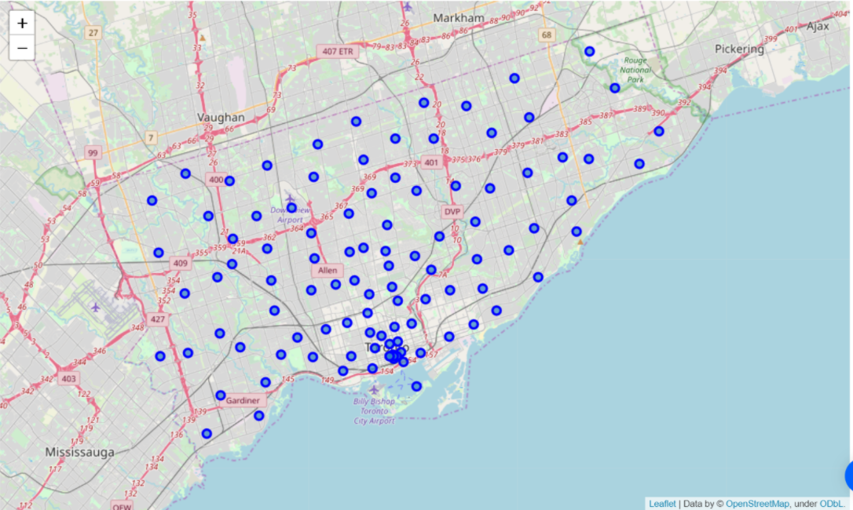

Fig 1. Map of Scarborough

1. **Methodology**
2. K-Means Clustering Approach

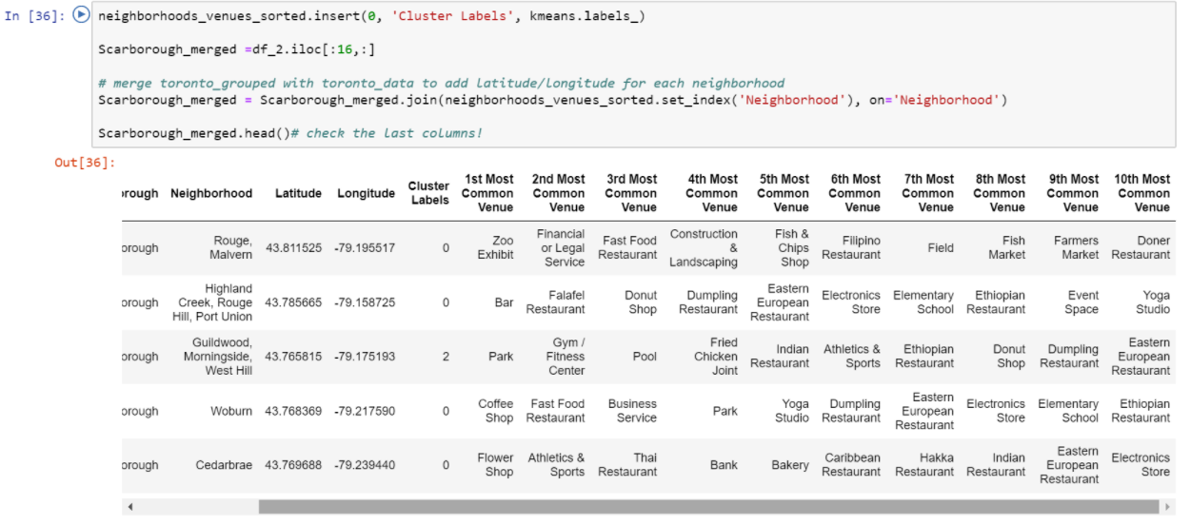

1. Most Common venues near Neighborhood

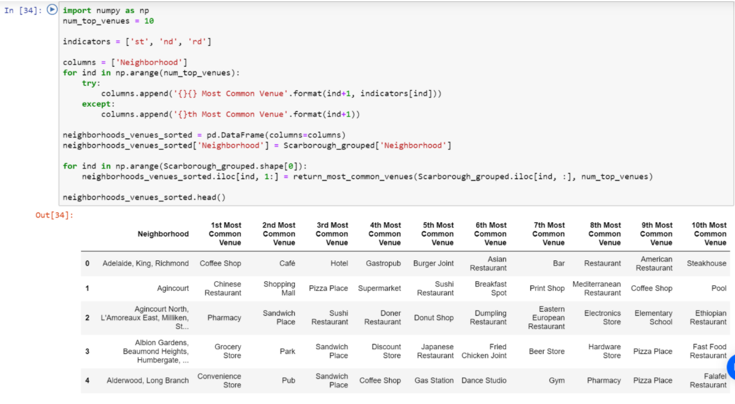

1. Work Flow

Using credentials of Foursquare API features of near-by places of the neighborhoods would be mined. Due to http request limitations the number of places per neighborhood parameter would reasonably be set to 100 and the radius parameter would be set to 500.

1. Package breakdown:

* *Pandas* : To collect and manipulate data in JSON and HTMl and then data analysis
* *requests* : Handle http requests
* *matplotlib* : Detailing the generated maps
* *folium* : Generating maps of London and Paris
* *sklearn* : To import Kmeans which is the machine learning model that we are using.

The approach taken here is to explore each of the cities individually, plot the map to show the neighbourhoods being considered and then build our model by clustering all of the similar neighbourhoods together and finally plot the new map with the clustered neighbourhoods. We draw insights and then compare and discuss our findings.

1. **Results**
2. Map of Cluster in Scarborough

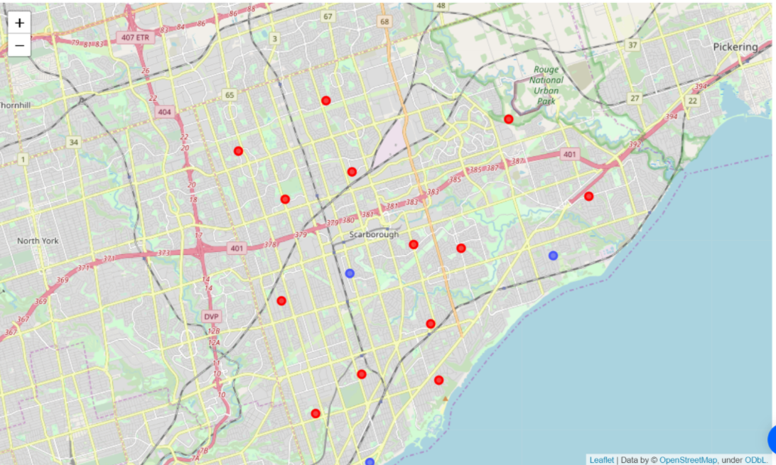

1. Average Housing Price by Clusters in Scarborough

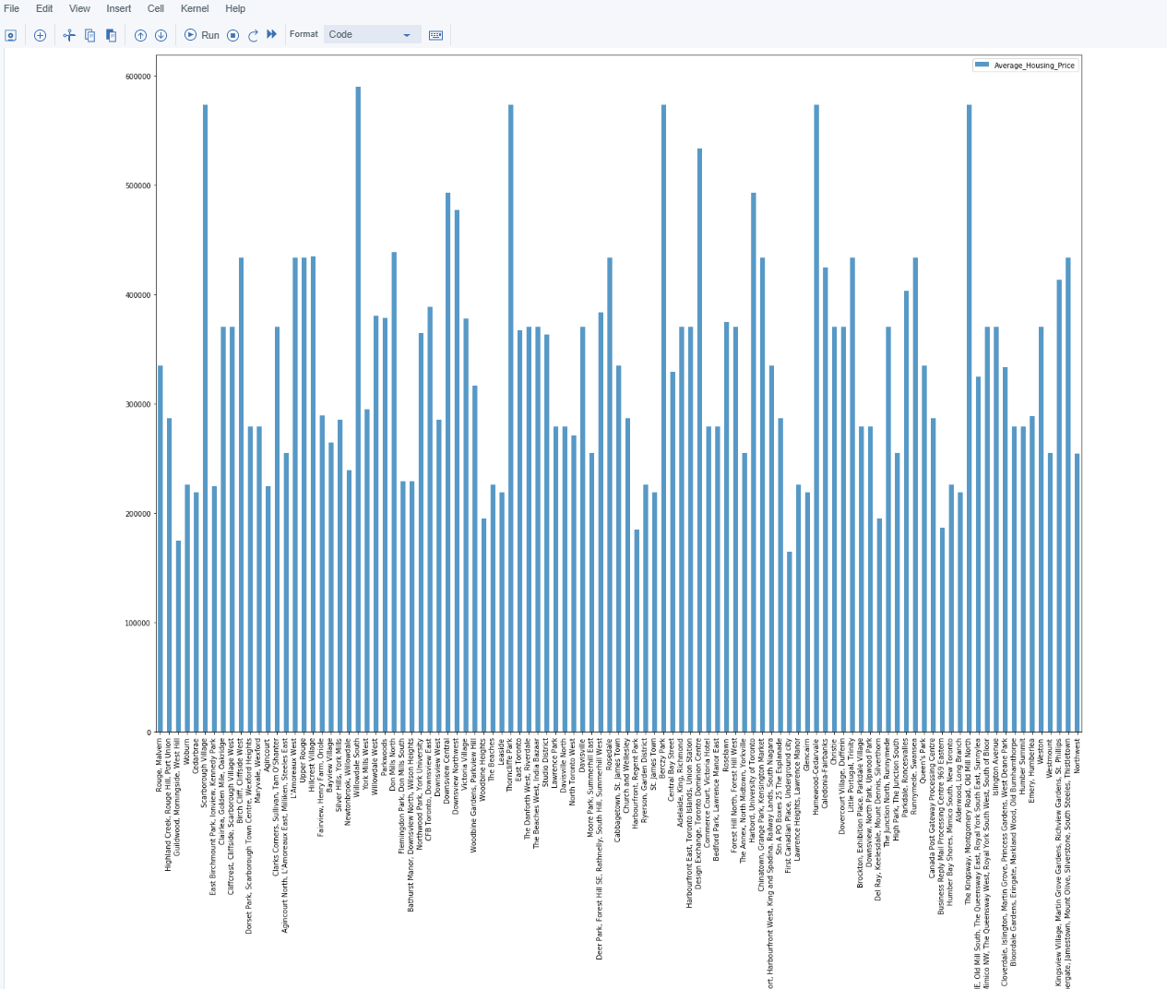

1. School Ratings by Clusters in Scarborough

Absis = School name

Ordinat = school rating

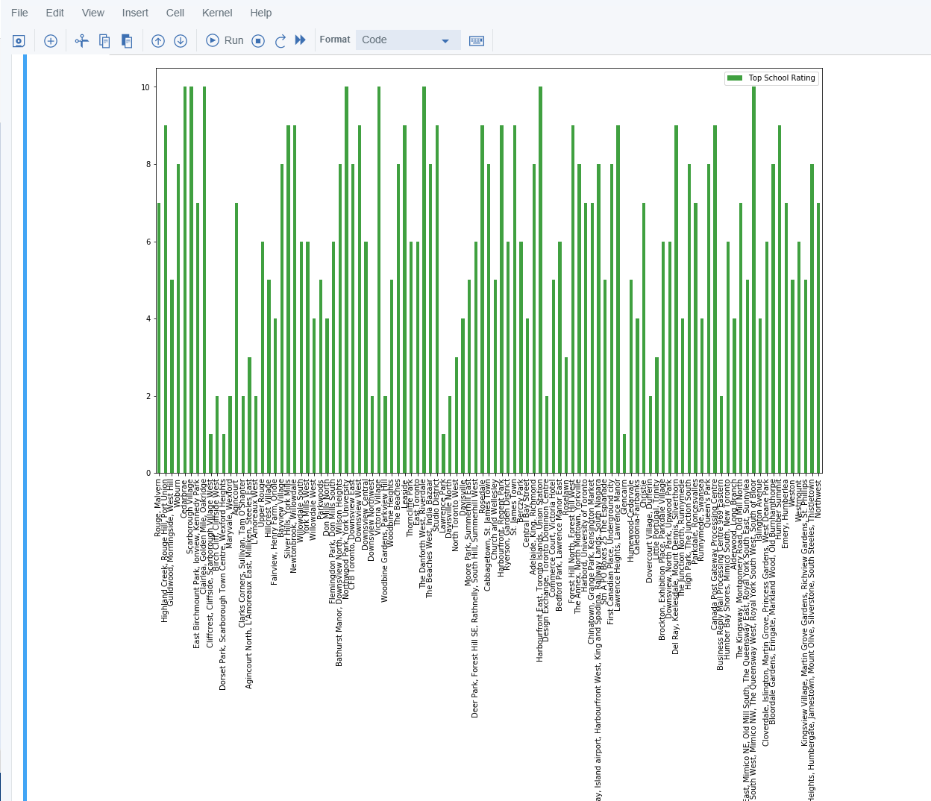

1. The Location

Scarborough is a popular destination for new immigrants to Canada to live in. As a result, it is one of the most diverse and multicultural areas in the Greater Toronto Area, home to a wide variety of religious groups and places of worship. Although immigration has been a hot topic over the last few years with more governments seeking more restrictions on immigrants and refugees, the general trend of immigration to Canada has been on the rise.

1. **Discussion**

The neighbourhoods of London are very mulitcultural. There are a lot of different cusines including Indian, Italian, Turkish and Chinese. London seems to take a step further in this direction by having a lot of Restaurants, bars, juice bars, coffee shops, Fish and Chips shop and Breakfast spots. It has a lot of shopping options too with that of the Flea markets, flower shops, fish markets, Fishing stores, clothing stores. The main modes of transport seem to be Buses and trains. For leisure, the neighbourhoods are set up to have lots of parks, golf courses, zoo, gyms and Historic sites. Overall, the city of London offers a multicultural, diverse and certainly an entertaining experience.

Paris is relatively small in size geographically. It has a wide variety of cusines and eateries including French, Thai, Cambodian, Asian, Chinese etc. There are a lot of hangout spots including many Restaurants and Bars. Paris has a lot of Bistro's. Different means of public transport in Paris which includes buses, bikes, boats or ferries. For leisure and sight seeing, there are a lot of Plazas, Trails, Parks, Historic sites, clothing shops, Art galleries and Museums. Overall, Paris seems like the relaxing vacation spot with a mix of lakes, historic spots and a wide variety of cusines to try out.

1. **Conclusion**

The purpose of this project was to explore the cities of London and Paris and see how attractive it is to potential tourists and migrants. We explored both the cities based on their postal codes and then extrapolated the common venues present in each of the neighbourhoods finally concluding with clustering similar neighbourhoods together

We could see that each of the neighbourhoods in both the cities have a wide variety of experiences to offer which is unique in it's own way. The cultural diversity is quite evident which also gives the feeling of a sense of inclusion.

Both Paris and London seem to offer a vacation stay or a romantic getaway with a lot of places to explore, beautiful landscapes, amazing food and a wide variety of culture. Overall, it's upto the stakeholders to decide which experience they would prefer more and which would more to their liking.