TruckerX Specification

Tar Software

Contents

Revisions 2

General description 3

Technical description 4

Companies 4

Job offers 4

Employees 4

Trucks 4

Locations 4

Docks 4

User interaction 5

Scenes 6

Style 7

Font 7

Screenshots 8

#S1 Startup screen 8

#S2 Menu screen 8

# Revisions

|  |  |
| --- | --- |
| Date | Modifications |
| 01/05/2021 | * I wrote a general description of the project * I wrote a technical description of all the elements in the game * I added the chapter about user interaction and added the use case diagram |
| 02/05/2021 | * I expanded the technical description with sub-chapters for locations and docks * I expanded the chapter “user interaction” with subchapter “scenes” and “screenshots” |
|  |  |
|  |  |
|  |  |
|  |  |
|  |  |

# General description

TruckerX is a 2D single player game where the player is in charge for creating, building, and maintaining a shipping business. The player is responsible for purchasing new property, hiring employees, purchasing trucks, accepting and scheduling jobs, maintaining partnerships, and keeping employees happy. The challenge of this game is to grow your business, all the while maintaining happiness of employees by scheduling them fairly and keeping customers happy by shipping on time.

# Technical description

This chapter gives a technical description for all the subsystems in TruckerX, and how these systems keep the game challenging for the player.

## Companies

Companies can make job offers to locations that the player has purchased. Companies have a trust factor which is dependent on successful and unsuccessful deliveries.

## Job offers

A job offer has one or multiple ship days per week. The days the shipments leave does not change. The reward for completing this job is fixed and the same for each ship day. The reward is paid out after the shipment has been delivered successfully. Shipments can be scheduled to leave the dock between 6am and 6pm.

## Employees

Employees can be scheduled to make shipments. An employee is tied to the location they are hired at. Employees can be scheduled to stay at the shipment location or immediately return home after the shipment has been completed. By staying at the shipment location employees can scheduled as efficiently as possible. However, employees that are away from their original location for too long, or are overworked, will become unhappy and eventually quit.

Employees are paid a fixed salary but expect raises relative to the revenue of the location they were originally hired at. Being underpaid will also result in unhappiness.

## Trucks

Each place has a garage with trucks. Each truck has an assigned employee. Employees will not be able to make a shipment when they do not have an assigned truck, resulting in a failed delivery. Trucks vary is fuel usage and maintenance cost. Cost of gas is paid when a truck leaves for a shipment. Maintenance cost is paid when a truck arrives at the shipment destination. Employees can be reassigned to different trucks at any time.

## Locations

The player starts off with one location. More locations can be purchased when the player has enough money to purchase the location. The price of the location depends on the size of the city it is located in.

## Docks

Each location starts with one loading dock. Locations can be upgraded to be equipped with up to 7 docks. Each dock has a separate schedule. By adding docks to a location, shipments can leave at the same time divided over the available docks.

# User interaction

This chapter gives an overview of all the interaction the user has with the system in the shape of a use case diagram.

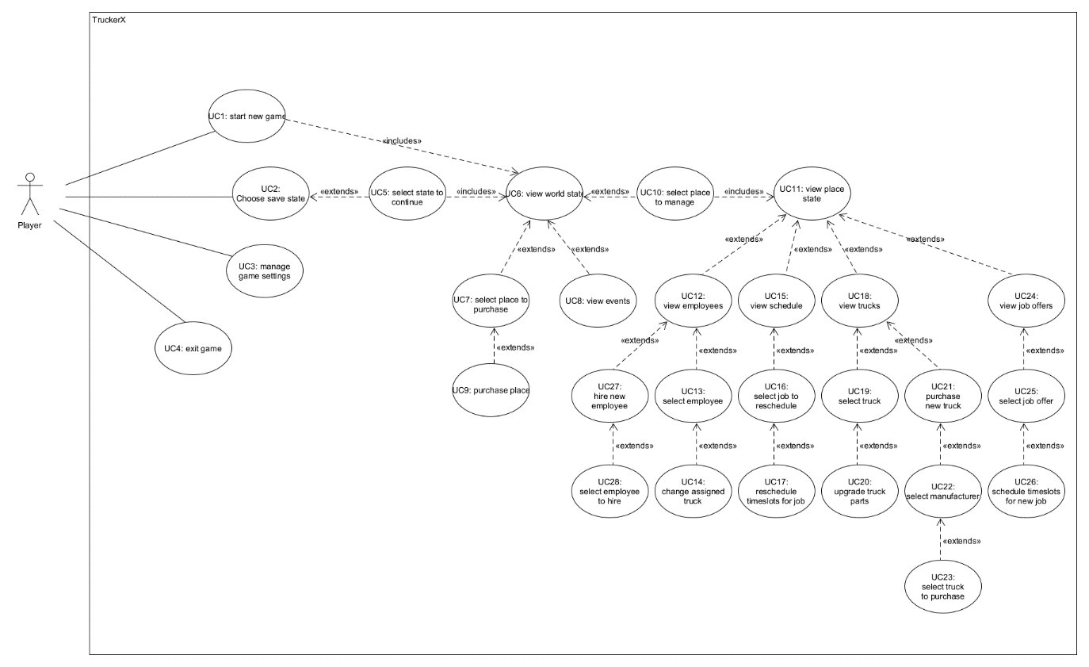

## Scenes

This chapter lists all scenes the user will interact with and links the screens to use cases.

|  |  |  |  |
| --- | --- | --- | --- |
| #ID | Name | Purpose | UC id’s |
| #S1 | Startup screen | Load assets |  |
| #S2 | Menu screen | Display options to user | UC1, UC2, UC4 |
| #S3 | Settings screen | Allow user to control audio and visual settings | UC3 |
| #S4 | Save state select | Display available save states and let the player choose one of them to continue with | UC5 |
| #S5 | World map | Display overview of places and show active jobs visually | UC6, UC7, UC9, UC8, UC10 |
| #S6 | Place detail | Display detailed information about the selected location | UC11, UC12  UC15, UC18  UC24, UC27  UC13, UC19  UC21, UC25 |
| #S7 | Employee hiring | Display a list of employees that are looking to work at the selected location | UC28 |
| #S8 | Employee overview | Display an overview of the selected employee’s schedule and allow the player to change their assigned truck | UC14 |
| #S9 | Schedule | Display the schedule for the selected location | UC16 |
| #S10 | Truck overview | Display an overview of the selected truck and allow the player to upgrade or sell the truck | UC20 |
| #S11 | Truck manufacturers | Display a list of truck manufacturers that the player can choose to buy a truck from | UC22 |
| #S12 | Truck purchase overview | Display details about the selected truck and allow the player to purchase the truck | UC23 |
| #S13 | Job offer overview | Display an overview of the selected job offer and allows the player to schedule timeslots for the job and assign an employee. | UC26, UC17 |

## Style

This chapter describes the general style of the user interface.

### Font

The font used in the game is “Exo”. The versions “light”, “medium” and “bold” can be used in both the italic and non-italic version.

## Screenshots

This chapter lists screenshots for all scenes and gives descriptions about how the user will interact with the scenes.

### #S1 Startup screen



The logo and text occupy 40% of the screen’s height.

### #S2 Menu screen

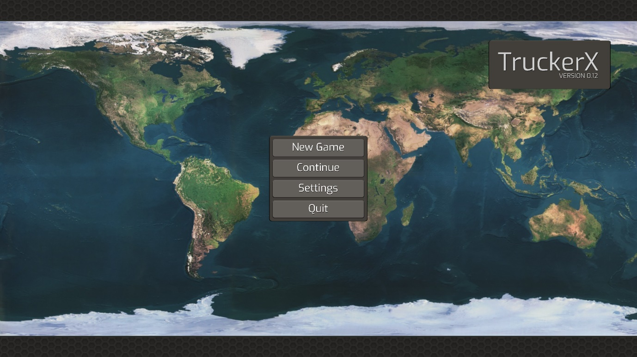

## #S4 Save state select

