Architecture

Adult Census Income Prediction

Content:

1. Abstract
2. Introduction
3. Scope
4. Architecture
5. Technology Stack
6. User I/O Workflow

Abstract:

Outstanding inequality of wealth and income is a major concern especially in the United States. Opportunities Poverty reduction is one of the most important reasons for reducing global poverty a growing level of economic inequality. The goal of the universe moral equality ensures sustainable development and improvement the stability of the national economy. Almost every country across the globe are trying their best to deal with this problem again to provide the right solution. This study aims to show use machine learning and data mining techniques in providing a solution to the income equity problem. UCI Adult Dataset used for a purpose. Separation is done predicting the annual income of a person in the US falls into income category greater than 50K Dollars or less equivalent up to the $ 50K category based on a specific set of attributes.

Introduction:

Why this Low Level Design?

The intention of LLD or a low level-degree design report(LLDD) is to present the inner logical layout of the actual program code for adult census income prediction. LLD describes the class diagrams with the methods and family members between classes and program specifications. It describes the modules so that in future if any programmers want to bring any modification they can code the program from the record.

Scope:

The motive of this low level design report is to present a detailed description of a machine learning model to describe whether he is earning good or not. Its going to provide an explanation for the motive and the functions of the machine, the interfaces of the model, what the system will do. This document is intended for stakeholders and developers so they can infer from here and could do give a upgraded baseline to the model and could be proposed to the better control of its approval.

The objective of this project is simple, its to check whether the person’s income is greater than 50K or not based on different attributes like their age, workclass, hours of week, etc.

Architecture:

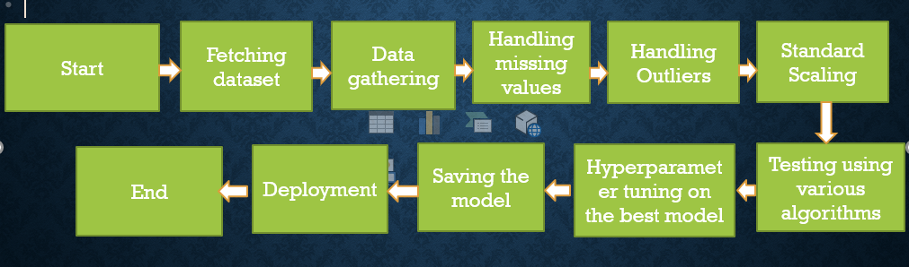

Technology Stack:

|  |  |
| --- | --- |
| Front End | HTML, CSS |
| Back End | Python |
| Deployment | Heroku |

User-I/O Workflow:

Several drop down options are given

Select relevant info and enter your age

Failure

Prediction on the new data

Predicting and Saving the model

Tuning parameters on the best accuracy algorithm

Modelling the dataset based on different algorithms

EDA on the data

Show error with proper exception handling

Data Validation

Exception Handling

It will process the info in backend