Adult Census Income Prediction

So the first thing anyone would see is this page.

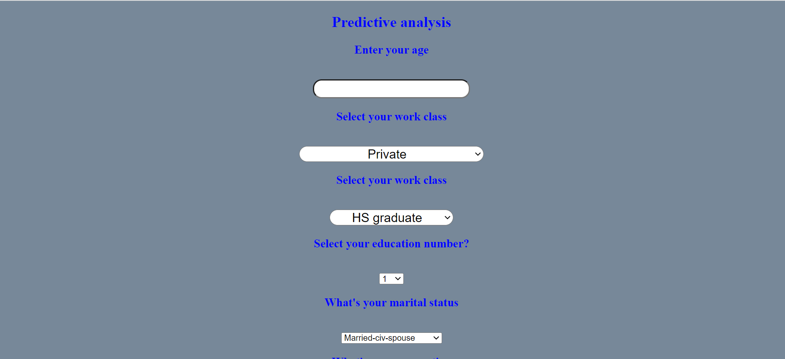

Here you need to type your age and hours per week you’re working.

The rest of the fields are drop down menu, which you can choose based on your status. For example if you click utmost right side then you will see a drop down menus just like you see in the below image.

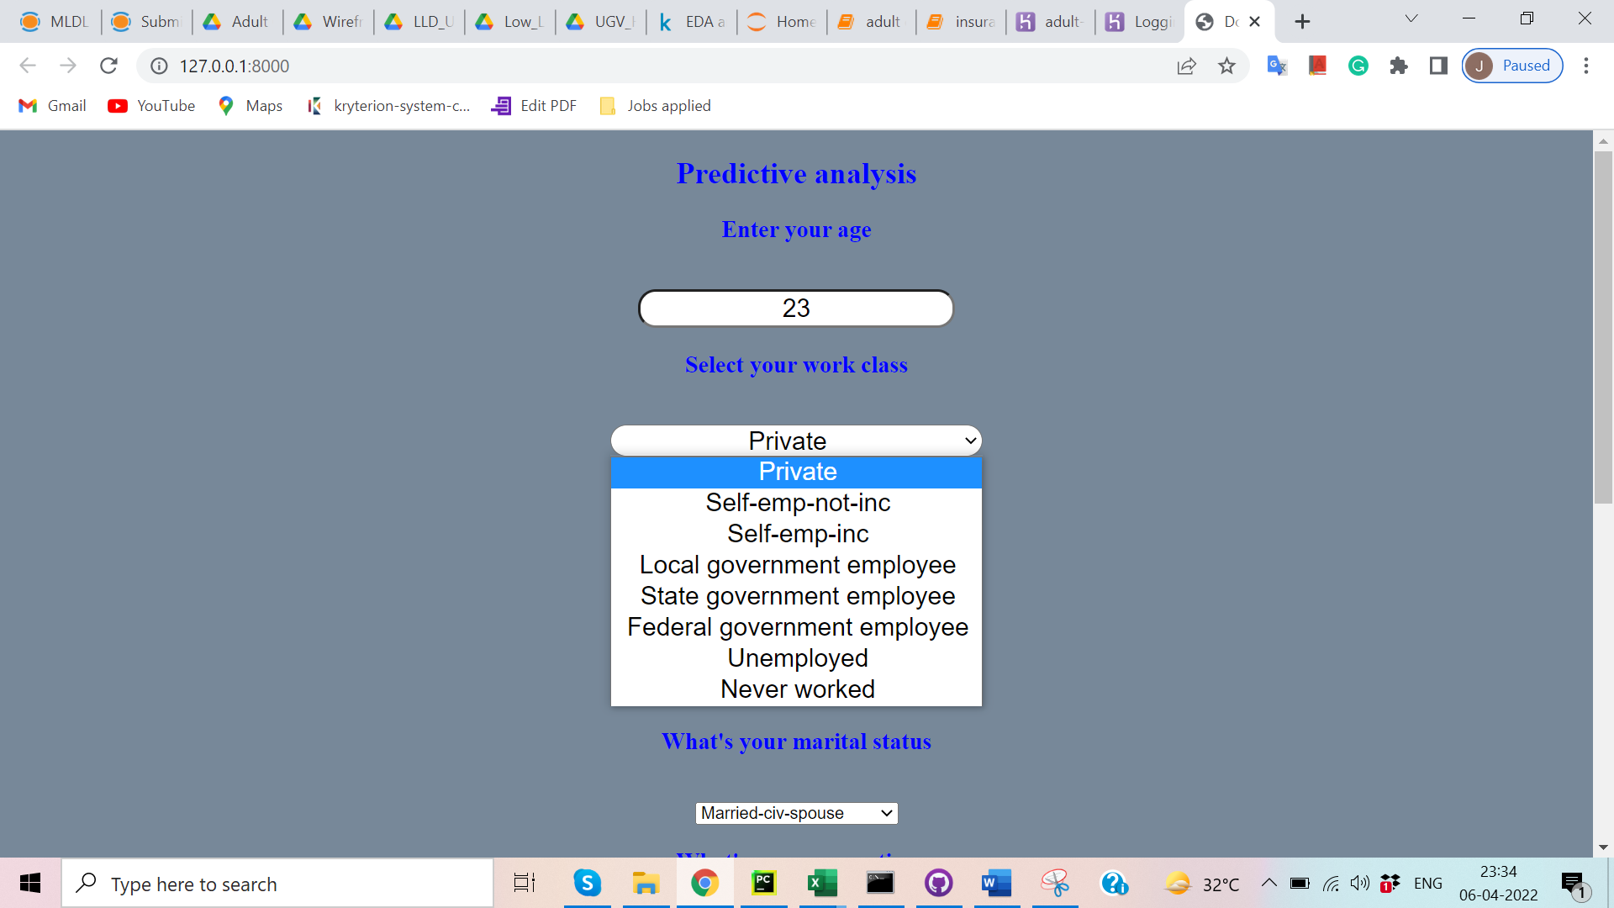

So when you click on the work class, it displays it lists out the variety of option based on your working class.

Lets assume you have filled all the filled and when you click on Predict income, it will predict the status of your income.

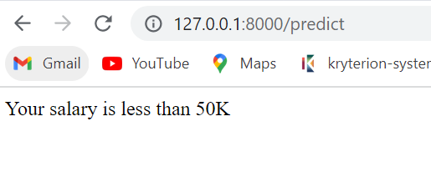

By this it has predicted the output based on your input.