GAMING CENTER MANAGEMENT
System Documentation

Prepared by: Aldrin Antony
Technology: Java SE | Swing | Oracle DB
Date: March 2026
Version: 1.0

1. Project Title
Gaming Center Management System
A desktop-based Java Swing application connected to an Oracle Database for managing the complete operations of a gaming center — customer registration, game catalogue, session bookings, and payment collection.

2. Introduction
Gaming centers require an efficient system to track customers, manage their game preferences, handle session bookings, and process payments. Manual record-keeping is error-prone and slow. The Gaming Center Management System addresses these challenges by providing a centralized, professional desktop application that automates these workflows.
2.1 Objectives
- Manage customer records (add, update, delete, view).
- Maintain a catalogue of available games with pricing information.
- Allow staff to create session bookings linking customers to games.
- Record and track payments for completed bookings.
- Provide a professional, intuitive Neon Arena themed user interface.
2.2 Technology Stack
Component | Technology
Frontend (UI) | Java Swing (JFrame, JTable, JPanel, etc.)
Backend Logic | Java SE 25
Database | Oracle Database (JDBC via ojdbc11.jar)
IDE | Apache NetBeans
Build System | Apache Ant (build.xml)

2.3 Scope
The system covers four core modules: Customer Management, Game Management, Booking Management, and Payment Processing. All operations are persisted immediately to the Oracle Database using JDBC.

3. Class Diagram
The diagram below illustrates the object-oriented design: model classes, DAO (Data Access Object) classes, their attributes, methods, and relationships.
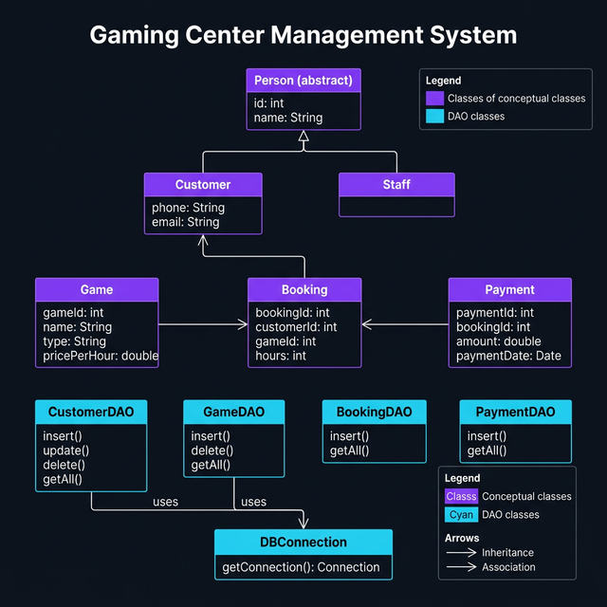
Figure 1 – UML Class Diagram (Gaming Center Management System)
3.1 Class Descriptions
Person (Abstract): Base class containing shared attributes id and name. Extended by Customer.
Customer: Stores customer contact details: phone and email. Inherits from Person. Persisted via CustomerDAO.
Game: Represents a game in the catalogue with name, type, and pricePerHour. Managed via GameDAO.
Booking: Links a Customer to a Game for a specified number of hours. References customerId and gameId as foreign keys.
Payment: Records a financial transaction for a Booking. Stores amount and payment_date (auto-set to Oracle SYSDATE).
DBConnection: Singleton utility that provides a JDBC Connection to Oracle DB.
CustomerDAO / GameDAO / BookingDAO / PaymentDAO: Data Access Objects encapsulating all SQL logic, keeping business logic separate from the UI layer.

4. Application Screenshots
The following placeholders represent each screen of the application. Replace each grey box with the actual screenshot taken from the running app.
4.1 Login Screen
Gradient branded panel on the left and a dark login card on the right with username/password fields and a LOGIN button.
[ Screenshot Placeholder – Login Screen ]

4.2 Dashboard – Main Menu
Left sidebar with emoji navigation links (Customer, Game, Booking, Payment, Exit) and a welcome area with four stat cards.
[ Screenshot Placeholder – Dashboard – Main Menu ]

4.3 Customer Management
Form card for Add/Update/Delete/Refresh with a live data table below. Clicking a table row auto-fills the form fields.
[ Screenshot Placeholder – Customer Management ]

4.4 Game Management
Form for adding and deleting games (name, type, price per hour) with a live table that loads on open.
[ Screenshot Placeholder – Game Management ]

4.5 Booking
Staff enter Customer ID, Game ID, and number of hours to create a session booking via the BOOK NOW button.
[ Screenshot Placeholder – Booking ]

4.6 Payment
Staff enter a Booking ID and amount collected to record a payment with the PAY NOW button.
[ Screenshot Placeholder – Payment ]

5. Database Design
The system uses Oracle Database. Primary keys are generated via Oracle sequences (e.g. customers_seq.NEXTVAL). Foreign key relationships enforce referential integrity between tables.
USERS
Table: USERS
username VARCHAR2(50)
password VARCHAR2(50)

CUSTOMERS
Table: CUSTOMERS
customer_id NUMBER (PK – customers_seq)
name VARCHAR2(100)
phone VARCHAR2(20)
email VARCHAR2(100)

GAMES
Table: GAMES
game_id NUMBER (PK – games_seq)
name VARCHAR2(100)
type VARCHAR2(50)
price_per_hour NUMBER

BOOKINGS
Table: BOOKINGS
booking_id NUMBER (PK – bookings_seq)
customer_id NUMBER (FK → customers)
game_id NUMBER (FK → games)
hours NUMBER

PAYMENTS
Table: PAYMENTS
payment_id NUMBER (PK – payments_seq)
booking_id NUMBER (FK → bookings)
amount NUMBER
payment_date DATE

