**RPG Battle Simulator | Game Design Document**

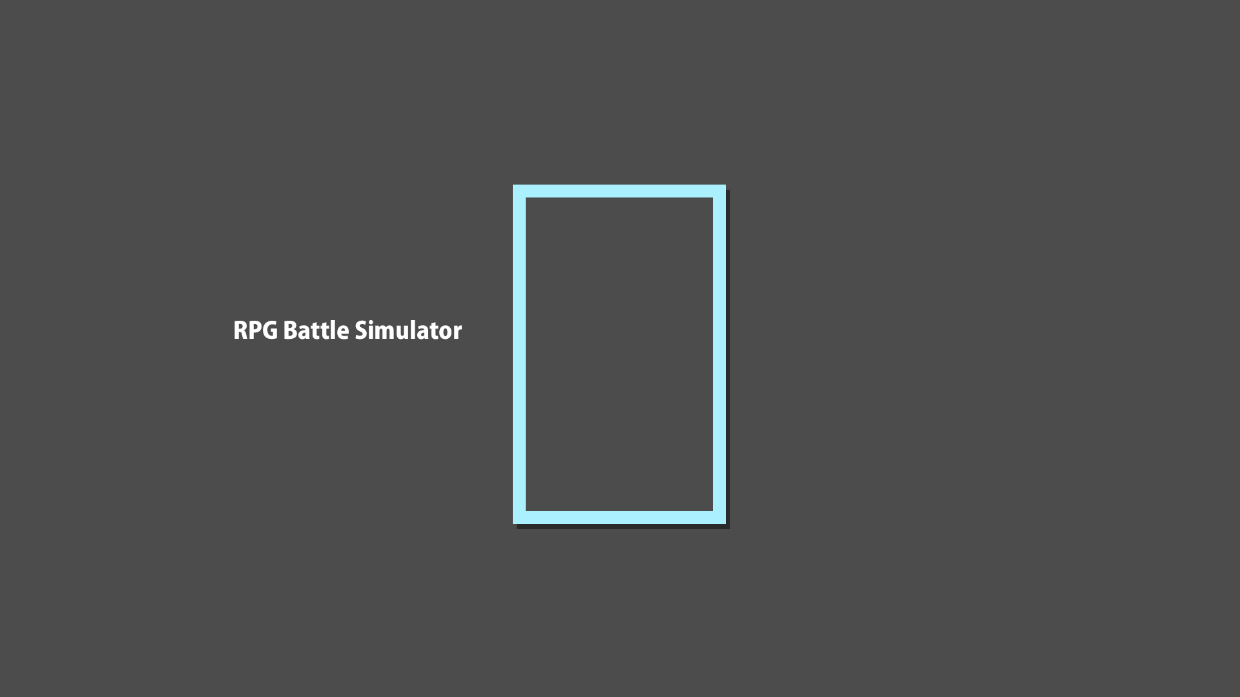

***‘RPGs are cool I guess’*** – Aldrin James Basa

This page: Table of Contents and Team Member Listing

|  |  |  |
| --- | --- | --- |
| Table of Contents  [1 Game Overview](https://n-xovwktmtjsnaxyc2mwes2xu7pohqedmdm6zjw5q-2lu-script.googleusercontent.com/userCodeAppPanel)  [2 High Concept](https://n-xovwktmtjsnaxyc2mwes2xu7pohqedmdm6zjw5q-2lu-script.googleusercontent.com/userCodeAppPanel)  [3 Genre](https://n-xovwktmtjsnaxyc2mwes2xu7pohqedmdm6zjw5q-2lu-script.googleusercontent.com/userCodeAppPanel)  [4 Unique Selling Points](https://n-xovwktmtjsnaxyc2mwes2xu7pohqedmdm6zjw5q-2lu-script.googleusercontent.com/userCodeAppPanel)  [5 Platform Minimum Requirements](https://n-xovwktmtjsnaxyc2mwes2xu7pohqedmdm6zjw5q-2lu-script.googleusercontent.com/userCodeAppPanel)  [6 Competitors / Similar Titles](https://n-xovwktmtjsnaxyc2mwes2xu7pohqedmdm6zjw5q-2lu-script.googleusercontent.com/userCodeAppPanel)  [7 Synopsis](https://n-xovwktmtjsnaxyc2mwes2xu7pohqedmdm6zjw5q-2lu-script.googleusercontent.com/userCodeAppPanel)  [8 Game Objectives](https://n-xovwktmtjsnaxyc2mwes2xu7pohqedmdm6zjw5q-2lu-script.googleusercontent.com/userCodeAppPanel)  [9 Game Rules](https://n-xovwktmtjsnaxyc2mwes2xu7pohqedmdm6zjw5q-2lu-script.googleusercontent.com/userCodeAppPanel)  [10 Game Structure](https://n-xovwktmtjsnaxyc2mwes2xu7pohqedmdm6zjw5q-2lu-script.googleusercontent.com/userCodeAppPanel)  [11 Game Play](https://n-xovwktmtjsnaxyc2mwes2xu7pohqedmdm6zjw5q-2lu-script.googleusercontent.com/userCodeAppPanel)  [11.1 Game Controls](https://n-xovwktmtjsnaxyc2mwes2xu7pohqedmdm6zjw5q-2lu-script.googleusercontent.com/userCodeAppPanel)  [11.2 Game Camera](https://n-xovwktmtjsnaxyc2mwes2xu7pohqedmdm6zjw5q-2lu-script.googleusercontent.com/userCodeAppPanel)  [11.2.1 HUD](https://n-xovwktmtjsnaxyc2mwes2xu7pohqedmdm6zjw5q-2lu-script.googleusercontent.com/userCodeAppPanel)  [11.2.2 Maps](https://n-xovwktmtjsnaxyc2mwes2xu7pohqedmdm6zjw5q-2lu-script.googleusercontent.com/userCodeAppPanel)  [12 Players](https://n-xovwktmtjsnaxyc2mwes2xu7pohqedmdm6zjw5q-2lu-script.googleusercontent.com/userCodeAppPanel)  [12.1 Characters](https://n-xovwktmtjsnaxyc2mwes2xu7pohqedmdm6zjw5q-2lu-script.googleusercontent.com/userCodeAppPanel)  [12.2 Metrics](https://n-xovwktmtjsnaxyc2mwes2xu7pohqedmdm6zjw5q-2lu-script.googleusercontent.com/userCodeAppPanel)  [12.3 States](https://n-xovwktmtjsnaxyc2mwes2xu7pohqedmdm6zjw5q-2lu-script.googleusercontent.com/userCodeAppPanel)  [13 NPC](https://n-xovwktmtjsnaxyc2mwes2xu7pohqedmdm6zjw5q-2lu-script.googleusercontent.com/userCodeAppPanel)  [13.1 Enemies](https://n-xovwktmtjsnaxyc2mwes2xu7pohqedmdm6zjw5q-2lu-script.googleusercontent.com/userCodeAppPanel)  [13.1.1 Enemy States](https://n-xovwktmtjsnaxyc2mwes2xu7pohqedmdm6zjw5q-2lu-script.googleusercontent.com/userCodeAppPanel)  [13.1.2 Enemy Metrics](https://n-xovwktmtjsnaxyc2mwes2xu7pohqedmdm6zjw5q-2lu-script.googleusercontent.com/userCodeAppPanel)  [14 Art](https://n-xovwktmtjsnaxyc2mwes2xu7pohqedmdm6zjw5q-2lu-script.googleusercontent.com/userCodeAppPanel)  [14.1 Setting](https://n-xovwktmtjsnaxyc2mwes2xu7pohqedmdm6zjw5q-2lu-script.googleusercontent.com/userCodeAppPanel)  [14.2 Audio](https://n-xovwktmtjsnaxyc2mwes2xu7pohqedmdm6zjw5q-2lu-script.googleusercontent.com/userCodeAppPanel)  [15 Procedurally Generated Content](https://n-xovwktmtjsnaxyc2mwes2xu7pohqedmdm6zjw5q-2lu-script.googleusercontent.com/userCodeAppPanel)  [15.1 Artificial Intelligence NPC](https://n-xovwktmtjsnaxyc2mwes2xu7pohqedmdm6zjw5q-2lu-script.googleusercontent.com/userCodeAppPanel)  [15.2 Audio](https://n-xovwktmtjsnaxyc2mwes2xu7pohqedmdm6zjw5q-2lu-script.googleusercontent.com/userCodeAppPanel)  [15.3 Minimum Viable Product (MPV)](https://n-xovwktmtjsnaxyc2mwes2xu7pohqedmdm6zjw5q-2lu-script.googleusercontent.com/userCodeAppPanel)  [16 Wish List](https://n-xovwktmtjsnaxyc2mwes2xu7pohqedmdm6zjw5q-2lu-script.googleusercontent.com/userCodeAppPanel)   |  | | --- | |  | | Game Development Team Members    PRODUCER  Aldrin James Basa    PRODUCTION MANAGER  Aldrin James Basa    PRODUCTION COORDINATOR  Aldrin James Basa  GAME DESIGNERS  Aldrin James Basa  SYSTEMS/IT COORDINATOR  Aldrin James Basa  PROGRAMMERS  Aldrin James Basa  TECHNICAL ARTISTS  Aldrin James Basa  AUDIO ENGINEERS  Aldrin James Basa  UX TESTERS  Aldrin James Basa |

|  |
| --- |
|  |

# 1 Game Overview

Title: RPG Battle Simulator

Platform: PC Standalone

Genre: Isometric Turn-Based RPG

Rating: (10+) ESRB

Target: Final Fantasy Fans, Turn-based RPG players, JRPG enthusiasts

Release date: May 9th, 2020

Publisher: RGG

Description: In this isometric turn-based RPG, you enter an RPG Battle Simulator where you can earn XP and Gold to develop your simulated character. Your main objective is to defeat the final boss at the end; you can achieve this by either choosing to level yourself up or challenging the boss at base level!

# 2 High Concept

RPG Battle Simulator takes heavy inspiration from early turn-based RPGs such as Final Fantasy. The player’s goal is to defeat the Purple endgame boss. The player can choose to gain XP through fighting the beginner mob to level up and increase their stats.

# 3 Genre

This game is an Isometric turn-based RPG. Isometric refers to the camera angle/style in which the camera is shifted to create a more spacious perspective. This game implements a turn-based camera inspired by Final Fantasy 7 in which players and enemies choose actions turn by turn.

# 4 Unique Selling Points

* Cool Turn-Based Combat
* Fire Soundtrack
* No time to play? No problem, this game is also 5 minutes long.

# 5 Platform Minimum Requirements

OS: Windows 7+

Graphics Card: DX9+ compatible cards.

# 6 Competitors / Similar Titles

* Final Fantasy
* Super Mario RPG: Legend of the Seven Stars
* Other CS583 Students’ Projects

# 7 Synopsis

You enter a VR simulator, and you enter a blocky world. The world is a testing grounds for an aspiring video game creator which contains several buggy turn-based RPG mechanics. As the player, you see the intricacies and struggles the video game creator is facing as he attempts to develop this passion project in a short amount of time.

# 8 Game Objectives

The objective of the game is to level up and defeat the end-boss, the Big Purple Block.

# 9 Game Rules

The main game is isometric, you can move around in the main world and choose actions to battle. The player has a basic attack, X-Slash for extra damage, and Cure to heal. Each action are all affected by stat modifiers such as base damage, strength, intelligence, and luck. Once you defeat the last boss, the game will end.

# 10 Game Structure

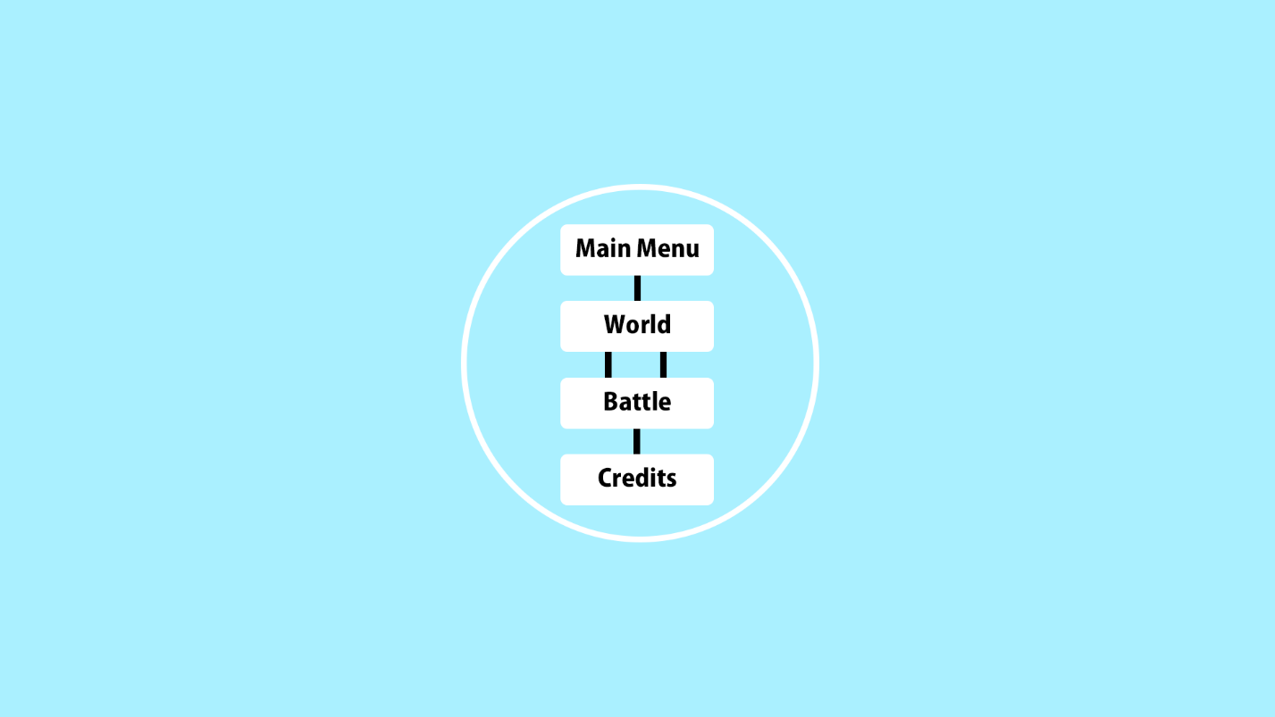

# 11 Game Play

## 11.1 Game Controls

Mouse Click -> Move Character, Choose Battle Actions

## 11.2 Game Camera

### 11.2.1 HUD

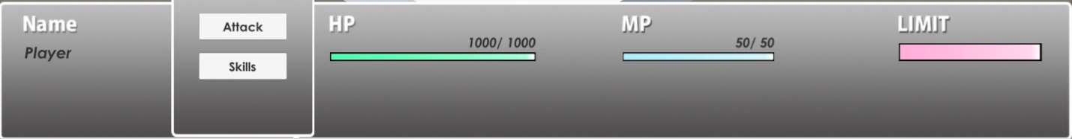

### 11.2.2 Maps

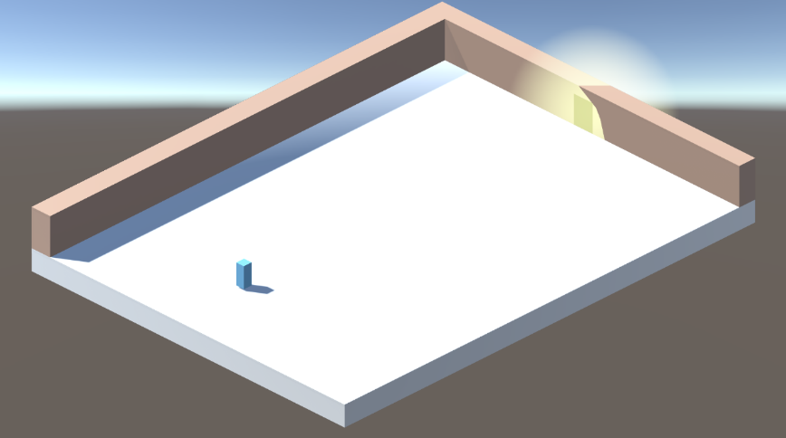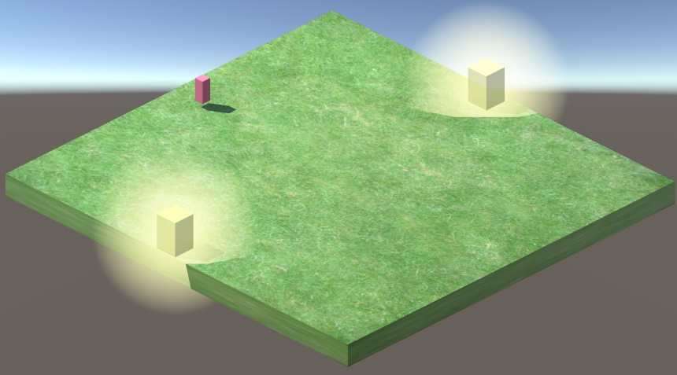

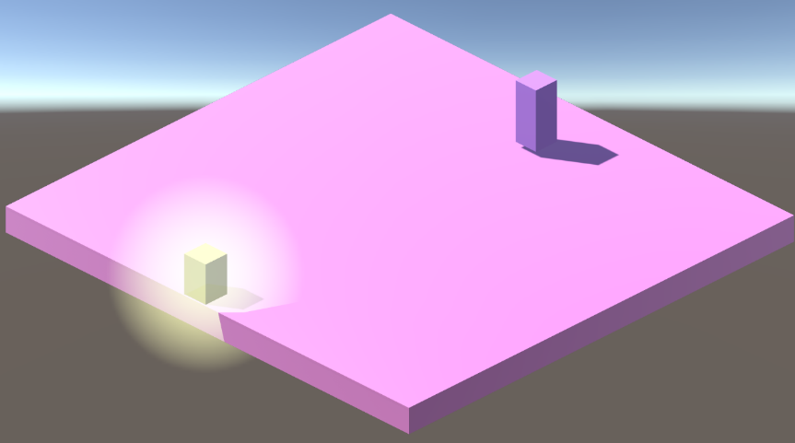

# 12 Players

## 12.1 Characters

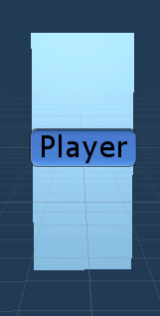

## 12.2 Metrics

**Player (Base Level):**

Health – 500

Damage – 50

Max Health – 500

Max MP – 50

Strength – 6

Intelligence – 0

Luck – 3

## 12.3 States

**Player States:**

Idle

Moving

Basic Attack

X-Slash

Cure

Limit Break

# 14 NPC

## 14.1 Enemies

## 

## 

### 14.1.1 Enemy States

**Red Block:**

Idle

Basic Attack

Death

**Big Purple Block:**

Idle

Basic Attack

Jump

Death

### 14.1.2 Enemy Metrics

**Red Block (Base):**

Health – 500

Base Damage – 100

MP – 10

XP Gained – 30

Gold Gained – 20

Strength – 5

Intelligence – 0

Luck – 1

**Big Purple Block (Base):**

Health – 2000

Base Damage – 100

MP – 20

XP Gained – 50

Gold Gained – 100

Strength – 8

Intelligence – 5

Luck - 1

# 15 Art

## 15.1 Setting

RPG Battle Simulator takes place within a testing environment inside of a simulator. In this world, non-cohesive levels are constructed in order to test out the RPG turn-based combat.

## 15.2 Audio

|  |  |  |
| --- | --- | --- |
| Sound File | Category | Description |
| cs583worldmusic1.wav | OST | Music played when on the main world. |
| cs583battlemusic1.wav | OST | Music played during battle. |
| hit.wav | FX | Basic Attack effect |
| hit2.wav | FX | Special Attack effect |
| menu1.wav | FX | Menu click effect |

# 16 Procedurally Generated Content

## 16.1 Artificial Intelligence NPC

The enemies in this game use a random roll between 1 and 4 (inclusive) to determine which action they will take.

## 16.2 Audio

An Audio Manager is implemented to handle which sounds are played in its respective spot.

## 16.3 Minimum Viable Product (MPV)

* For this game, I wanted to take inspiration from the video games that I have been playing during quarantine. The two games that I have spent a lot of time on during this time are Path of Exile, an isometric action RPG, and Final Fantasy 7 Remake, which is a Japanese Role Playing Game that is action oriented, however the original was turn-based.
* In this game, I implemented an isometric camera to mimic that feel of an isometric action RPG and also implemented a turn-based combat heavily inspired by Final Fantasy 7.

# 17 Wish List

* More content
  + Originally, I wanted to make a bigger world/field and have the camera move along with the character. Heavily inspired by the older Final Fantasy games, I wanted to have a world similar to those games. However, due to time constraints and development struggles, I had to opt for a more simpler design.
* Items
  + It honestly is not an RPG game without a full item system. The item system I had in mind was going to have items that altered the Player’s stat modifiers in order to create a sense of depth. Also scrapped due to time constraints.