**Test Story. Game Design Document**

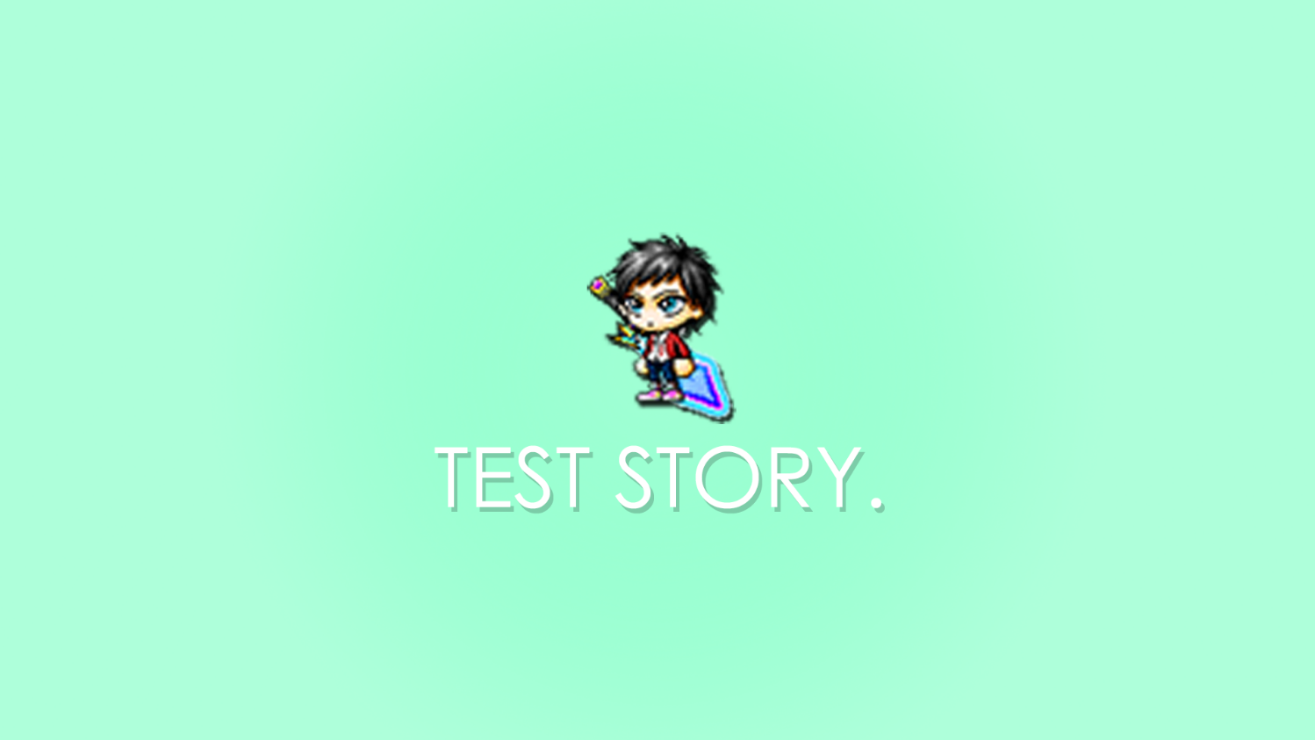

***‘Just a test, it most definitely isn’t the best.’*** -Aldrin

This page: Table of Contents and Team Member Listing

|  |  |  |
| --- | --- | --- |
| Table of Contents  [1 Game Overview](https://n-xovwktmtjsnaxyc2mwes2xu7pohqedmdm6zjw5q-2lu-script.googleusercontent.com/userCodeAppPanel)  [2 High Concept](https://n-xovwktmtjsnaxyc2mwes2xu7pohqedmdm6zjw5q-2lu-script.googleusercontent.com/userCodeAppPanel)  [3 Unique Selling Points](https://n-xovwktmtjsnaxyc2mwes2xu7pohqedmdm6zjw5q-2lu-script.googleusercontent.com/userCodeAppPanel)  [4 Platform Minimum Requirements](https://n-xovwktmtjsnaxyc2mwes2xu7pohqedmdm6zjw5q-2lu-script.googleusercontent.com/userCodeAppPanel)  [5 Competitors / Similar Titles](https://n-xovwktmtjsnaxyc2mwes2xu7pohqedmdm6zjw5q-2lu-script.googleusercontent.com/userCodeAppPanel)  [6 Synopsis](https://n-xovwktmtjsnaxyc2mwes2xu7pohqedmdm6zjw5q-2lu-script.googleusercontent.com/userCodeAppPanel)  [7 Game Objectives](https://n-xovwktmtjsnaxyc2mwes2xu7pohqedmdm6zjw5q-2lu-script.googleusercontent.com/userCodeAppPanel)  [8 Game Rules](https://n-xovwktmtjsnaxyc2mwes2xu7pohqedmdm6zjw5q-2lu-script.googleusercontent.com/userCodeAppPanel)  [9 Game Structure](https://n-xovwktmtjsnaxyc2mwes2xu7pohqedmdm6zjw5q-2lu-script.googleusercontent.com/userCodeAppPanel)  [10 Game Play](https://n-xovwktmtjsnaxyc2mwes2xu7pohqedmdm6zjw5q-2lu-script.googleusercontent.com/userCodeAppPanel)  [10.1 Game Controls](https://n-xovwktmtjsnaxyc2mwes2xu7pohqedmdm6zjw5q-2lu-script.googleusercontent.com/userCodeAppPanel)  [10.2 Game Camera](https://n-xovwktmtjsnaxyc2mwes2xu7pohqedmdm6zjw5q-2lu-script.googleusercontent.com/userCodeAppPanel)  [10.2.1 HUD](https://n-xovwktmtjsnaxyc2mwes2xu7pohqedmdm6zjw5q-2lu-script.googleusercontent.com/userCodeAppPanel)  [10.2.2 Maps](https://n-xovwktmtjsnaxyc2mwes2xu7pohqedmdm6zjw5q-2lu-script.googleusercontent.com/userCodeAppPanel)  [11 Players](https://n-xovwktmtjsnaxyc2mwes2xu7pohqedmdm6zjw5q-2lu-script.googleusercontent.com/userCodeAppPanel)  [11.1 Characters](https://n-xovwktmtjsnaxyc2mwes2xu7pohqedmdm6zjw5q-2lu-script.googleusercontent.com/userCodeAppPanel)  [11.2 Metrics](https://n-xovwktmtjsnaxyc2mwes2xu7pohqedmdm6zjw5q-2lu-script.googleusercontent.com/userCodeAppPanel)  [11.3 States](https://n-xovwktmtjsnaxyc2mwes2xu7pohqedmdm6zjw5q-2lu-script.googleusercontent.com/userCodeAppPanel)  [11.4 Weapons](https://n-xovwktmtjsnaxyc2mwes2xu7pohqedmdm6zjw5q-2lu-script.googleusercontent.com/userCodeAppPanel)  [12 NPC](https://n-xovwktmtjsnaxyc2mwes2xu7pohqedmdm6zjw5q-2lu-script.googleusercontent.com/userCodeAppPanel)  [12.1 Enemies](https://n-xovwktmtjsnaxyc2mwes2xu7pohqedmdm6zjw5q-2lu-script.googleusercontent.com/userCodeAppPanel)  [12.1.1 Enemy States](https://n-xovwktmtjsnaxyc2mwes2xu7pohqedmdm6zjw5q-2lu-script.googleusercontent.com/userCodeAppPanel)  [12.1.2 Enemy Spawn Points](https://n-xovwktmtjsnaxyc2mwes2xu7pohqedmdm6zjw5q-2lu-script.googleusercontent.com/userCodeAppPanel)  [13 Art](https://n-xovwktmtjsnaxyc2mwes2xu7pohqedmdm6zjw5q-2lu-script.googleusercontent.com/userCodeAppPanel)  [13.1 Setting](https://n-xovwktmtjsnaxyc2mwes2xu7pohqedmdm6zjw5q-2lu-script.googleusercontent.com/userCodeAppPanel)  [13.2 Level Design](https://n-xovwktmtjsnaxyc2mwes2xu7pohqedmdm6zjw5q-2lu-script.googleusercontent.com/userCodeAppPanel)  [13.3 Audio](https://n-xovwktmtjsnaxyc2mwes2xu7pohqedmdm6zjw5q-2lu-script.googleusercontent.com/userCodeAppPanel)  [14 Procedurally Generated Content](https://n-xovwktmtjsnaxyc2mwes2xu7pohqedmdm6zjw5q-2lu-script.googleusercontent.com/userCodeAppPanel)  [14.3 Artificial Intelligence NPC](https://n-xovwktmtjsnaxyc2mwes2xu7pohqedmdm6zjw5q-2lu-script.googleusercontent.com/userCodeAppPanel)  [14.6 Minimum Viable Product (MPV)](https://n-xovwktmtjsnaxyc2mwes2xu7pohqedmdm6zjw5q-2lu-script.googleusercontent.com/userCodeAppPanel)  [15 Wish List](https://n-xovwktmtjsnaxyc2mwes2xu7pohqedmdm6zjw5q-2lu-script.googleusercontent.com/userCodeAppPanel)   |  | | --- | |  | | Game Development Team Members    PRODUCER  Aldrin James Basa    PRODUCTION MANAGER  Aldrin James Basa    PRODUCTION COORDINATOR  Aldrin James Basa  GAME DESIGNERS  Aldrin James Basa  SYSTEMS/IT COORDINATOR  Aldrin James Basa  PROGRAMMERS  Aldrin James Basa  TECHNICAL ARTISTS  Aldrin James Basa  AUDIO ENGINEERS  Aldrin James Basa  UX TESTERS  Aldrin James Basa |

|  |
| --- |
|  |

# 1 Game Overview

Title: Test Story.

Platform: PC Standalone

Genre: 2D Survival Platformer

Rating: (10+) ESRB

Target: Casual gamer (aging from 12 - 30)

Release date: April, 2020

Publisher: RGG Studios

Description: Test Story. is a 2D survival platformer where the player takes the role of a mid-level swordsman entering an instanced testing grounds for a Party Quest. The Party Quest’s premise is to survive the incoming waves of enemies and defeat the incoming boss for potential loot. The player can obtain points by defeating incoming enemies and ultimately the boss.

# 2 High Concept

Test Story. utilizes the concept of an online 2D Platformer MMORPG where the player enters an instanced Party Quest. The player’s goal is to defeat the instance’s boss in order to obtain EXP and potential loot. The player is in the shoes of a mid-level swordsman with a sizable sword to defeat enemies; in addition, there is a hidden wave dash mechanic to create a level of complexity of movement.

# 3 Unique Selling Points

* Nostalgic Artwork
* Movement inspired by Maplestory and Super Smash Bros.
* No time to play? No problem, the game is 5 minutes long.

# 4 Platform Minimum Requirements

OS: Windows 7+

Graphics Card: DX9+ compatible cards.

# 5 Competitors / Similar Titles

* Maplestory
* Other students in Spring 2020 CS583

# 6 Synopsis

You have logged into an MMORPG and are progressing your character for the day. In order to accomplish this, you decided to open an instanced solo Party Quest.

# 7 Game Objectives

The objective of the game is to defend yourself from incoming waves of enemies and defeat the final boss, Mushmom.

# 8 Game Rules

The main game is enclosed in an area that consists of three platforms: base, mid, and high platforms. The player has movement abilities such as the super jump to maneuver to these platforms from below or from any angle they choose. The enemies spawn on random platforms and the goal is to defeat those waves of enemies. After a certain wave, the final boss will appear and the game ends once it is defeated.

# 9 Game Structure

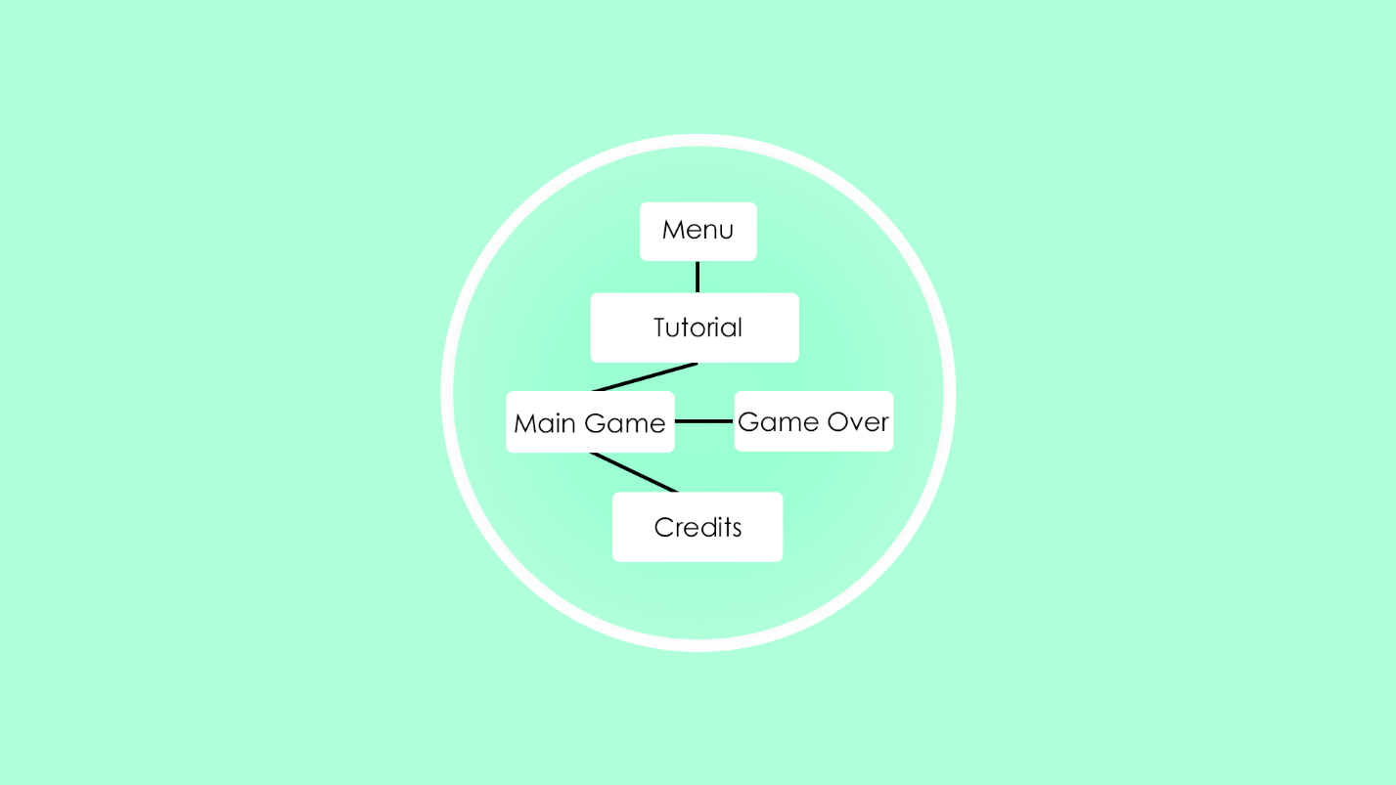

# 10 Game Play

## 10.1 Game Controls

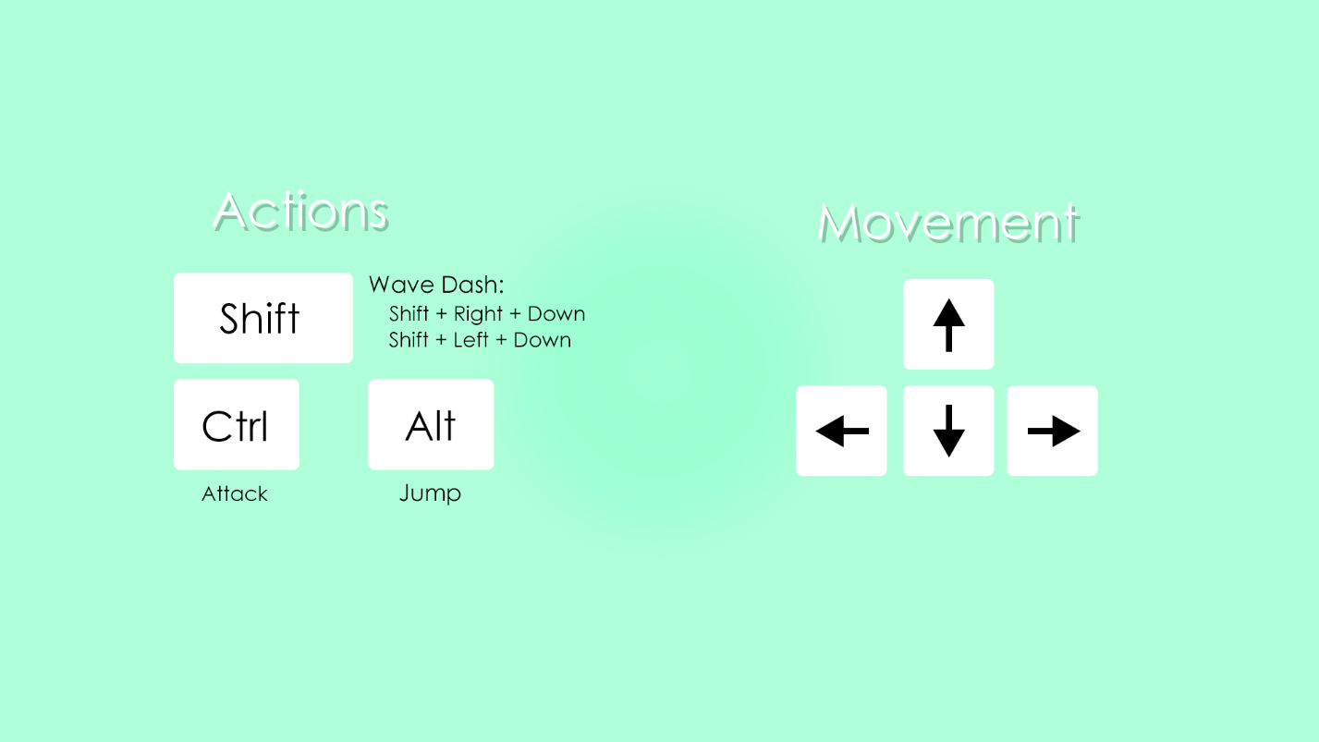

## 10.2 Game Camera

### 10.2.1 HUD

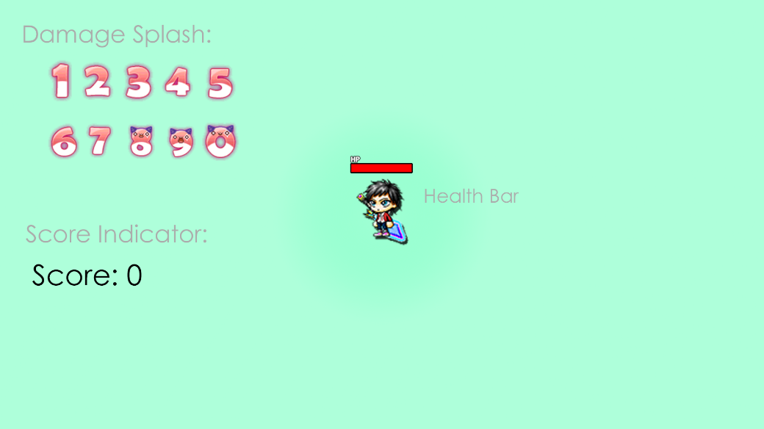

### 10.2.2 Maps

Tutorial Level

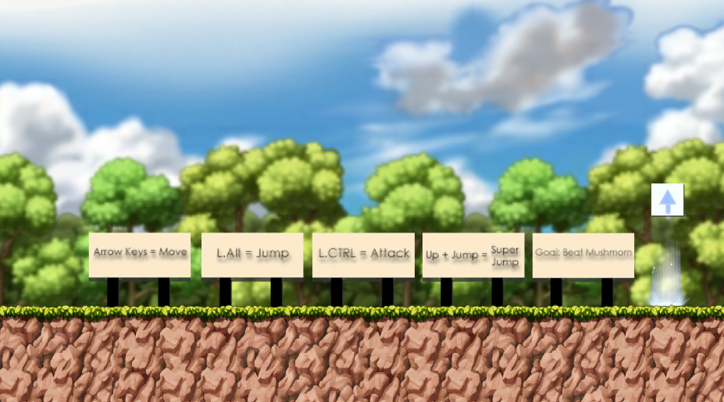

Main Level

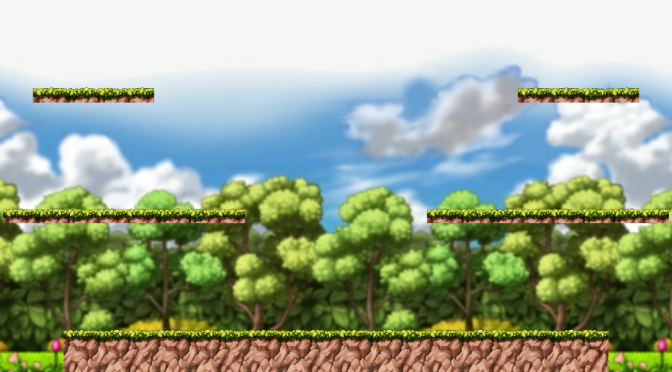

# 11 Players

## 11.1 Characters

Player



## 11.2 Metrics

**Player:**

Health – 100

Damage – 11 -> 90

Movement Speed – 3.14

Attack Speed – 2

## 11.3 States

**Player States:**

Idle

Moving

Attacking

Grounded

In Air

Wave Dashing

# 12 NPC

## 12.1 Enemies

## 

### 12.1.1 Enemy States

**Enemy States:**

Idle

Moving

Death

### 12.1.2 Enemy Metrics

**Snail:**

Health – 50

Damage – 10

Movement Speed – 1.5

**Blue Snail:**

Health – 90

Damage – 10

Movement Speed – 2

**Orange Mushroom:**

Health – 150

Damage – 10

Movement Speed – 2.5

**Mushmom:**

Health – 400

Damage – 10

Movement Speed – 5

### 12.1.3 Enemy Spawn Points

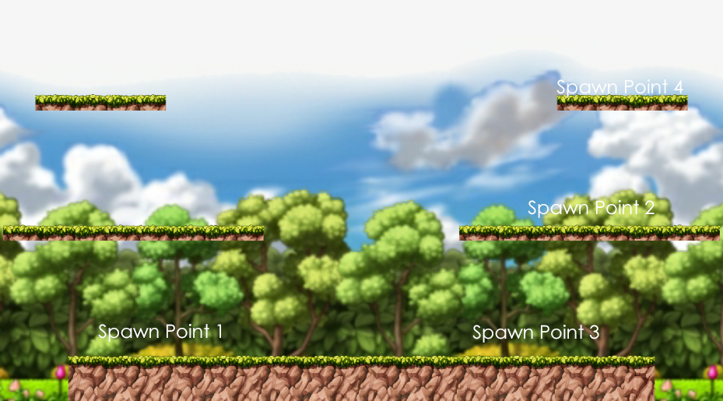

# 13 Art

## 13.1 Setting

The game takes place in an environment called Maple Forest. Maple Forest is home to life such as snails and mushrooms.

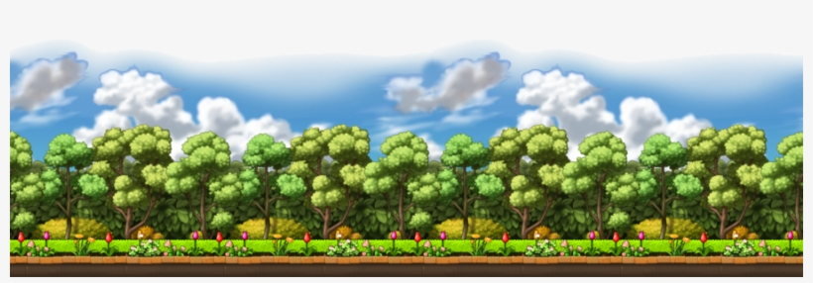

## 13.2 Level Design

The main level is inspired by Super Smash Bros. and Maplestory maps. The platforms are used to create extra layers in which the player can maneuver through.

## 

## 13.3 Audio

|  |  |  |
| --- | --- | --- |
| Sound File | Category | Description |
| bweep.mp3 | FX | Game Start Effect |
| die.mp3 | FX | Death sound effect |
| hit.mp3 | FX | On hit effect |
| Jump.mp3 | FX | Player jump |
| PickUpItem.mp3 | FX | Played when item is picked up (not implemented) |
| portaal.mp3 | FX | Effect played when player enters portal |
| swordS.Attack.mp3 | FX | Player sword sound |

# 14 Procedurally Generated Content

## 14.1 Artificial Intelligence NPC

The enemies in this game have a sight radius that determines when the enemy begins “following” the player. Once the player is within range the enemies will begin moving towards the player based off of their position.

## 14.2 Wave System

The enemies in this game spawn in waves. The waves have a 5 second timer before the wave begins. After the enemies are defeated, the next group of enemies will then spawn after the set timer.

**Spawn Rates**

Snail: 5

Blue Snail: 5

Orange Mushroom: 3

Mushmom: 1

## 14.2 Minimum Viable Product (MPV)

* Moveable player with mechanics heavily inspired by Maplestory and Super Smash Bros.
* Enemies to defeat, I decided against a level-based design because a wave-based design seemed more fun at the time of creation.

# 15 Wish List

* Move to a level-based design
  + Originally, the game was supposed to have multiple levels that the player must traverse through with the Mushmom guarding the final level. However, due to time-constraints, the one-level, wave-based design would make development easier.
* Items
  + Having power-ups and other items to help defeat enemies would create more depth of in game mechanics.
* Music
  + I wanted to produce music using Ableton Live and include it in the game, however this was scrapped due to time constraints.