Math.pow(a, b);
Where a is taken to the power of b

a^{b}

Math.pow(4, 2); this is 4-squared!

Math.pow(radius, 4); this is whatever the value of a

A = P * (1 +r)^{t}

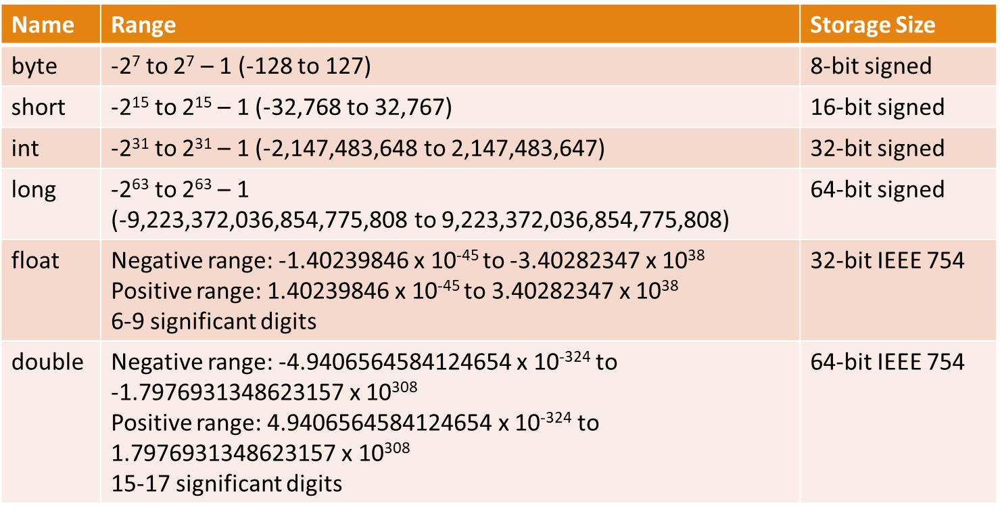
🧑‍🏫 Instructor Guide: Chapter 2 – Elementary Programming (Slides 42–58)

Slide 42: Division – Integer vs Floating-Point
Key Concepts:
- Division behavior depends on operand types.
- Integer division truncates decimals.
- Floating-point division preserves precision.
Live Demo:
Java
System.out.println(5 / 2); // 2
System.out.println(5.0 / 2); // 2.5

Instructor Notes:
- Ask: “Why does 5 / 2 give 2 instead of 2.5?”
- Emphasize operand types, not variable type.
- Use Scanner to let students test their own inputs.

Slide 43: Integer Literals and Ranges
Key Concepts:
- Integer literals must fit within the data type range.
- Use L suffix for long literals.
Live Demo:
Java
byte b = 127;
byte bError = 128; // Compile error
long big = 2147483648L;

Instructor Notes:
- Ask: “What happens if we assign 128 to a byte?”
- Use System.out.println(Byte.MAX_VALUE); to show limits.

Slide 44: Floating-Point Literals
Key Concepts:
- Default type is double.
- Use F suffix for float.
Live Demo:
Java
float f = 3.14F;
double d = 3.14;

Instructor Notes:
- Ask: “Why might we choose float over double?”
- Discuss memory vs precision trade-offs.

Slide 45: Scientific Notation
Key Concepts:
- Java supports scientific notation via E.
Live Demo:
Java
double sci1 = 1.23456E2; // 123.456
double sci2 = 1.23456E-2; // 0.0123456

Instructor Notes:
- Ask: “Where might you use scientific notation in real-world code?”
- Mention physics, astronomy, finance.

Slide 46: Fahrenheit to Celsius Conversion
Key Concepts:
- Formula: C = (5 / 9) * (F - 32)
- Demonstrates operator precedence.
Live Demo:
Java
double fahrenheit = 100;
double celsius = (5.0 / 9) * (fahrenheit - 32);
System.out.println("Celsius: " + celsius);

Instructor Notes:
- Ask students to write this live or in breakout.
- Emphasize parentheses and precedence.

Slide 47: Operator Precedence
Key Concepts:
- Multiplication/division before addition/subtraction.
- Parentheses override precedence.
Quick Quiz:
Java
System.out.println(5 + 2 * 3); // 11
System.out.println((5 + 2) * 3); // 21

Instructor Notes:
- Ask: “What’s the difference between these two?”
- Use this as a bridge to rounding and conversions.

Slide 48: Displaying the Current Time
Key Concepts:
- Use System.currentTimeMillis() to get time since 1970.
- Convert milliseconds to seconds, minutes, hours.
Live Demo:
Java
long totalMilliseconds = System.currentTimeMillis();
long totalSeconds = totalMilliseconds / 1000;
long currentSecond = totalSeconds % 60;
System.out.println("Current second: " + currentSecond);

Instructor Notes:
- Ask: “Why do we use modulo here?”
- Discuss time formatting and real-world applications.

Slides 49–50: Augmented Assignment Operators
Key Concepts:
- Combine math and assignment: +=, -=, *=, /=, %=.
Live Demo:
Java
int count = 0;
count += 1; // same as count = count + 1;
count *= 2;
System.out.println("Count: " + count);

Instructor Notes:
- Ask: “Why might this be more readable?”
- Transition to increment/decrement.

Slides 51–52: Increment and Decrement Operators
Key Concepts:
- ++ and -- simplify adding/subtracting 1.
- Prefix vs postfix behavior.
Live Demo:
Java
int count = 0;
System.out.println(count++); // prints 0, then increments
System.out.println(++count); // increments, then prints

Instructor Notes:
- Ask: “When does the value change?”
- Use a mini quiz to reinforce.

Slides 53–54: Numeric Type Conversions
Key Concepts:
- Smaller types convert to larger types automatically.
- byte + byte becomes int.
Live Demo:
Java
byte a = 10, b = 20;
int sum = a + b;
System.out.println("Sum: " + sum);

Instructor Notes:
- Ask: “Why is the result an int?”
- Transition to narrowing conversions.

Slides 55–57: Narrowing Conversions and Casting
Key Concepts:
- Explicit casting required when converting to smaller types.
- Data may be lost (truncation, overflow).
Live Demo:
Java
int x = (int) 4.5; // truncates to 4
int y = (int) 20000000000L; // overflow
System.out.println("x: " + x);
System.out.println("y: " + y);

Instructor Notes:
- Ask: “What happens when we cast a large long to int?”
- Discuss safe casting practices.

Slide 58: Rounding to Two Decimal Places
Key Concepts:
- Use casting and arithmetic to round values.
Live Demo:
Java
double cost = 11.856;
cost = (int)(cost * 100 + 0.5) / 100.0;
System.out.println("Rounded cost: " + cost);

Instructor Notes:
- Ask: “Why do we add 0.5 before casting?”
- Use this as a lead-in to next class on rounding errors and formatting.

⏱️ Suggested Timing Breakdown
- Slides 42–45: 20 minutes (division, literals, scientific notation)
- Slides 46–47: 15 minutes (expression evaluation)
- Slides 48–50: 15 minutes (time + augmented operators)
- Slides 51–54: 15 minutes (increment/decrement + conversions)
- Slides 55–58: 10 minutes (casting + rounding)

📌 Suggested Wrap-Up
- End with a quick Zoom poll or Microsoft Form:
  - “What’s one thing you learned about numeric types today?”
  - “What’s still unclear about casting or rounding?”
- Reminders:
  - Lab 3 is open
  - Assignment 1 is available
  - Thursday’s class will finish Chapter 2 with rounding errors and formatting

