[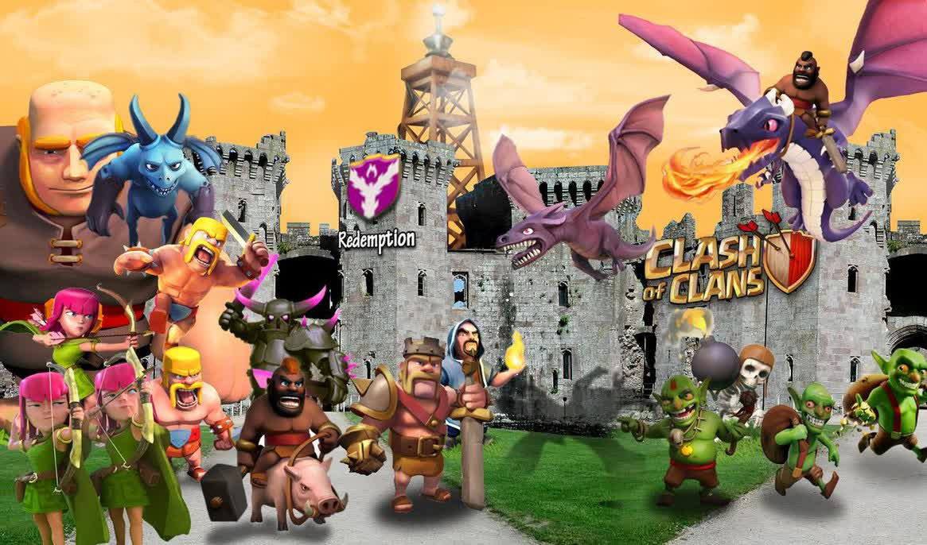](http://th06.deviantart.net/fs71/PRE/i/2014/097/c/e/clash_of_clans_wallpaper_hd_by_notoriousking-d7de0ge.jpg)

Setelah bayak yang request tentang cara mengganti email coc maka kali ini [wongtamfan.blogspot.com](http://wongtamfan.blogspot.com/) akan memberikan tutorial lengkapnya :) cara ini juga berguna kalau anda mau jual akun coc tp tidak ingin kehilangan emailnya juga... Ok simak baik-baik caranya  
  
1. bikin email baru dulu caranya klik pengaturan > akun> tambahkan akun > pilih google dan masukan alamat gmail baru.  
  
2. buka coc lalu masuk ke setting

[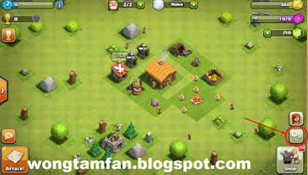](http://3.bp.blogspot.com/-nUAduCEI2Ms/VPrpH3RyNEI/AAAAAAAAAJQ/stJko468cHo/s1600/Screenshot_16.jpg)

3. **Masuk ke in-game setting kembali, pilih Help and Support**kemudian klik **Villages, Account & Passwords**, yang letaknya berada di bawah

[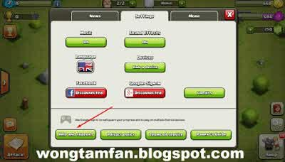](http://2.bp.blogspot.com/-qlz3NgtWmAY/VPrpcgWDHaI/AAAAAAAAAJg/__OGUNpK_PQ/s1600/Screenshot_18.jpg)

 4. Setelah itu, pilih **i’ve lost my village! Can I get it back?**

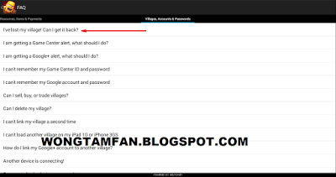

5. **Setelah itu klik gambar mail**

[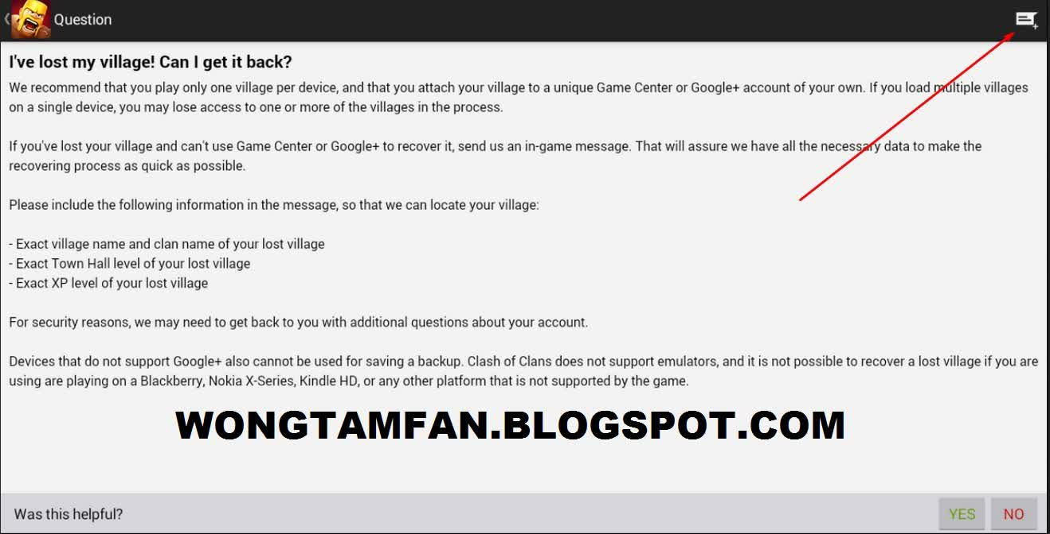](http://2.bp.blogspot.com/-69xOANSpzwo/VPwmA_aHDrI/AAAAAAAAAKc/QAJw67C2ScY/s1600/Screenshot_21.jpg)

Berikut adalah **percakapan lengkap** saya dengan customer service di gamesupport.supercell.net ( Dilakukan pada 10 Mei 2015)  
  
 (1) **Saya** 10 Mei 2015 22:37

[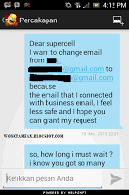](http://4.bp.blogspot.com/-nHzqEA4Ox-M/VWqhFKD1NPI/AAAAAAAABV0/URJMrAR_2VY/s1600/Screenshot_2015-05-16-16-12-05.png)

Dear supercell  
i want to change email from (alamat email agan yg lama) to (alamat email yg baru) because the email that i connected with business email, i feel less safe and i hope you can grant my request  
  
(2) **Supercell** 15 Mei 2015 16:06

[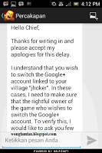](http://4.bp.blogspot.com/-6dQl1O1F8x8/VWqiFddNAeI/AAAAAAAABV4/UAXs-NUK12s/s1600/Screenshot_2015-05-16-16-12-21.png)

 Hello Chief,  
  
Thanks for writing in and please accept my apologies for this delay  
  
I understand that you wish to switch thr Google+ account linked to your village "joker". In these cases, I need to make sure that the rightful owner of the game who wishes to switch the Google+ account. To verify this, I would like to ask you few question to confirm that this account is yours and was created by you:

* when (month & year) did you star playjg on this account ?
* where (which city) did you create the account?
* what device (model#) do you use to play the account ?

Regards,

(3) **Saya** 15 Mei 2015 16:16

[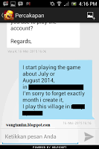](http://4.bp.blogspot.com/-RgeUygtuYUo/VWqiW5crILI/AAAAAAAABWA/qA1zQu0hPL8/s1600/Screenshot_2015-05-16-16-16-27.png)

i star playing the game about (kapan anda buat cocnya, bulan & tahun), in (kota anda waktu buat coc). Im sorry to forget exactly month i create it, i play this village in (merk hp dan model yg anda gunakan)  
  
(4)**Supercell**16 Mei 2015 18:20

[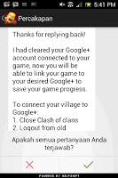](http://1.bp.blogspot.com/-WAmOGbbguTI/VWqihROa5XI/AAAAAAAABWI/F08YsYdLKgQ/s1600/Screenshot_2015-05-17-17-41-58.png)

Thanks for replying back!  
  
I had cleared your Google+ account connected to yout game, now you will be able to link your game to your desired Google+ to save your game progress.  
  
To connected your village to Google+:  
1. Close Clash of Clans  
2. Logout from old Google+  
3. Login with your desired Google+  
4. Open Clash of Clans and go to the in-game setting.  
Press the Google+ sign in button to connect your village to Google+  
  
If you would like to know anything else about using Clash of Clans with Google+ please do not hesitate to ask  
  
Have a good day!   
  
  
Setelah menerima balasan seperti itu biasanya akan disconnected sendiri seperti ini

[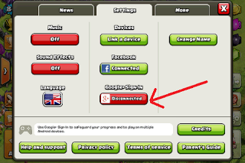](http://2.bp.blogspot.com/-LYK0rhoMRvk/VWqfNT6akZI/AAAAAAAABVk/sU_lsAGSxAo/s1600/Screenshot_2015-05-17-18-02-27.png)

Nah kalo sudah seperti itu tinggal click disconnected kemudian pilih email yg baru agan buat tadi :)  
  
  
Ok cukup sekian tutorial yg bisa saya sampaikan semoga dapat membantu and :) Salam Tamfan