WEEK 6 – HOMEWORK 2

Update with name “ALBANY” set column “capital” with value true:

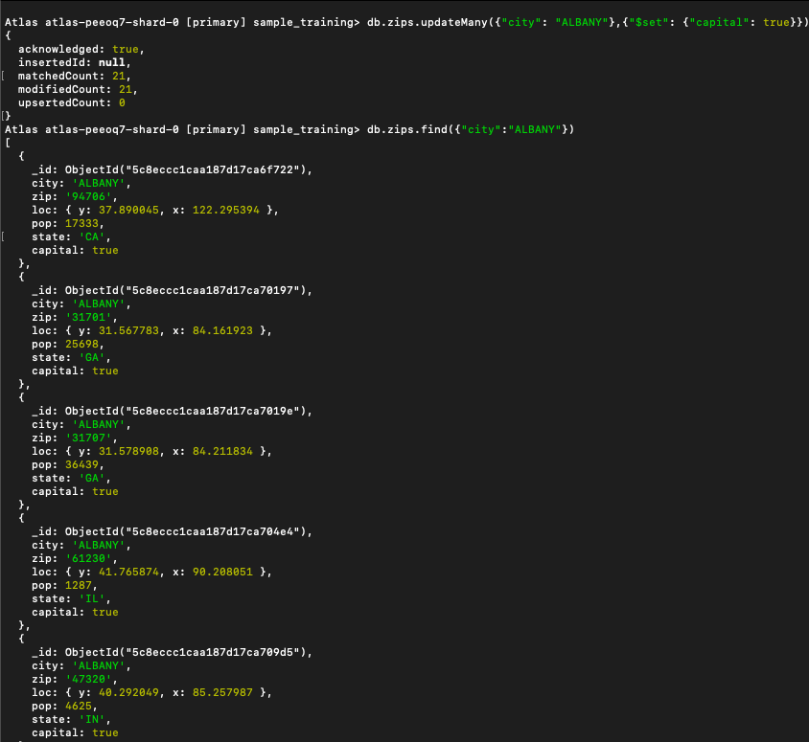

Update with name “NEW YORK” set column “capital” with value false:

