Travel n Study

Design Description

Version 1.1

Revision History

Date | Version | Description | Author
2002-00-00 | 0.01 | Initial Draft | DSD staff
2012-11-09 | 1.00 | First version of the document | Travel n Study project team members
2012-11-11 | 1.05 | Slight changes in the entire document | Branimir Lochert
2013-01-20 | 1.10 | Final version of the document | Travel n Study project team members

Table of Contents
1. Introduction 5
1.1 Purpose of this document 5
1.2 Intended Audience 5
1.3 Scope 5
1.4 Definitions and acronyms 5
1.4.1 Definitions 5
1.4.2 Acronyms and abbreviations 5
1.5 References 6
1.6 Name change 6
2. Software architecture 7
2.1 Conceptual design 7
2.1.1 Domain Model 7
2.1.2 Dynamic Loader 7
2.1.3 Data Access 8
2.1.4 Business Logic 8
2.1.5 Server – Client Interface 8
2.1.6 Presentation 8
2.2 System specification 8
2.3 External Components 8
3. External interfaces 9
3.1 Software Interfaces 9
3.2 User Interfaces 9
3.2.1 Introduction 9
3.2.2 Choice 11
3.2.3 Content 13
4. Detailed software design 14
4.1 Component model 14
4.2 Solution overview 14
4.2.1 StudyAbroad.Presentation 15
4.2.2 StudyAbroad.BusinessLogic 15
4.2.3 StudyAbroad.DomainModel 16
4.2.4 StudyAbroad.DataAccess 16
4.2.5 StudyAbroad.DynamicLoading 16
4.3 Domain Model 16
4.4 Database definition 19
4.4.1 Entity – relationship diagram 19
4.4.2 Database description 20
4.4.3 Database schema 21
4.5 Data Loader 22
4.6 Data access 23
4.7 Business logic 24
4.7.1 Suggestion system 24
4.7.2 Recommendation system 24
4.7.3 Climate classification 25
4.7.4 Cost of life classification 26
4.7.5 Search engine 26

Introduction

Purpose of this document
This document defines the design of the system which will be developed during the Travel n Study project. The information contained in this document will be used during project implementation. Next chapters describe the details of the domain model, database and interfaces that are going to be used in the Travel n Study application. This document is written before the implementation of the system and it is expected that there will be some changes in the future.

Intended Audience
This document will be mostly used by system developers and people who monitor the project development.
Intended Audience:
- Project Leader
- Team Leader
- Supervisor
- Leader Developer
- Developers (server side)
- Developers (client side)

Scope
This document provides details of the implementation design and architecture of the system. All parts of the application that will be made must be in accordance with this document. Any changes in the implementation details of the application must be added in the future versions of this document.

Definitions and acronyms

Definitions

Keyword | Definitions
Visual Studio | Microsoft Visual Studio is an integrated development environment (IDE) from Microsoft.
Object-relational mapping | Technique for converting data between incompatible type systems in object-oriented programming languages.
nHibernate | nHibernate is an object-relational mapping (ORM) solution for the Microsoft .NET platform

Acronyms and abbreviations

Acronym or  abbreviation | Definitions
VS | Visual Studio
DS | Data Source
OR mapping | Object-relational mapping
ER diagram | Entity–relationship diagram
HTML | HyperText Markup Language
CSS | Cascading Style Sheets
AJAX | Asynchronous JavaScript and XML
XML | Extensible Markup Language
API | Application Programming Interface
ODSM | Object Data Source Mapping
UI | User Interface

References
Project homepage: http://www.fer.unizg.hr/rasip/dsd/projects/Travel n Study

Name change
Please note that at the time of writing the latest revision of this document (20.01.2013) the project has undergone a name change from the name StudyAbroad to the name Travel n Study due to copy write reasons. However since the implementation of the system has already been accomplished there may still be some references to the old name in code and then in this document which offers detailed information about the design aspects of that code.

Software architecture

Conceptual design

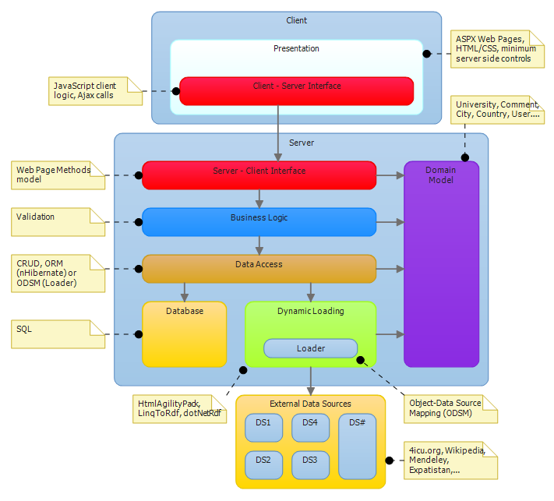
Figure 1: Conceptual diagram
System is made up of two parts, client side and server side. Server side gets the information and prepares it so that the user side can get it through the interface.

Domain Model

Domain model is a component used by all server components. It presents a group of classes and their attributes which describe the domain and it will contain classes such as University, Review, User, City, etc.

Dynamic Loader

Travel n Study application presents some information that is dynamically retrieved from external sources and some information which is stored inside the local database. Dynamic Loader component retrieves information from external open data sources and presents it to the Data Access Layer packaged inside of domain model objects. Some external sources offer APIs for data retrieval while others need to be parsed/scraped. HtmlAgilityPack is a library which will be used for html parsing, and for data retrieval from sources which offer APIs we will use custom made libraries and REST libraries.

Data Access

The Data Access component queries information from either the database or from repositories returned by the Dynamic Loader component and offers it to the other parts of the application. Other components don’t need to know where the information is coming from, as they are using them in the same way through the Data Access interface.

Data stored in the database tables (relations) is mapped to objects with nHibernate (ORM tool), and the data from external data sources (OData) is mapped to objects with the Dynamic Loader (ODSM tool).

Business Logic

The Business Logic component contains all the classes and methods which constitute the server side interface endpoint towards the client. It is used as a wrapper for the Data Access component by forming methods of the server side interface and as a validation checkpoint for all data persisted in the local database. Besides that this layer stores all the specific logic used in our application, such as the suggestion system, recommendation system, search engine and more.

Server – Client Interface

The server – client interface is presented by the business logic methods and properties which encapsulate the inner workings of the server side components and externally expose only what is needed by the presentation component to accomplish the system functionalities.

Presentation

Client side holds the components and modules which present data to the user. Presentational component retrieves the data from the server through the client – server interface and presents it on the user interface. User interface uses HTML for defining the structure, CSS for defining the presentation and JavaScript (jQuery) for defining the client logic of the pages which constitute the presentational component.

The client – server interface is implemented by a set of JavaScript functions which are using Ajax calls for communicating with the server exposed interface via ASP.NET web page methods model.

System specification
Operating system that is required on the server is Windows Server 2008. The user interface of the application is accessed through commonly used web browsers such as Internet Explorer, Mozilla Firefox and Google Chrome. Programming languages that are used are C# on server side and JavaScript (with jQuery) on the client side.

External Components
IIS 7 is used for the web server application, SQL Server 2008 for the database management system and nHibernate for object relational mapping. We will use .NET Framework, and for data gathering we will use HtmlAgilityPack library for HTML parsing and REST libraries for data sources with API. Besides that we will use ASP.NET Framework, jQuery, jQuery UI libraries and Ajax technology.

External interfaces

Software Interfaces

System is communicating with external data sources through the interface. Certain data sources offer APIs, but some data sources we need to parse to get requested information. Dynamic Loader is our component for communicating with external data sources. It retrieves exactly the information we want and exactly when we want it. The way the Dynamic Loader works is described in section 4.5.

Application depends on the availability of external data sources, because of the fact it is retrieving the data at the moment when the user requests it.

User Interfaces

As shown in figure 2. we divided the pages of our application in three groups: Introduction, Choice, Content (Knowledge).

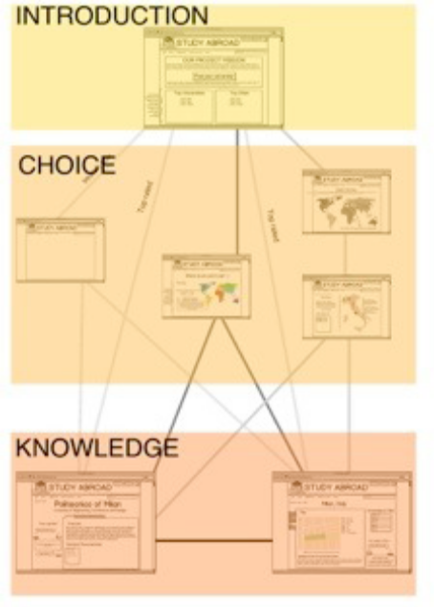
Figure 2: Application pages groups

Introduction

This group refers to the main page. Here we explain to the user what our application is about and how it can help him to reach his goal ( to find a university ). We also provide here the entry point for the navigational paths.


Figure 3: Home Page

After log in the home page changes to include the recommendation system module into the page. The module offers a selection of recommended universities for the user.


Figure 4: Home page after log in
In the home page we show the navigational paths that our users can take in order to access the content pages (city and university) starting from the entry point of the application. The paths are: Suggestion, Explore and Search. Every path allows the user to reach the content page easily with a minimum of three clicks from the Suggestion and Exploration and two clicks for the Search path. The Suggestion path strongly depends on the number of questions used to understand user’s preference and the way it is displayed.

Choice

The choice group of pages leads the user to reach his decision providing him suggestions or other general
information about cities and universities to narrow down his research. These pages contain the links to the actual
content pages.

On the exploration page the user can browse the map of the world and find universities on world, continent, region, country and city level. Once a university is located the user can easily get to the neccesary content pages.

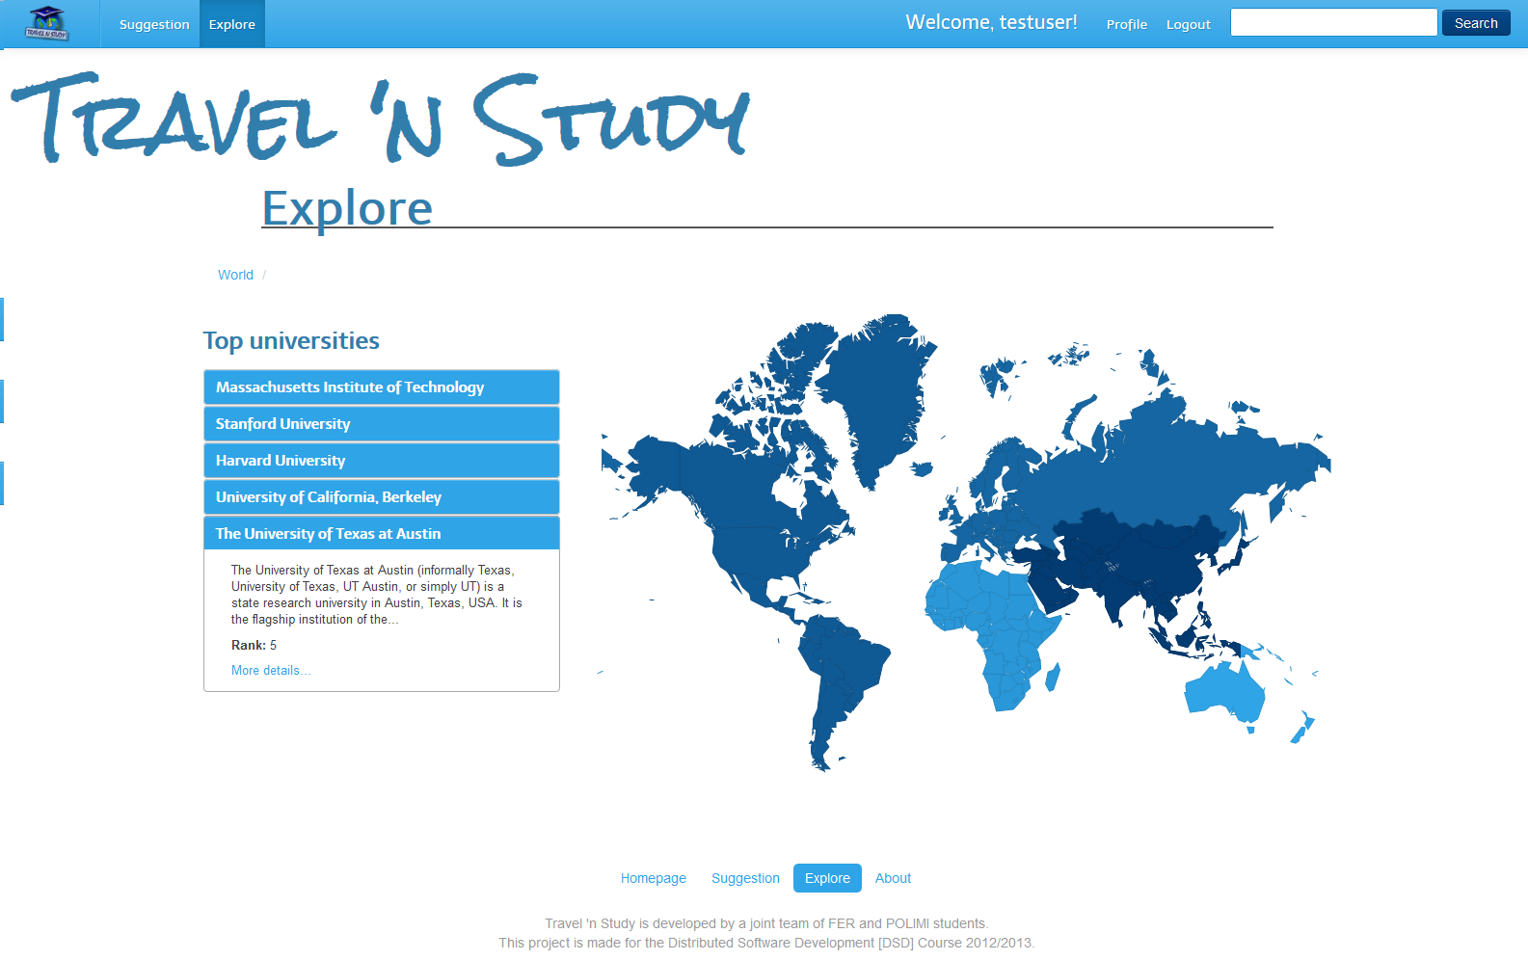
Figure 5: Exploration page - world view

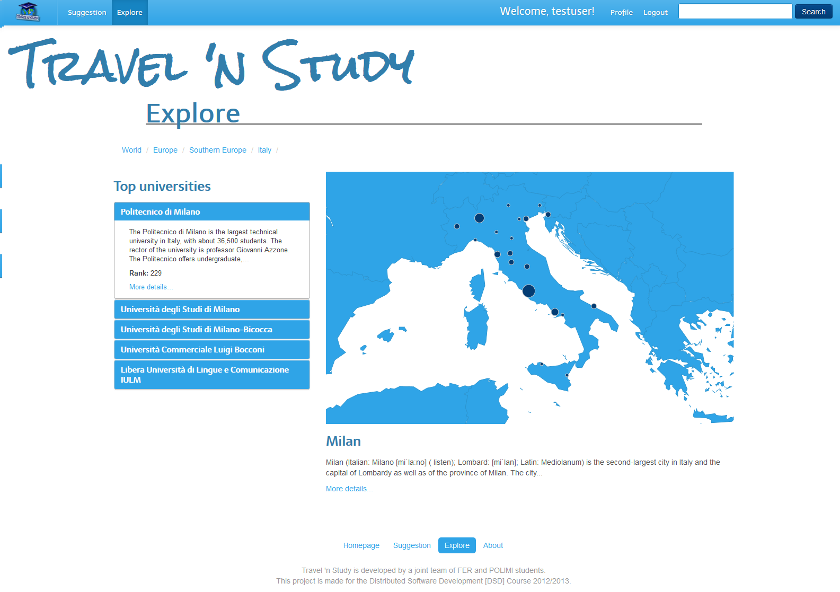
Figure 6: Exploration page - country/city view
On the suggestion page the user is presented a wizard which contains questions that gather user preferences and then the user is presented with a list of universities that are suitable for him/her based on those preferences. By clicking on any university on this list, the user gets taken to the content pages.

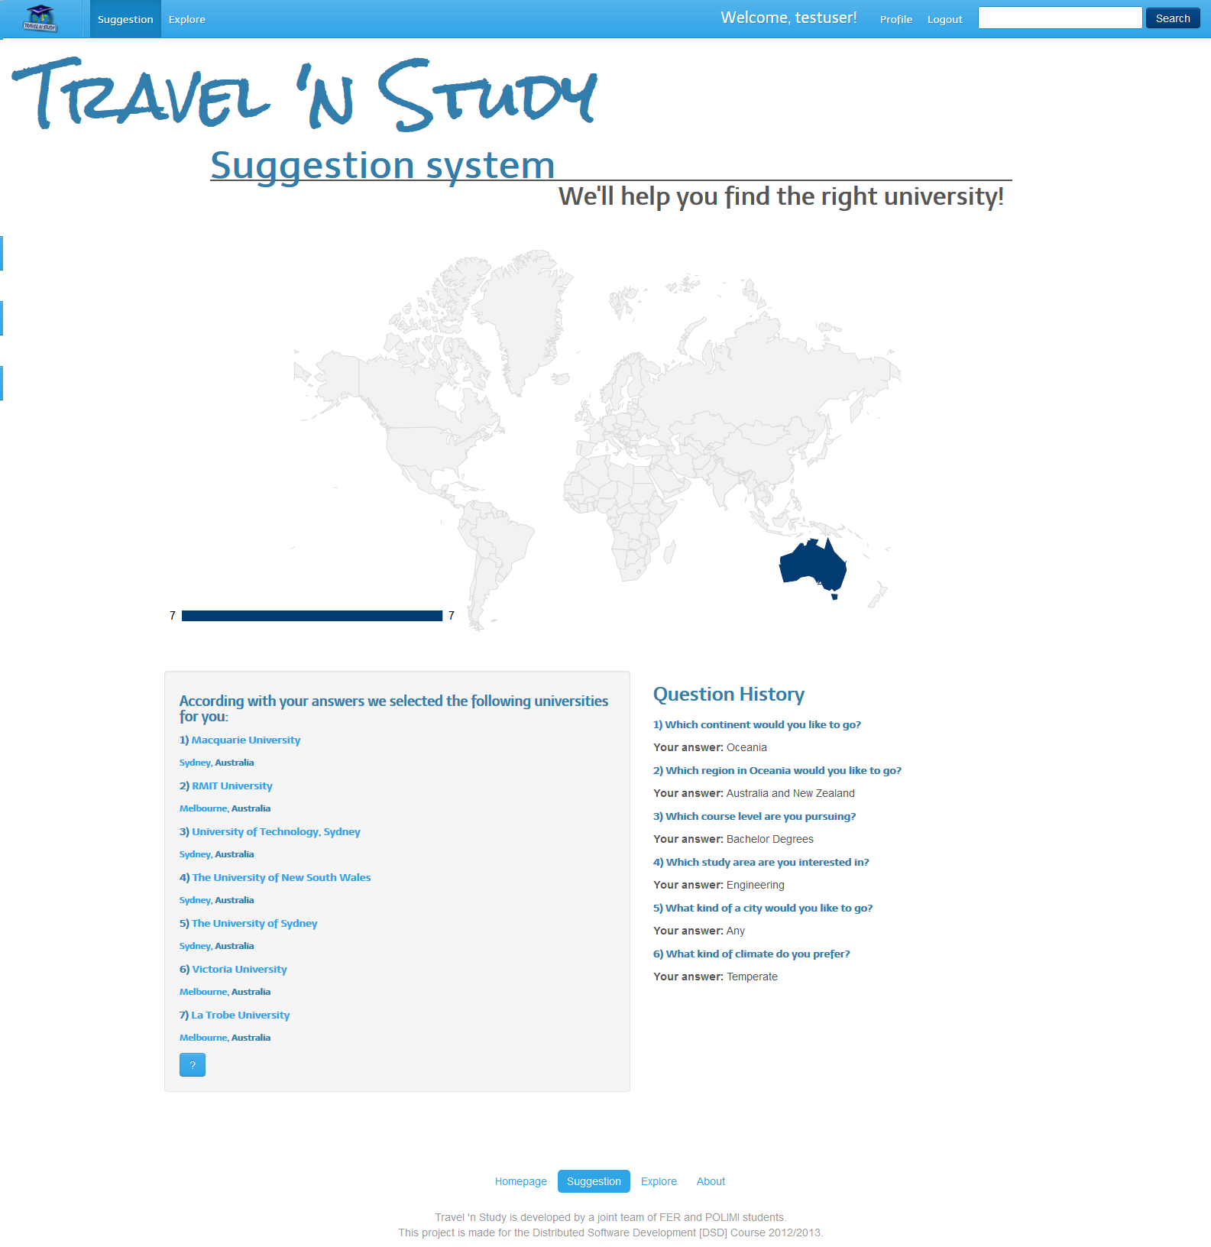
Figure 7: Suggestion system – results

On the search page, the user enters keywords and then gets presented by the results of the search. The results correspond to the list of universities and cities that are most similar to the searched keyword. By clicking on any of the universities or cities on the list the user gets taken to the content pages.

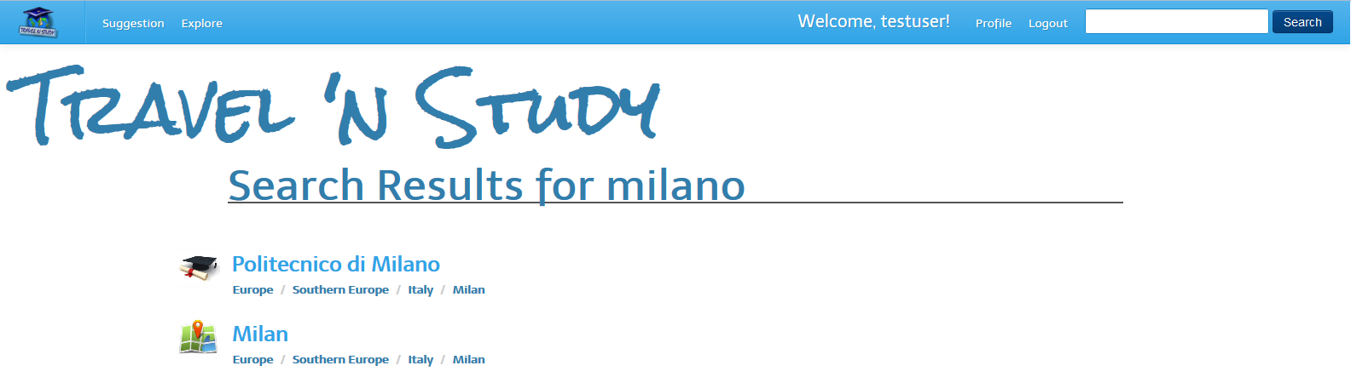
Figure 8: Search - results

Content

The content group is composed of pages describing specific cities or universities. Here the user will find most of the data we retrieved from various data sources.

The university page holds content information about universities divided into five categories: introduction, details and contacts, costs and admissions, reviews and university life. The city page holds content information about cities divided into six categories: introduction, general, climate, costs, reviews and city life.


Figure 9: University page – introduction

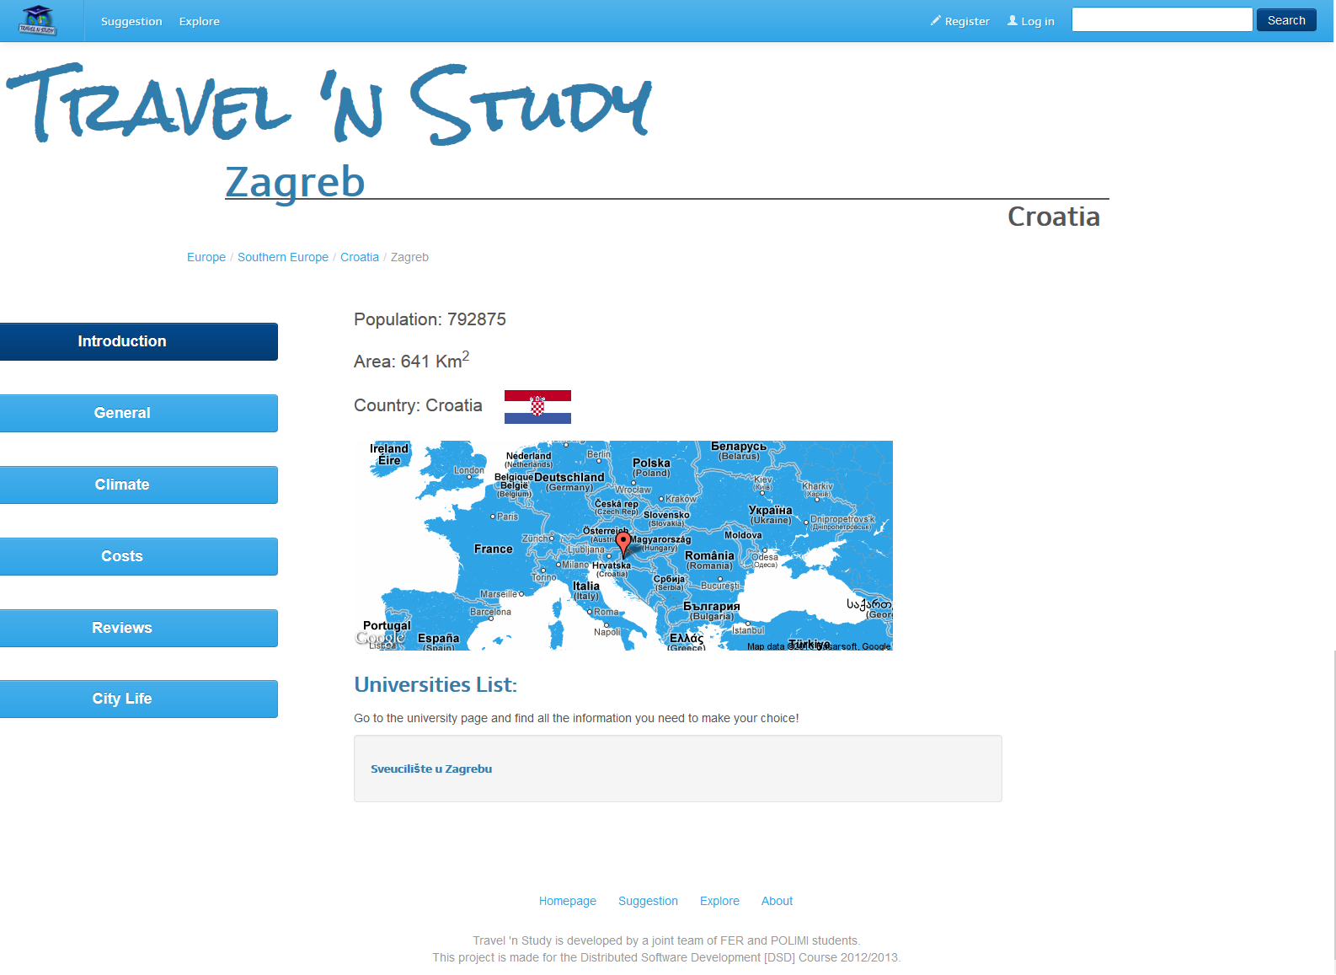
Figure 10: City page - introduction

Detailed software design

Component model

Figure 11. shows the component diagram of the entire system. As you can see the architecture is a typical client server architecture with multi layers server side.
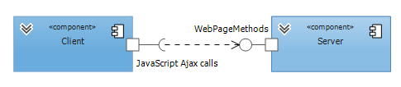
Figure 11: Component model of system
Next figure shows the detail decomposition of the server on major components.

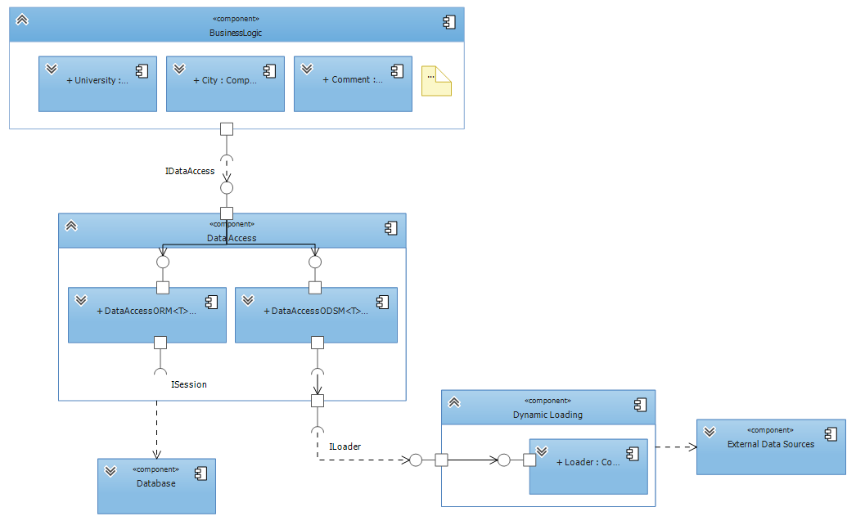
Figure 12: Component model of server side

Solution overview

Visual Studio solution is separated into several projects which tasks are to implement layers from the conceptual diagram. Each individual layer is responsible for storing or processing data in a way that provides a service to other layers. The idea of the concept in the real implementation environment is shown in the following picture.
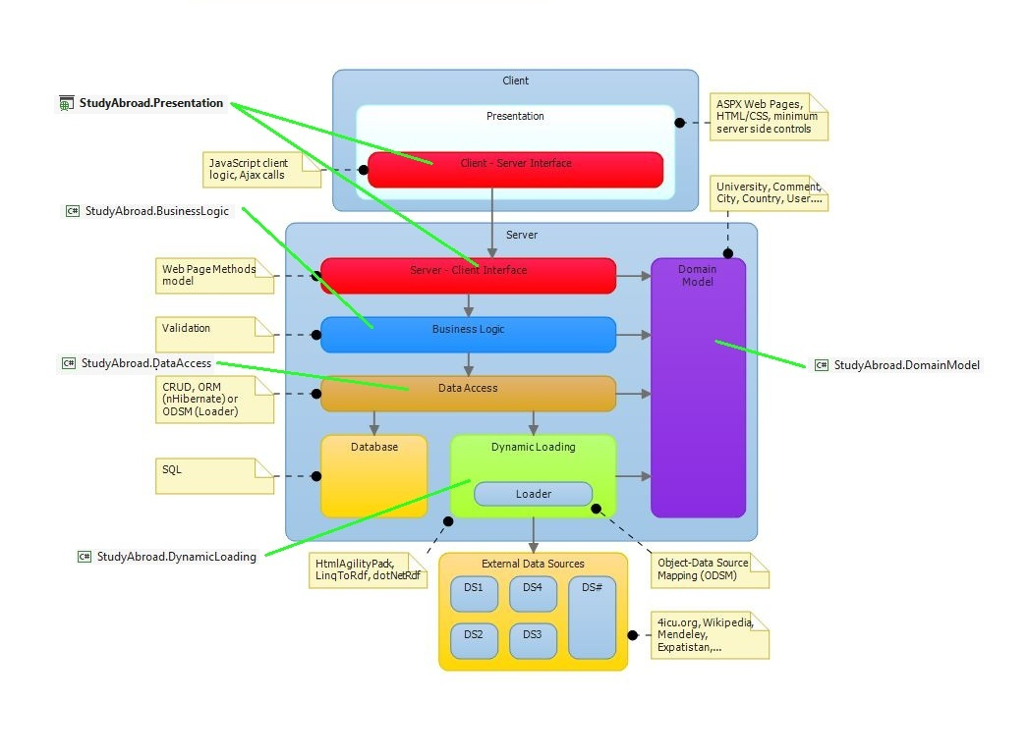
Figure 13: Mapping conceptual layers to VS solution projects

As you can see in the attached figure, layers from conceptual diagram correspond to the projects in Visual Studio. Each layer from the concept corresponds to the actual implementation in the solution.

StudyAbroad.Presentation

The presentation project is responsible for presentation of information that is provided by the Business Logic layer. There will be websites on the client side which will call the web methods from the interface. That websites will be made in HTML/CSS technology and the methods will be called using Ajax. Services, which will be provided by web page methods, will depend on the services of other layers in the system. There are two parts of this project. One is the HTML/CSS website presented to users with background JavaScript logic and the other one is C# code behind which provides web page methods.

StudyAbroad.BusinessLogic

The business logic project is responsible for the coordination between Data Access layer and Server – Client interface. It usually calls the methods from the lower layers and coordinates the data flow. This project will also perform data validation before storing it into the database. Besides that this layer is used for any specific logic that needs to be implemented to accomplish the requirements of the Travel n Study project such as the suggestion system, recommendation system, search engine and more.

StudyAbroad.DomainModel

The domain model project contains the implementation of the Domain Model layer of this project. It contains basic classes which describe the domain of the system. Details of the Domain Model will be explained in section 4.3.

StudyAbroad.DataAccess

The data access project represents Data Access layer from the conceptual diagram. It encapsulates the details of fetching data from the lower data layers. Thanks to it, the higher layers do not have to worry about the source from which the data is coming from. Their method call is always the same regardless of whether the data is retrieved from the database or from an external source because of the interface established here.

StudyAbroad.DynamicLoading

The dynamic loading project is responsible for the connection between the system and external data sources. This layer contains classes which are responsible for communication with each external data source. The details of that communication are hidden from higher layers with the interface. Other (higher) layers do not have to worry about the details of how the communication with external sources is implemented. More details about this layer will be written in section 4.5.

Domain Model

The Domain Model represents a set of basic information and functionality holder classes needed to model the domain of the project. It usually contains business practices and operational details. In this project, the Domain Model classes are mostly information holders which contain collected data from the external data sources. Thus allow us to assign meaning to the collected data and classify them into appropriate groups. This way we can manage our collected data inside an object oriented environment. This is also very important in OR mapping because the classes of the domain are mapped in database tables using nHibernate.

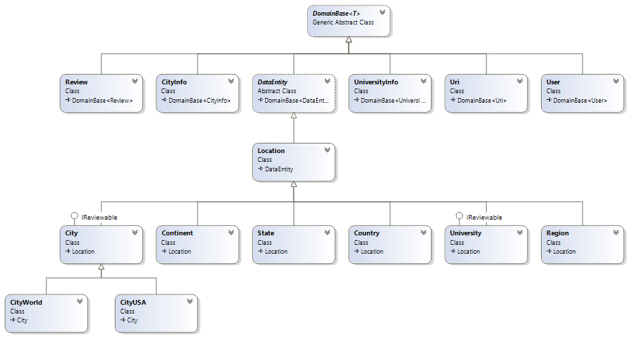
Figure 14: Domain Model class diagram

As can be seen in the diagram, there is a base super-class which is inherited by all other members of the Domain Model. It is because the class contains the Id data member which is important in OR mapping using nHibernate. In this way, all the classes inherit that data member. Also, due to the mapping, data members must be public and in each class there must exist a parameter less constructor.

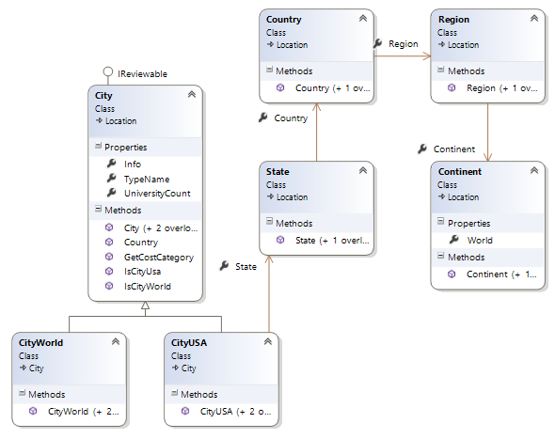
Figure 15: Geographical location classes

Regional division is presented with a series of classes that indicate the geographical location. Class City, Country, Region and Continent are representing geographic concepts and are used to precisely locate the university. These classes are also information holders for facts about the location. Classes are connected with associations so every class knows to which region it belongs.

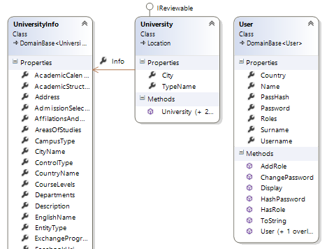
Figure 16: University and User classes

The class User stores user private data that will be used to create its profile and for his authentication. Class University stores information about every university with its internal class UniversityInfo. This class holds all the information parameters about the university gathered from various data sources. Both classes have a connection to a location class. In the University class that connection represents the location of the university (city) while in the User class it represents the home country of the user.

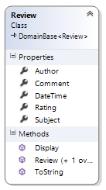
Figure 17: User reviews

User reviews are modeled by the Review class which contains an association to the User class (author of review). Each review contains a comment by the user and a rating. Subject of the review can be either a University or a City, this is ensured by a IReviewable interface which only allows cities and universities to be reviewed.

Database definition

Entity – relationship diagram

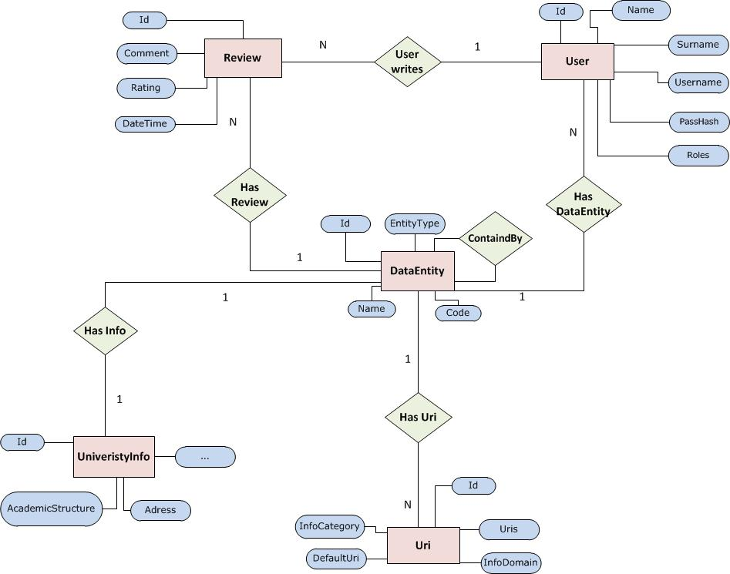
Figure 18: ER diagram

Database description

Since there are a lot of entries in the database, it is designed with efficiency in mind. A central data entity relation holds all the entities in our system, such as universities, cities, countries, regions etc. All of these entities can be described by the same set of initial attributes such as name, code, contained_by etc.

Types of entities are distinguished by the discriminator attribute entity_type. For every entity a foreign key to the information relation table exists where additional information may be stored for that entity type. For example every university entity has a connection to the university info relation that stores all the information about that university. Each data entity has one or more uri entries which are links to external resources connected to that entity. These external resources may be additional information, images or similar.

Besides the data entity relation which forms the core of the database, there are the user and review relations which hold all the information about users in our system and their reviews on various universities and cities. These relations are crucial for recommendation and suggestion systems because they provide the data from which models that run these systems are built.

For the creation and querying of the database an OR mapping tool called nHibernate is used together with Fluent for dynamic mapping and schema updates. nHibernate provides a framework for mapping an object-oriented domain model to a traditional relational database. Object-relational mapping (OR mapping) in computer software is a programming technique for converting data between incompatible type systems in object-oriented programming languages.

As you can see in the ER diagram, entities tables correspond to classes in the Domain Model of the system. In the Domain Model chapter it is stated that data members must be public, and that each class must have a parameter less constructor. It is very important for the realization of OR mapping.

The mapping strategy used in this database is called table per hierarchy (TPH). The entire inheritance tree formed by geographical classes in the domain model is created through one table only. The inheritance depends on a conditional mapping which is defined by a condition such as the discriminator database field. The condition is used to define records as different types.

Database schema

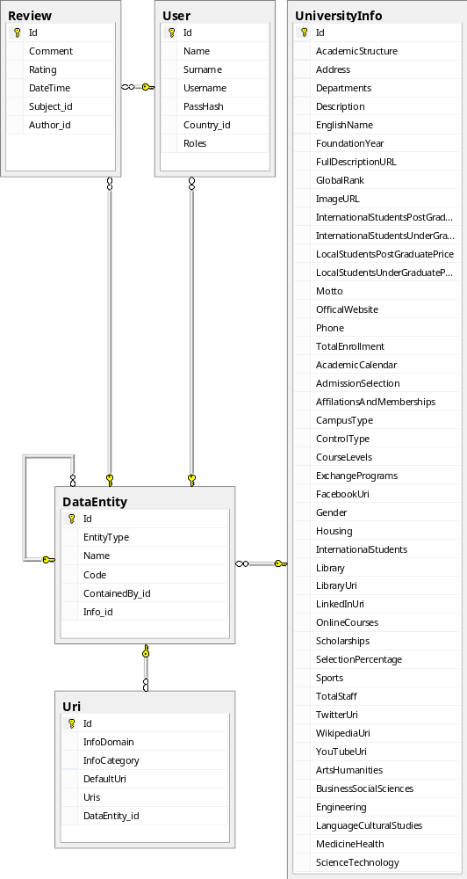
Figure 19: Database schema

Data Loader

The way that the application works is by loading the data either from the database or from the external data sources and mapping them to domain model objects which are used in the application. The object-relational mapper used in the application is nHibernate and the explanation of how that framework works is beyond the scope of this document. The object-data source mapper used in the application is developed so that the data gathered from external data sources such as open data sources can be mapped to domain model objects.

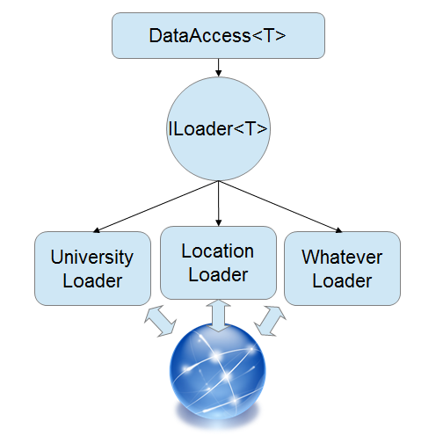
Figure 20: Loader model

The principle is simple: in order to query data the data access layer needs to be provided with a loader to fetch data into a local repository. To get only the data we need loaders have been designed to have several methods but all are accessed through a common and generic ILoader interface. For this principle to work several factories are necessary which together with configuration classes allow the programmer to create a loader which will load only the data needed and only when it is needed.

The loaders themselves are nothing more than a collection of HTML parser methods (for scraping web pages) or a collection of API access methods (for open data sources which provide an API). The loader uses methods according to the configuration settings provided and loads the local repository with data which can then be queried by the data access layer.

Loaders can be easily added once additional data sources are available and as long as they implement the common ILoader interface they will integrate seamlessly into the application.

Data access

The data access layer is defined by the generic IDataAccess interface which provides a unique way of accessing data from the business logic which sits on top of it. Business logic uses the data access layer through this interface never really knowing whether the data comes from the database or external data sources.

Classes DataAccessORM and DataAccessODSM implement the methods of the interface in their own way which is specific to the data source they query. DataAccessORM queries the database and uses nHibernate ORM tool to perform CRUD operations on the database. DataAccessODSM queries external data sources and uses HTML parsing or REST API calls to get data from these sources.

The interface encapsulates the details of where and how the data comes from and offers it too upper layers through a uniquely defined set of methods.

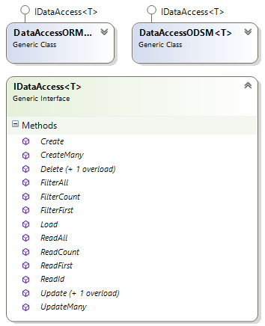
Figure 21: Data access layer

Business logic

The business logic primary function is to further encapsulate the data access layer and provide the interface to the client side presentation layer. All the data that is generated by the user while using the application goes through the business logic layer on its way to being stored in the database. This is why the business logic layer is also used as a validation checkpoint to make sure all the data being stored is in the correct state.

The secondary function of this layer is to host application specific logic described in the following sections.

Suggestion system

The application is capable of offering a list of suggested universities to the user after asking him a set of questions to gather his preferences. The suggestion system that allows this is implemented in a modular way where questions implement a standardized interface IQuestion. This allows additional questions to be added with ease as long as they implement the interface.

Since every question offers a criteria by which a set of original universities gets narrowed down to a smaller set of result universities which satisfy the criteria, every question must also implement a filter which conforms to the IFilter interface.

The suggestion system presents the user one question at a time (the order of the questions does not matter) and after each answer applies the question criteria to the result set. After all the questions have been asked or the result set becomes too small, the resulting list of suggested universities is presented to the user.

Besides the above the suggestion system also has some advanced features such as question history, question memory, explanations of why some university was chosen and more.

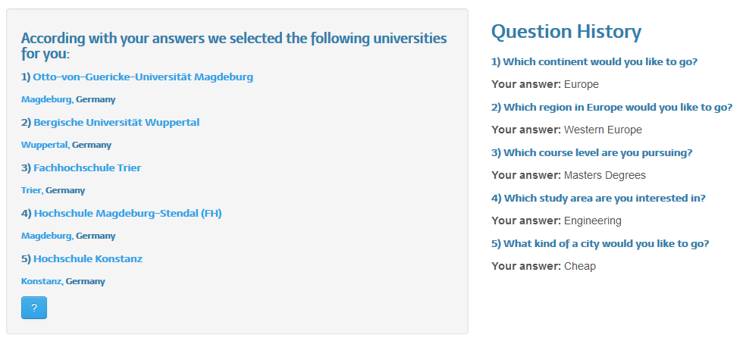
Figure 22: Suggestion system interface

Recommendation system

The application is capable of offering a list of recommended universities based on user ratings of universities and cities. The system uses familiar recommendation system algorithms such as the SlopeOne whose explanations go beyond the scope of this document. At certain intervals a model is built which is based on all of the applications users and their reviews which are stored in the database. This model is then used to recommend a list of universities which are individual to each user in the system.
In order to get personalized recommendations the user has to at least review one university or city. Then this review can be connected with other people who reviewed the same university or city and the data on other reviews these users have done can be used to recommend a set of universities to the initial user based on similar users. If the user has no reviews a list of most popular universities will be presented.

The recommendation system in our application integrates with the other parts of the system in two ways:

- Home page integration – on the home page each user gets a list of top ten universities which are recommended for him
- Suggestion system integration – on the suggestion system each user gets a list of suggested universities in order which are best recommended for him


Figure 23: Recommendation system interface

Climate classification

Climate classification algorithms are used to categorize the climate of a city according to the Köppen climate classification. Climate data gets gathered from external data sources through the data access layer interface and then gets used to calculate the climate category of the city. The possible climate category outcomes are:

- Tropical
- Dry
- Temperate
- Continental
- Polar

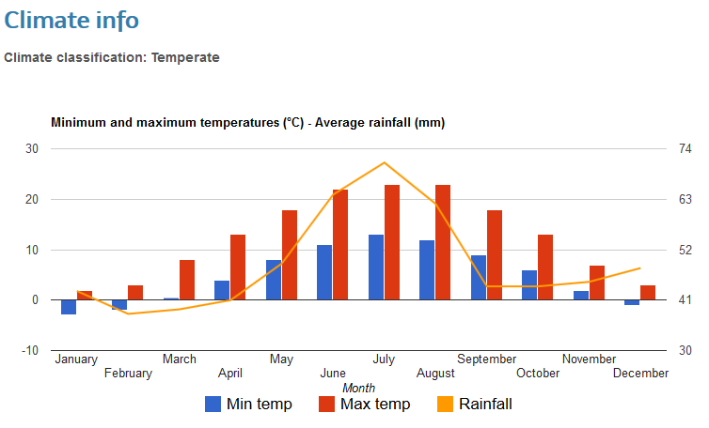
Figure 24: Berlin climate classification and graph

Cost of life classification

Cost of life algorithms are used in order to calculate a cost index of living in a city. External data sources are used to gather pricing information on several items which are then used to calculate the city index. The city is then classified into several categories:

- Very cheap
- Cheap
- Moderate
- Expensive
- Very expensive

Search engine

The application implements a keyword search engine that uses algorithms such as Levenshtein distance calculator algorithms and Fuzzy search algorithms. The first is used to calculate a numerical distance between two strings and the second to calculate a score value for an item based on that numerical distance.

Once a user enters a search keyword the database is queried and a list of results is formulated ordered by the score of each item. The higher the score, it is more likely that the result is what the user searched for.

