TravelNStudy

User Manual

Version 1.0

Revision History

Date | Version | Description | Author
2013-01-20 | 1.0 | Initial public revision | DR / MC

Table of Contents
1. Introduction 5
1.1 Purpose of this document 5
1.2 Intended Audience 5
1.3 Scope 5
1.4 Definitions and acronyms 5
1.4.1 Definitions 5
1.4.2 Acronyms and abbreviations 5
2. Homepage 5
2.1 Navigation links 6
2.2 Login/Register 6
2.3 Direct Search 6
2.4 Top universities links 6
2.5 Reccomendation system 6
3. Registration 7
4. Login 8
4.1 User profile 9
5. Administrator privileges 10
6. Explore 11
6.1 Interface 11
6.2 View universities 12
6.3 Explore a region 12
6.4 Going back to a higher level region 13
6.5 View details of a city 13
7. Suggestion system 13
7.1 Interface 13
7.2 Answering a question 14
7.3 Changing an answer 15
7.4 Viewing results 15
7.5 Viewing how the suggestions are made 15
8. Browsing city and university pages 15
8.1 Interface 15
8.2 View Google Places suggestions 16
8.2.1 Interface 16
8.2.2 Toggling categories 16
8.2.3 View details 17
8.3 Reviews 18
8.3.1 Adding a new review 18
8.3.2 Editing a review 19
8.3.3 Deleting a review 19
9. Direct search 20
9.1 Make a search 20
9.2 Viweing search results 20

Introduction

Purpose of this document
The purpose of this document is to help the end user with the usage of our product. Altough our interface is designed to be as simple and intuitive as possible, here we explain of to take advantage of all the features of the project.

Intended Audience
Any end user of the application.

Scope
The document gives detailed instructions about the usage of all the functionalities of the product. Some minor cases that may occur (such as an unresolved address error for a google places tab) are not listed here, but they can be easily understood without any reference.

Definitions and acronyms

Definitions

Keyword | Definitions

Acronyms and abbreviations

Acronym or  abbreviation | Definitions

Homepage
This is the first page that you will see connection to our website, the entry point of our application
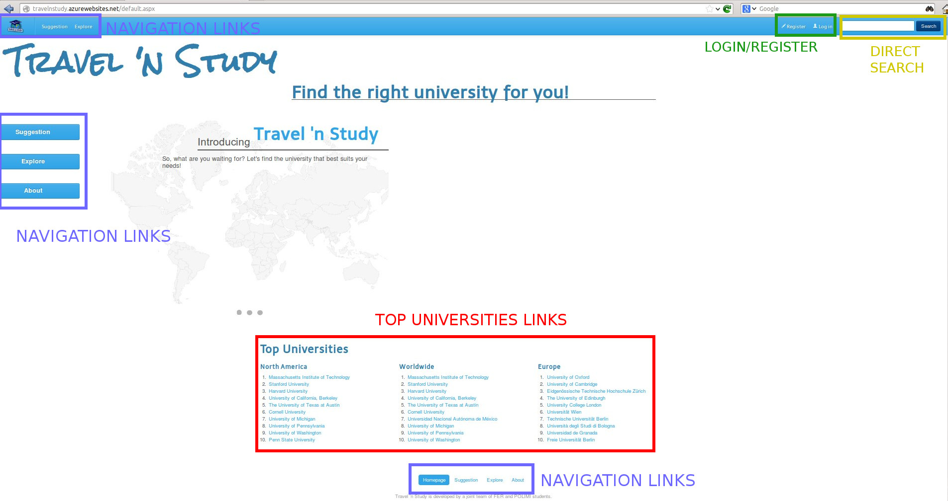
Figure 1 - Home Page

Navigation links
These links bring you to the different functionalities of the application, that are the suggestion system (section 7) and the free exploration of the map (section 6). You can also access the About page where you can read credits for the application.
The header and the footer are viewable from any page of the website. Note that clicking the Travel n Study logo in the top left corner you are redirected to the homepage itself.

Login/Register
Users can create a new account that enables new features of the application (sections 3, 4, 5)

Direct Search
In this text field you can type a university or a city name; clicking on the Search button you can execute a search with the key you entered over our database of universities and cities.

Top universities links
These three columns show the top rated universities in North America, in the world and i Europe. Clicking on a name among these you get redirected directly to the university page on our website.

Reccomendation system
If you are logged in the homepage has a different look: instead of the top universities links, you will see three reccommened universities. These reccomendations are computed with an advanced engine that uses your reviews and navigations. You can also see more reccomendations clicking the “See more suggestions!” button.

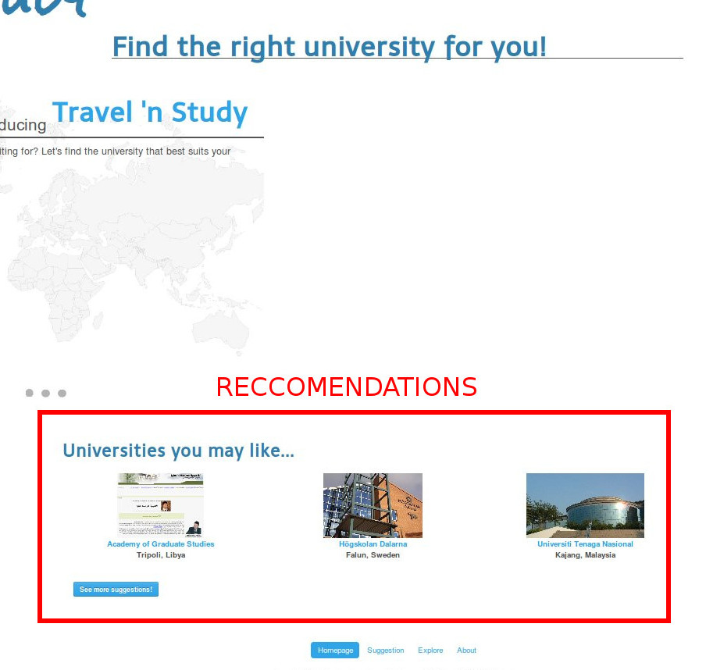
Figure 2 - Reccomendations

Registration
Registered users can get recommendations from Recommendation system and they can also rate universities or leave a comment.
For registration user needs to click on Registration button in the header of Travel n Study page.

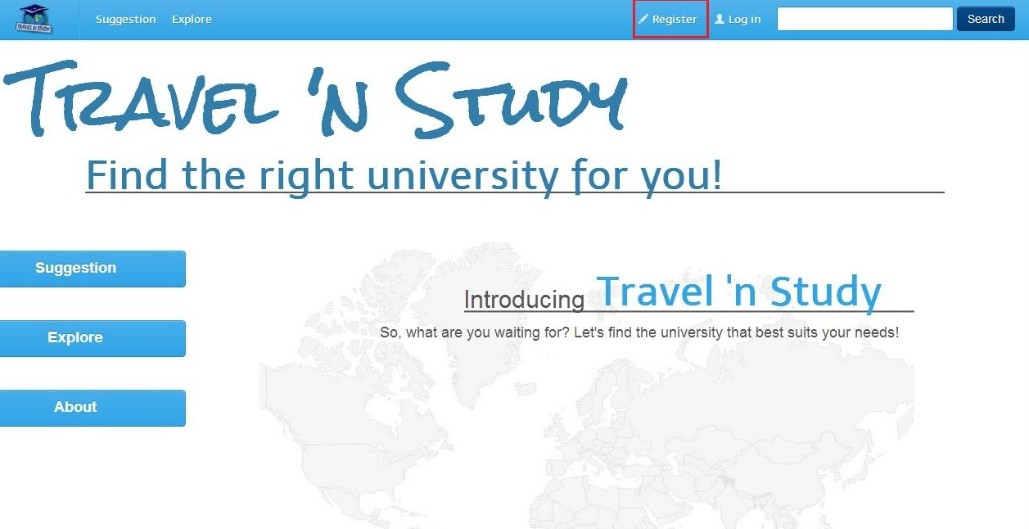
Figure 3 - Registration button
After that he needs to fill the boxes in page that opens. These are the basic information about the user that could be used for recommendation. Private information about the user will not be open to the public. After the user fills out the fields must press the button Register on the bottom of the page.

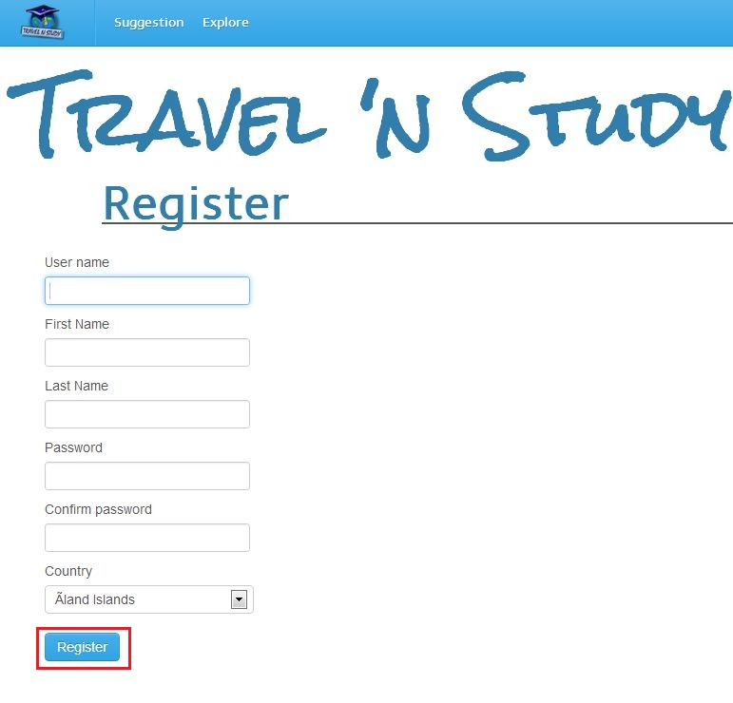
Figure 4 - Registration

Login
After registration, the user is redirected to the Login page. Login page can also be accessed by selecting the Login button next to the Registration button in the header of the page. With the Login button user can access to account if he previously created one.

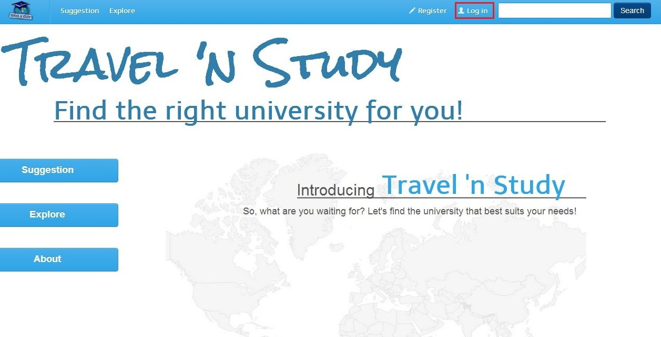
Figure 5 - Login button

For accessing the profile, user must pass a standard procedure with entering username and password.

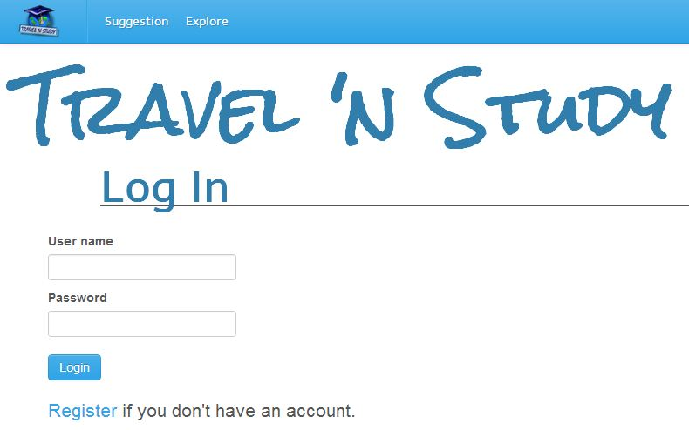
Figure 6 - Login page

Of course, user can Logout by pressing the Logout button.

User profile
After the user logs in, he can access personal information which was entered during registration. This can be done by selecting the profile button that appears in the header after Login.

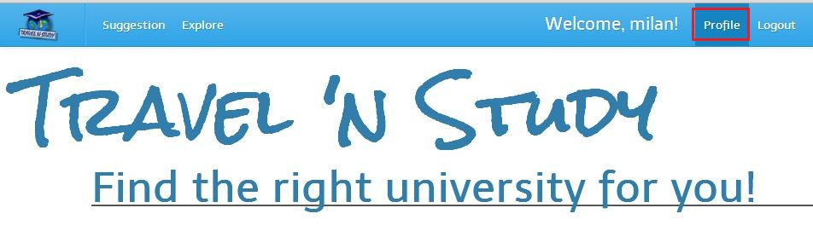
Figure 7 - Profile button

On the profile page, the user can edit his personal information or he can change password. He can also delete his account pressing Delete Account button. For editing personal information user needs to click on Edit button and then he can change his name, surname and country. After that he needs to press the Save button.

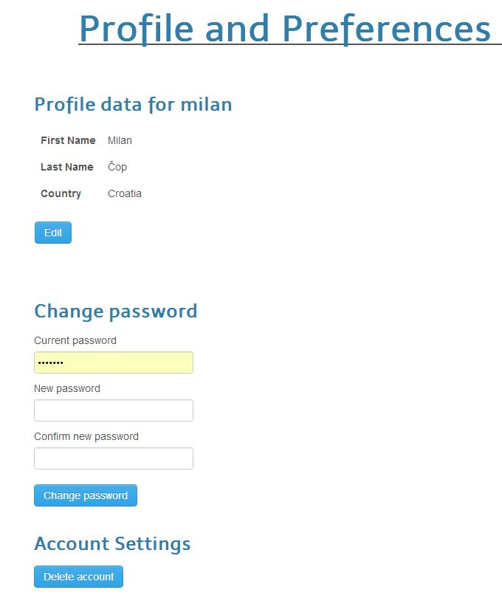
Figure 8 - User profile page

Administrator privileges
There are two types of users in TravelnStudy application: administrator and user. Users are all person that register on website with standard procedure. Administrator is only person that can edit other’s accounts and edit their reviews. Administrator is usually defined by person who installed the program. He logs in on standard way, but has slightly different interface. There is a Manage button, with which the administrator can edit or delete user accounts.

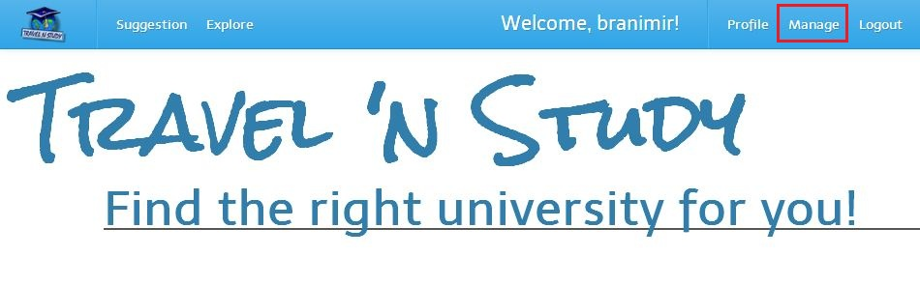
Figure 9 - Administrator interface
After clicking on Manage button new page opens. On that page there are options Administrator needs to manage user accounts. If he wants to changes somebody’s account there is Modfy button, and there is also Delete button for deleting user account.
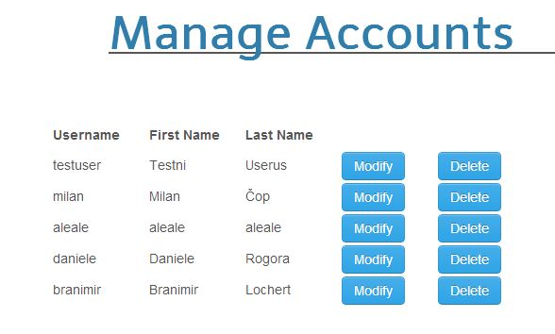
Figure 10 - Manage account administrator option
Administrator can also edit or delete other’s user comments on university. He has Edit and Delete button on all reviews.
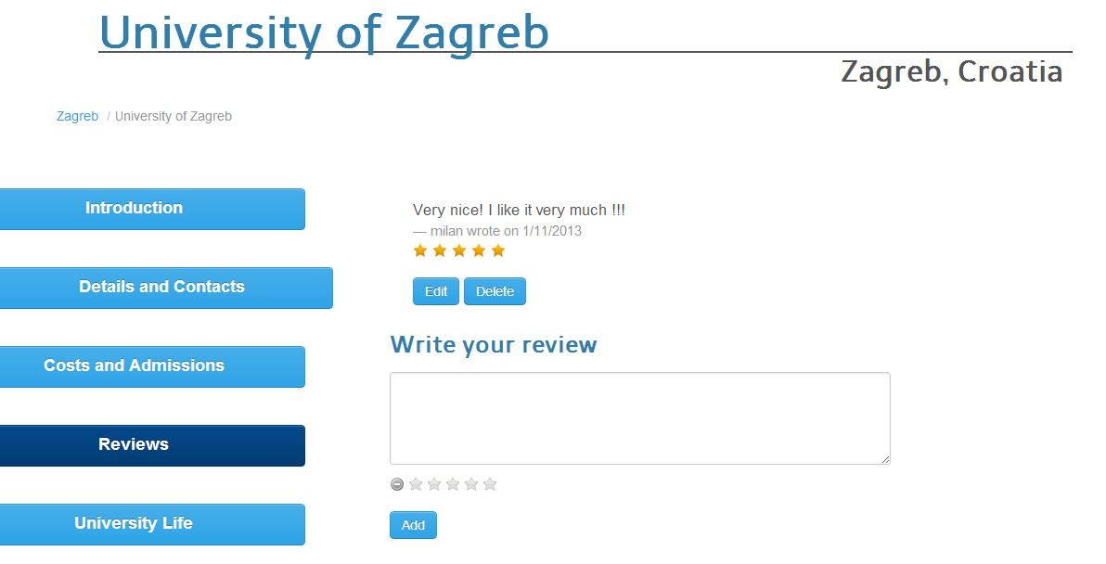
Figure 11 - Administrator additional options

Explore

Interface
The following picture shows the simple interface of the exploration functionality: there is simply a list of universities on the left side of the page, a map on right side and a recap of the current region above.

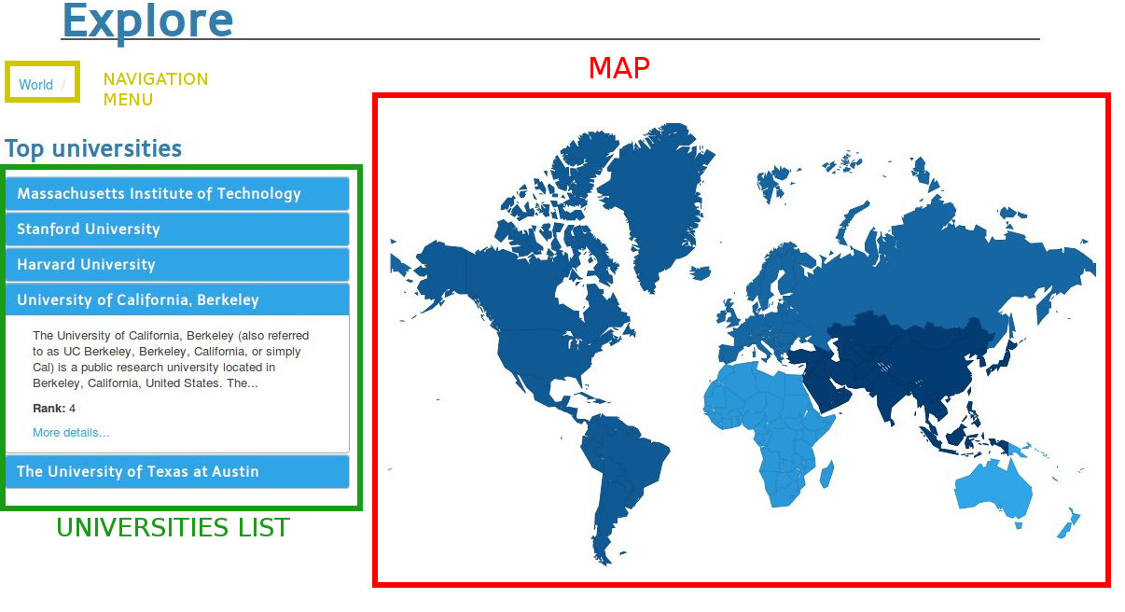
Figure 12 - Exploration interface

View universities
Moving the mouse cursor over the list of universities you can expand it to show some brief details, like a short description and the global rank. You can also find a link that brings to the university page on our website.

Explore a region
If you want to open a specific region in the world you simply have to move the mouse cursor over the map: you will see a tooltip with the name of that region and its number of universities. When you choose the region simply click on it.

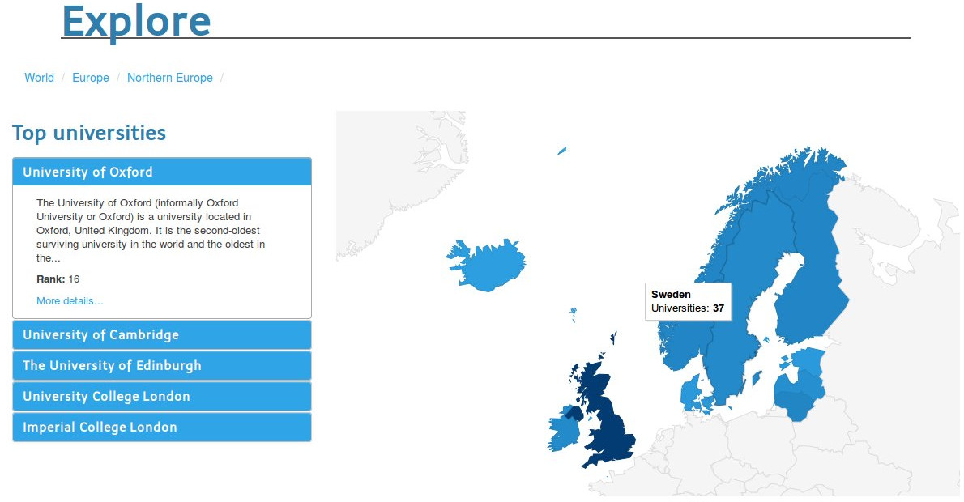
Figure 13 - Exploring a region

Going back to a higher level region
If you want to return to a previously visited region you simply have to click on its name in the navigation bar.

View details of a city
When you are at country level the style of the map changes: instead of showing subregions it shows circular blue markers; these represent cities in that country.
Moving the mouse cursor over one marker spawns a tooltip with its name and the number of universities. Clicking the marker instead opens an additional paragraph below the map, containing a brief abstract of the city and a clickable link to the city page in our website.

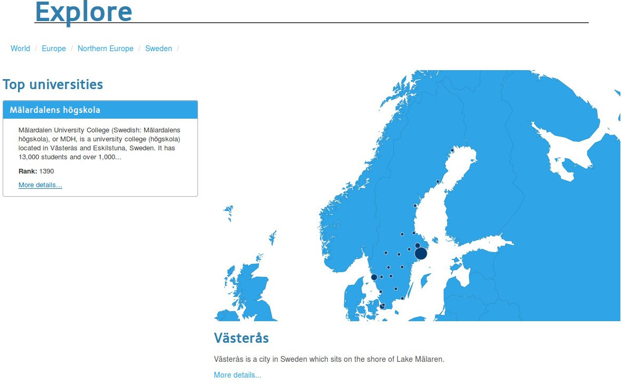
Figure 14 - Viewing a city

Suggestion system

Interface
The following picture shows the simple interface of the suggestion functionality: there are three main components.
The first is the current question box, where you can read the next question you should answer to complete the selection. On its right there is the wizard overview, that is a list of the questions answered up to a specific moment with the answer you gave.
Above these there is a map: it shows which regions are still choosable with the answer given so far.

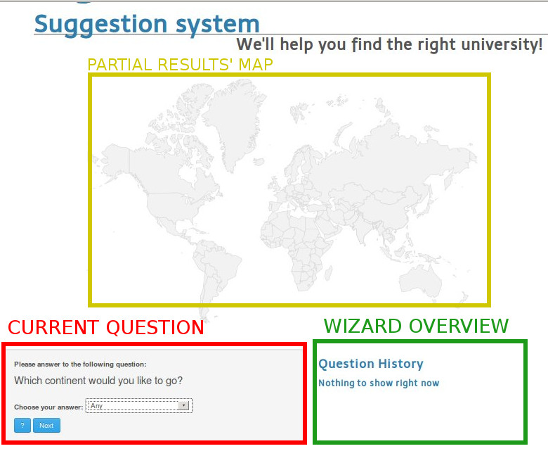
Figure 15 - Suggestion system interface

Answering a question
To answer a question you must simply click on the list box next to the “Choose your answer” tag, and then click on the option you prefer. Finally push the “Next” button to confirm your answer.

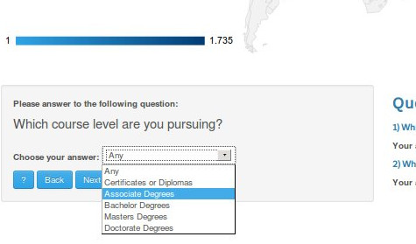
Figure 16 - Answering a question

Changing an answer
If you want to change an answer already given you can push the “Back” button: this will take you exactly to the last answered question, discarding the selection done with the unwanted answer.

Viewing results
Once you answered all the six questions of the wizard you will see a list like that of the following picture, where you can click both on university and city names, that take you to the related page on our website.

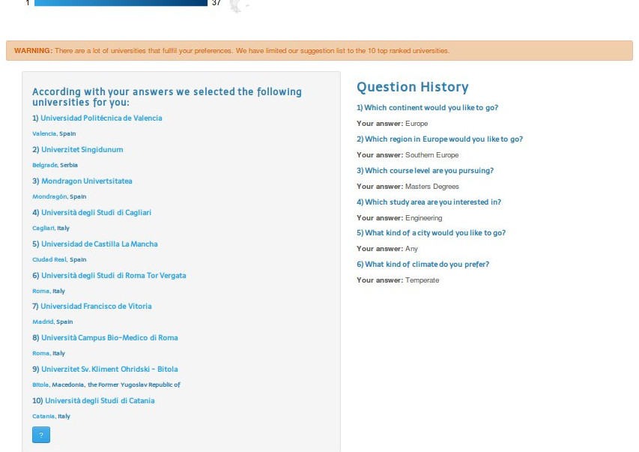
Figure 17 - Viewing suggestions

Viewing how the suggestions are made
Clicking the “?”button at any step of the wizard you can see a brief description of how the suggestion system work.

Browsing city and university pages

Interface
The following picture shows the layout of a page of one university.
On the left side of the page there are various buttons that represent different tabs. The currently active tab is represented by the darker button.
On the right instead there is the content of the active tab, that obviously changes as a consequence of a click on a tab button.
Above these there is a navigation link that brings to the page of the city related to the specific university.
The city page works exactly in the same way; the only difference is about the available tabs and and the navigation link, that states the regions in which the city is and that brings the user to the exploration page on the corresponding page.
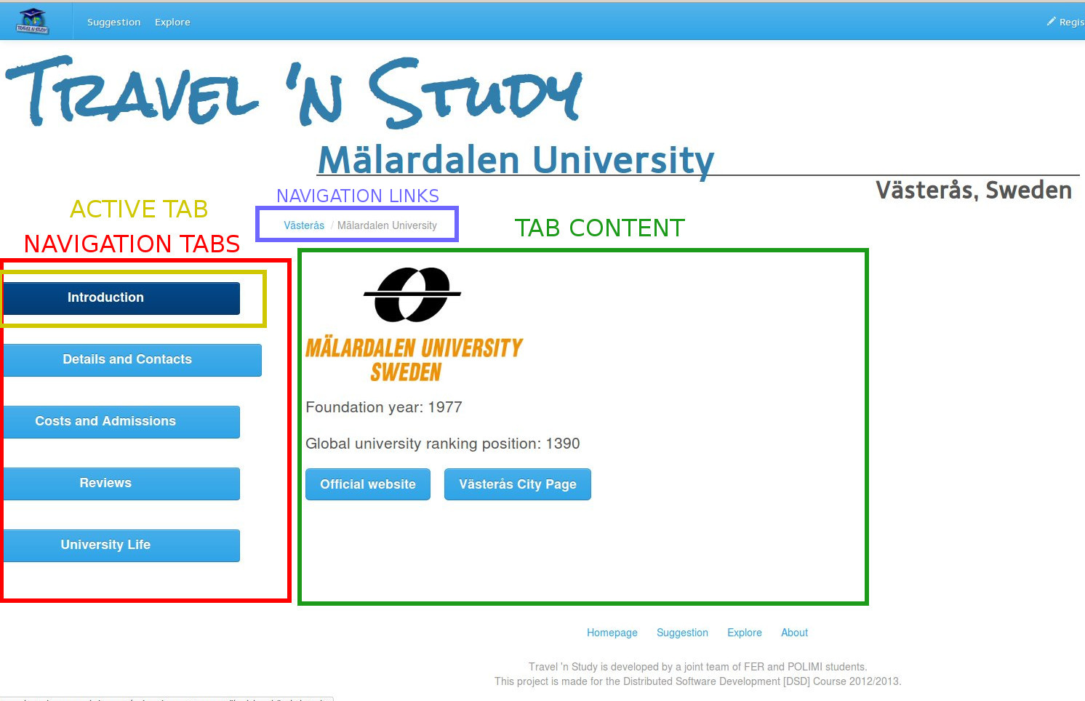
Figure 18 - Uni/City page layout

View Google Places suggestions

Interface
The interface is simple: there is a map and a list of buttons that represent different categories of places.

Toggling categories
You can click arbitrarily on any category button above the map.
If the chosen category is enabled for the first time in the current page the number of found places is printed next to the clicked category name and the map is populated with styled markers representing each place found
If the chosen category was already shown on the map the corresponding markers are hidden on the map
If the chosen category was already enabled but hidden on the map the corresponding markers are shown again
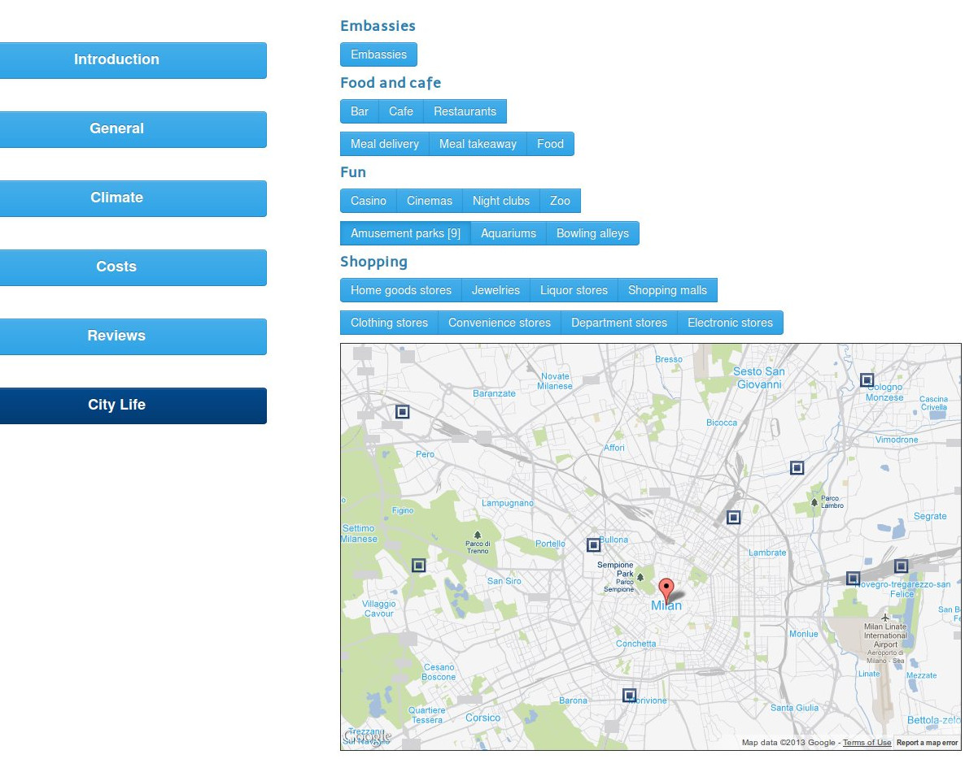
Figure 19 - Google Places interface

View details
Clicking on one marker of the map you can access all the details present on Google Places related to the corresponding place.
These info contain photos, website, phone number, opening hours and reviews. Note that not all the places have all these info.
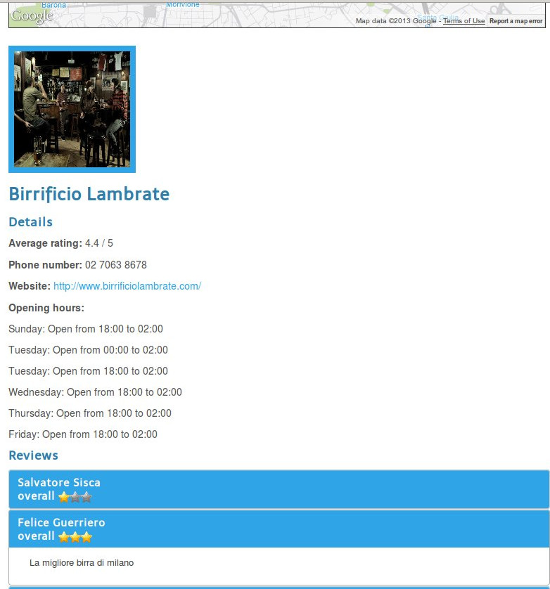
Figure 20 - Place details

Reviews
Note that these functionalities are available only for logged in users.

Adding a new review
Opening the “Reviews” tab of one city or university, you can see the following interface. It’s very simple to add your review: just type whatever you want in the text field (with a maximum length of 5 lines of text), choose the rating you want (represented by the colored stars below the text field) and click “Add”

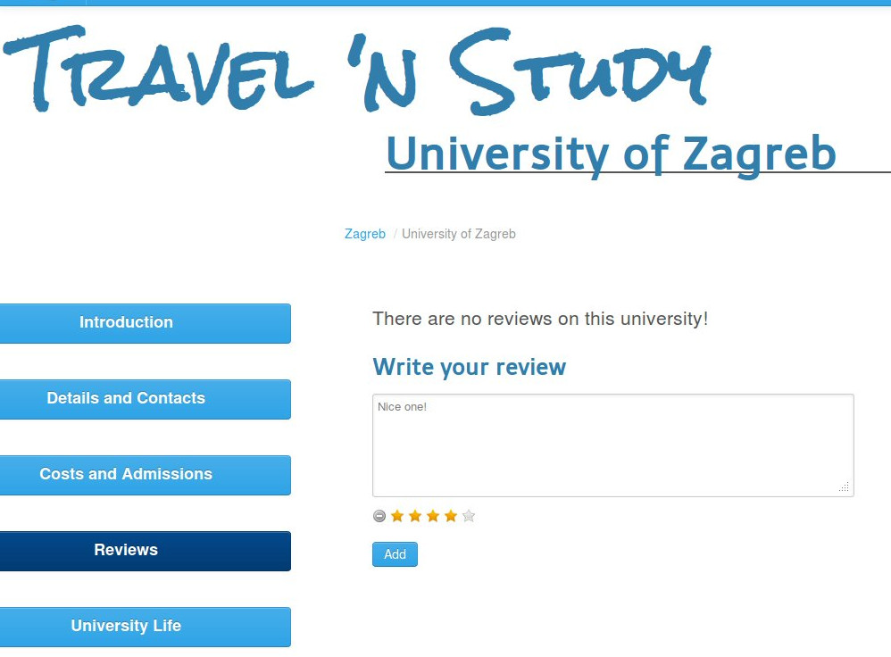
Figure 21 - Writing a new review

Editing a review
Once you created one review you can edit it anytime you want: you simply have to open again the “Reviews” tab of the entity you want to change the review for and click the “Edit” button below it.
You can see again the same interface used to add the first review that can be used in the same way.

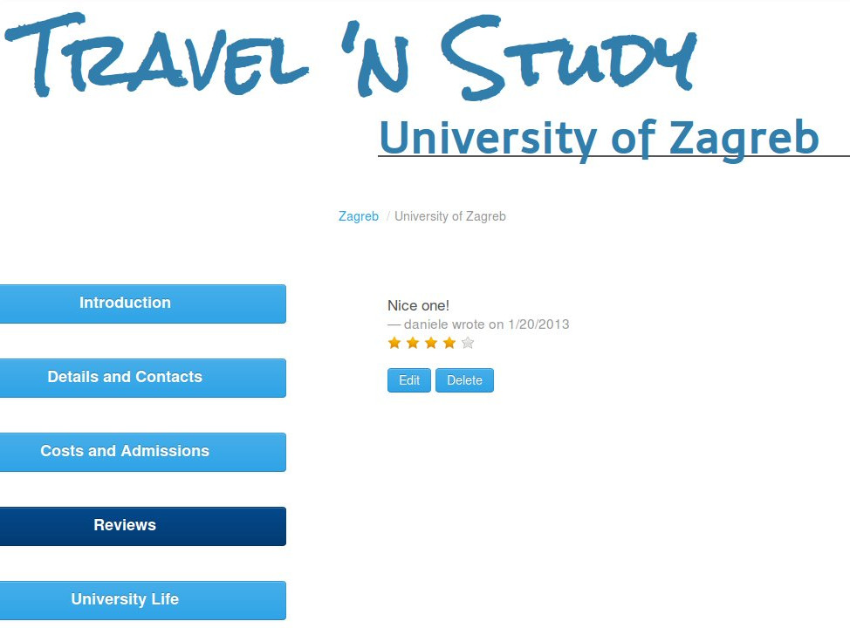
Figure 22 - Editing a review

Deleting a review
Once you created one review you can delete it anytime you want: you simply have to open again the “Reviews” tab of the entity you want to change the review for and click the “Delete” button below it.
After you confirm your intention clicking “Ok” on the alert box your review is definetely deleted.

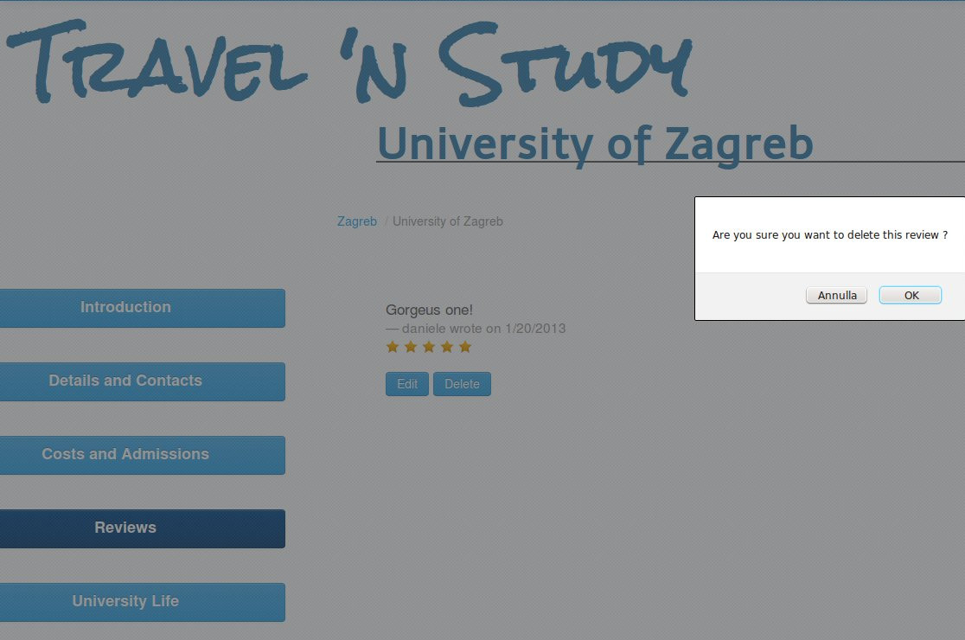
Figure 23 - Deleting a review

Direct search

Make a search
It is extremely simple to search for a keyword in our database of cities and universities: it is enough to write your query in the text field in the top right corner of the page and push the “Search” button.

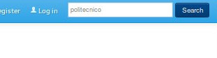
Figure 24 - Search field

Viweing search results
As a result of the search a list of universities and cities is shown. You can click any element you want to be redirected to the corresponding page on our website.

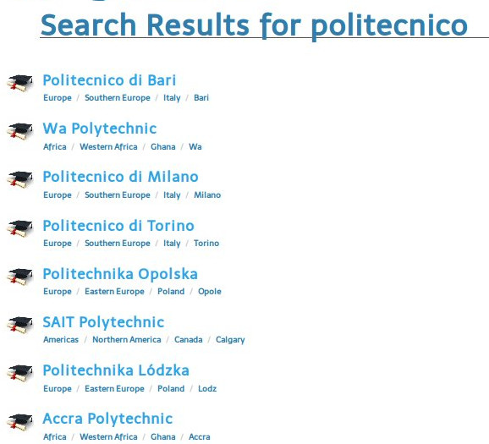
Figure 25 - Search results

