Client Data Requirements Report

Version 1.0

Contents
1. Introduction 4
1.1 Purpose of this document 4
1.2 Document organization 4
1.3 Intended Audience 4
1.4 Scope 4
1.5 References 4
2. Home page 5
3. Explore map page 5
3.1 City dataset 5
3.2 Country dataset 5
4. University information page 5
5. City information page 6

Introduction

Purpose of this document
The purpose of this document is to provide an overview of the data that is required on the presentation layer of the StudyAbroad project.

Document organization
The document is organized as follows:

- Section 1, Introduction, describes the contents of this report.
- Following sections describe the data required on each web page of the application.

Intended Audience
The intended audience is:
- All team members of the StudyAbroad project.

Scope
This document addresses general information about the data to be consumed on the presentation layer, which does not mean that the domain model should mirror it but we should provide some transformation mechanisms to match the expectations of the presentation layers to our doman object model.

References

Home page
So far this page needs to consume a dataset that provides the following:
- A collection of the top city names that correspond to the top universities without duplicates. This will require some processing, especially because the ranking provides the university name and the country, so we will need to get the city from Freebase or DBpedia.

- A collection of the top university names.

Both collections should belong to the same ranking type, and since it is for the home page I believe that can be the first 10 or 20 of the ranking of the top 500 universities in the world.

Explore map page
So far this page needs 2 datasets:

City dataset
Independently of the domain model, we should be able to query it by providing a city name and be able to get a dataset with the following:
- An abstract or general description of the city. This information is in DBpedia or Freebase.
- A collection of the university names that are located in the city.

Country dataset
Independently of the domain model, we should be able to query it by providing an ISO country ID and be able to get a dataset with the following:

- A collection of universities with the following data members:
  - Name
  - Ranking position
  - Location: This is the city name but some have campuses in a single city and other in multiple cities. This is provided by DBpedia or Freebase.

University information page
The idea is to provide an infobox like this:
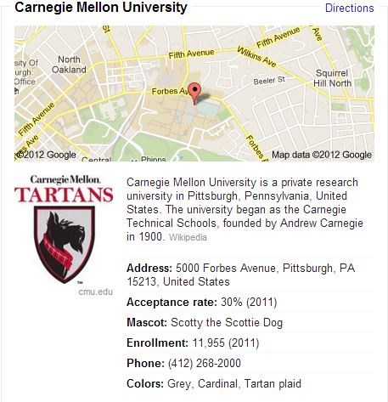
Independently of the domain model, we should be able to query it by providing a university name in native language and be able to get a dataset with the following:

- An abstract or general description of the university. This information is in DBpedia or Freebase.
- Logo: This is the logo url or serialized image. This information is in DBpedia or Freebase.
- Address: Physical address. This information is in DBpedia or Freebase.
- Coordinates: To be used together with the physical address to display a map. This information is in DBpedia or Freebase.
- Phone: Using country code+number.
- Enrollment: Amount of students. This information is in DBpedia or Freebase.
- Founded: Foundation date. This information is in DBpedia or Freebase.

City information page
The idea is to provide an infobox like this:
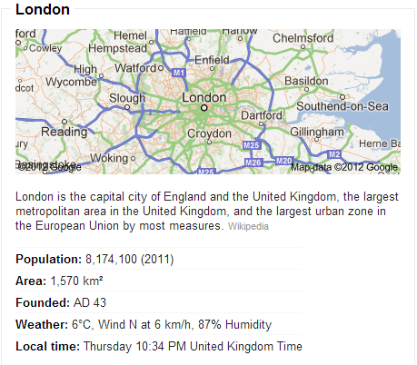

Independently of the domain model, we should be able to query it by providing a city name in native language and be able to get a dataset with the following:

- An abstract or general description of the city. This information is in DBpedia or Freebase.
- Logo: This is the logo url or serialized image. This information is in DBpedia or Freebase.
- Elevation: In meters. This information is in DBpedia or Freebase.
- Area: In squared meters. This information is in DBpedia or Freebase.
- Coordinates: To be used display a map. This information is in DBpedia or Freebase.
- Timezone: For winter and summer time. This information is in DBpedia or Freebase.
- Population: Total inhabitants.
- Density: Number of inhabitants per square meter.
- Web: URL of the official web site. This information is in DBpedia or Freebase.
- Founded: Foundation date. This information is in DBpedia or Freebase.

