Data and Information Quality Report

Project ID: 36
Assigned Dataset: 9
Students:
Marta Ravazzoni 11098105
Alessandro Vitobello 10710941

Project Structure
To maintain a modular and scalable workflow, we have decoupled each stage of the pipeline into dedicated Jupyter notebooks. The execution sequence and their respective outputs are detailed below:
Step | Notebook | Description | Output Format
1 | diq_dataq.ipynb | Initial Data Quality Assessment | —
2 | diq_datap.ipynb | YData Profiling | .html
3 | diq_dataw.ipynb | Data Wrangling | .csv
4 | diq_datac.ipynb | Data Clustering | .csv
5 | diq_datam.ipynb | Missing Values Handling | .html, .csv
6 | diq_datao.ipynb | Outlier Detection & Correction | .csv
7 | diq_datad.ipynb | Duplicate Detection & Deduplication | .html, .csv
8 | diq_dataq_final.ipynb | Final Data Quality Assessment | —

Setup Choices
Task | Libraries Used
Data Manipulation | pandas, numpy, re
Profiling & EDA | ydata-profiling, seaborn, matplotlib
Machine Learning | scikit-learn (IsolationForest, Ensemble), hdbscan
Dimensionality/NLP | umap-learn, sentence-transformers, scipy
Data Matching | recordlinkage

Quality Assessment
The initial phase involved a comprehensive database analysis to establish a baseline for data integrity. We extracted key metadata, including schema definitions and column names, while evaluating critical metrics such as duplicate counts, completeness ratios, and feature correlations (e.g., the relationship between Superficie Altri Usi and Superficie Totale).
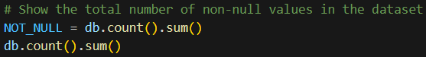
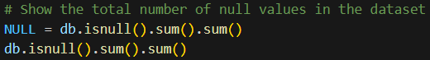
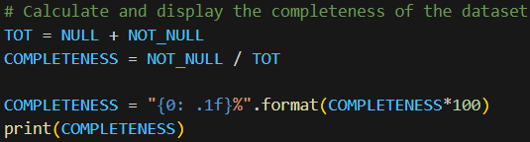

Data Profiling
We employed the ydata-profiling library to provide a comprehensive overview of the dataset, offering deep insights into data distribution, variability, and completeness.

Data Wrangling
This section marks the first stage of data transformation. To ensure consistency across the entire dataset, we began by standardizing all string values to lowercase.
Following the initial cleaning, we focused on decomposing the Settore Merceologico field. By parsing the internal text strings, we successfully expanded this single attribute into five distinct columns to better categorize the data.
Consequently, the Settore Merceologico column was standardized to include only five valid categories: Alimentare, Non Alimentare, Tabella Speciale Carburanti, Tabella Speciale Farmacie, and Tabella Speciale Monopolio. Erroneous entries, such as 'Automobilli' or 'foglio 216 part. 83 sub. 716 (z.d. 8)' were excluded as they fall outside the attribute's defined domain.
Following the standardization of Settore Merceologico, we addressed the Ubicazione field. This attribute typically contains a composite of Tipo Via, Via, and Civico, alongside secondary details such as Interno and Accesso. To facilitate cleaning and extraction, we defined a 'valid triplet' consisting of the primary address components. We then initialized a secondary DataFrame (db2) from the source data (db) to isolate and clean the Ubicazione strings before further parsing.
Subsequently, we derived a consolidated Indirizzo field by concatenating the validated triplet (Tipo Via, Via, and Civico). This new field served as a reference to validate the original Ubicazione entries; where a match could not be established, the Ubicazione value was flagged as “missing”.
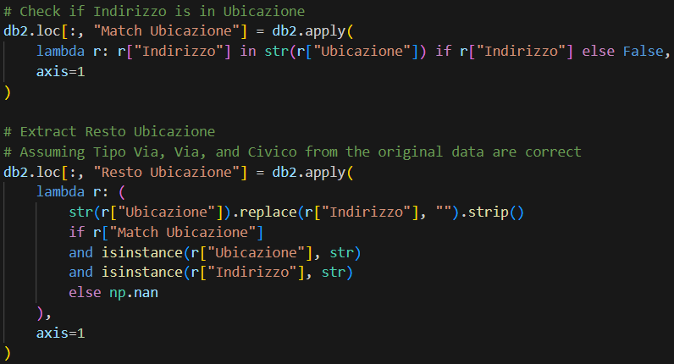
We then generated a Resto Ubicazione column within a temporary DataFrame (tmp) to store the residual strings from the original address field. Using this staging data, we parsed the remaining text to extract the Isolato and Accesso attributes.
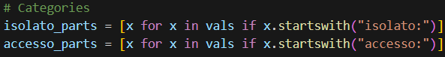
Finally, we isolated and extracted the ZD attribute from the remaining string data.
Subsequently, we integrated the newly extracted attributes from the temporary DataFrame into db2. We decided to terminate further extraction from the Resto Ubicazione field, due to the high volume of missing values (exceeding 80%). We then consolidated our work by merging db with db2. The resulting schema is structured as follows:
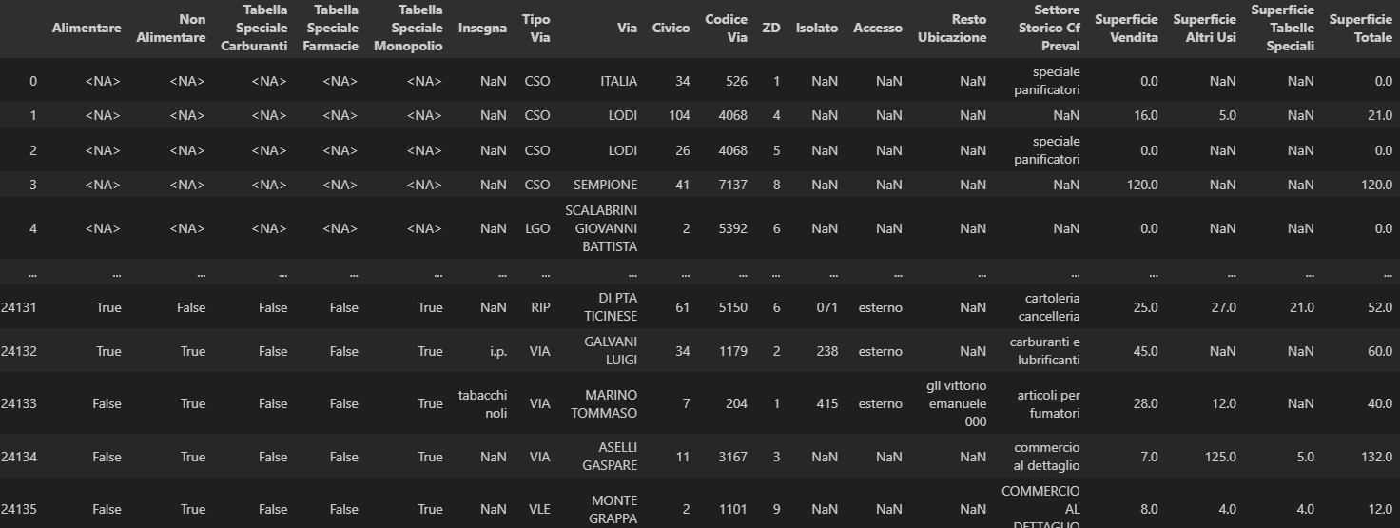

Clustering
In this section, we processed the Settore Storico Cf Preval attribute. As a preliminary step, we performed a string normalization by converting all characters to lowercase. Additionally, we handled null values by imputing them with the label “missing” to ensure the dataset was compatible with the subsequent clustering algorithm.
We then employed UMAP (Uniform Manifold Approximation and Projection) for dimensionality reduction, facilitating more efficient clustering and a clearer visualization of the data distributions
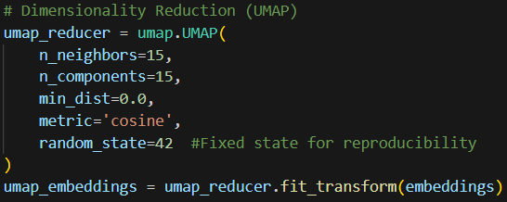
With the dimensionality reduced, we proceeded to execute the clustering algorithm to identify distinct groupings within the processed feature space.
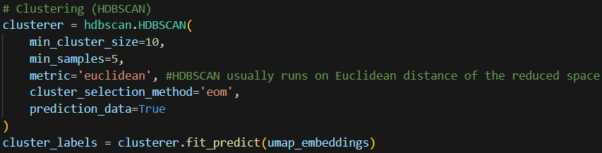
The clustering process successfully consolidated the Settore Storico Cf Preval attribute, reducing its cardinality from 2,119 unique labels to 230 distinct groupings.

Missing Values Handling
Missing values were handled through a combination of column removal, targeted imputation, and explicit placeholder assignment. First, variables exhibiting an excessive proportion (>65%) of missing observations, namely Insegna (71.0% of missing values), Resto Ubicazione (81.2% of missing values), and Superficie Tabelle Speciali (95.3% of missing values), were entirely removed from the dataset to avoid introducing noise or unreliable imputations.
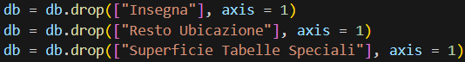
For surface-related measures, zero values in Superficie Vendita were explicitly recoded as missing, reflecting their semantic equivalence to absent information and enabling consistent treatment during imputation.
Missing values in a subset of key binary and numerical variables (Alimentare, Non Alimentare, Tabella Speciale Carburanti, Tabella Speciale Farmacie, Tabella Speciale Monopolio, Superficie Vendita, and Superficie Altri Usi) were then imputed using a Random Forest–based approach, that learns from the combined information of other relevant variables in the dataset to make the best possible estimates.
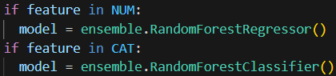
Following this step, the original variables with missing data were replaced by their imputed counterparts. No imputation techniques were applied to the remaining categorical variables (Tipo Via, Via, Civico, Accesso), as these features represent identifiers or labels that cannot be meaningfully inferred from observed values. Instead, they were completed by assigning an explicit “missing” category, preserving their categorical nature while avoiding row deletion. Similarly, selected numerical identifiers (Isolato, ZD, Codice Via) were filled with zero values, which were used solely as neutral placeholders rather than as statistically imputed estimates.
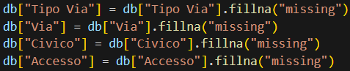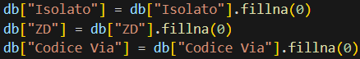
An exploratory consistency check showed that Superficie Totale was not consistently defined in the original dataset and could not be treated as an independently imputable variable. After removing Superficie Tabelle Speciali due to extensive missingness and imputing the remaining surface variables, Superficie Totale was recomputed as a derived measure as the row-wise sum of Superficie Vendita and Superficie Altri Usi, ensuring internal consistency after imputation.
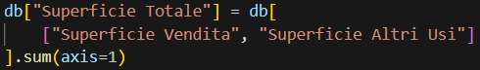

Outliers Detection and Correction
Outlier handling was conducted through a sequence of rule-based and model-based checks applied to key address and surface variables. For the street-number field (Civico), the pipeline first extracted the leading numeric component from the original string representation via a regular-expression rule and filled non-parsable cases with zero to enable quantitative screening; potential outliers were then flagged using a standard-deviation criterion, followed by a second, street-aware procedure that examined the ordered Civico progression within each street to identify anomalous jumps. The standard deviation threshold was intentionally set to 1 to increase the sensitivity of the outlier detection procedure. Given the non-Gaussian and discrete nature of the Civico variable, conventional thresholds (e.g. 2 or 3 standard deviations) were considered too conservative.
Records identified as Civico outliers were not removed; instead, their original Civico values were replaced with an explicit “missing” placeholder in the main dataset. Since these anomalous values were not intended to be used in the analysis, treating them as missing was equivalent to excluding their information while preserving the corresponding records. Diagnostic scatterplots of Civico versus an ordinal encoding of Via were generated before and after this correction to visually assess the impact of the procedure.
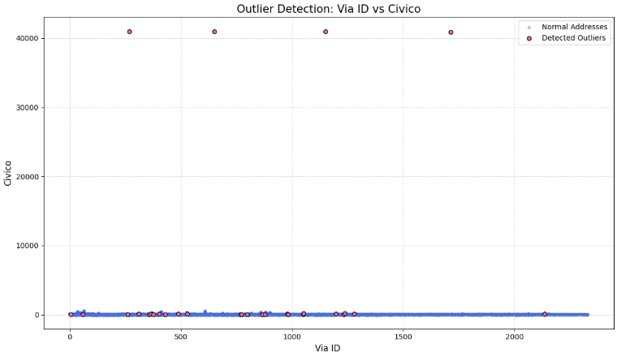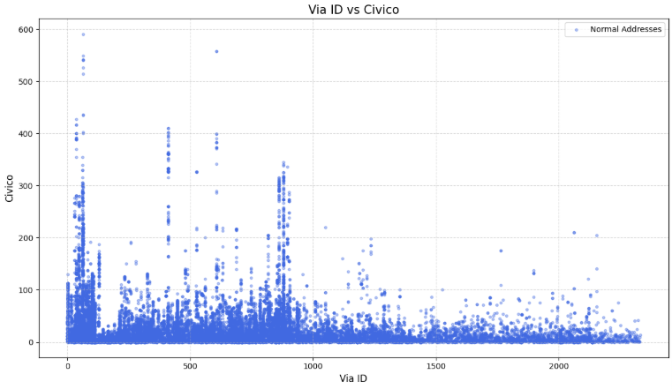
Outliers in ZD were addressed separately using a standard-deviation rule with a larger threshold (th = 3), replacing detected anomalies with zero. This choice was informed by preliminary exploratory analysis: several threshold values were tested, and th = 3 was selected because it identified 60 as the only outlier, consistent with prior inspection of the data, while preserving all other valid observations. A boxplot of ZD by Codice Via, together with inspection of unique ZD values, was used for exploratory assessment and validation of this choice.
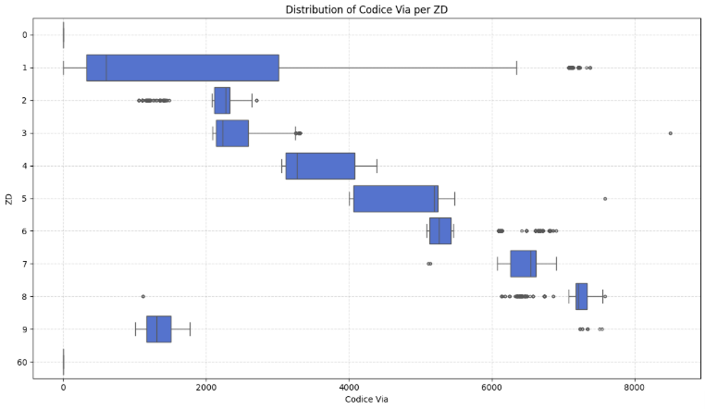
Finally, for the two continuous area measures (Superficie Vendita and Superficie Altri Usi), an Isolation Forest model was fitted to their joint distribution to identify multivariate outliers. The contamination level was set to 0.01 to reflect the expectation, based on prior exploratory analysis, that only a very small fraction of observations represented true joint anomalies, thereby ensuring a conservative detection of extreme cases.
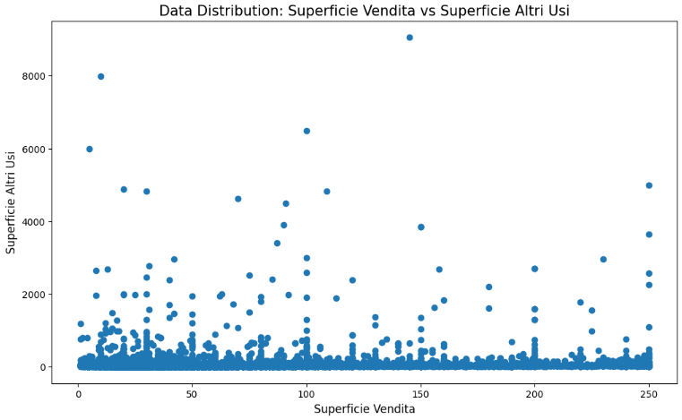
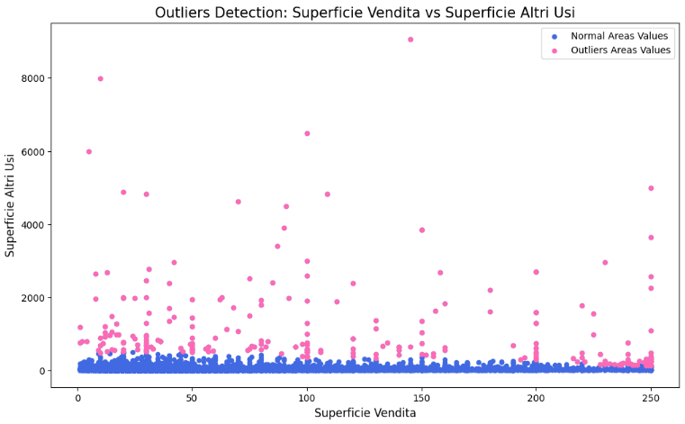
The flagged observations had their area values set to missing (NaN) and were subsequently imputed using Random Forest models after categorical features were encoded, with the original area columns dropped and replaced by the imputed versions and the column order restored. The Isolation Forest procedure was then rerun and visualized on the corrected data to confirm the post-correction distribution.
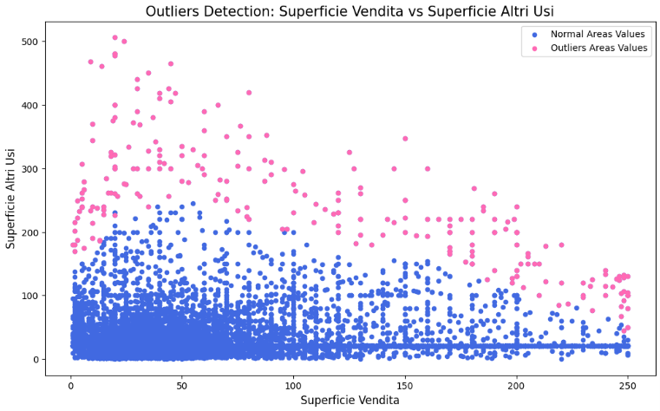

Duplicates Detection and Data Deduplication
Duplicate handling was performed in two stages combining direct row-level checks with probabilistic record linkage. The pipeline first quantified exact duplicates and then removed strictly identical records.
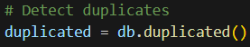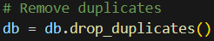
To capture near-duplicates that may not be perfectly identical, a record-linkage procedure was subsequently applied. Candidate record pairs were generated by blocking on the Via field (i.e., comparisons were restricted to records sharing the same street, assuming that true duplicates were very unlikely to be on different streets).
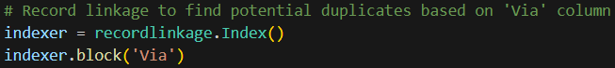
Each candidate pair was scored using a comparison object that included exact agreement checks on a set of columns alongside string-similarity comparisons using the Jaro–Winkler method for Via and Settore Storico Cf Preval. A Jaro–Winkler similarity threshold of 0.85 was adopted to allow for minor spelling variations in street names while maintaining a conservative matching criterion. This value was informed by exploratory inspection and chosen to minimize false positives.
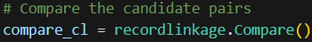
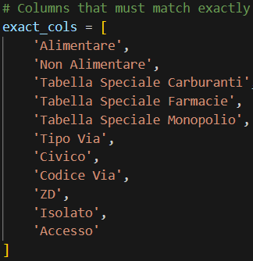
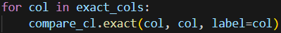
Pairs were classified as duplicates only when the computed feature vector indicated agreement on essentially all comparison features (implemented as a sum greater than 12, corresponding to all 13 features), and the corresponding duplicate records were removed from the dataset by dropping one member of each matched pair while preventing repeated deletions through index tracking.
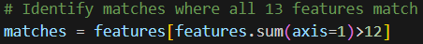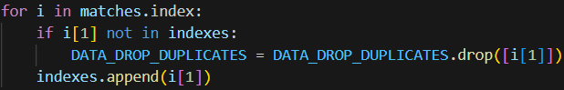

Final Observations
In conclusion, our data quality assessment demonstrates a significant improvement in the integrity and reliability of the dataset through targeted cleaning, imputation and deduplication processes. Initially, the original dataset, comprised of 24,136 records, was flagged for containing numerous duplicate entries and missing values across several fields.
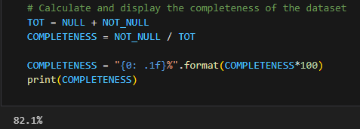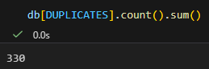
By implementing a rigorous quality framework, we successfully refined the data into a final set of 23,454 unique records. This process achieved 100% completeness in the final version, effectively eliminating null values and redundant entries while ensuring that the remaining data points are both distinct and accurate.
