Alea Job Scheduling Simulator

Downloading the Alea
Ale ais distributed on GitHub: https://github.com/aleasimulator/alea

Running Alea
Ale ais distributed as a Netbeans Project, so the most convenient way is to download Netbeans IDE (https://netbeans.org/) and open Alea there. After opening, it will be probably necessary to “resolve reference problem” by selecting simjava.jar and gridsim.jar libraries, that are required to run the simulator. Those are distributed along with the Alea in the ./lib directory.
Once libraries are loaded (it is important to load simjava.jar as the first library – see the screenshot), you can compile and run the simulator. You can also run the simulator without the IDE by executing the Alea.jar file located in the ./dist folder. Use the command when located in the main Alea folder: java -jar "./dist/Alea.jar"
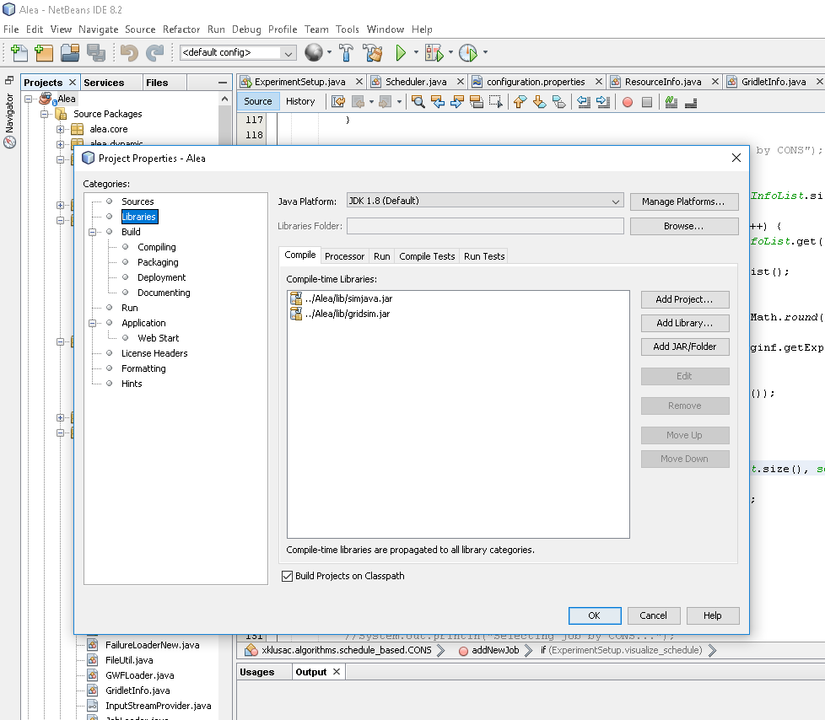

Workloads
Alea needs a valid data set (workload) to be located in the ./data-set directory. Each workload needs two files – job description and machine description file. The format of the workload file is typically identical to SWF format (http://www.cs.huji.ac.il/labs/parallel/workload/swf.html), while the machine-description file in Alea uses its own format. Machine-description file is stored in a file with .machines filename extension. The file format specifies one computer cluster per each line, attributes are separated by TAB space. One line has the following attributes:
cluster_id <tab> cluster_name <tab> number_of_nodes <tab> CPUs_per_node <tab> CPU_speed <tab> RAM_per_node_in_KB
So, in the following example we have two clusters (zewura/zegox), having 20/48 nodes, each having 80/12 CPUs per node (with default speed 1) and approx. 500/90 GB of RAM per each node:
0 zewura 20 80 1 529426432
1 zegox 48 12 1 94035968

Configuration
The simulator can be configured by the ./configuration.properties file located in the main directory. Here you can specify:
- the names of the workloads to be used
- the number of jobs to be used from each such workload
- the type of scheduling algorithm(s) to be used. Some basic scheduling algorithms are already provided such as:
  - 0 – FCFS
  - 2 – Easy Backfilling
  - 4 – Conservative Backfilling
  - 6 – Shortest Job First
  - 7 – Fair-Share FCFS
  - 9 – Fair-share Conservative Backfilling
  - 22 – Fair-share Easy Backfilling
and various other scheduling –related parameters. For example, you can specify whether:
- job runtime estimates will be used and if so, which type of estimate will be used (user-provided or “artificial”).
- fair-sharing should be used and if so, whether decay should be applied and what type of resource tracking metric will be used.
- “on the fly” visualization should be used, showing either general metrics like utilization and waiting/running jobs or prepared schedule. (Schedule visualization is however only possible for planning-based algorithms such as Conservative backfilling and similar. It will not work for pure queue-based algorithms since there is no schedule to visualize).

Results
Results are generated as the simulation proceeds and are collected in a complex folder structure in the ./results directory. Each simulation gets a distinctive folder where the simulation configuration file is copied as well. Beside some general preprocessed results allowing for quick comparison, this folder contains one folder per each workload and per each algorithm. Within each such folder a complete list of processed jobs (and their parameters) and a list of users is kept, allowing to perform “post mortem” analysis of simulation performance (using your own job parser).

